Name_______________________________________________Date________________

- Where should the medication tray be placed for the pharmacist to access the drugs in it during a code blue emergency?
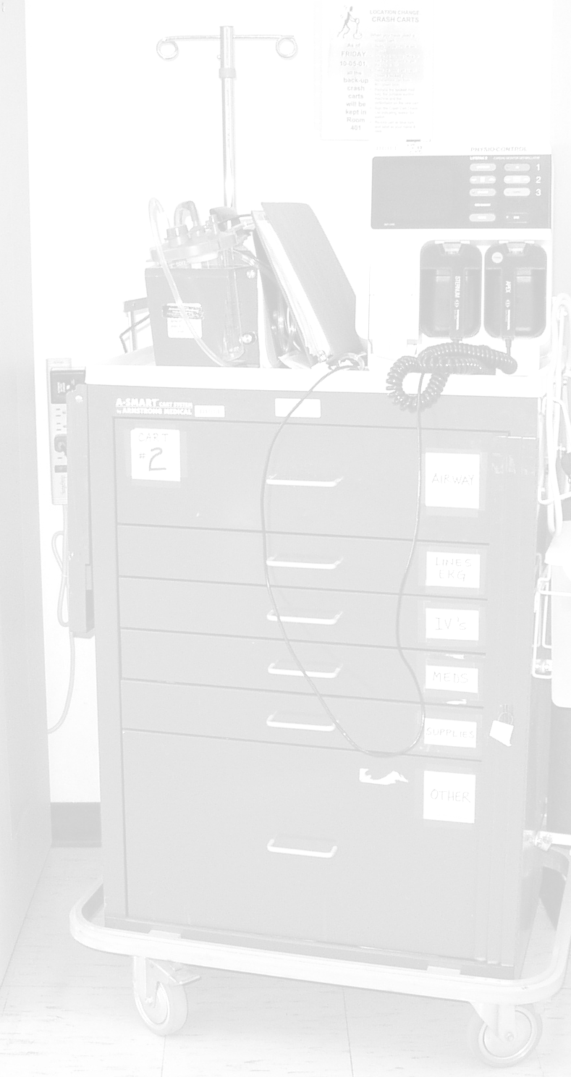

- What two medications should be assembled at the beginning of a code blue emergency?

- True or False: Pre-treatment/pre-medication is necessary before intubation.

- When the physician requests a medication, what does the pharmacist do in conjunction with passing the medication to the physician or nurse who will be administering it?

- Which NMB has the quickest onset of action?

- What do you do with the empty syringe boxes as the code progresses? Why?

- Which IVPB medication should NOT be given in the same line as an alkaline IV solution?

- What diluent should be avoided when making a norepinephrine drip?

- What is an Ambu Bag™ used for?

- A MD wants to sedate with etomidate. What dose do you recommend for a 70 kg patient?

