Tutorial 2: Tricellular Model

Objectives:

- Explain the horizontal and vertical movement of heat energy within the atmosphere.
- Explain how the types of surface wind belts relate to the global atmospheric circulation system.
________________________________________________________________

Questions:

1. DRQ Practice

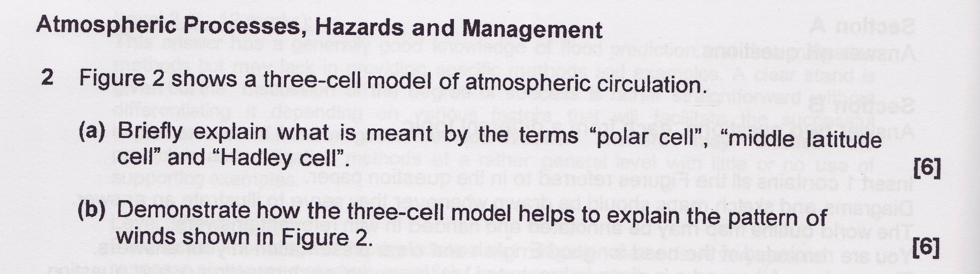
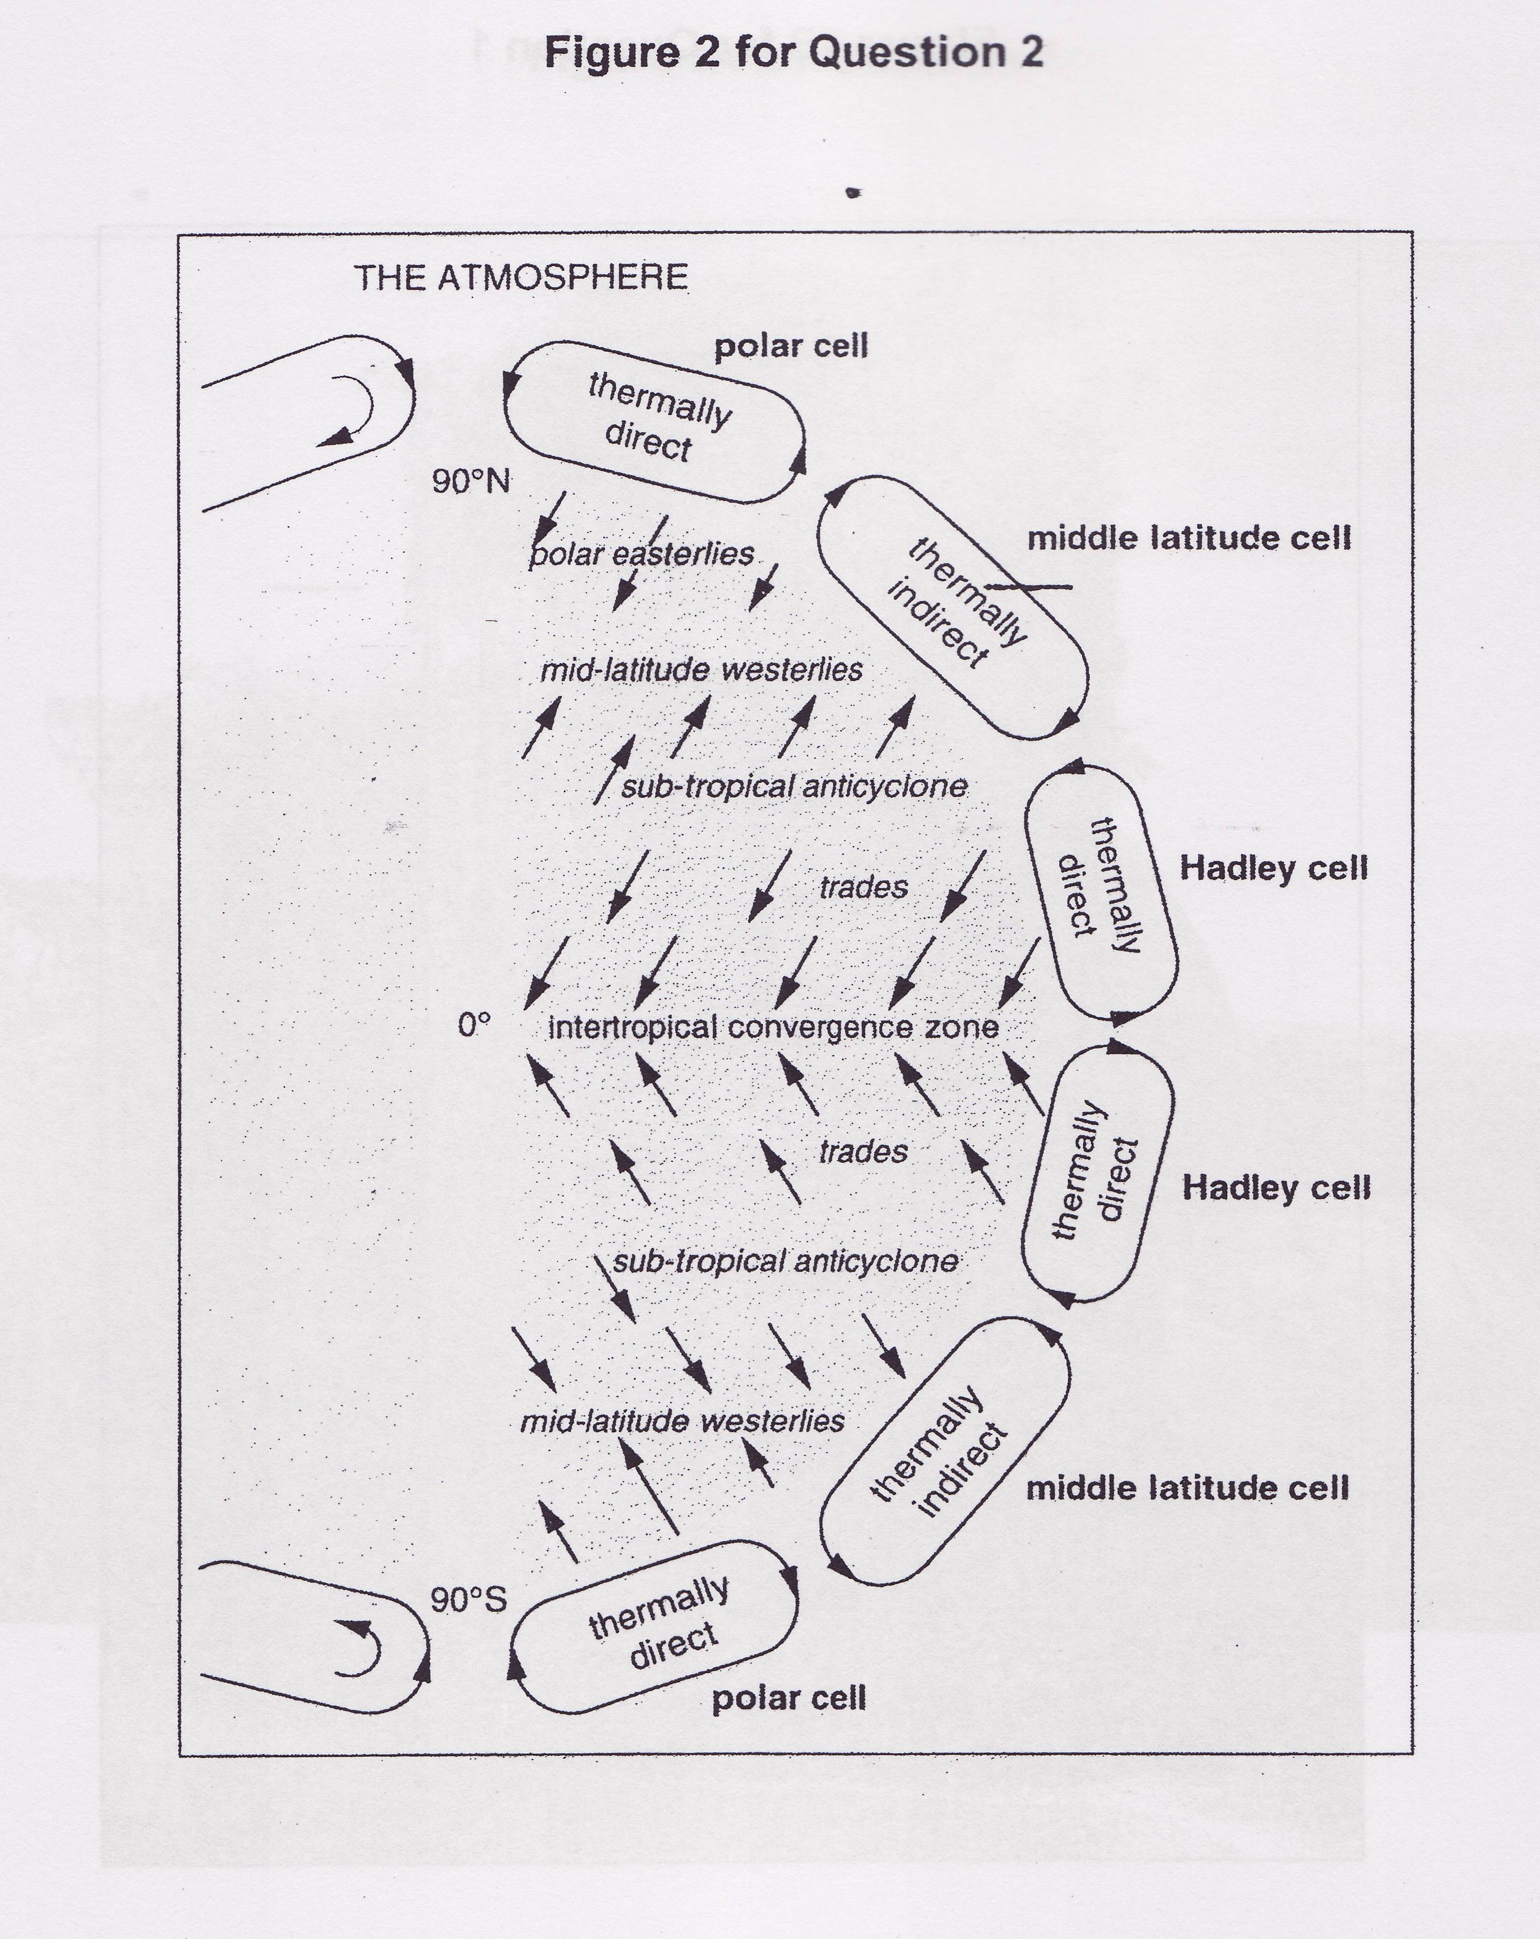

2. Essay practice: Write an outline to the following question.

Show how the tricellular atmospheric circulation model helps explain the occurrence of the major wind belts and their associated weather patterns. [16]

