Running Head: Lesson Plan

ESL Lesson Plan 1

Name:

Institution:

Instructor:

ESL Lesson Plan

Background Information:
This lesson has been designed for English major students at Universidad Autonoma de Chiriqui, a public university. Students´ ages range from 19 to 20 years old. These are second year students whose first language is Spanish and are still at this point struggling with the target language. They have a high intermediate level in English. They are required to take a total of three writing courses: Writing Communication, Intermediate Writing and Advance Writing. Groups in this state university are big varying from 30 to 40 students per group. .
Previous Lessons:

- Students have learned to write simple, compound and complex sentences in previous lessons.
- Students have learned how adjectives and adverbs modify nouns, adjectives, and other adverbs.
Goal(s):
- By the end of this lesson, students should be able to develop more effective sentences when writing paragraphs that will help them become more versatile writers.
Objectives:

- Demonstrate understanding of and the ability to use adjectives and adverbs to write creative sentences.
- Demonstrate their ability to put words together to write sentences with meaning, clarity, coherence, emphasis, conciseness, and rhythm.
Appropriate length of lesson

- Students will use this lesson in a morning class (90 minutes).

Materials/Resources needed:
- Blackboard
- Monolingual Dictionary
- Magazine picture
- OHP
- Tranparency

Procedures:

Pre-Activity (10 minutes)
- Teacher reviews material from previous class. (use of modifiers: adjectives and adverbs)
- Students discuss and compare how adjectives and adverbs are used in their native language to their use in English.
While Activity
Time Allotted: (15 Minutes)
- Teacher distributes a magazine picture to all students.
- Students analyze the picture.
- Teacher elicits from the students simple sentences about the picture and lists them on the board.
Possible sentences:
- There is a woman in the laundry room.
- There are two children by the dryer.
- The woman has two children.
- The woman is talking on the phone.
- The woman is standing by the washing machine.
- Teacher asks the students what is wrong with those sentences and students should come up with the conclusion that the sentences are boring.
- Teacher elicits from students what could be added to those sentences to make them more interesting (referring to the previous class where using modifiers was introduced)

Time Allotted: (10 Minutes)
- Teacher explains and discuss with the students that when adding adjectives and adverbs to make effective sentences, they must consider six qualities: meaning, clarity, coherence, emphasis, conciseness, and rhythm. These points are presented in a transparency.
Time Allotted: (35 minutes)
- Teacher writes the following sentence describing the picture previously distributed to students on the board:
The woman stood by the washing machine.
1 2 3
- Teacher makes students aware of the different colors that words have in the sentence and the numbers underneath them.
- Students are asked to form groups of three.
- Students number from 1 to 3.
- Each member of the group must work with the part of the sentence that has their number.
- Individually, students must add modifiers to their part, keeping the original details.
- Students are given the time to work individually on their part.
- Students in their group put the sentence together, and decide which combination they like and which ones they don´t.
- After students have decided on the best sentence, they must evaluate their work considering the six basic qualities presented on the board.
Time Allotted: (20 minutes)
- One person from each group comes to the board and writes the sentence for their group and reads it.
- As a whole group, students provide feedback about the sentences considering the six qualities.

Post-Activity
- For homework, students are to choose a magazine picture and write a paragraph about the picture using modifiers and considering the six qualities for effective sentences.
Assessment:

- Students will be informally assessed while working in class, the teacher will walk around and monitor how students are working.
- Students will be formally assessed through the homework assignment on the following class.
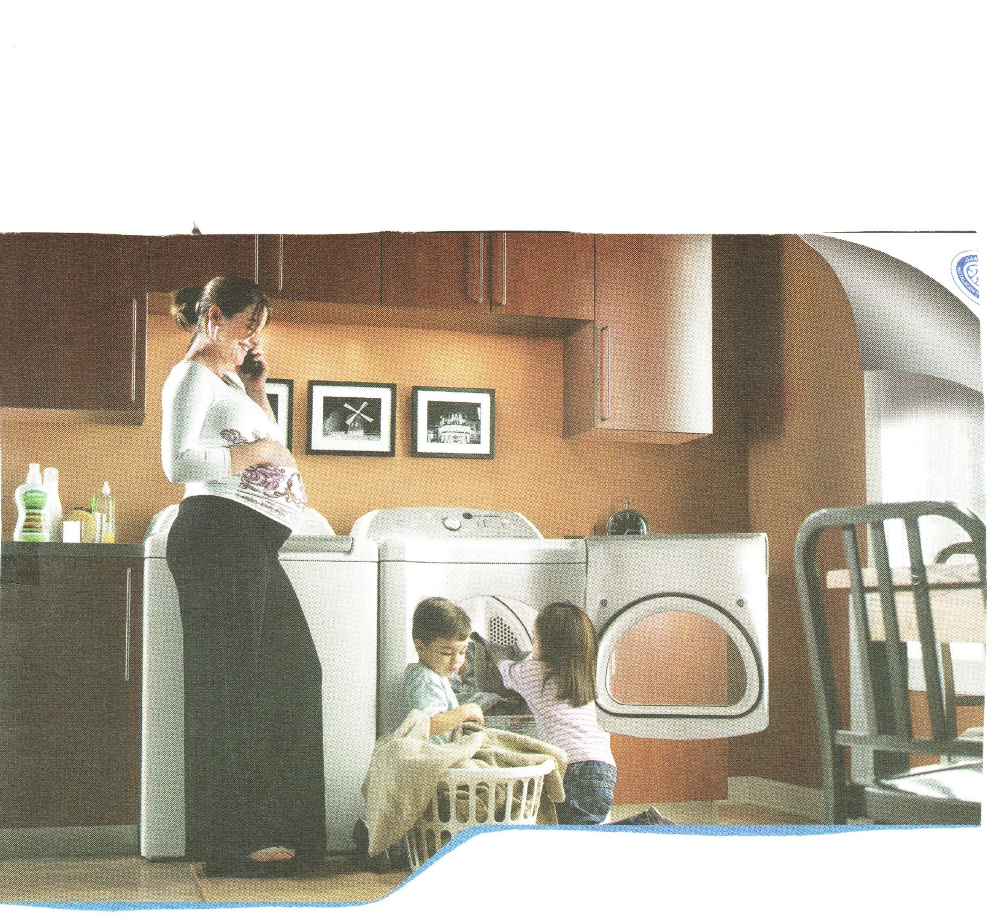
Magazine Picture

(Transparency)
Six basic qualities to consider when writing sentences

- Meaning. As far as you can determine, have you conveyed the idea intended by the original author?
- Clarity. Is the sentence clear? Can it be understood on the first reading?
- Coherence Do the various parts of the sentence fit together logically and smoothly?
- Emphasis. Are key words and phrases put in emphatic positions (usually at the very end or at the very beginning of the sentence)?
- Conciseness. Does the sentence clearly express an idea without wasting words?
- Rhythm. Does the sentence flow, or is it marked by awkward interruptions? Do the interruptions help to emphasize key points (an effective technique), or do they merely distract (an ineffective technique)?

REPORT
The overall approach of this lesson plan is Communicative Language Teaching. (CLT) is an approach to the teaching of second and foreign languages that emphasizes interaction as both the means and the ultimate goal of learning a language. With this approach, the role of the teacher and the students are paramount. In this lesson, the role of the teacher and the students were those that Brown (2007) described:
¨The role of the teacher is that of facilitator and guide... Students are encouraged to construct meaning through genuine linguistic interaction with other students and with the teacher. Students in a CLT class are active participants in their own learning process. Learner-centered, cooperative, collaborative learning is emphasized…¨

Implementing CLT in writing classes is not easy but possible. As a matter of fact, teaching writing skills to EFL students is not an easy task for language teachers. The concern of many language teachers is ¨How can we best teach second language learners of English how to write? ¨ In a writing class, traditional teachers tend to focus on the final product and not on the process. This is a mistake. To be able to teach students how to write effective paragraphs, compositions, essays, articles, and so on; teachers must focus on the process approach to writing instruction. According to Brown (2007), Process approaches do the following:
- Focus on the process of writing that leads to the final written product
- Help student writers to understand their own composing process
- Help students build repertoires of strategies for prewriting, drafting and rewriting
- Give students time to write and rewrite
- Place central importance on the process of revision
- Let students discover what they want to say as they write
- Give students feedback throughout the composing process (not just on the final product) as they attempt to bring their expression closer and closer to intention
- Encourage feedback from both the instructor and peers
- Include individual conferences between teacher and student during the process of composition
- I decided to follow the process approach when elaborating this lesson plan. In writing classes, students need to be personally involved in writing exercises in order to make the learning experience of lasting value. Encouraging student participation in the exercise, while at the same time refining and expanding writing skills is a must. When writing up this lesson plan, first, I focused on the skill that I wanted to develop on my students (writing). Writing was the main skill but I integrated all of the skills throughout my lesson because according to Brown (2007), integrating the skill in language instruction develops communicative competence. I considered their level (intermediate), age (19-20), reasons for being in that course (curriculum requirement), specific future intentions for the writing (to be able to write creative paragraphs with sentences with meaning, clarity, coherence, emphasis, conciseness, and rhythm.) Next, I decided on the type of exercise and material that would facilitate learning of the target area. Students are given a task as the main activity. They have to work in groups to come up with a sentence. Nunan (1999) says that tasks give learners practice in cooperating with other learners and their teachers in making creative use of the language they have learned. I decided to use authentic material (a picture from a magazine). Richards (2001) defines authentic material as texts, photographs, video selections, and other teaching resources that were not intended for teaching purposes. Learners find authentic material more motivating and interesting. Consequently, I decided on how students would work on the activity. I decided to have students work in groups of three. Brown (2007) says that small group work enables students in interactive communication for a short period of time with a minimum of logistical problems. Group activities have the advantage that they maximize the amount of oral interaction on the part of the students and students are less likely to be inhibited when working with peers. In addition, students help prompt, encourage and correct one another, allowing the teacher the freedom to move from group to group and give whatever help is needed. Finally, I had to choose the best means of assessment and I considered that for this lesson, the best approach was to have students do self assessment and peer assessment. Brown (2007) makes reference to research by Alderson & Banerjee, 2001; Brown & Hudson, 1998; O´Malley & Perce, 1996) where some of the advantages of self and peer assessment are speed, direct involvement of students, the encouragement of autonomy, and increased motivation. By the end of the 90 minutes of class, students should be able to develop more effective sentences when writing paragraphs that will help them become more versatile writers.

REFERENCE
Brown, H.D. (2007). Teaching by principles: An interactive approach to language pedagogy (3rd ed.). New York: Longman.

Nunan, D. (1999). From the traditional to the contemporary in second language teaching and learning. In D. Nunan, Second languge teaching and learning. Heinle & Heinle.

Richards, J. (2001). The role and design of instructional materials. In J. Richards, Curriculum development in language teaching.Cambridge University Press.

