Having Fun with Case Studies
I think it is helpful to look at the breakdown of questions and then generate an outline (APA level headings) that corresponds with the questions. This helps organize the material, makes it easier to write, and prevents you from missing any required elements:
1. Which is the primary body system involved in this diagnosis? If the diagnosis is a syndrome, then specify the main systems involved. (5%)
2. What is the pathology behind the disease in the system as the cellular level? At the organ level? At the system level? What factors may contribute to this pathology and how? (40%)
3. What other systems would you anticipate could be affected by this pathology and how would they be affected? (20%)
4. How might these pathologic processes/system interactions present in a client? (What is the typical presentation?) (25%)
5. If the client has comorbidities, then how might the pathology affect these comorbidities? (10%)
So, for example, an outline might look like:
Brief introduction (no heading needed)
Main Systems Involved (level 3 heading) [since it is a syndrome].
Cellular Pathology of Metabolic Syndrome (level 3 heading)
Organ Pathology for Metabolic Syndrome (level 3 heading)
System Pathology for Metabolic Syndrome (level 3 heading)
Factors Contributing to Pathology (level 3 heading)
How these Factors Contribute to Pathology (level 3 heading)
Other Systems Affected and How (level 3 heading)
Presentation and System Interactions (level 3 heading)
Co-morbidities and how the Pathology of Metabolic Syndrome may affect Co-morbidities (level 3 heading)
Conclusion (level 1 heading)
References (level 1 heading)
Now we have an outline, we are ready to populate it with resources, so we can generate a response to the case study assignment. How do we do this?
A good starting place might be the Disease Database at http://www.diseasesdatabase.com/disease_index_m.asp where we would find metabolic syndrome as Reaven syndrome X
Looking quickly at this, we find some interesting possibilities:
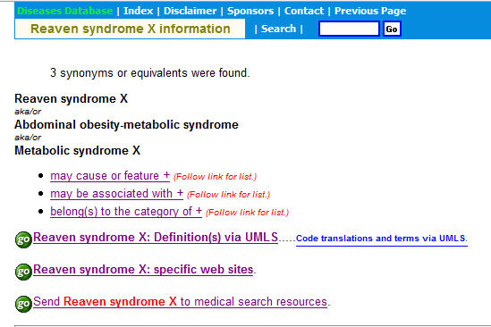
Following any of these links will get us a large yield quickly.
Then we can leverage PubMed into service as follows:
Brief introduction (no heading needed) – we will leave the introduction and conclusion until last – it’s easier that way.
Main Systems Involved (level 3 heading)
We can determine this from quick inspection of the disease database resources.
Cellular Pathology of Metabolic Syndrome (level 3 heading)
We will do a PubMed search on metabolic syndrome AND cellular pathology, choose Reviews and harvest what we need from there. It is probable that a careful read of some of the more likely titles and abstracts will give us everything we need for the cellular pathology of metabolic syndrome. So we can throw together a paragraph or two, with appropriate inline citations.
Organ Pathology for Metabolic Syndrome (level 3 heading)
Similarly here we will do a PubMed search on metabolic syndrome AND organ pathology, choose Reviews and harvest what we need from there. We might want to use specific organs as level 4 subheadings and write a brief paragraph under each – this is up to personal preference.
System Pathology for Metabolic Syndrome (level 3 heading)
We will do a PubMed search on metabolic syndrome AND system pathology, choose Reviews and harvest what we need from there. This will give us enough material to develop a couple of paragraphs on the various systems most affected by metabolic syndrome, along with some anchoring inline citations.
Factors Contributing to Pathology (level 3 heading)
Here we will use PubMed Clinical Queries found in the left hand navigation bar and search on metabolic syndrome and check etiology – the rest is easy.
How these Factors Contribute to Pathology (level 3 heading)
If we did not get enough material with Clinical Queries – etiology, we can do Clinical Queries – diagnosis and go from there.
Other Systems Affected and How (level 3 heading)\
A good start might be to check the Disease Database at http://www.diseasesdatabase.com/disease_index_m.asp and look at the may be associated with link. This will give us some useful information. Then we should check metabolic syndrome AND associated pathology at PubMed, for further clues.
Presentation and System Interactions (level 3 heading)
This is an easy one. We will just search on metabolic syndrome AND clinical presentation, choose Reviews and we have most of what we need. Any confirmatory material will definitely be found in McCance & Huether, or Harrison’s available online from Athabasca University library.
Co-morbidities and how the Pathology of Metabolic Syndrome may affect Co-morbidities (level 3 heading)
We have to decide if there is any evidence of co-morbidities rather than make assumptions, and then go from there.
Conclusion (level 1 heading)
Now it is time to write a brief conclusion, which essentially (and briefly) summarizes what you have just told the reader. Then you go zoom back up to the introduction and write that as a re-purposing of your conclusion into a form similar to a summary of what you are about to tell the reader.
References (level 1 heading)
Using your favourite bibliographic management software (Refworks is free for AU library users), you simply generate your references listing in perfect APA 5th edition format. Then go for a walk, come back and proofread, spell and grammar check, and then put it away for a day or two. This allows reflection/incubation time and if you need to make any changes, now is the time. Send it in and you are home dry and free to do something else. ☺
Jack

