The Battle of Crécy (1346)
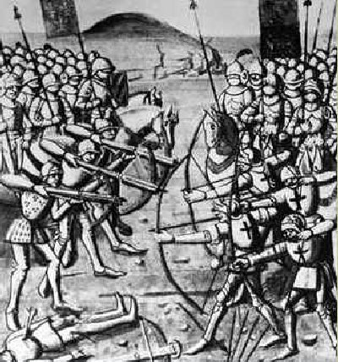

France was the big nation in Western Europe. It had a bigger population, more knights and more opulences than any other neighboring country. The odds were that the English army had no chance but they possessed a secret weapon: the longbowman. The longbow was a simple but lethal weapon and the longbowmen played an important role for the victory against the French. The longbowmen killed roughly 10.000 Frenchmen during the Battle of Crécy.

