The Treaty of Brétigny
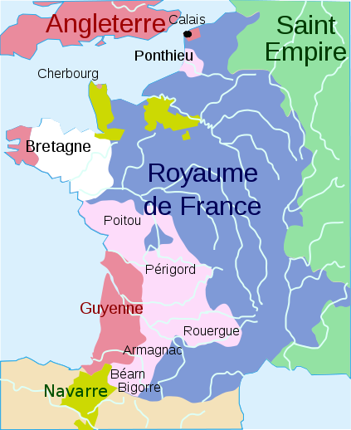
The Treaty of Brétigny was an agreement between John II and Edward III which established the end of the first phase of the war. The contract said that John II will be freed in exchange for a ransom and hostages. Moreover it said that Edward III will obtain Calais, Guyenne, Gascony, Limousin, Poitou and several other parts of France. Edward the III should, according to the treaty, renounce all claims to the French throne and in addition give up the duchy of Touraine, the countships of Anjou and Maine, the suzerainty of Britanny and of Flanders.

