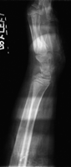
This artifact occurred because the plate reader loaded two imaging plates (IPs) in a single cassette. After an exposure, the bottom IP was extracted, read and replaced as usual, leaving the top IP to be exposed numerous times. Artefact remedy: double-loaded cassettes will be discovered during routine IP cleaning. If a cassette containing two IPs is discovered, the IPs should be erased before being put back into use.

http://bjr.birjournals.org/cgi/content/full/74/878/195

