Operator error. The moire' pattern seen in this knee image was caused by using a grid with a frequency of 33 lines cm-1, which was oriented with the grid lines parallel to the plate reader's scan lines. Artefact remedy: use grids with no less than 60 lines cm-1. In addition, grid lines should run perpendicular to the plate reader's laser scan lines.[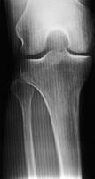](http://bjr.birjournals.org/cgi/content/full/74/878/195/F14)

<http://bjr.birjournals.org/cgi/content/full/74/878/195#top>