**PRELOAD**

First, envision the heart, lungs and vena cava and aorta as compartments, with the heart being divided into two compartments: Left and Right. Envision this as a system of hoses (lungs and blood vessels) and pumps with valves.

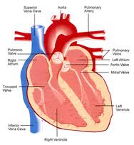 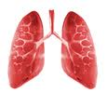 

Vena Cava Rt Heart Lungs Lt Heart Aorta

(Valves) Tricuspid Pulmonic Mitral Aortic

Preload is defined as the pressure on the atrial walls at the end of diastole.

Preload is not only affected by blood volume, and the rate at which the blood comes to the atria, but also by qualities of the heart wall: compliance and thickness. Factors include: Muscle fiber tension, muscle fiber stretch, muscle fiber length, end diastolic volume, end-diastolic filling pressure.

If the stress on the walls of the heart is too great, blood has no option but to back up into the preceding compartments: into the venous circulation resulting in high JVP and peripheral edema in the case of the Rt side of the heart; or into pulmonary vasculature resulting in pulmonary edema in the case of the Left side of the heart.

Note that there is a preload for both the right and left atrium: the right side of the heart’s preload comes from the volume of blood and the rate of fill via the vena cavas; the left side of the heart’s preload comes from the lungs via the pulmonary veins. (Since it is a closed system, the Lt side of the heart will eventually affect the Rt side.)

Preload, and things determining preload, are represented in the following diagram.

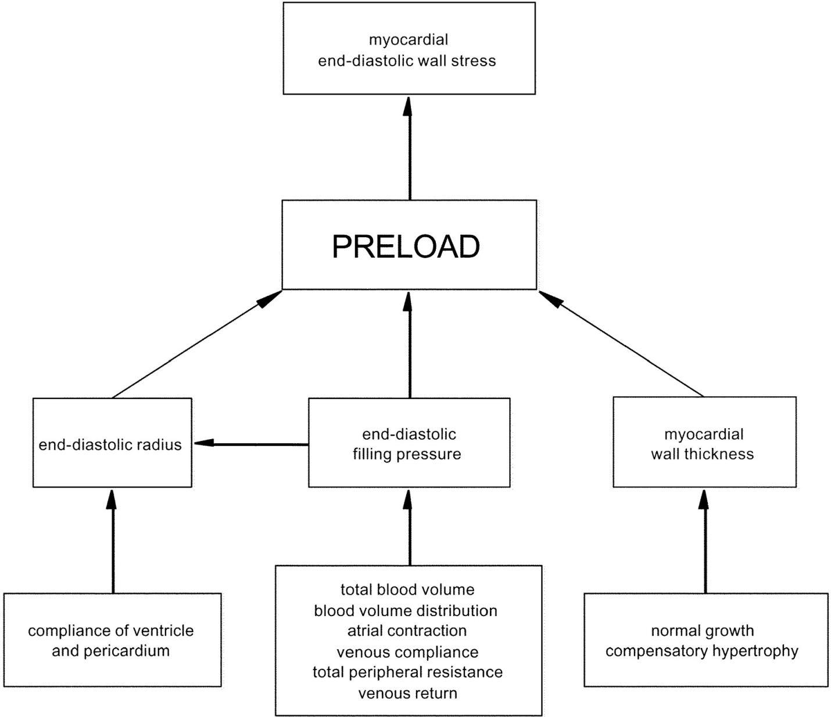

Norton, J. (2001). Toward consistent definitions for preload and afterload. *Advanced Physiologic Education*, 25, 53-61 Retrieved from <http://advan.physiology.org/content/25/1/53/F1.large.jpg>

Practical applications:

By following the diagram above, you can see that edema in the lungs or periphery can be relieved by reducing preload via altering blood volume. Hypertrophy and compliance of the heart muscle are much harder to remedy, and take much longer to repair (usually via a betablockers or a surgical repair).

Conversely, preload that is too low reduces cardiac output in terms of volume and pressure. Think of dehydration or hypovolemia from hemorrhage. We can correct preload by increasing the amount of circulating fluid. Another preload problem: think of a cardiac problem which restricts the ability of the cardiac muscle to stretch - the pressure on the heart walls will be high despite normal amounts of circulating blood filing the atria. This, too, is a preload problem but not a fluid problem although it may be accompanied by peripheral or pulmonary edema because the end-diastolic pressures are too high. Heart transplant is usually the only option for treatment for restrictive cardiomyopathies.