1. Make a 1-page overview table which lists...
Connor Becker - Overview
Roles | Assistant Project Manager
Roles | Business Analyst
Roles | Database Developer
Roles | Information Architect/Assistant UML Architect
Roles | Documentation Designer/Architect
Tools | Acclaro DFSS
Tools | Microsoft Word and Visio
Tools | Eclipse (Java EE) Indigo with Git VCS
Tools | Basecamp Project Management System
Tools | IHMC Concept Map Tools
Tasks Assigned* | UML Use-case Model
Tasks Assigned* | Use-case Specification: CRUD Student Preferences
Tasks Assigned* | Development of Bingo Sheet Data Model
Tasks Assigned* | Development of Bingo Sheet API
Tasks Assigned* | Class Presentation Compilation
Tasks Assigned* | Information Architecture (Design Matrix, DSM)
Tasks Assigned* | UML Architecture (Class & Component diagrams)
Tasks Assigned* | FMEA
Tasks Completed | UML Use-case Model
Tasks Completed | Use-case Specification: CRUD Student Preferences
Tasks Completed | Development of Bingo Sheet Data Model
Tasks Completed | Class Presentation Compilation [#s 1, 2, and 3]
Tasks Completed | FMEA
(* This only enumerates tasks for which I am “in charge” and are of significance; i.e. the cover page deliverable is not listed)
2. Make a table of tasks completed and describe...
Tasks Completed
Name | Task Description | Start Date | End Date
UML Use-case Model | UML use-case “bubble diagram” for “CRUD Student Preferences” | 18 Jan | 25 Jan
Use-case Specification: CRUD Student Preferences | Use-case specification for the use-case “CRUD Student Preferences”, following template given by sponsor. | 25 Jan | 1 Feb
Development of Bingo Sheet Data Model | Create a data model for the Bingo Sheet data to be represented in the database. | 8 Feb | -
Class Presentation Compilation [#s 1, 2, 3] | Compile class slideshows from group members' slides. | 16 Jan | 9 Apr
FMEA | Failure Mode Effects Analysis | 13 Jan | 12 Apr

3. You completed 11 SWEBOK reviews and 9 PMBOK reviews by now...

(Beginning on following page, each of the three sub items for this question is presented as follows: 1) the verbatim SWEBOK/PMBOK review, followed by 2) a description of my roles' relation to the KA, then 3) screen shots of work output (if any), and finally 4) a description of the work output and how I obtained it (if any).)
Connor Becker
Dr. Tanik
CS360
16 December 2011
SWEBOK KA-1: Software Requirements
Software requirements are “[properties] that must be exhibited in order to solve a problem.” (SWEBOK Ch. 1) The Software Requirements knowledge area of SWEBOK has subareas including Fundamentals, Process, Elicitation, Analysis, Specification, Validation, and Practical Considerations. This knowledge area covers everything from the definition of requirements to getting initial input from the customer, from the analysis of customer needs to explicit specification, all the way to testing the feasibility of the requirements themselves. Software requirements play a major role in my group's project; the customer's needs were fairly explicitly defined in a project abstract from which we formed the foundations of our requirements. Meeting these requirements are the primary goal of our project.
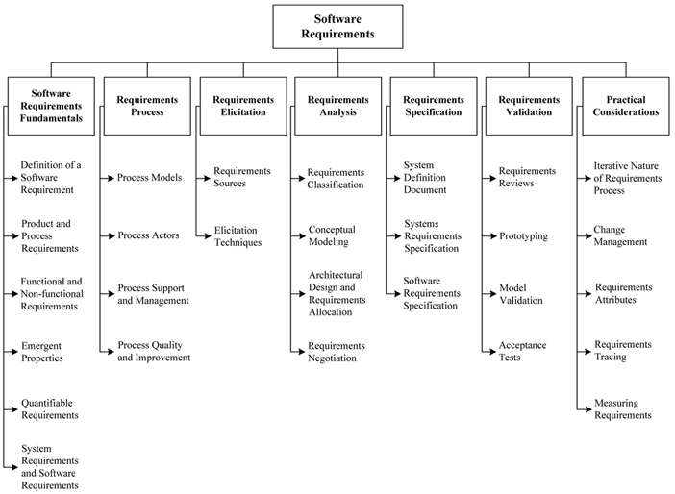
As I'm the business analyst for our group, SWEBOK KA-1 relates directly to the process I undertook, being to process the “voice of the customer” into potential functional requirements to be used by engineers. To organize the functional requirements I came up with, I used the Acclaro tool; this served as a “decomposition”
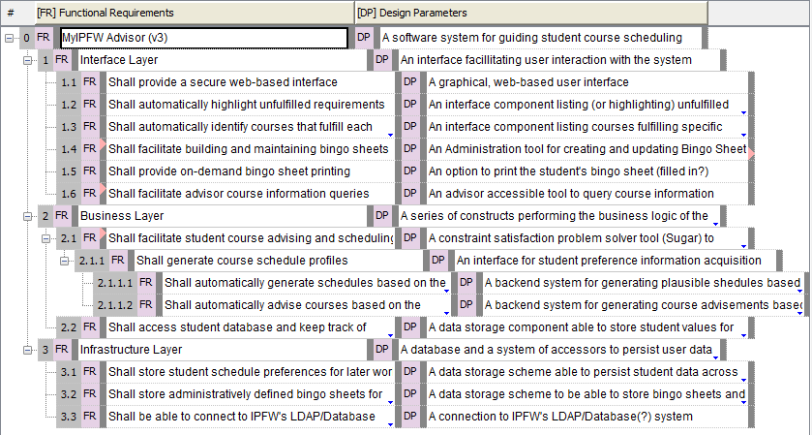
The above (old) picture is a screenshot from the Acclaro tool. This allowed me to lay out functional requirements and rearrange them to build a coherent hierarchy. When I was finished, it conveniently gave me a place to put design parameters and see the two side by side.

Connor Becker
Dr. Tanik
CS360
16 December 2011
SWEBOK KA-7: Software Engineering Management
SWEBOK KA-7 concerns the use of management techniques to oversee and organize software engineering activities. Consistent with SWEBOK's primary assumption, that the development of software is best undertaken as an engineering discipline, KA-7 seeks to explain how to “manage software engineering in the same way as any other (complex) process”. While it does acknowledge that there are some caveats that come about through the nature of the developer customer relationship and the usually iterative process of software development, KA-7 epitomizes the SWEBOK mindset of process and workflow control.
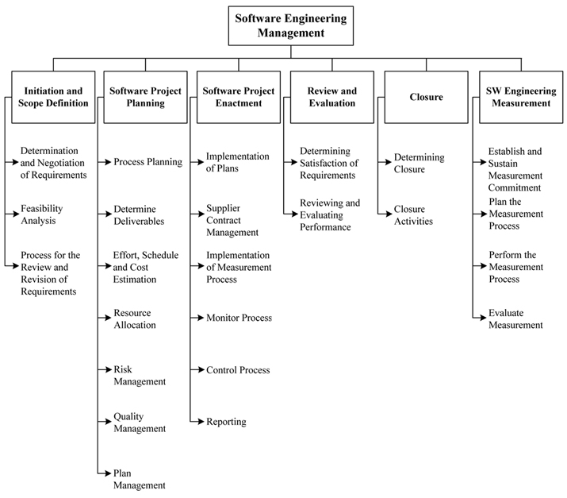
Software engineering management became very important to my group early on in the semester. Our group leader's management style wasn't working out—he was taking a hands off, laissez faire approach leaving the group wondering what was going on. We came to terms with it and started moving toward a more delegated task-assignment style which worked much better for us.
As assistant project manager, SWEBOK KA-7 has become has become very important to me. This role is relatively new to me; Trent was the assistant manager last semester and earlier this semester. The last few weeks I've been trying to get our group to move some of their focus back to the class documents. While we've made great progress on our project, SWEBOK teaches us that software engineering is not all about programming, but is an engineering discipline that must be attacked that way. Our team is back on track to finish all of the 22 deliverables by the end of the semester.
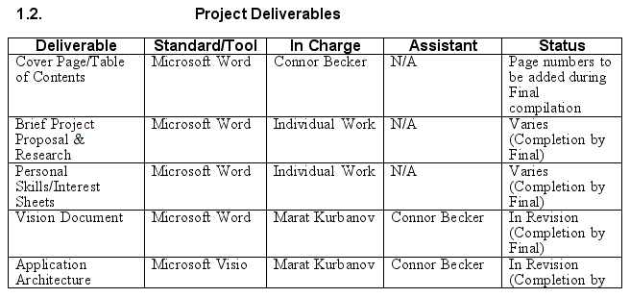
The above is a screenshot from our project management plan's deliverables table, designed in Microsoft Word. In this table we've outlined the major project deliverables, who's in charge of them, how they're made, and when they will be complete. Building this has helped our group get back on track with regards to the engineering paperwork we have to get done by the end of the semester.

Connor Becker
Dr. Tanik
CS460
18 January 2012
PMBOK KA-1: Project Integration Management

The first PMBOK knowledge area covers the “putting it all together” aspect of project management. During the planning and construction of any given project, there are many different processes that take place. Planning how these processes will be coordinated and their respective objectives is important to overall project management—which is of course the art of mitigating risks in large enterprises.

Our group has been having a tough time integrating. For better or worse, we chose to use a version control system for our source codes. The system that ended up being chosen was Git, a source control system seemingly designed for early '90s hackers. Early on we had problems working on the same code base, making it necessary to branch the code base into separate code branches. Now that our individual codes are ready, we have to merge them back into the “master” branch. This has been a difficult task, resulting in many of us having to have Trent show us how to perform the merge many times over. This area doesn't really relate to any of my roles.
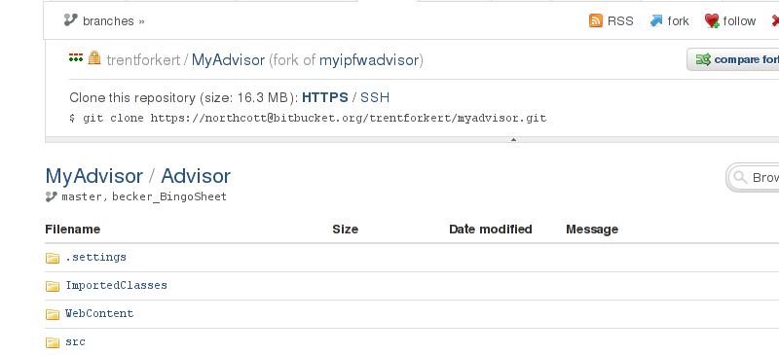
The above screenshot shows one of the web views of our source code repository, hosted on BitBucket.org. Having a central repository is nice (and in this case free and encrypted), but can sometimes make managing a project much more difficult. Most of the time, one member of our group has to be trusted to keep everything going. Luckily, our human resource management payed off with good teammembers.
4. Attach: All your individual progress reports...
Progress Reports
Start to 1 Feb. | Last week was the week of the UML bubble diagrams; spent an hour on that and half an hour on PMBOK KA-1  This week I spent two hours doing the RUP use case specification and an hour on PMBOK KAs 2 and 3 and re-finding and updating my cmap.
1 Feb – 8 Feb | Progress Report for 1 February - 8 February  - Created 3 slides for Slideshow (.5 hours)  - Put together group Slideshow (1 hour)  - Updated Use-Case Specification "CRUD Student Preferences" (.5 hours)  Goals for Next Week  - Update group Cmap to include use-case material (UML diagrams and RUP specifications)  - Get Eclipse J2EE set up for coding  - Think about requirements structures (assigned by Dr. Sedlmeyer)  - Maybe write up a few PMBOK KA's
8 Feb – 15 Feb | Progress Report:  - Revised Feb.6 PowerPoint (.5 hours)  - Diagrammed and wrote up summary of thoughts on Data Model (4 hours)  Next Week Goals:  - Build a working database system out of the data model previously conceptualized  - Get caught up on PMBOKs  - Start getting things together for next PowerPoint (I think that's in a week or two...)  - Help YeiSol get up and running with our code base.
15 Feb – 22 Feb | Progress Over Last Week:  - Worked on Requirements/Satisfiers tree traversal simulation for Dr. Sedlmeyer (7.5 hours)  Goals for Next Week:  - Finish Database Connection for Tree Traversal  - Work with Trent on Satisfiers and Business Rules  - Work with Marat on database and requirements design  - Work with YeiSol on representing data structures  - Get those PMBOKs done!
22 Feb – 29 Feb | Progress this last week:  - Compiled PowerPoint (1 hour)  - Worked on data model (cleaning up code, 3 hours)  Goals for next week:  - PMBOK 4-6  - Data model API
1-2 Mar, 12-14 Mar | Progress this "week":  - Redesigned and updated database to take into account our storing of student satisfiers (3 hours)  - Finished preparing group presentation for Monday (1 hour)  Goals for next week:  - Prepare for exam (get those PMBOK's done...)  - AQuAP: finish at least rough API to db for Marat and YeiSol  - Work with Trent on Git issues
14 Mar – 21 Mar | Progress This Week:  - Redesigned database, compiled my SQL scripts and entered them into softbase.ipfw.edu server (1 hour) (thanks to Trent for setting up access to that!)  - Worked out a ton of bugs in the Java code for the data model exposed by the new server (3 hours)  - Codified API for requirements and the bingo sheet header (1 hour)  - Wrangled with VPN issue/got YeiSol connected [may not really count:)] (1 hour)  Goals for Next Week:  - Go over SWEBOK/PMBOK areas (completely blanked on the exam)  - Write some more PMBOK KA summaries  - Finish satisfier API and encapsulate the requirements and the bingo sheet header in a single object  - Work with YeiSol on JSP for her bingo sheet display (and re-explain my API, hopefully correctly)  - Find time to work with Marat on the bingo header API  - De-link "Progress Report" and "Goals for Next Week"; post progress report before any future Wednesday meetings and goals sometime after (to avoid late-night situations like this)
21 Mar – 28 Mar | Progress made last week:  - Worked on BingoHeader object's being written back to the database (1 hour)  - Started on encapsulating BingoHeader and a Requirement reference into a single class (BingoSheet) as per Dr. Sedlmeyer's request (1 hour)  Progress to be made this week:  - Finish database writeback for BingoSheet, BingoHeader, and Satisfier  - Advise YeiSol and Marat on their use of the BingoSheet API to display and create BingoSheet objects  - Work with Trent to get business rules and Satisfiers integrated  - Work with Trent and Alek to build some calls to facillitate the scheduling page on which they're working.  - Compile everyone's slides into presentation.
28 Mar – 4 Apr | Progress made last week:  - Worked on and completed working implementation of the BingoSheet API (4 hours)  - Wrote BingoSheet API Guide v1, Requirement Processing API Guide v1 (1 hour)  Goals for this week:  - Work on integrating Trent's business rule code into the BingoSheet/Requirement classes  - Test Requirement system using IS degree  - Get PMBOKs done, since they're apparently not due May 1 as per previous announcements  - Finish/Polish BingoSheet and Satisfier APIs  - Look into updating paperwork
4 Apr – 11 Apr | Progress Made Last Week:  - Created FMEA (2 hours)  - Added deliverables table to PMP v2 (1 hour)  - Planned and started Satisfier API (1 hour)  - Finished preparing presentation (.5 hour)  Goals for Next Week:  - Finish Satisfier API  - Get BingoSheet package tested and merged  - Work with rest of team on integration  - Finish PMBOK, Exam I Redo, and Exam II  Personal Score for Last Week: 9

