What is Biomimicry?

http://biomimicryinstitute.org/about-us/what-is-biomimicry.html

Biomimicry (from bios, meaning life, and mimesis, meaning to imitate) is a new discipline that studies nature's best ideas and then imitates these designs and processes to solve human problems. Studying a leaf to invent a better solar cell is an example. I think of it as "innovation inspired by nature."
The core idea is that nature, imaginative by necessity, has already solved many of the problems we are grappling with. Animals, plants, and microbes are the consummate engineers. They have found what works, what is appropriate, and most important, what lasts here on Earth. This is the real news of biomimicry: After 3.8 billion years of research and development, failures are fossils, and what surrounds us is the secret to survival.
Like the viceroy butterfly imitating the monarch, we humans are imitating the best adapted organisms in our habitat. We are learning, for instance, how to harness energy like a leaf, grow food like a prairie, build ceramics like an abalone, self-medicate like a chimp, create color like a peacock, compute like a cell, and run a business like a hickory forest.
The conscious emulation of life's genius is a survival strategy for the human race, a path to a sustainable future. The more our world functions like the natural world, the more likely we are to endure on this home that is ours, but not ours alone.

Looking at Nature as Model, Measure, and Mentor

If we want to consciously emulate nature's genius, we need to look at nature differently. In biomimicry, we look at nature as model, measure, and mentor.
Nature as model: Biomimicry is a new science that studies nature’s models and then emulates these forms, process, systems, and strategies to solve human problems – sustainably. The Biomimicry Guild and its collaborators have developed a practical design tool, called the Biomimicry Design Spiral, for using nature as model.
Nature as measure: Biomimicry uses an ecological standard to judge the sustainability of our innovations. After 3.8 billion years of evolution, nature has learned what works and what lasts. Nature as measure is captured in Life's Principles and is embedded in the evalute step of the Biomimicry Design Spiral.

Biomimicry: A Tool for Innovation

Innovators from all walks of life—engineers, managers, designers, architects, business leaders, and more--can use biomimicry as a tool to create more sustainable designs. The Biomimicry process of consulting life’s genius, described in the Design Spiral, can serve as a guide to help innovators use biomimicry to biologize a challenge, query the natural world for inspiration, then evaluate to ensure that the final design mimics nature at all levels—form, process, and ecosystem.
Our methodology brings nature’s wisdom not just to the physical design, but also to the manufacturing process, the packaging, and all the way through to shipping, distribution, and take-back decisions. We use a spiral to emphasize the reiterative nature of the process—that is, after solving one challenge, then evaluating how well it meets life’s principles, another challenge often arises, and the design process begins anew. For instance, an innovator might design a wind turbine that mimics life’s streamlining principles, but then ask how will it be manufactured? Will the energy use and chemical processing mimic nature too? It can, with another cycle through the design method.

The Challenge to Biology Design Spiral

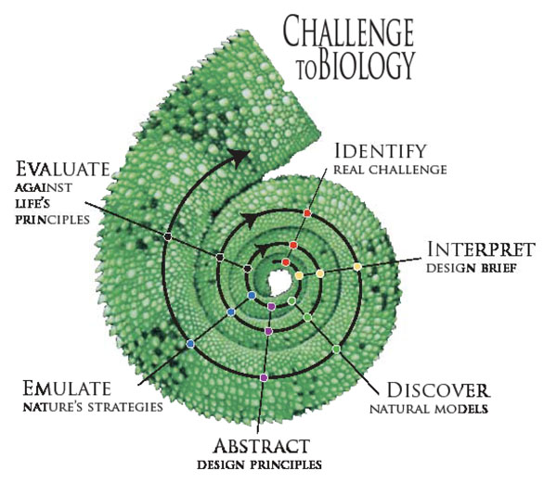

The Steps of the Design Spiral

Identify
Develop a Design Brief of the human need:
- Develop a Design Brief with specifics about the problem to be resolved
- Break down the Design Brief to identify the core of the problems and the design specifications
- Identify the function you want your design to accomplish: What do you want your design to do? (not “what do you want to design?”). Continue to ask why until you get to the bottom of the problem.
- Define the specifics of the problem:
  - Target Market: who is involved with the problem and who will be involved with the solution?
  - Location: where is the problem, where will the solution be applied?
Interpret
Biologize the question; ask the Design Brief from Nature's perspective:
- Translate the design function into functions carried out in nature. Ask “How does Nature do this function?” “How does Nature NOT do this function?”
- Reframe questions with additional key words.
- Define the Habitat/Location
  - Climate conditions
  - Nutrient conditions
  - Social conditions
  - Temporal conditions
Discover
Look for the champions in nature who answer/resolve your challenges
- Find the best Natural Models to answer your questions.
- Consider Literal and Metaphorical
- Find champion adapters by asking “whose survival depends on this?”
- Find organisms that are most challenged by the problem you are trying to solve, but are unfazed by it.
- Look to the extremes of the habitat
- Turn the problem inside out and on its head
- Open discussions with Biologists and specialists in the field
Abstract
Find the repeating patterns and processes within nature that achieve success
- Create taxonomy of life’s strategies
- Select the champions with the most relevant strategies to your particular design challenge.
- Abstract from this list the repeating successes and principles that achieve this success.
Emulate
Develop ideas and solutions based on the natural models
- Develop concepts and ideas that apply the lessons from your Natural teachers.
- Look into applying these lessons as deep as possible in your designs:
  - Mimicking Form:
    - Find out details of the morphology
    - Understand scale effects
    - Consider influencing factors on the effectiveness of the form for the organism
    - Consider ways in which you might deepen the conversation to also mimic process and/or ecosystem
  - Mimicking Function:
    - find out details of the biological process
    - Understand scale effects
    - Consider influencing factors on the effectiveness of the process for the organism
    - Consider ways in which you might deepen the conversation to also mimic the ecosystem
  - Mimicking Ecosystem:
    - Find out details of the biological process
    - Understand scale effects
    - Consider influencing factors on the effectiveness of the process for the organism
Evaluate
How do your ideas compare to Life’s Principles, the successful principles of nature?
- Evaluate your design solution against Life’s Principles
- Develop appropriate questions from Life’s Principles and continue to question your solution
- Identify further ways to improve your design and develop new questions to explore. Questions may now be about the refinement of the concept:
  - Packaging, Manufacture, Marketing, Transport
  - New Products - additions, refinement
  - etc...
Identify
Develop and refine design briefs based on lessons learned from evaluation of Life's Principles
Nature works with small feedback loops, constantly learning, adapting and evolving. We can also benefit from this thinking, evolving our designs in repeated steps of observation and development, unearthing new lessons and applying these constantly throughout our own design exploration.

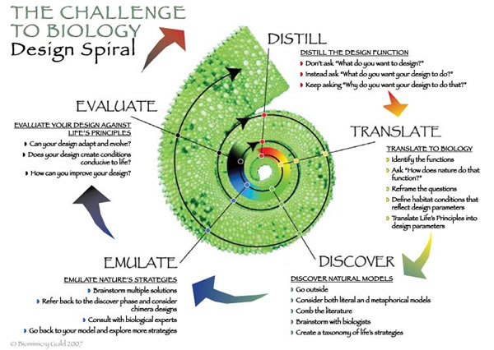
Life's Principles

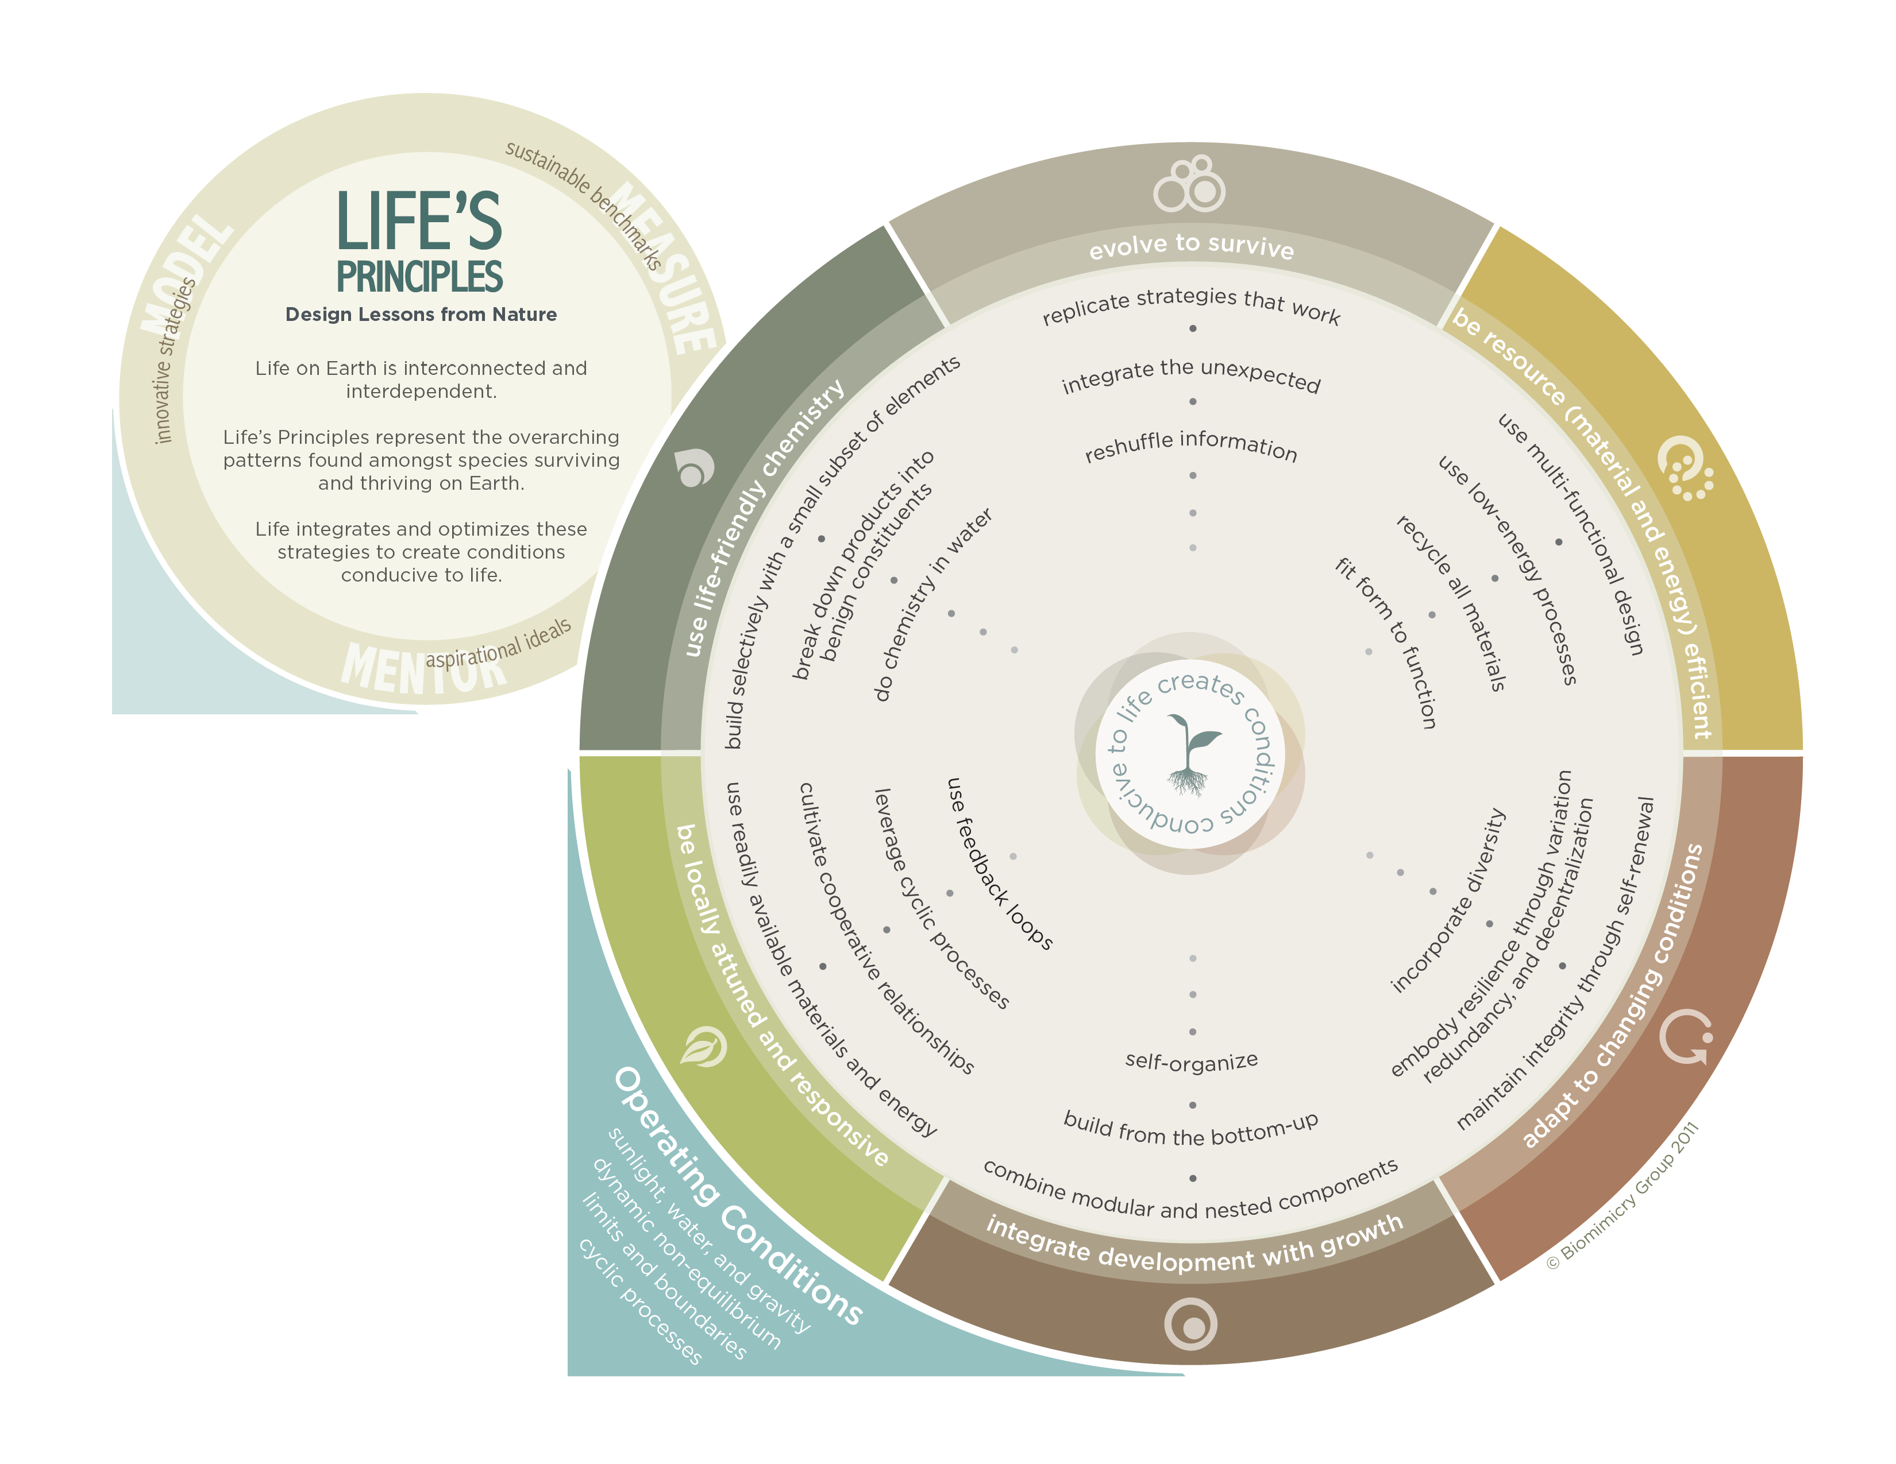

The Biomimicry Design Spiral

