[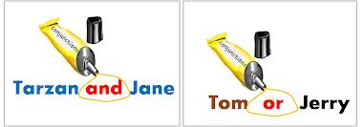](http://www.google.com.pa/imgres?sa=X&hl=es&qscrl=1&rlz=1T4NDKB_esPA533PA534&biw=1024&bih=474&tbm=isch&tbnid=_oeyEa87H1X9-M:&imgrefurl=http://schoolsquestiontime.org/what-is-a-conjunction/&docid=8HMW5ntZnjwC8M&imgurl=http://schoolsquestiontime.org/wp-content/uploads/2012/08/what-is-a-conjunction-example.png&w=1190&h=416&ei=1iWLUZPAMIyI8QSBhYHoCQ&zoom=1&ved=1t:3588,r:72,s:0,i:384&iact=rc&dur=1293&page=6&tbnh=118&tbnw=318&start=61&ndsp=14&tx=166&ty=52)