LibX Extension update
It seemed to me that if time were our least available resource then minimizing time on repetitive tasks might be helpful in expanding time as a resource. I have modified a generic Athabasca LibX browser extension to be of use for CNHS students (and faculty). If you install the extension, and click on the icon , you will see a pop-up window:
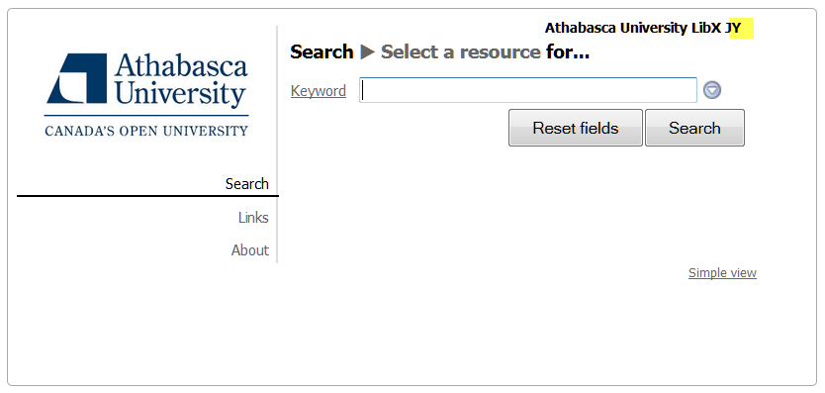
the modified version is shown with JY at the end of the title. When a user clicks on Links, they have immediate access to the following:
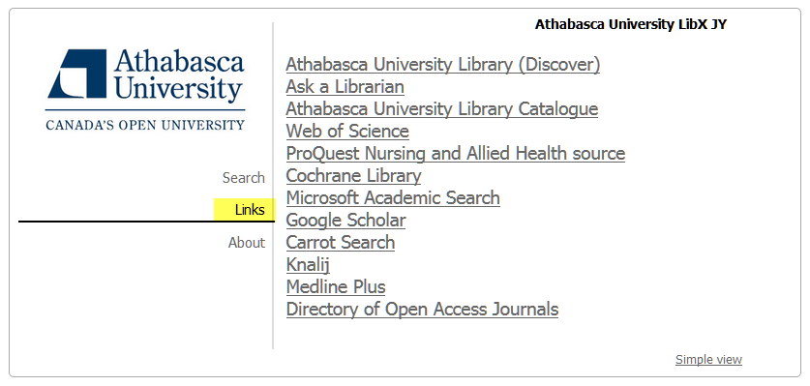
If you would like any other links added, let me know and I can update the extension. Some quick and dirty testing showed a time savings of about 12% for time on task in typical academic workflows. This was reflected in many less keystrokes and hence reduces the potential for repetitive strain injury.
The Google Chrome extension is here and the Firefox extension is here.

Jack

