Teaching Experiments and the Carbon Cycle Learning Progression

The goal of the carbon cycle learning progression (CCLP) is to describe how students’ accounts of carbon cycling processes develop from grades 4-12, with a focus on students’ reasoning about matter, energy, and scale. The current CCLP describes the development of student reasoning in classroom environments without special instructional intervention. It is one pathway, or trajectory, that students follow—a pathway that is currently more the norm than the exception in American classrooms. Our work shows that progress to Upper Anchor reasoning is limited to a small percentage of students—only 10% of high school students demonstrate the type of reasoning we would hope students could engage in upon leaving high school. Interestingly, many students demonstrate an ability to give scientific “names” to systems and processes that exceeds their ability to construct scientific explanations. These results indicate that while level 4 is a realistic and obtainable goal for high school students, students may need special instructional intervention to support them in not only learning scientific terms and names, but also explanations that adhere to scientific principles. At present, we are exploring alternative pathways toward the Upper Anchor through teaching experiments that emphasize these types of principle-based explanations. We describe our motivation and goals for the teaching experiments and how they contribute to our understanding of the CCLP and learning progression work in general.

Lindsey Mohan, Michigan State University
Charles W. Anderson, Michigan State University

Introduction
Our work on the Environmental Science Literacy Project documents the investigating, accounting, and decision-making practices students use to reason about processes that occur in natural and human social systems. The carbon cycle strand of this project focuses on reasoning about the movement of carbon through different systems and processes. At the macroscopic scale the processes include growth of plants and animals, weight loss, decay, and burning. At the large scale the processes include the movement of carbon between reservoirs and global warming. Thus, the carbon cycle learning progression (CCLP) encompasses a large domain of content transcending the traditional boundaries that define life, earth, and physical sciences, as well as the social sciences.
The goal of our work has been to develop a learning progression that describes how accounts of carbon cycling processes develop from grades 4-12, with a focus on students’ reasoning about matter, energy, and scale. During the past five years we focused on developing a learning progression framework that described what is—a framework that documented the current reality of how student reasoning changes, or evolves, without special instructional interventions from researchers. The purpose of this work was to develop an initial CCLP framework that captured patterns in student reasoning and a set of assessments that could tap into different kinds of reasoning. The development process used an iterative approach, where framework development and empirical data from assessments informed each other. We first developed an initial framework, used the framework to develop assessments, then used assessment data (as well as other sources of information) to revise the framework, and so on. What emerged from several years of work was a learning progression grounded in empirical data from classrooms (NRC, 2007, Gunckel et al., 2009), and one that documented remarkably consistent patterns among student responses over several years of research (Mohan, Chen, & Anderson, in press). Our project used a design-based research approach (e.g., Brown, 1992; Collins, 1992), with our initial design products, or design artifacts, including a learning progression framework and assessments. The framework and assessment are described in other papers presented at this conference—Gunckel et al., (2009) provides a thorough description of the framework that developed and the nature of our work on the Environmental Science Literacy Project and Jin, Choi, & Anderson, (2009) describe the development of assessments within the carbon strand.
As we turn toward the development of teaching tools and materials, we enter a new phase of our work. In addition to elaborating on our framework and refining our assessments, we are also developing practical interventions to support alternative learning pathways. The teaching tools and materials represent a third design product emerging from our work. The focus of this paper is to further explore this design product and consider how teaching experiments can be used to inform learning progression frameworks. Before discussing the teaching experiments, we briefly describe the CCLP framework. Next, we explore the idea of alternative learning pathways, or trajectories, in the CCLP. We then describe the development of teaching tools and materials and conclude with a discussion of the role teaching experiments play in developing and validating learning progression work.

The Carbon Cycle Learning Progression Framework
Our learning progression framework includes a Lower Anchor (level 1) that describes what students know and can do at upper elementary level. The progression also includes an Upper Anchor (level 4) based mostly on what we (i.e., science educators) would hope students would know and do by the end of high school. There are two transitional levels (levels 2 and 3) that describe intermediate levels of reasoning between the two anchor points. Our research indicates that Upper Anchor reasoning, while obtainable by high school students, is quite rare (Mohan et al., in press).
The work on the CCLP is grounded in a socio-cultural perspective on teaching and learning. We seek to describe how progress toward Upper Anchor reasoning not only results in changes in students’ conceptual understanding, but also results in changes in the discourse and practice students use within particular communities (see Gunckel et al., 2009). We have come to believe that achieving Upper Anchor reasoning in the CCLP requires substantial shifts in students’ worldview and discourse. We briefly describe the Discourse-Knowledge-Practice framework that guides our work on the Environmental Science Literacy Project and the CCLP, and then explore how this framework has been used to inform our teaching experiments.

Changes in Discourse
By “discourse” we mean general ways of thinking and manner of talking about the world. We all participate in multiple discourses, including our primary discourse—the ways of thinking and talking that we acquire in our homes and families—and secondary discourses that we encounter in school, church, work, etc (Gee, 1996). Discourses are associated with communities of practice: groups of people who share common activities, values, and ways of talking and thinking. We are especially interested in one secondary discourse: scientific discourse, which has been developed in scientific communities of practice. We are especially interested in how students come to learn and appropriate scientific discourse, and what this means for their participation in communities outside of the school context.
Level 1 (force dynamic) discourse. Students acquire a “theory of the world” as they learn to speak grammatical English and experience everyday events. Although all students do not share the same primary discourse, linguists such as Stephen Pinker (2007) and developmental psychologists such as Leonard Talmy (1988) argue that there is a “theory of the world” built into the basic grammar of our language, so we all must learn that theory in order to speak grammatical English. Level 1 discourse, the way of talking about the world that is built into our everyday language, explains the events of the world in terms of actors and abilities, enablers, and purposes. The world as constructed by everyday English is dominated by actors (including people, animals, plants, flames, and machines), who fulfill their needs with help from enablers to accomplish their purposes. When actors come into conflict, the more powerful actor can control what happens. The results, or outcomes, are determined by the forces at play—the enablers that help the actors, and the antagonists that prevent actors from fulfilling their purpose (e.g., flames need oxygen to burn, but water can prevent flames from burning). Understanding the world means understanding the powers, needs, and purposes of all the different actors (see Gunckel et al., 2009, for additional explanation).
Level 4 (scientific) discourse. Even though scientists may speak in English, scientific discourse has constructed an entirely different kind of world. Instead of actors in settings scientists see a hierarchy of dynamic systems at different scales. Instead of powers and purposes scientists see laws—fundamental principles that govern the working of the systems. We have organized the CCLP around three key principles: the hierarchy of systems and scales, conservation and cycling of matter, conservation and degradation of energy.
- Hierarchy of systems and scales. The world is organized into dynamic systems that have structures at multiple scales (we are concerned about atomic molecular to global scales). The systems are dynamic in that matter and energy are constantly flowing through them and being changed by them.
- Conservation and cycling of matter. Matter flows through smaller systems such as cells and organisms and cycles within larger systems, such as ecosystems or earth systems. In chemical and physical changes it always obeys conservation laws at two scales:
  - Conservation of mass. There is a quantitative conservation law that applies at all scales. The mass of the material products of a chemical or physical change is equal to the mass of the inputs or reactants.
  - Conservation of atoms. There is also a version of this law that explains what qualitative changes in substances are possible. At a macroscopic scale, the rules seem completely arbitrary: Why is it possible to change carbon dioxide and water into glucose but impossible to change lead into gold? At an atomic molecular scale, though, those rules make perfect sense: Chemical processes can rearrange atoms into new molecules, but they never create or destroy atoms.
- Conservation and degradation of energy. Energy is an elusive entity. Light, heat, sound, glucose, height, motion, etc., don’t appear on the surface to have much of anything in common. If we can learn to recognize and measure the different forms of energy in a system, we can use two other laws that constrain all processes.
  - Conservation of energy. Energy is like matter in that it is not created or destroyed in physical and chemical changes. The total amount of energy at the end is the same as the amount of energy in the beginning. (First Law of Thermodynamics.)
  - Degradation of energy. Energy is not like matter in that it cannot be recycled. All processes change energy from more useful to less-useful forms, especially low-grade heat. (Second Law of Thermodynamics.)
One important conclusion from our work, and our experiences in classrooms, is the following: When students enter school they use their primary discourse—force-dynamic discourse—to explain how the world works. As students continue to learn more about science, they try to fit the new information they learn into their existing narratives about how the world works. In the end, students may have developed more elaborate narratives, but those narratives are still dominated by the students’ primary discourse. Mastering the secondary scientific discourse requires fundamental changes in students’ worldview.
Changes in Practice
The Environmental Science Literacy project is ultimately interested in three practices that are essential for environmentally responsible citizenship, represented in Figure 1 below. Our work in the carbon strand thus far has focused on the practice of accounting—accounts that explain and predict what is happening in a situation.
Figure 1. Environmental science literacy practices
Discourses: Communities of practice, identities, values, funds of knowledge

Explaining and Predicting (Accounts)
What is happening in this situation? What are the likely consequences of different courses of action?

Investigating
(Inquiry)
What is the problem?
Who do I trust? What’s the evidence?
Deciding
(Citizenship)
What will I do?

Level 1 explaining and predicting practices. Level 1 students explain and predict using the language and theories of force dynamic discourse. A good explanation identifies the three key elements that determine the course of an event: the actors and their abilities, the needs or enablers, and purposes or results. Aspects of settings (air, water, earth, etc.) are not important unless they satisfy needs of actors. A good prediction concerns whether actors achieve their purposes. They can achieve their purposes if they have all the necessary enablers and if there are no antagonists or opposing actors. If there are antagonists, then the outcome depends on which actor has greater powers (i.e., the interplay of forces).
Level 4 explaining and predicting practices. Level 4 students explain and predict using the language and theories of scientific discourse. A good explanation connects observations to patterns and models. We are particularly interested in explanations that trace matter and energy through processes that transform carbon from organic to inorganic forms and back, using the key principles of matter, energy, and scale. A good prediction uses data about the particular situation with the laws of nature—models that follow principles—to determine the movement and transformations of matter and energy.
Changes in Knowledge
Knowledge is embedded within discourses and practices, so students at different levels have very different ideas about what they need to know. Figure 2 shows how we have organized the domain of knowledge at the Upper Anchor with respect to carbon cycling processes.
Figure 2. Loop diagram for carbon cycling in socio-ecological systems
Human Impact: Waste from human energy use (CO₂)

Human Social and Economic Systems

Human Actions in
Roles such as:

Consumers
Voters
Workers
Learners

Environmental Systems

CO₂ emissions

Atmosphere (Physical Systems)
(composition of air; atmospheric CO₂)

Oxidation of organic carbon & Energy dissipation (respiration, combustion)
Generation of organic carbon & Harnessing of energy (photosynthesis)

Biosphere (Biological Systems)

Transformation of organic carbon & Passing on of energy
(biosynthesis/growth, digestion, food chains, sequestration)

Combustion

Food & Fuels

Environmental system services: Foods and fuels as the sources for energy use

Level 4 knowledge. The Carbon Cycle Loop Diagram specifies that scientifically literate citizens need to be able to interpret the boxes and arrows of Figure 2 in terms of chemical models. The right-hand Environmental Systems box includes the familiar ecological carbon cycle, which students need to understand at multiple scales—as atomic-molecular, cellular, organismal, and ecological processes. It highlights carbon-transforming processes in environmental systems, as well as the process of combustion that connects environmental systems to the needs and impact of human systems. We grouped the processes into those that generate organic carbon through photosynthesis, those that transform organic carbon through biosynthesis, digestion, and food chains, and those that oxidize organic carbon through cellular respiration and combustion. We have chosen to organize the Upper Anchor around these processes because they are the means by which living and human systems acquire energy and the means by which environmental systems regulate levels of atmospheric CO₂.
The goal of science is to build up coherent systems that help us explain and predict the world around us. Figure 2 is one representation of a coherent system that traces matter and energy through systems at multiple scales. Table 1 shows the contrast between knowledge (and organization of knowledge) at the Upper Anchor with that of the Lower Anchor.
Table 1: Contrasting ways of grouping carbon-transforming processes

Upper  Anchor | Carbon-transforming process | Generating organic carbon | Transforming  organic carbon |  |  | Oxidizing  organic carbon
Upper  Anchor | Scientific accounts | Photosynthesis | Biosyn-thesis | Digest-ion | Biosyn-thesis | Cellular respiration |  | Combustion
Macroscopic events |  | Plant growth |  | Animal growth |  | Breathing  Exercise  Weight loss | Decay | Burning
Lower Anchor:  Informal accounts |  | Natural processes in plants and animals, enabled by food, water, sunlight, air, and/or other things |  |  |  |  | Natural process in dead things | Flame consuming fuel

Level 1 knowledge. Students at level 1 feel a need to know facts about the world, organizing their world based on actors as opposed to processes. Actors are organized into living things, machines, and flames. The students pay particular attention to the different needs and abilities of these actors, and to the outcomes of events that involve actors struggling to fulfill their natural tendencies. Dead things have lost their capacity to be actors (students often say that they “have no energy”), so they are prone to decay. In this way, understanding enablers and potential antagonists are important for building coherent stories about actors.

Pathways Toward the Upper Anchor
Transitional Levels and the current CCLP
The anchor points—Levels 1 and 4—have been described in detail above. The current CCLP also includes two intermediate levels in which students show increasing sophistication in their accounts about carbon cycling processes, as shown in Figure 3.

Figure 3. Transitional Levels 2 and 3
Level 4: Processes and Systems Constrained by Principles
Level 3: Chemical Change with Unsuccessful Constraints
Level 1: Force-Dynamic Accounts of Actors and Events
Level 2: Hidden Mechanisms about Events

Level 2 was prevalent among all age groups (39% of elementary students, 44% of middle school students, 40% of high school students, from Mohan et al., in press). An important characteristic of level 2 reasoning was the emergence of “hidden mechanisms” to explain macroscopic events (i.e., changes in visible systems result from internal or invisible parts and mechanisms, such as organs (e.g., lungs, stomach), microbes, and gases (CO₂, O₂)). Even though level 2 accounts continued to focus mostly on observable enablers supporting the actors, students also accounted for observable products (e.g., dead tree becoming soil). Thus, level 2 students started to show commitment to conservation of matter, especially in terms of solids and liquids. They recognized gases as materials, and sometimes used chemical names for the most familiar ones: oxygen and carbon dioxide. They recognized oxygen and carbon dioxide as enablers or products of processes in plants, animals, and burning materials. For example, they recognized oxygen must be present for breathing and burning, but treated it as a condition, or enabler, as opposed to a material that is combined with other materials.
Level 2 students appeared to rely on two key cycles involving changes in materials as shown in Figure 4—the solid-solid and gas-gas (CO₂-O₂) cycles. The solid-solid cycle followed food through food chains, which later became soil and nutrients through decay that were reabsorbed by plants. The gas-gas cycle followed carbon dioxide and oxygen between plants and animals (i.e., people take in oxygen and exhale carbon dioxide, while the opposite is true for plants). The cycles were an important achievement of level 2 reasoning because the students paid attention to the flow of materials through systems at the macroscopic and “hidden” scales. The cycles were indicative of how level 2 students still treated gases as ontologically different from solids and liquids—that is, while gases were recognized as materials, level 2 students did not see gases as having mass like other solid and liquid materials.
Figure 4. Gas-gas and solid-solid cycles at level 2
Animals
Plants
Carbon dioxide
Oxygen
The oxygen-carbon dioxide cycle
Decay
Plants
Nutrients, soil
Food chain
The solid-solid cycle

Level 3 was observed among many high school students (35% of students, from Mohan et al., in press). In contrast with level 2 students who showed little awareness of chemical processes, level 3 students tried to explain both life processes and combustion in chemical terms (i.e., the hidden mechanisms observed at level 2 were replaced by mechanisms for chemical change). Level 3 accounts recognized the transformation of matter as essential to carbon-transforming processes, but their accounts were limited by their lack of understanding of chemical substances and their continued use of energy as a “fudge factor”—to account for materials that seemed to mysteriously appear or disappear. They had a general commitment to tracing matter, recognizing that the materials in objects and organisms have to come from somewhere and go somewhere, but still resorted to matter-energy conversions rather than solid-gas conversions. Like level 2 students, level 3 students were reluctant to attribute mass gain and loss to gases. Thus, they were unsuccessful at using conservation of matter or conservation of energy as constraints on processes.
Alternative Pathways
What we described above is one pathway, or trajectory, that students follow in the context of status-quo teaching—a pathway that is currently more the norm than the exception in American classrooms. The current CCLP is not a “base-line” or “default” pathway, but rather one way students make progress toward the Upper Anchor of the CCLP. Unfortunately, our work shows this progress is limited to a small percentage of students. Only 10% of high school students demonstrate level 4 reasoning in the CCLP, while many more demonstrate levels 2 and 3 reasoning (Mohan et al., in press). These results indicate that while level 4 is a realistic and obtainable goal for high school students, many students do not reach the Upper Anchor.
It is important to point out that the current learning progression is largely based on student reasoning in classroom environments without special instructional intervention. Our approach to learning progression work is notably different from other learning progression work given that many learning progression researchers focus on specifying carefully laid out instructional sequences that get students from point A to point B in the learning progression (e.g., Schauble, 2009; Wiser & Smith, 2008; Wiser, Smith, Asbell-Clarke, & Doubler, 2009). These projects document what is made possible for students given a specific instructional context and what students are capable of doing in those environments. From this perspective, learning progressions foreground the development of teaching materials and focuses on the boundaries of what could be. Differently, our work to date documents what is happening in the instructional context of our schools today. We are concerned with documenting the current reality with a focus on framework and assessment development. Our work suggests practical changes to classroom instruction that may result in more effective pathways to the Upper Anchor, but there is less attention given to carefully sequenced teaching materials.
At present, we are exploring alternative pathways toward the Upper Anchor through teaching experiments. Through these teaching experiments we hope to identify transitional levels that are more successful in supporting progress toward the Upper Anchor. Figure 5 shows the CCLP observed in classrooms (solid line), and a desirable alternative we are testing in our teaching experiments (dashed line).
Figure 5. Multiple Pathways
Level 4: Processes and Systems Constrained by Principles
Level 3: Chemical Change with Unsuccessful Constraints
Level 1: Force-Dynamic Accounts of Actors and Events
Level 2: Hidden Mechanisms about Events
Level 2: Successful Conservation at Macroscopic Scale
Level 3: Principled Accounts at Molecular Scale without Chemical Details
Pathway: Details-First focusing on Naming
Pathway: Principles-First focusing on Explaining

The pathway illustrated by the solid line shows CCLP levels observed in classrooms with very little to no instructional intervention. These levels represent a pathway that focuses on increasing the amount of chemical details students learn as they go through school. In this pathway, students’ ability to “name” systems, processes, and materials exceeds their ability to develop explanations about those systems and processes. The students’ ability to name breaks down when students are asked to give an explanation about an event, especially in the context of a question that does not appear on traditional classroom assessments (e.g., what does it mean to conserve matter or energy in the context of a tree growing, a car burning gasoline, or a person losing weight?). While students in the current CCLP may be able to identify and name the “correct” chemical process in response to these questions, they cannot explain how those processes change matter and energy (even when explicitly asked to explain what happens to matter and energy). What we observe is less attention given to scientific principles, such as conservation, because students are assumed to know and be able to use these principles with little to no support in the classroom. The results are students who “name” systems and processes in scientific terms (level 3 or 4), but default to their primary discourse when trying to explain those systems and processes (level 1 or 2).
The pathway represented by the dashed line represents an alternative pathway being tested through teaching experiments—one in which scientific principles and principle-based explanations are emphasized across systems and processes. Within this pathway, students are encouraged to develop explanations, even if the students are unclear about chemical details. In this pathway, naming the appropriate systems and processes is only as good as the explanations that follow.
More on Naming and Explaining
The alternative pathways shown in Figure 5 rely on the idea that “naming” and “explaining” represent two recognizable dimensions in the CCLP framework. Naming focuses on key words and phrases characteristic of particular levels of reasoning. Explaining focuses on the structure of explanations, and how grounded these explanations are in terms of scientific principles.
The data from our previous work shows that many students in American classrooms, as well as Chinese classrooms, demonstrate levels of naming that exceed levels of explaining (Jin, Zhan, & Anderson, 2009; Jin et al., 2009; Mohan et al., in press). These students acquire new words and phrases without being able to use this newfound language to construct scientific explanations (e.g., may identify “photosynthesis” as a key process in plants but cannot explain how it changes matter or energy). The solid line in Figure 5 shows the pathway students take when they have more advanced naming strategies but lag behind in their explanations. The transcript below illustrates one student on this pathway. This student shows level 3 in terms of naming, but level 2 in terms of explaining.

Example 1: Naming Pathway
INTERVIEWER: How does sunlight help photosynthesis?
DRH: The, well like the vitamins and stuff in it, like that’s what it uses.
INTERVIEWER: And you also talked about a food...What do you mean by food?
DRH: Like glucose that the tree uses to grow.
INTERVIEWER: Okay. So where does glucose come from?
DRH: The tree makes it from all the different things that it uses.
INTERVIEWER: Could you talk a little bit about what are the different things?
DRH: Like air, vitamins, the soil, nutrients, sun and water.
... ...
DRH: Well, yeah I think that uses like all the same…after it makes its food it uses the glucose for energy.
INTERVIEWER: Glucose is a type of energy?
DRH: Yep.
... ...
INTERVIEWER: Okay. Now, you know, the tree, when the tree grows it becomes heavier, right? It will put on more weight. So where does the mass come from?
DRH: It comes from the, all like glucose that it makes, it like keeps building on and building on until it gets as big as it is.
INTERVIEWER: So what are the energy sources for the tree?
DRH: Well, the same as photosynthesis, vitamins, water, air, light, yeah.

Student DRH is able to provide scientific names for processes (photosynthesis) and materials (glucose) that are characteristic of level 3 reasoning. The student understands that plants make glucose from other components and that glucose contributes to the increase in mass. Yet, DRH cannot explain this process in chemical terms or differentiate the key materials needed to make glucose. Instead DRH defaults to an explanation of “keeps building on and building on” and appears to be confused about glucose as a form of matter or a form of energy.
Alternately, some students show a commitment to principle-based explanations even when they do not have the chemical details and language to provide a full description. These students are on a pathway in which explanations either exceed naming, or in which both are aligned.
Example 2: Explaining Pathway
INTERVIEWER: You said sunlight, can you tell me a little bit about sunlight, how does it supply the tree with energy, do you know how it happens?
ER: It comes in, obviously as a form of light energy, and that being a form of energy, it then converts through photosynthesis, it converts that to a form of energy that the tree can use.
INTERVIEWER: What form of energy is that?
ER: Either kinetic or stored, I am not sure, probably more stored.
INTERVIEWER: Keep going.
ER: And it would use kinetic for whatever growing it does at the moment, but it would probably use more stored energy to store it away for another time to use.
INTERVIEWER: Where does the tree store its energy?
ER: It stores it mostly in the trunk, since that’s the largest area, but in all of the branches of it, the form of starch.
INTERVIEWER: Do you think energy is stored in molecules?
ER: No.
INTERVIEWER: You mentioned a form of starch, do you think starch is a molecule and do you think energy is stored in that?
ER: It is. I am not sure how it’s stored in it. It might be with the molecules vibrations or something. I am not positive.

Student ER has developed a story about energy transformations in plants that recognizes different forms of energy. ER admits not knowing how starch stores energy, but does not default to the matter-energy conversions often observed among level 2 and 3 students on the details-first pathway (solid line). ER shows a commitment to conservation of energy without fully understanding the chemical nature of molecules.

Teaching Experiments and Principled-Based Explanations

The goal of our teaching experiments is to develop materials that will support students in making progress toward Upper Anchor reasoning, focusing especially on a pathway that encourages the development of principle-based explanations. When working with a large age span of students, this means generating reasonable expectations to have at each age band. Given that our current learning progression documented a pathway to Upper Anchor reasoning that was successful for only a minority of students, we needed to not only determine aspects of students’ starting knowledge at each level that we could capitalize upon, but we also needed to develop an approach to foreground scientific principles and principle-based explanations. One important piece of this development process was constructing a framework for including principles in the curriculum when teaching about many different systems and processes. We used patterns in student accounts, as well as our goals for principle-based reasoning, to construct this framework for our materials.
Patterns in student accounts. Student accounts, regardless of the system or process being described, generally followed a similar structure: students described the 1) inputs/enablers that support the actor or systems/process, 2) the actors or systems/processes themselves, and 3) the products or purposes. Students reasoning at level 1 describe needs or enablers (which may include materials, forms of energy, or conditions) that actors must have to accomplish their purpose (see Figure 6). The results are usually not in material forms; matter is simply allowed to appear or disappear without accounting for it. Level 1 students describe the end purpose or results accomplished by actors when they obtain enablers they need.

Figure 6. Patterns in Lower Anchor Accounts
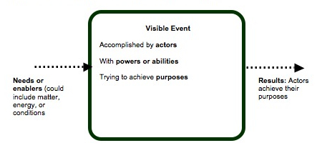

At level 4, the inputs are distinguished in terms of matter and energy inputs, for particular processes, and the results are matter and energy outputs (see Figure 7). Thus, there is a storyline about how matter and energy transform during a particular process.

Figure 7. Patterns in Upper Anchor accounts
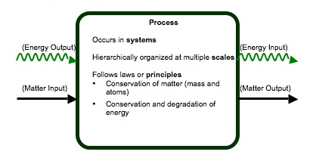
Table 2 summarizes how we used these patterns in accounts to develop goals for how we would like students at each level to explain matter and energy transforming processes. In elementary school we do not think it reasonable to expect students to switch to fully scientific discourse and practice, but students can learn to elaborate on their force dynamic accounts in ways that make them aware of the hierarchy of systems and scale and help them to trace matter and energy through systems (focusing particularly on distinguishing between different types of enablers, and becoming more aware of gases as a form of matter). We believe middle school students can learn how to use atomic molecular models to explain transformations of matter and energy, though without much chemical detail. High school students can master additional chemical details.
Table 2. Goals in our hypothetical (desired) learning progression
Level | Enablers or Inputs | Actors and Settings or Systems | Results: Purposes or Products
Level 1. Lower Anchor, elementary starting point | Needs or enablers | Abilities or powers of actors  Settings for events | Achieving purposes or goals of actors
Principle-based Level 2. Elementary goal | Different kinds of enablers:  --materials (solid, liquid, gas)  --energy sources  --conditions | Abilities of actors plus internal structure (organs, cells) and movement of materials and energy through settings and actors | Material products  --gas-gas cycles  --growth as matter moving into bodies  Energy products
Principle-based Level 3. Middle school goal | Material inputs, distinguishing organic from inorganic materials  Forms of energy, including chemical energy (C-C and C-H bonds) | Movement of materials through systems at multiple scales  Living systems made of organic materials | Changes in matter obeying conservation laws  Transformation and degradation of energy
Level 4. Upper Anchor, high school goal | Material inputs with specific chemical identities  Energy inputs | Movement of atoms in molecules through systems at atomic-molecular to large scale socio-ecological systems | Material products tracing atoms between inorganic and organic forms  Transformation and degradation of energy
Tools For Principled Reasoning

Using the goals from Table 2 as a guide, and the patterns in students accounts (Figures 6 and 7), we developed reasoning tools we believe will help students make progress toward more sophisticated, and principled-based accounts that support both naming and explaining dimensions. These tools are built into the teaching experiment materials, so students and teachers use the tools repeatedly across multiple systems and processes. Our tools are designed to support reasoning about the following principles:
- Conservation of Matter-Atoms
- Conservations of Matter-Mass
- Conservation of Energy
- Energy degradation
- Scale

Conservation of Matter and Energy. A key tool we use in our teaching experiments is called the Process Tool. This tool can be used to describe both macroscopic events (e.g., match burning) and chemical processes (e.g., combustion of wood) depending on the level of students, and the goals from Table 3. The process tool requires that students trace both matter and energy inputs and outputs (keeping the two separate). This tool was designed to support students in using conservation of matter and conservation of energy to reason about events or processes. Students are given a limited numbers of forms of matter—solids, liquids, and gases—that they can name using either macroscopic descriptors/language (e.g., food) or chemical identities (e.g., glucose: C₆H₁₂O₆). The tool also uses a limited number of energy forms—light energy, motion energy, chemical energy, electrical energy, and heat (they are also given a blank energy label for instances they need to talk about other energy forms, such as nuclear energy, gravitational potential energy, etc). Students much decide the matter inputs and the form of matter required for the event or processes. They do the same for energy inputs. Then students determine matter and energy outputs. See Figure 8 for an example of our process tool and Appendix A for additional examples. The process tool is used in the classroom in three forms: a 3x4 poster with Velcro or magnetic tabs for matter and energy labels, in student activity pages, and in powerpoints for the teacher to use during whole group instruction).

Figure 8. Snapshot of Process Tool
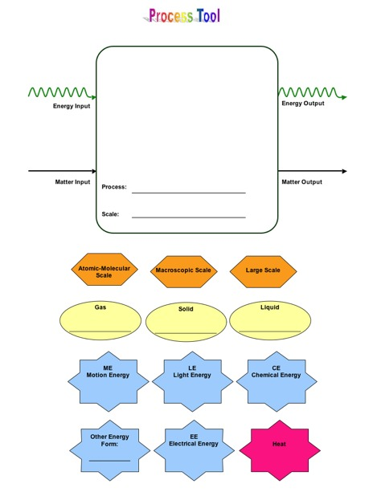

Note that “heat” is treated differently from other forms of energy. Heat has a different color in the process tool label in Figure 8 and is also noted with a different color in the process tool diagrams in Appendix A. We wanted to provide teachers with a way of helping students work on the principle of energy degradation. Where most energy transformations use a “green arrow”, transformations to heat energy use a “red arrow” indicating that this form of energy is no longer usable to organisms or objects. For example, the food chain diagram in Appendix A shows that chemical energy continues to move from organism to organism, but heat leaves the system.
In addition to the process tool, molecular models kits are used to help students conserve atoms and identify substances with chemical energy. When students build molecular models, they are taught a general rule of thumb for indentifying materials with chemical energy. They look for C-C and C-H bonds. In this way materials, such as foods and fuels, can be compared in terms of similarities in chemical structure. The students use the molecular models to simulate a chemical process, with a focus on the idea that chemical processes involve the rearrangement of atoms that result in both matter and energy transformations.

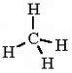
Figure 9. Example of Molecular Model Kit Activity

Methane burns by combining with oxygen in the air to make carbon dioxide and water vapor. One methane molecule reacts with 2 oxygen molecules:

CH₄ + 2 O₂ → CO₂ + 2 H₂O

 | Reactants and Products of the Chemical Change |  |  | Does the substance contain Energy
 | How many carbon atoms does it have? | How many oxygen atoms does it have? | How many hydrogen atoms does it have? | What type of bonds does the substance contain? (C-C, C-H, O-H, C-O, O=O) | Is the substance a source of chemical energy?  (yes or no)
Begin with…
Methane

Oxygen

End with…
Carbon Dioxide

Water

To help students work on conservation of mass, they use both the process tool and digital balances. Digital balances are used at all grade levels to measure mass change over time. For example, consider the following activity: students measure the mass change in a cup of crickets over a period of 1-2 days (without feeding crickets). They find that mass decreases and use the process tool to help identify where the mass has gone.

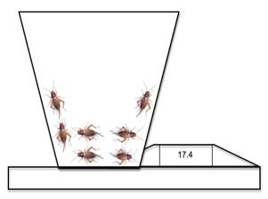
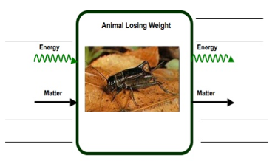
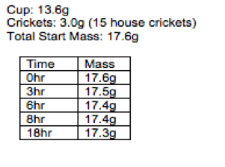
Example of Digital Balance Activity

Hierarchy of Scales. Students use powers of ten to reason about processes at different scales. Several representations of powers of ten are built into classroom activities. Students view the Eames brothers Powers of Ten DVD. Teachers use a 3x4 wall chart to locate systems using powers of ten (see Figure 10).

Figure 10: Powers of Ten Classroom Chart
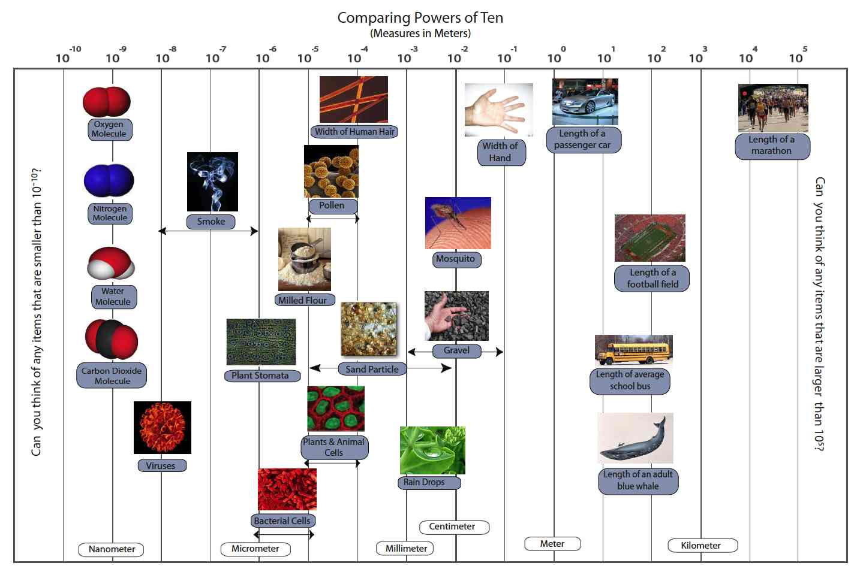

We have also developed powerpoints that use powers of ten to zoom into different systems (e.g., zoom into a cloud, zoom into a flame, zoom into a hand, zoom into a plant, etc). Figures 11 and 12 are screenshots of powerpoints that zoom into a flame and a plant.
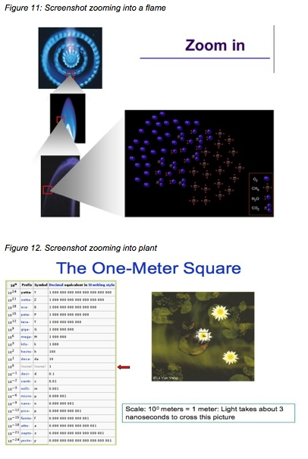

Powerpoints may include animations of chemical change. For example, the powerpoint that zooms into a flame includes an animation of combustion of methane. This way students can discuss why a flame is a mixture of gases at the atomic-molecular level.

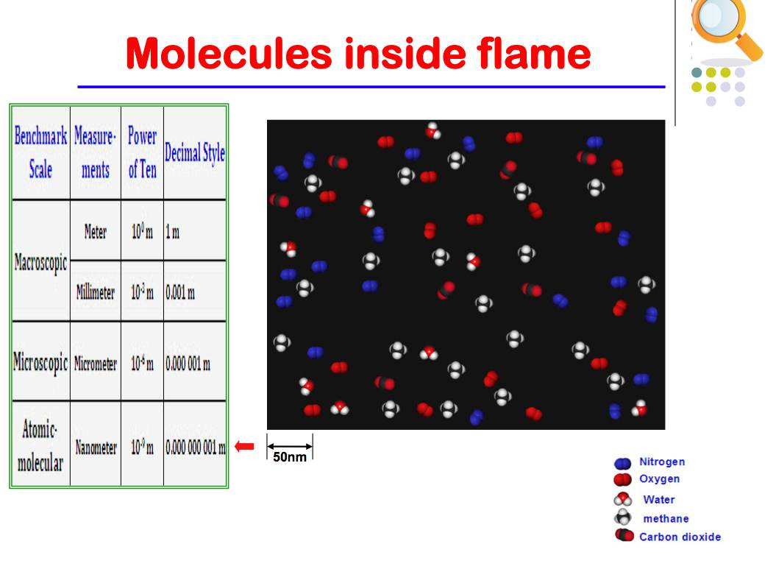
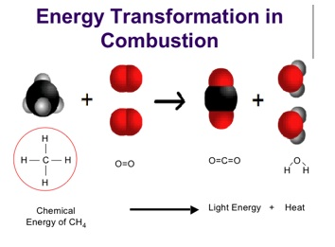
Figure 13. Powerpoints with animations: scale, matter, and energy
Discussion

The CCLP uses design-based research with the goal of producing three design products—a learning progression framework, assessments, and teaching tools and materials. While our project has spent a great deal of time developing an initial framework and assessments, our work on the third design product is just beginning. We hope the teaching experiments not only provide valuable information to inform our understanding of alternative pathways, but also ultimately support more students in developing and using Upper Anchor reasoning.
Teaching experiments are one piece of our validation process. As with all the learning progressions on the Environmental Science Literacy project, we seek to address three standards, or qualities, for producing a valid learning progression:
- Conceptual coherence: a learning progression should “make sense,” in that it tells a comprehensible and reasonable story of how initially naïve students can develop mastery in a domain.
- Compatibility with current research: a learning progression should build on findings or frameworks of the best current research about student learning. This research rarely provides precise guidance about what Learning Performances are appropriate for students at a particular grade level, but it does provide both domain-specific (i.e., focusing on specific subject matter) and domain-general (i.e., focusing on more general aspects of learning and reasoning) constraints on learning progressions.
- Empirical validation: The assertions we make about student learning should be grounded in empirical data about real students.
We have made reasonable progress on developing a conceptual coherent CCLP that is compatible with current research. The teaching experiments represent are large component of our work to improve conceptual coherence and empirically validate the CCLP.
Table 3. Criteria for Validity of Learning Progressions
Characteristic of Learning Progressions | Conceptual Coherence | Compatibility with Current Research | Empirical Validation
Learning performances | Learning performances have consistency across (a) knowledge, (b) practice, and (c) context—real-world systems and phenomena for any given process and principle. | Learning performances are compatible with those described in the research literature. | Learning performances describe actual observed performances by real students. Students’ learning performances are consistent across different questions or modes of assessment.
Levels of Achievement | Levels are conceptually coherent and reflect some underlying consistency in reasoning. | Levels reflect consideration (explicit or implicit) of strands of scientific literacy. | Levels have predictive power and students should show similar Levels of Achievement across principles and processes.
Principles and processes | Principles and processes capture important aspects that reflect some underlying consistency in reasoning. | Progress from one Level to the next is consistent with research on students’ learning. | Progress from one Level to the next can be achieved through teaching strategies.
The shaded cell represents where we see teaching experiments as being critical to our validation process. With these teaching experiments we hope to show that teaching strategies, especially through the use of tools that emphasize matter, energy, and scale, result in progress from one level to the next.
As mentioned previously, a notable characteristic of the CCLP work compared to other learning progression work has been our orientation toward documenting the current reality (what is) as opposed to documenting the limits, or boundaries, of what students can do given specific instruction (what could be). The difference between these two approaches is not trivial, but both approaches have something useful to share with the other. Both approaches believe in “ground-truthing” knowledge claims using data from real students in real classrooms. Both use an iterative approach, where the frameworks, assessments, and teaching materials are continually negotiated and revised based on empirical data. Laurel Hartley, an ecologist who is participating in our learning progression work, points out parallels between this process and ecological model-building.
[We can make] parallels between a learning progression and an ecological model. The steps seem very much the same in that 1) you start with some initial information and you create a framework or model that you think is an accurate representation of how things really are, 2) then you make predictions based on your model and you "ground-truth" those predictions by seeing if what your model predicts is what happens in actuality, 3) then you use that new information about how well your model worked to further refine the parameters of your model, 4) then you ground-truth and adjust parameters again and again until your model becomes a satisfactory representation of reality. In ecology, you can use a good model to predict future events before they happen or to generate reliable approximations about a system without having to take a ton of expensive, time-consuming field measurements. In science education, a good model can help teachers predict the development of their students' understanding over time and it can help a curriculum writer or assessor to create developmentally appropriate material in a more efficient way. (Hartley, personal communication, 2/14/08)
As Dr. Hartley argues, a good model can be a powerful thing in education as well as in ecology. We can’t create good models, though, just by developing conceptually coherent frameworks and using them. The model gains both power and validity through “ground-truthing”—the painstaking process of empirical validation.
The Environmental Science Literacy learning progressions represent an example of learning progressions work that “ground-truths” claims using written assessment and interview data. Our approach documents the current reality through a broad survey orientation. We emphasized the development of two design products first—an initial framework and assessments. This approach offers a learning progression grounded in empirical data from students, and one that describes consistent patterns in what students bring to the classroom at different age levels. While many students on the current CCLP pathway are unsuccessful in reaching the Upper Anchor, our work confirms that this type of reasoning is obtainable by high school students. We now have a rich understanding of the pathway that is currently the norm for most students, and can use our understanding of this pathway to develop practical instructional interventions to support alternative pathways toward the Upper Anchor.
In addition to the strengths of this approach, there are two notable limitations. The first limitation is a lack of understanding more productive and successful pathways. We have proposed what we believe to be an alternative (and hopefully more successful) pathway and are using this to design teaching materials and tools, but we still know relatively little about student progress within this context and only have a limited number of classrooms involved in testing these materials. A second limitation is that our project initially focused on designing a framework and assessments, with less attention given to developing instructional materials. Our goal is not to develop highly prescriptive materials that support progress from one level to the next, which means we do not offer ready-made instructional materials for teachers. We, along with the teachers on our project, are still exploring the degree to which an intervention is necessary to reach the Upper Anchor and have focused more on designing flexible “tools” as opposed to specific lesson sequences. While this provides more freedom for teachers, it inevitably leads to a wide range of ways the tools could be implemented in the classroom.
The second approach to learning progression work foregrounds the development of teaching approaches as a design product (e.g., Schauble, 2009; Wiser & Smith, 2008; Wiser et al., 2009). These learning progressions researchers can justifiably criticize our work because we have failed to describe the instructional conditions that result in the observed trajectory. These researchers may argue that learning progressions need to describe processes of change in students as well as levels of achievement. In an exchange with Dr. Schauble, she explained that, “a learning progression is not something that capitalizes on the usual patterns of children's thinking (under no particular conditions of instruction). Instead, to me, it illuminates the usual patterns of children's thinking UNDER CAREFULLY DESCRIBED CONDITIONS OF INSTRUCTION. In other words, the theory of learning must include an account of the means by which learning is supported.”
So this paper is in part our contribution to a continuing dialogue about different approaches to learning progressions work: Researchers taking specific instructional approaches tend to advocate more strongly for the plasticity of student learning—to say that student learning is always contingent on instruction, and that existence proofs can show us the way to more powerful learning. We tend to be less optimistic about the plasticity, if not of students, of our cultures and educational systems. Thus a starting point for our teaching experiments is that we are exploring minimal interventions that will help more students can achieve Upper Anchor reasoning by the end of high school. Our hope is that this goal can be achieved if teachers engage students in the consistent, but flexible use of tools for reasoning that embody key principles such as conservation of matter and energy.

Acknowledgements

The authors would like to thank several people for their invaluable contributions to the work presented in this paper. We would like to acknowledge the contributions made by Hui Jin and Li Zhan from Michigan State University in helping to develop materials and tools for the teaching experiments. We would also like to thank Jing Chen, Jonathon Schramm, Kennedy Onyancha, Hamin Baek, and Hsin-Yuan Chen from Michigan State University and Karen Draney, Mark Wilson, Yong-Sang Lee, and Jinnie Choi, at the University of California, Berkeley.
References

Brown, A.L. (1992). Design experiments: Theoretical and methodological challenges to creating
complex interventions in classroom settings. The Journal of the Learning Sciences, 2(2),
141-178.
Collins, A. (1992). Toward a design science of education. In E. Scanlon & T. O’Shea (Eds.),
New directions in educational technology (pp. 15-22). New York: Springer-Verlag.
Gee, J. P. (1996). Social linguistics and literacies: Ideology in discourses (2nd ed.). Bristol, PA:
Taylor & Francis.
Gunckel, K. L., Covitt, B. A., & Anderson, C. W. (2009, June). Learning a secondary discourse:
Shifts form force-dynamic to model-based reasoning in understanding water in socio-
ecological systems. Paper presented at the Learning Progressions in Science, Iowa City,
IA.
Jin, H., Choi, J., & Anderson, C.W. (2009, June). Development and validation of assessments for a learning progression on carbon cycling in socio-ecological systems. Paper presented at the Learning Progressions in Science, Iowa City, IA.
Jin, H., Zhan, L., & Anderson, C.W. (2009, April). Secondary students’ understanding of
carbon cycling: A Comparative Study in US and China. Paper presented at the annual
meeting of the National Association for Research in Science Teaching, Garden Grove,
CA.
Mohan, L., Chen, J., & Anderson, C.W. (in press). Developing a multi-year K-12 learning progression for carbon cycling in socio-ecological systems. Journal of Research in Science Teaching.
National Research Council (2007). Taking science to school: Learning and teaching science in grades K-8. Committee on Science Learning, Kindergarten through Eighth Grade. Richard A. Duschl, Heidi A. Schweingruber, and Andrew W. Shouse, editors. Board on Science Education, Center for Education, Division of Behavioral and Social Sciences and Education. Washington, DC: The National Academies Press.
Pinker, S. (2007). The stuff of thought: Language as a window into human nature. New York:
Penguin Group.
Schauble, L. (2009, April). What’s foundational for science learning? Plenary presented at the annual meeting of the National Association for Research in Science Teaching, Garden Grove, CA.
Smith, C., Wiser, M., Anderson, C. W., and Krajcik, J. (2006). Implications of research on children’s learning for assessment: Matter and atomic molecular theory. Measurement: Interdisciplinary Research and Perspectives, 14 (1 & 2), 1-98.
Talmy, L. (1988). Force dynamics in language and cognition. Cognitive Science, 12(1), 49-100.
Wiser, M., & Smith, C.L. (2008). Learning and teaching about matter in grades K-8: When
should atomic-molecular theory be introduced? In S. Vosniadou (ed.) The International
Handbook of Conceptual Change. Taylor & Francis
Wiser, M., Smith, C.,L. Asbell-Clarke, J., & Doubler, S. (2009, April). The Inquiry Project:
Grades 3-5. C. Smith (Chair) Developing and Refining a Learning Progression for
Matter From Pre-K to Grade 12: Commonalities and Contrasts Among Four Current
Projects. Symposia presented at the annual meeting of the American Educational
Research Association, San Diego, CA.
Appendix A: Additional Process Tool Examples

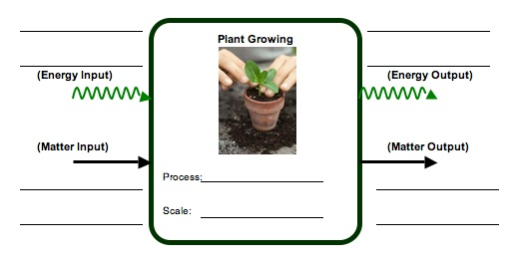
Single Process

Multiple Pathways
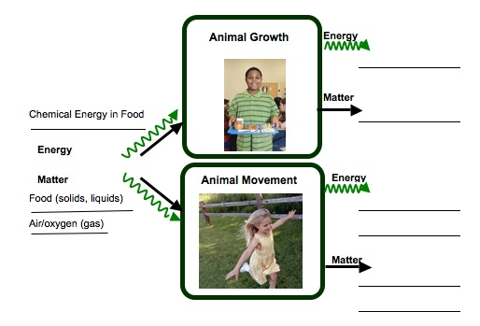

Note: Processes in human beings are categorized with other animal processes, thus we use “animal growth” and “animal movement” to describe processes in humans.
Connected Chain of Processes

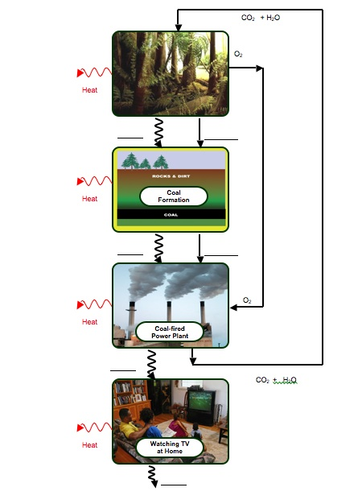

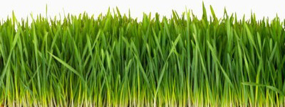


Process Tool for Food Chain with Answers in blue and red fon
CO₂ (gas)
H₂O (gas/liquid)
H₂O (gas/liquid)
H₂O (gas/liquid)
CO₂ (gas)
CO₂ (gas)
Motion Energy
Motion Energy
HEAT
HEAT
HEAT
Cellular
Respiration

Rabbit Body Structure (solid)
Chemical Energy
Grass Structure (solid)
Sugar & Starch in Grass Structure (solid)
Sunlight
Carbon Dioxide (gas)
Water (liquid)
Chemical Energy
Chemical Energy
Photosynthesis

Grass Growth Biosynthesis

Rabbit Growth
Biosynthesis

Cellular
Respiration

Wolf Growth
Biosynthesis

Cellular Respiration

Matter Cycles
Energy Flows

