COLLABORATIVE PROBLEM SOLVING

SOME TOOLS:

-Concept Mapping
- Systems Thinking

- Comprehensive
Analysis:
(environmental,
economic, social
sustainability)

- Ecosystem Analysis
(ESWAPAH: energy, soil, water, air, plants. animals, human interaction.)

- Using the environment
as a framework for
integrated learning

- (Using integration as
an effective strategy for meeting Learning
Results and Taking Responsibility.)

- (Place-based education
and service learning)

Objective Criteria:
-sustainablility
-long term vs
short term
-satisfying common
interests

-Teaching collaborative
conflict resolution

- Stewardship as
a citizenship
skill

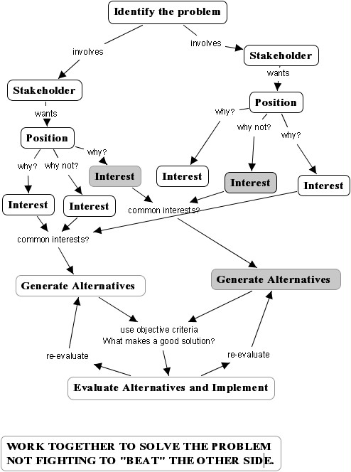

Adapted from Getting to Yes, 1984, Rogher Fisher and William Ury.
The concept map was generated using CmapTools, www.cmap.coginst.uwf.edu
Other problem solving resources:
- How Big is Your Backyard, Institute for Global Ethics, www.globalethics.org
- Environmental Problem Solving, Bardwell, et al, www.naaee.org/publications/pubdescriptions.php

COLLABORATIVE PROBLEM SOLVING Name:____________________________________

Collect information about your issue and begin working towards solving the problem collaboratively using the following analysis:

1. What is the problem?

2. Who are the major stakeholders? What are their position? What are at least 2 interest behind each interest?

Stakeholder Position Interests
a. a. a1.

a2.

b. b. b1.

b2.

c. c c1.

c2.

d. d. d1.

d2.

3. What might be some rules for judging whether something is a “good” solution?
a.

b.

c.

d.

4. Generate alternatives that meet the most needs?

a.

b.

5. What are some of the advantages and disadvantages of the alternatives? Judge them by the objective criteria listed in #3.

6. How could the alternative be better adjusted to meet some of the disadvantages?

