Jane Heinze-Fry Bio
2017

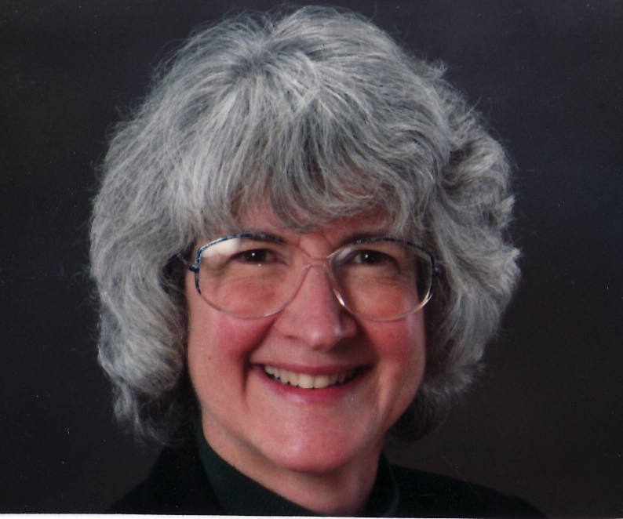

Jane Heinze-Fry, Ph.D. is the Special Programs Director at the Museum Institute for Teaching Science (MITS). With four decades of experience in the science and environmental education fields, she has served as an educational collaborator, presenter, writer, teacher, and researcher. She has worked with MITS staff and Lead Educators across Massachusetts to offer professional development institutes to K-12 teachers in hands-on, minds-on inquiry-based science. Jane has presented extensively at state and national science education conferences. Her teaching experience ranges from courses in teaching methods at the graduate level to K-12 teachers of all subjects to life science courses at the middle school, high school, and college levels.

In addition to her teaching experience, she worked with the Department of Elementary and Secondary Education to develop the life science and earth science strand maps of the Science, Technology/Engineering Framework. Her current strand maps target weather and climate of the Massachusetts standards and of the Next Generation Science Standards.

Jane's writing includes journal articles that address various applications of concept mapping to science education and instructional materials to accompany environmental science textbooks. She has recently shared her concept map linking to climate change science and climate change education resources at the 2016 International Conference on Concept Mapping in Estonia. She is currently working on a Metacognition Toolbox which includes a Vee Diagram of Science and Engineering Practices.

Jane has served in a variety of leadership capacities including chair of the Secretary's Advisory Group on Environmental Education, co-coordinator of Bowman Elementary School's Big Backyard Program, and co-chair of the Environmental Education Committee of the Science Teachers' Association of New York State. She earned her M.S. in Environmental Education from the University of Michigan in 1978 and Ph.D. in Science and Environmental Education from Cornell University in 1987.

