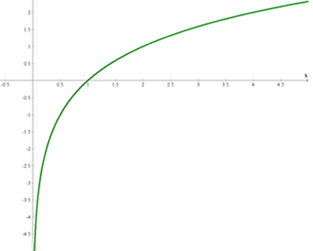
x
1/8 | -3
1/4 | -2
1/2 | -1
1 | 0
2 | 1
4 | 2
8 | 3

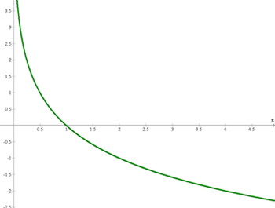
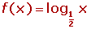
x | 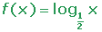
1/8 | 3
1/4 | 2
1/2 | 1
1 | 0
2 | −1
4 | −2
8 | −3

