I have learned that students dislike having to add DOIs to their references listing, as to them it seems labor and time intensive to find them, so here is a quick and easy way to do them all at once:

Use CrossRef Simple Text Query

Enter your reference listing as text in APA format, using copy/paste, e.g.
Arghode, V. (2012) Qualitative and quantitative research: Paradigmatic differences. Global Education Journal, 4, 155-163.
Grossoehme, D. (2014). Overview of qualitative research. Journal of Healthcare Chaplaincy, 20(3), 109-122.
Kramer-Kile, M. (2012). Situating methodology within qualitative research. Canadian Journal of Cardiovascular Nursing, 22(4), 27-31.
Leedy, P. D., & Ormrod, J. E. (2013). Practical research: Planning and design (10th ed.). Upper Saddle River, NJ: Pearson.
Maggs-Rapport, F. (2000). Combining methodological approaches in research: Ethnography and interpretive phenomenology. Journal of Advanced Nursing, 31(1), 219-225.
Petty, N., Thomson, O., & Stew, G. (2012). Ready for a paradigm shift? Part 2: Introducing qualitative research methodologies and methods. Manual Therapy, 17(5), 376-384.
Polit, D., & Beck, C. T. (2004). Nursing research: Principles and methods (7th ed.). Philadelphia, PA: Lippincott Williams & Wilkins.
Szyjka, S. (2012). Understanding research paradigms: Trends in science education research. Problems of Education in the 21st Century, 43, 110-118.
Yilmaz, K. (2013). Comparison of quantitative and qualitative research traditions: Epistemological, theoretical, and methodological differences. European Journal of Education, 48(2), 311-325.
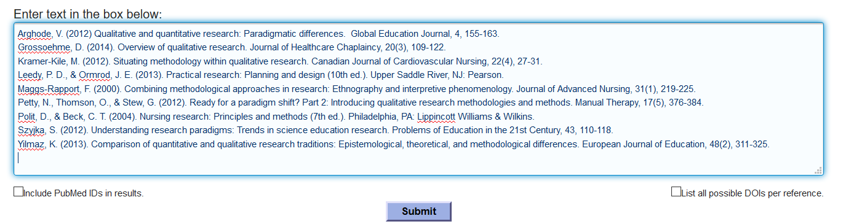
The click Submit and in seconds you will see:
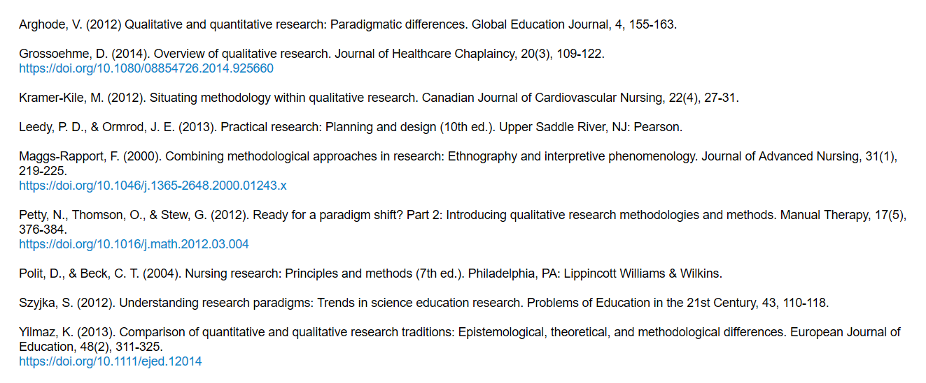
Copy and paste this material into your Word document, then apply hanging indents. The shortcut method is to select all text, then Ctrl-T on PC or Cmd-T on a Mac. Using Word, it would be (Select all, Home, Paragraph, Indentation, Special, Hanging):

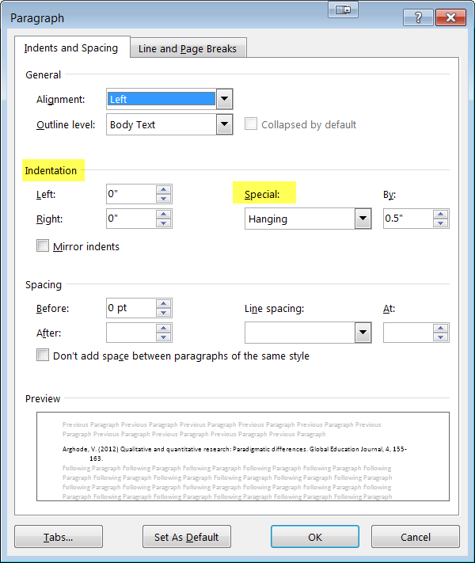
to produce:

Arghode, V. (2012) Qualitative and quantitative research: Paradigmatic differences. Global Education Journal, 4, 155-163.
Grossoehme, D. (2014). Overview of qualitative research. Journal of Healthcare Chaplaincy, 20(3), 109-122. https://doi.org/10.1080/08854726.2014.925660
Kramer-Kile, M. (2012). Situating methodology within qualitative research. Canadian Journal of Cardiovascular Nursing, 22(4), 27-31.
Leedy, P. D., & Ormrod, J. E. (2013). Practical research: Planning and design (10th ed.). Upper Saddle River, NJ: Pearson.
Maggs-Rapport, F. (2000). Combining methodological approaches in research: Ethnography and interpretive phenomenology. Journal of Advanced Nursing, 31(1), 219-225. https://doi.org/10.1046/j.1365-2648.2000.01243.x
Petty, N., Thomson, O., & Stew, G. (2012). Ready for a paradigm shift? Part 2: Introducing qualitative research methodologies and methods. Manual Therapy, 17(5), 376-384. https://doi.org/10.1016/j.math.2012.03.004
Polit, D., & Beck, C. T. (2004). Nursing research: Principles and methods (7th ed.). Philadelphia, PA: Lippincott Williams & Wilkins.
Szyjka, S. (2012). Understanding research paradigms: Trends in science education research. Problems of Education in the 21st Century, 43, 110-118.
Yilmaz, K. (2013). Comparison of quantitative and qualitative research traditions: Epistemological, theoretical, and methodological differences. European Journal of Education, 48(2), 311-325. https://doi.org/10.1111/ejed.12014

then apply italics, where needed:
Arghode, V. (2012) Qualitative and quantitative research: Paradigmatic differences. Global Education Journal, 4, 155-163.
Grossoehme, D. (2014). Overview of qualitative research. Journal of Healthcare Chaplaincy, 20(3), 109-122. https://doi.org/10.1080/08854726.2014.925660
Kramer-Kile, M. (2012). Situating methodology within qualitative research. Canadian Journal of Cardiovascular Nursing, 22(4), 27-31.
Leedy, P. D., & Ormrod, J. E. (2013). Practical research: Planning and design (10th ed.). Upper Saddle River, NJ: Pearson.
Maggs-Rapport, F. (2000). Combining methodological approaches in research: Ethnography and interpretive phenomenology. Journal of Advanced Nursing, 31(1), 219-225. https://doi.org/10.1046/j.1365-2648.2000.01243.x
Petty, N., Thomson, O., & Stew, G. (2012). Ready for a paradigm shift? Part 2: Introducing qualitative research methodologies and methods. Manual Therapy, 17(5), 376-384. https://doi.org/10.1016/j.math.2012.03.004
Polit, D., & Beck, C. T. (2004). Nursing research: Principles and methods (7th ed.). Philadelphia, PA: Lippincott Williams & Wilkins.
Szyjka, S. (2012). Understanding research paradigms: Trends in science education research. Problems of Education in the 21st Century, 43, 110-118.
Yilmaz, K. (2013). Comparison of quantitative and qualitative research traditions: Epistemological, theoretical, and methodological differences. European Journal of Education, 48(2), 311-325. https://doi.org/10.1111/ejed.12014

now you are home free in just seconds!

CrossRef metadata search allows searching the metadata of 86,424,526 journal articles, books, standards, datasets & more:

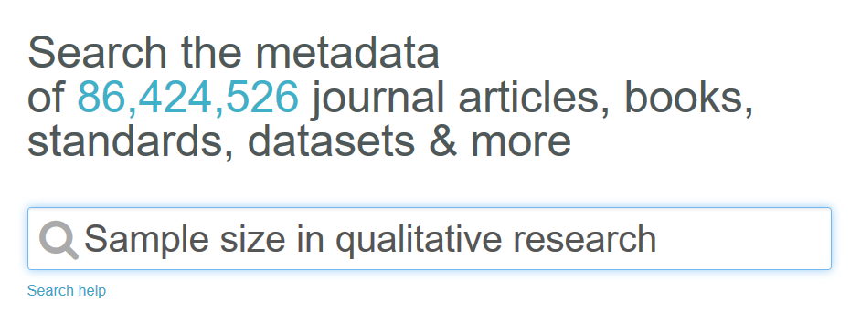
Which yields:
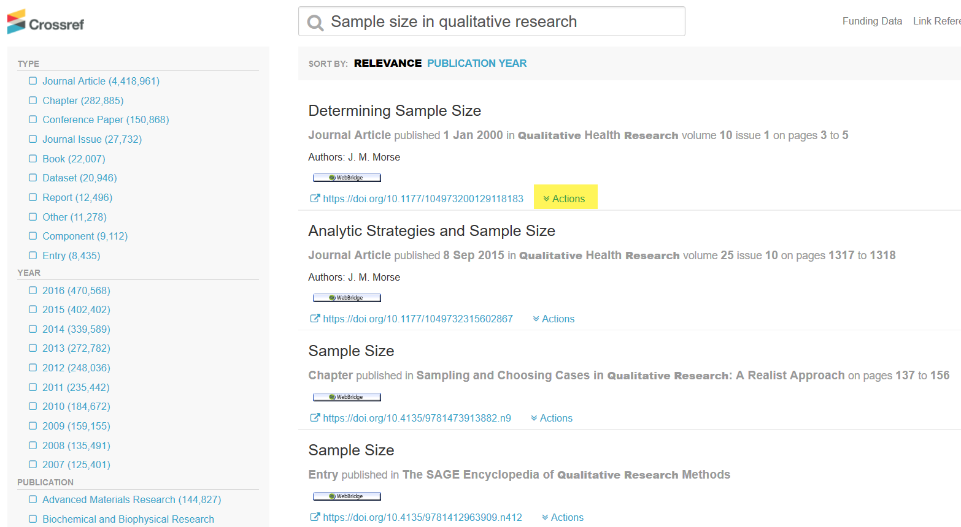

Notice the helpful WebBridge button to look up resources at AU Library. Notice too, the DOI link for each resource. If you wish to cite a resource, simply click on the Actions link for a drop down menu:
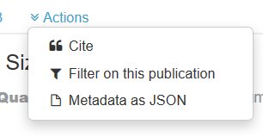
When you choose Cite, then APA, you get the ability copy/paste your chosen resource in APA format to your document:

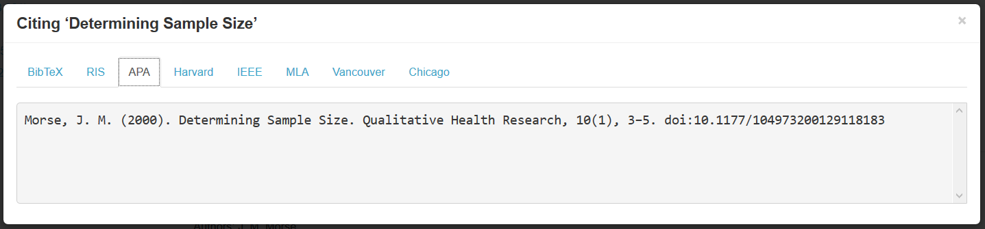
This function of CrossRef needs refining, since the APA format is not quite accurate yet, as it should be lower case for the article title, and the journal name and volume number should be italicized, and the preferred display format for the DOI (as of March, 2017) should be https://doi.org/10.1177/104973200129118183
Note: The dx is dropped from the domain name, and the protocol is changed from http:// to https://
I am working with CrossRef to get the APA formatting tuned up to reflect current APA guidelines and working with APA to update the DOI display from the older alternatives of DOI:10.1177/104973200129118183 or http://doi.org/10.1177/104973200129118183

Jack

