The Hundred Years‘War (1337-1453)
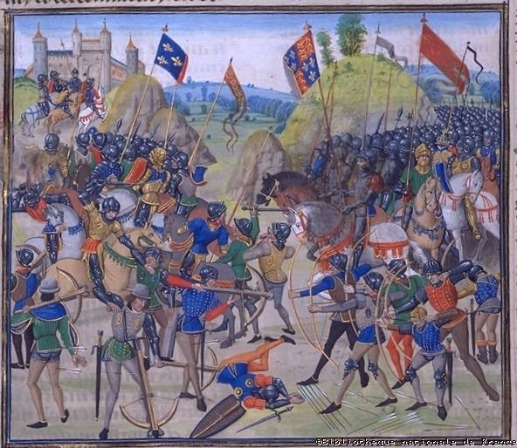
The Hundred Years’ War is the term for the conflict between two royal houses, namely the House of Plantagenet and the House of Valois, for the French throne. The House of Valois claimed the title of King of France, while the Plantagenets from England claimed to be Kings of France and England.

