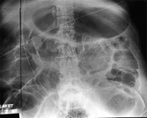
The dark line along the lateral portion of this upper abdomen is caused by backscatter transmitted through the back of the cassette. The line corresponds to the cassette hinge where the lead coating was weakened or cracked. Artefact remedy: to reduce backscatter, the radiographer should collimate when possible. Since backscatter cannot be eliminated in every case, knowledge of the radiographic appearance of cassette backs is useful.

http://bjr.birjpournals.org/cgi/content/full/74/878/195#top

