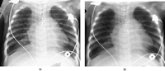

Edge enhancement was increased from the default level for this paediatric chest image. Notice the marked increase in lung markings, which could indicate interstitial infiltrates. (b) The same image processed with normal edge enhancement. Artefact remedy: select a standard set of image processing parameters, especially for frequency and edge enhancement, with the help of applications specialists. Once a standard set of processing parameters are selected, post-processing changes should not be needed frequently.

http://bjr.birjournals.org/cgi/content/full/74/878/195#top

