Artifacts caused by hardware related issues

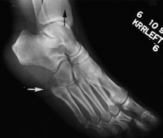
Laser printer artefact. This oblique foot image demonstrates two different artefacts. The fine white line (black arrow) running parallel with the long dimension of the film is an artefact from the laser printer. The line running perpendicular to the long dimension of the film (white arrow) is caused by dirt on the light guide of the photomultiplier tube in the plate reader, as in Figure 5. Artefact remedy: service personnel can use a camel hair lens brush to clean the mirror.
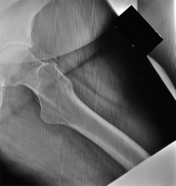
The pattern of lines seen on this oblique hip view occurred intermittently. The artefact was traced to the plate reader's electronics. Artefact remedy: the electronic board that controlled the photomultiplier tube was replaced.

http://bjr.birjournals.org/cgi/content/full/74/878/195#top

There are other aspects of the systems hardware that could produce artifacts on film as well. Inside the reader the laser beam pick up the light signal from the plate. The photo multiplier tube converts this signal to analog. And the analog digital converter converts the signal into a digital signal to be read by the computer or PACS system. Any malfunction with any of these intricate hardware pieces can cause artifacts on the image

