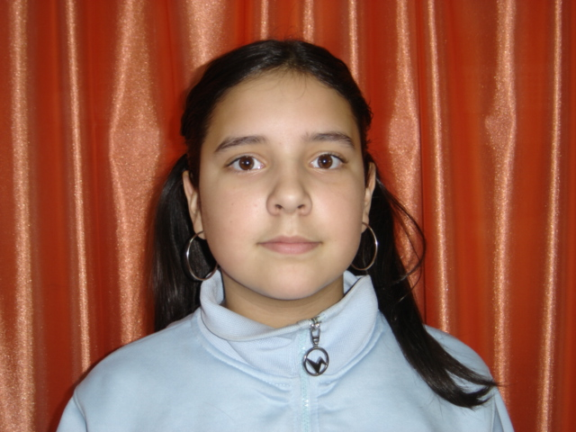
Hello .
My name is Minerva .
I’m eleven years old .
I live in Acebes,a small village in the north of Spain .
I have got one sister .
I haven’t got animals .
My favourite colour is pink and black .
My favourite animal is snake .
My favourite food is spaghetti .
My favourite singer is Madonna .
I went to the cinema and watched “Chicken Little”
Bye, bye , one kiss for you .
Minerva.

