TOPIC: BOTTOM STRUCTURE

Learning Objectives :

At the end of the lesson the student should be able to do the following:

15. Understand the functions and construction of the inner bottom structure or the double-bottom.

15.1 For a longitudinally- and a transversely-framed ship, sketch and label for each
(a) a solid floor, and

(b) a bracket floor.

15.2 Briefly describe the functions of the double bottom structure.
Explain the construction of adjacent tanks when different liquids are to be stowed.

15.3 Briefly describe the hydrostatic-testing of a tank, and with the aid of sketches, describe the safe method of carrying out this test with respect to the avoidance of excessive pressure build-up.
Bottom Structure

Originally ships were constructed with single bottoms, liquid fuels and fresh water being contained within separately constructed tanks. The double bottom structure which provides increased safety in the event of bottom shell damage, and also provides liquid tank space low down in the ship, has only evolved during the early part of this century. Smaller vessels such as tugs, ferries, and cargo ships of less than 500 gross tons have a single bottom construction. Larger ocean-going vessels, other than older tankers, are fitted with some form of double bottom.

Single Bottom Structure

Single bottom are common for vessels not exceeding 90 metres in length.

In single bottom construction, vertical plate open floors are fitted at every frame space and are stiffened at their upper edge.

Where a bar keel is fitted the floors are continuous from bilge to bilge; but where a flat plate keel is provided a continuous longitudinal centre girder may be used instead.

Intercostal (i.e. non-continuous) side girders are fitted and extend as far forward and aft as possible. One side girder is fitted each side of the centre line where the beam is less than 10 m. Where the beam is between 10 and 17 m two side girders are fitted and if any bottom shell panel has a width to length ratio greater than four, additional continuous or intercostal stiffeners are fitted. The continuous centre and intercostal side girders are stiffened at their upper edge.

In way of the machinery spaces additional side girders will be fitted to support the heavier machinery weight.

A wood ceiling may be fitted across the top of the floors if cargoes are to be carried but this does not constitute an inner bottom offering any protection if the outer bottom shell is damaged.

Drainage holes are normally cut in the floors as close as possible to the ship’s bottom to provide drainage.

Double Bottom

All ocean-going ships with the exception of some older tankers are fitted with a double bottom which often extends from the fore peak bulkhead to the after peak bulkhead.

Some of the functions of the double bottom are:

- It increases the longitudinal strength of the ship.

- It provides for additional safety in the event a bottom plate is damaged by limiting the extend of flooding.

- The tank top provides a good platform for cargo and machinery.

- The double bottom tanks can be used for carriage of fresh water and ballast water.

- It provides for additional protection against environmental pollution for ships carrying liquid cargoes in their holds in the event that the bottom plate is damaged.

Double Bottom Construction

A double bottom as its name implies will have two bottoms. The outer bottom is the bottom shell plating and the inner bottom is the tank top plating.

The tank top plating normally extends from side to side of a ship to provide a better degree of safety since there is a substantial area of bilge, which has a higher likelihood of being damaged.

If the tank top plating does not extend to the side a margin plate is fitted to keep the outboard sides of the double bottom intact. A margin plate is normally fitted perpendicular to the turn of the bilge.
If grabs are used for discharging cargo the plate thickness for the tank top has to be increased to compensate for the wear and tear produced by the grabs.

Manholes with watertight covers are fitted on the tank top to allow access into the double bottom.

The height of the double bottom tank is dependent on the height of the centerline girder of the ship and generally varies between 1000 mm and 1500 mm but should not be less than 630 mm in height due to access,

A double bottom is normally subdivided longitudinally and transversely into large tanks. If each tank is to be intact, then the longitudinal girders, the forward and aft end plate floors which serve as partition walls must be watertight. In many ships only one watertight longitudinal division, a centre girder, is fitted, but larger modern ships are often designed with three or four tanks across the ship. The tanks are tested by pressing them up until they overflow. Since the overflow pipe usually extends above the weather deck, the tank top can be subjected to a tremendous head of pressure which, in most cases will exceed the load from the cargo in the hold and the tank top plating must be thick enough to prevent undue distortion.

Double bottoms may be framed longitudinally or transversely, but where the ship's length exceeds 120 m it is considered desirable to adopt longitudinal framing. The explanation of this is that on longer ships tests and experience have shown that there is a tendency for the inner bottom and bottom shell to buckle if welded transverse framing is adopted.

This buckling occurs as a result of the longitudinal bending of the hull, and may be avoided by having the plating longitudinally stiffened.

Double bottoms in the way of machinery spaces, which are adjacent to the after peak are required to be transversely framed.

The internal structure arrangement details of the double bottom would depend upon whether a transverse or longitudinal framing system is adopted.

Transversely framed double bottom

The construction of the above assembly has the following features:

The continuous centre girder, the side girders, transverse plate floors (also called solid floors) and bracket floors (or open floors) provide the principal support for the inner bottom(or tank top) and bottom shell plating. A margin plate may be fitted at the transverse ends of the tank top plating perpendicular to the turn of the bilge.

Solid floors may be spaced up to 3 m apart, with bracket floors at frame spaces between the solid floors. A solid floor (or a plate floor) is constructed from a piece of steel plate. It is usually fitted as a continuous plate extending from the centre girder to the margin plate. To ensure the escape of air and water from each frame spaces to air pipes and suctions, holes are cut in the plate floors. Access holes are also cut on plate floors (also girders) to provide access to all parts of the double bottom.

Solid floors are fitted at every frame space in the engine room and in the pounding region and in the cargo hold where grabs are used for discharge of cargo.

The shell and tank top between the widely-spaced solid floors are stiffened by bulb angles or similar sections running across the ship (bottom transverse frames) and attached at centerline and the margin to large flanged plate brackets. Additional support is given to these stiffeners by the side girder and by intermediate struts, which are fitted to reduce the span. Such a structure is known as a bracket floor (or open floor).

One side girder is provided port and starboard where the ship's breadth does not exceed 20 m and two are fitted where the ship’s breadth is greater. The side girder is not a continuous plate, but broken on each side of the floor plate and is said to be intercostals. In way of the bracket floors, a vertical welded flat stiffener is attached to the side girder.

Additional side girders are provided in the engine room, and also in the pounding region forward.

Longitudinally framed double bottom

The construction of the above assembly has the following features:

The longitudinally framed double bottom consists of a centerline girder, side girders (their number depending on the breadth of the ship), solid plate floors and bracket floors. A margin plate may be fitted at the transverse ends of the tank top plating perpendicular to the turn of the bilge.

In addition to these members, outer (i.e. bottom shell) and inner (i.e. inner bottom) longitudinals spaced at about 750 mm apart are fitted to the outer and inner bottom plating.

Plate floors are fitted at every frame space under the main engines, and at alternate frames outboard of the engine seating. They are also fitted under boiler seats, transverse bulkheads, and the toes of stiffener brackets on deep tank bulkheads. Elsewhere, the spacing of the solid plate floors generally does not exceed 3.8 m and in the pounding region they are on alternate frame spaces.

At intermediate frame spaces brackets are fitted at the tank side, and at the centre girder where they may be up to 1.25 m apart. Each bracket is flanged and will extend to the first longitudinal.

One intercostal side girder is fitted port and starboard if the ship's breadth exceeds 14 m and where the breadth exceeds 21 m, two are fitted port and starboard. These side girders always extend as far forward and aft as possible. Additional side girders are provided in the engine room, under the main machinery.

As the unsupported span of the bottom longitudinals should not exceed 2.5 m, vertical angle or channel bar struts may be provided to support the longitudinals between widely spaced solid floors.

Testing Double Bottom Compartments
Each compartment is tested on completion with a head of water representing the maximum pressure head, which may be experienced in service, i.e. to the top of the air pipe. This requires blanking off all openings, and then filling up the compartments with water. Water head tank tests are carried out selectively by the surveyor because filling up a tank may cause stability problem.

Alternatively air testing is carried out before any protective coatings are applied. The air pressure may be raised to 0.21 kg/cm2, and then lowered to a test pressure of 0.14 kg/cm2. A column of water in a large clear plastic U-tube represents the test pressure i.e. 1.4 metre water column is equivalent to 0.14 kg/cm2 pressure. This is a safe method of testing because excessive pressure build-up is prevented through water overflow.

With the compartment under the air pressure, any suspect joints are then patiently subjected to a soapy liquid solution test. Air test is frequently carried out tanks because it is safe and simple.

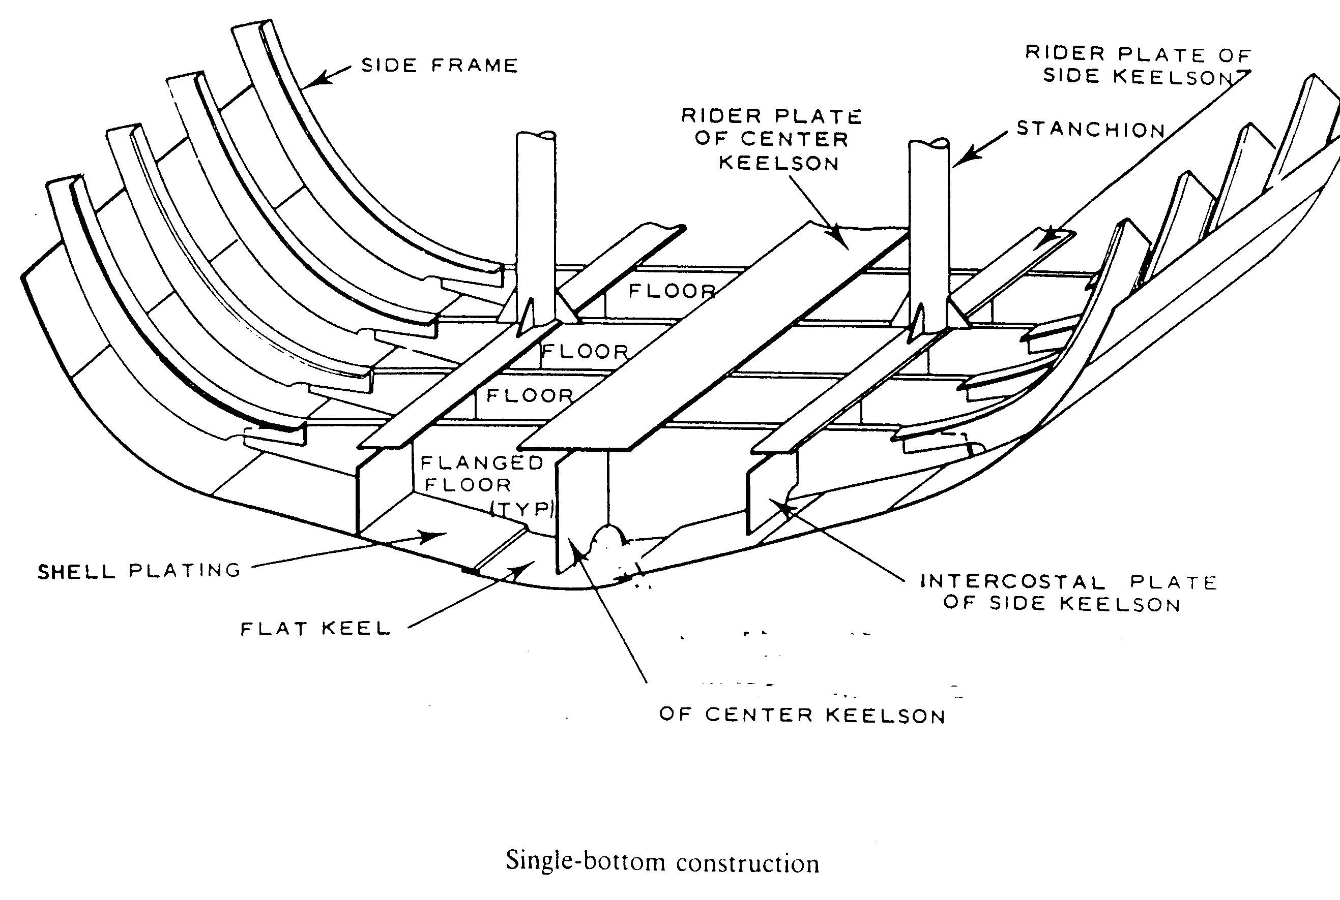

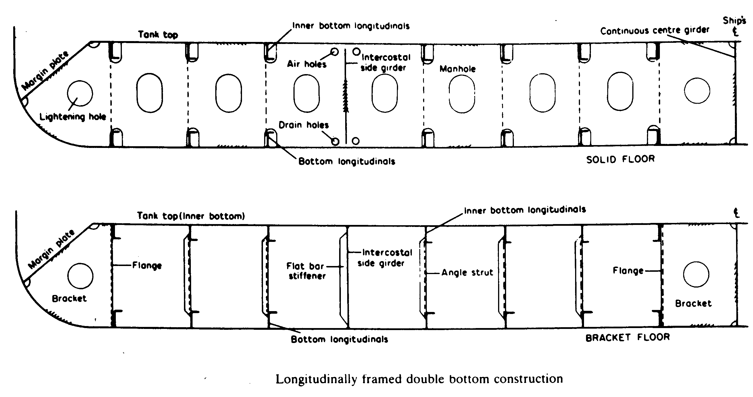

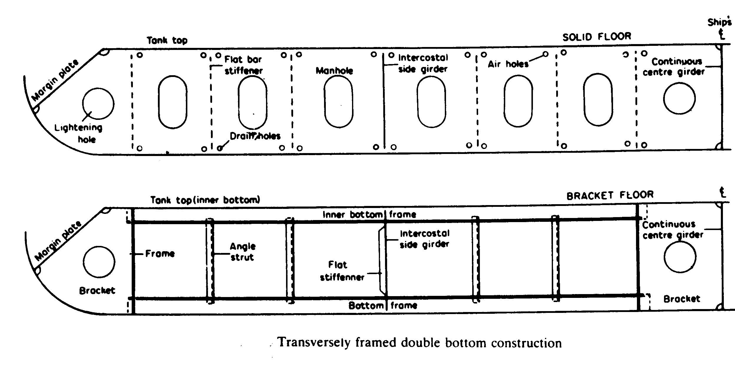

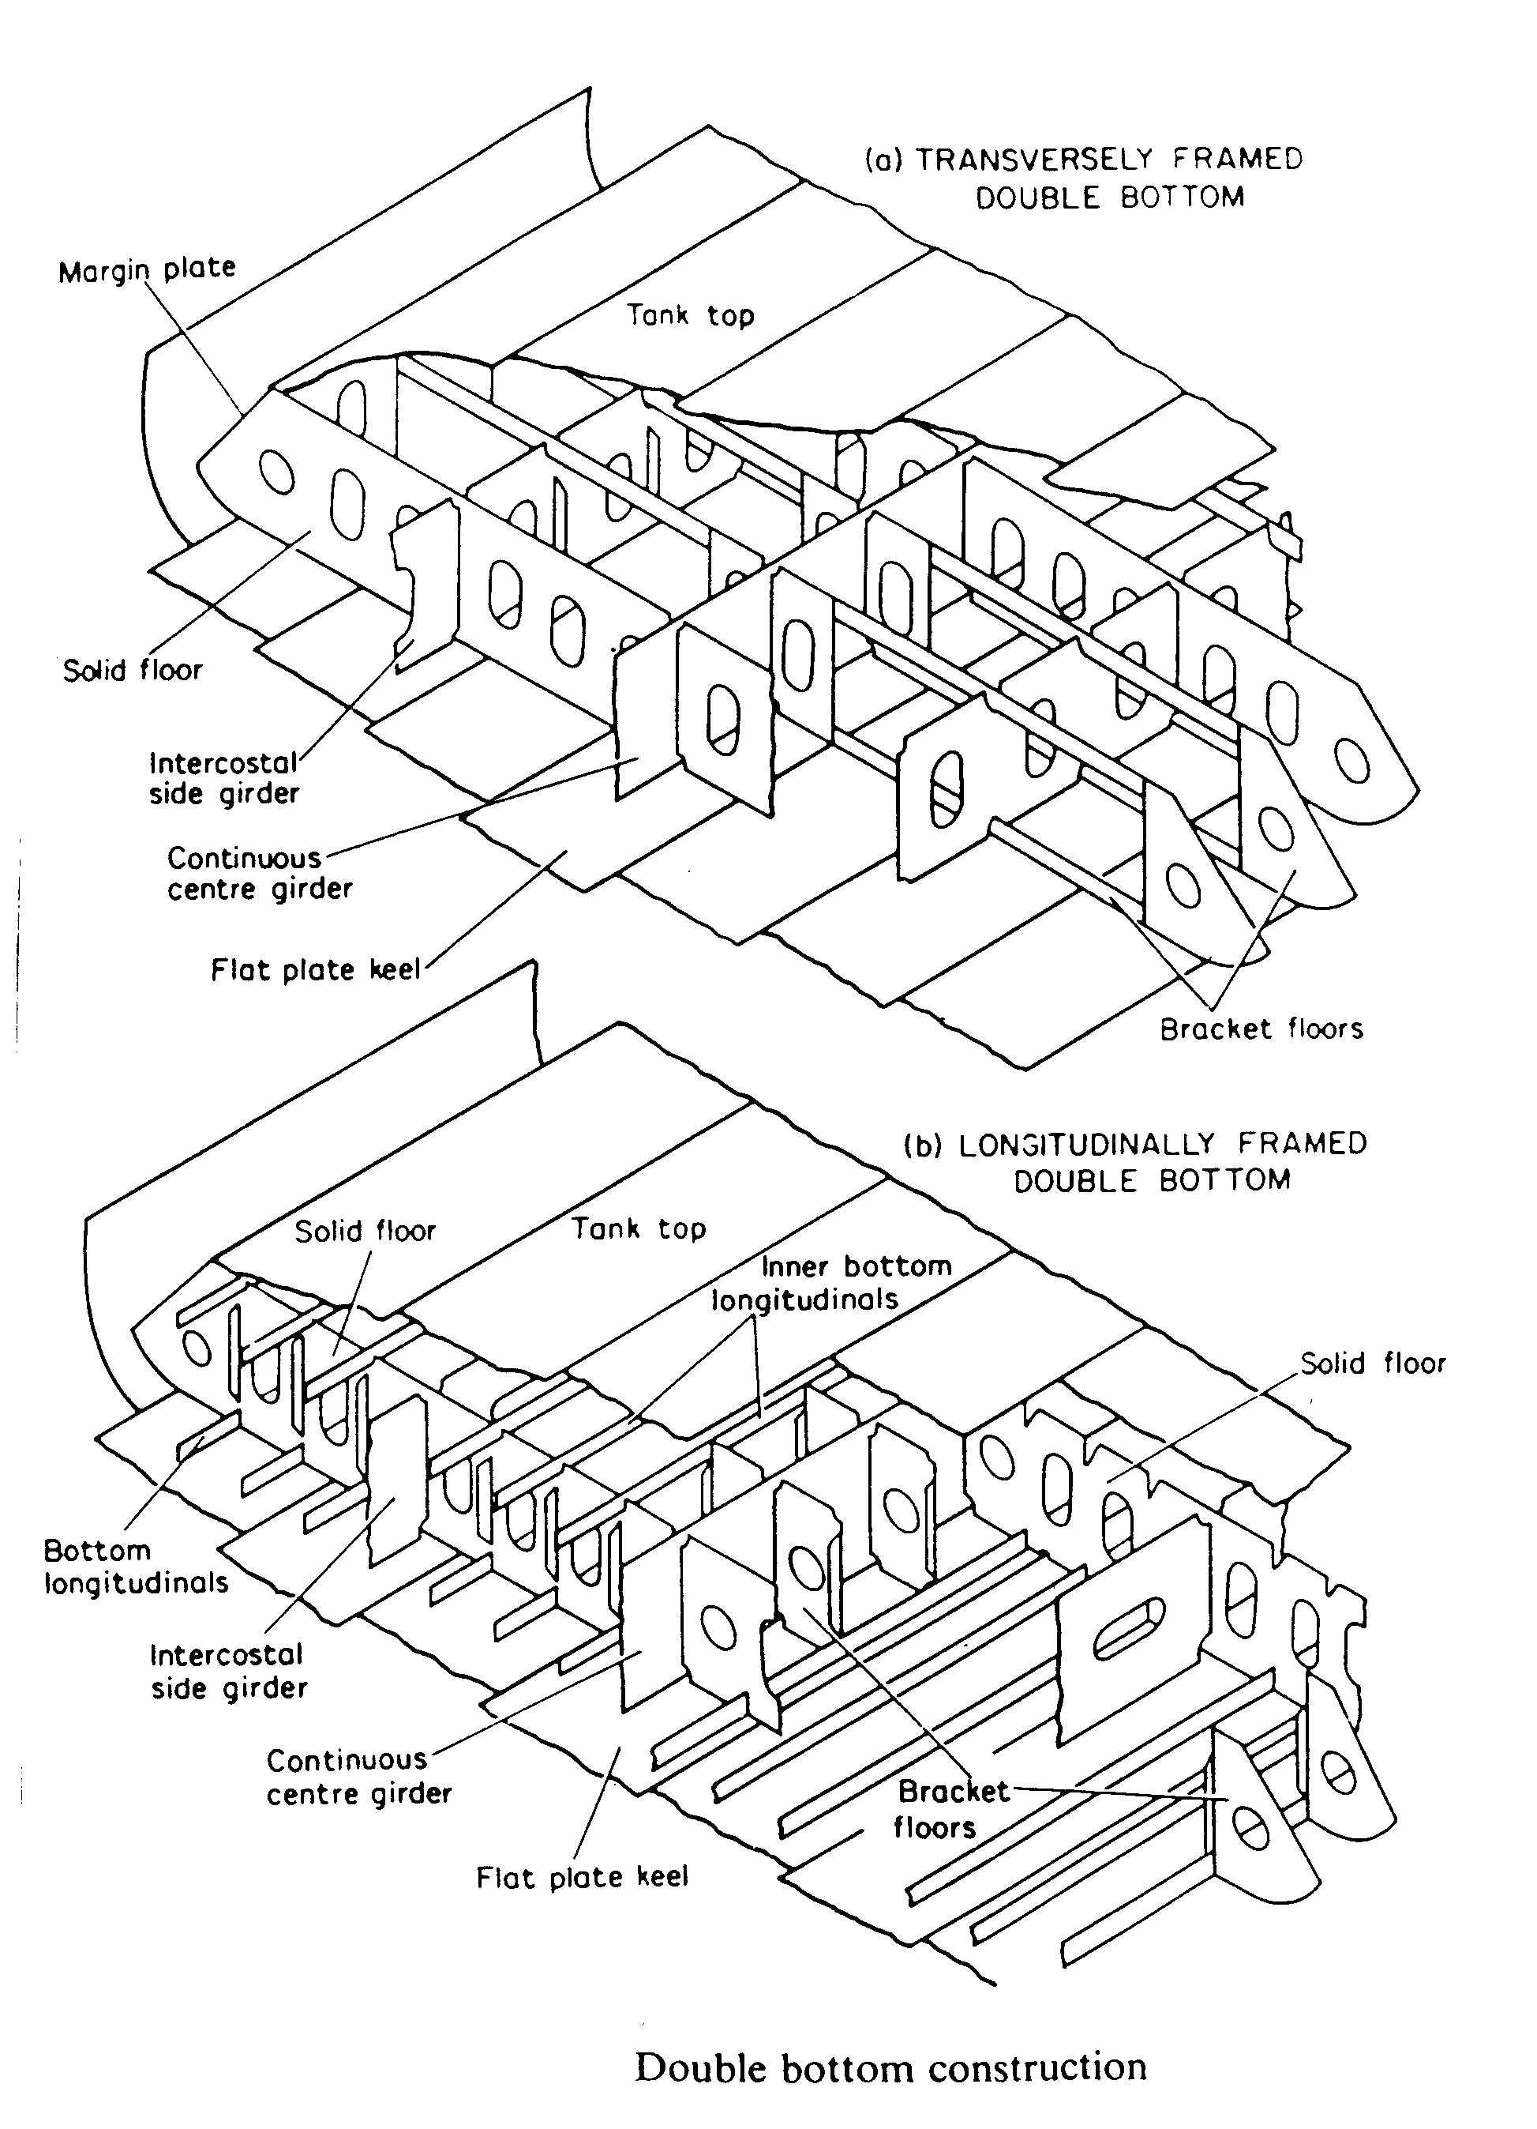

---The End of Chapter---

