TOPIC:
5. SHIP LOADS and STRESSES

Learning Objectives :
At the end of the lesson the student should be able to do the following:
Appreciate how a ship is stressed in various loading conditions and when moving in a seaway.

5.1 Distinguish between static and dynamic ship loads.

5.2 Briefly explain how a ship hull is loaded like a beam (hull girder loading).

5.3 With respect to hull girder loading and with the aid of sketches, briefly explain the derivation of the buoyancy curve, the weight curve, the load curve, the shear force curve, & the bending moment curve.

5.4 With the aid of diagrams, explain the effects of slamming, panting, and racking; and explain briefly, with the aid of sketches, how a ship should be designed to counter the above-mentioned effects.

5.5 Name the structural components, which are significant contributors to the hull girder strength. significant contributors to the hull girder strength. significant contributors to the hull girder strength.

Introduction
The ship at sea or lying in still water is constantly being subjected to a wide variety of stresses and strains, which result from the action of forces from outside and within the ship. The ship must at all times be able to resist and withstand these stresses and strains throughout its structure. It must therefore be constructed in a manner, and of such materials, that will provide the necessary strength. The ship must also be able to function efficiently as a cargo-carrying vessel. For simplicity, forces will be considered individually and the particular measures adopted to counter each type of force will be outlined.

The forces may initially be classified as
- static and
- dynamic.
These static and dynamic forces create longitudinal, transverse and local stresses in the ship's structure. Longitudinal stresses are greatest in magnitude and result in bending of the ship along its length.

Static force
They are due to
- internal forces result from structural weight, cargo and machinery weight, and
- external static forces include the hydrostatic pressure of the water on the hull.

Consider a ship floating in calm water. Two different forces will be acting upon it along its length. The weight of the ship and its contents will be acting vertically downwards. The buoyancy or vertical component of hydrostatic pressure will be acting upwards. In total, the two forces exactly equal and balance one another such that the ship floats at a particular draught. The centre of the buoyancy force and the centre of the weight will be vertically in line.

A transverse section of a ship is subjected to static pressure from the surrounding water in addition to the loading resulting from the weight of the structure, cargo, etc. Although transverse stresses are of lesser magnitude than longitudinal stresses, considerable distortion of the structure could occur, in the absence of adequate stiffening.

The structures which resist transverse stresses are transverse bulkheads, solid floors in the double bottom, deck beams, side frames and the brackets between them and adjacent structure such as tank top flooring or margin plates.

Dynamic forces
They result from
- the ship's motion in the sea,
- the action of the wind and waves, and
- the effects of operating machinery.

A ship is free to move with six degrees of freedom, three linear and three rotational. The various forces acting on a ship are constantly varying in degree and frequency. Consider a ship moving among waves. Distribution of buoyancy will vary as a result of the waves. The movement of the ship will also introduce dynamic forces. The ship's structure will be subjected to constantly fluctuating stresses as waves move along the ship's length.
The hull girder bending in waves takes place continuously throughout the seagoing lifetime of any ship. It has been estimated that in a 20-year ship lifetime, a typical ship undergoes on the order of 100 million such bending reversals.

Buoyancy Curve
Consider the curve of buoyancy, which represents the upward force at various points along the length of the ship. The forces increase from zero at the ends of the ship's waterline to a constant value over the parallel middle body section.

Weight Curve
The total weight of the ship consist mainly of the steel structure, items of machinery and cargo. The actual weight at various points along the length of the ship is unevenly distributed and is represented by a weight curve. The weight curve actually starts and finishes at the extremes of the ship's structure.

Load Curve
However, at various points along the ship's length there may be an excess of buoyancy or an excess of weight. The difference between weight and buoyancy equals resultant load. This loading of the ship's structure results in vertical forces, which act up or down and create shear force.

Shear Force Curve
The shear force at any point is the vertical force acting. It can also be considered as the total load acting on either side of the point or section considered. The actual shearing force at any section is, in effect, the area of the load diagram to the point considered.

Bending Moment Curve
The loading of the ship's structure will also tend to bend it. The bending moment at any point is the sum of the various moments to one side or the other. At any section, the moment is represented by the area of the shear force diagram to the point considered. Maximum bending moment occurs when the shear force is zero.

Hogging
If the wave crest is considered at mid-ships then the buoyancy in this region will be increased. With the wave trough positioned at the ends of the ship, the buoyancy here will be reduced. This loading condition will result in a significantly increased bending moment, which will cause the ship to hog. This will be an extreme condition giving the maximum bending moment that can occur in the ship's structure.

Also consider a ship loaded with the weights concentrated at the bow and the stem, which tends to droop. This leads to the hogging of ship hull. When a ship is hogged, the decks will be subjected to tensile stresses and the bottom plating will be under compressive stresses. Somewhere in between these two forces lies a line where neither force is felt. This line is known as the neutral axis.

Sagging
In a heavy seaway, a ship may be supported at the ends by the crests of waves while the middle remains unsupported. If the wave trough is now considered at mid-ships then the buoyancy in this region will be reduced. With the wave crest positioned at the ends of the ship, the buoyancy here will be increased. This loading condition will result in a bending moment which will came the ship to sag.

Consider heavy weights concentrated at mid-ships of a ship. The middle hull part tends to droop more than the ends. This causes sagging of ship hull. When a ship is sagged, the keel and bottom plating will be under tension while the deck will be under compression. Somewhere in between these two forces, not necessarily at the exact middle, is the neutral axis.

Racking
When a ship rolls in a seaway, it results in forces in the structure to tending distort it transversely and may cause deformation at the corners. The deck tends to move laterally relative to the bottom structure, and the shell on one side to move vertically relative to the other side. This type of deformation is referred to as 'racking'. Transverse bulkheads primarily resist such transverse deformation, the side frames contribution being insignificant, provided the transverse bulkheads are at their usual regular spacing.

Its greatest effect is felt when the ship is in the light or ballast condition. The brackets and beam knees joining horizontal and vertical items of structure are used to resist this distortion.

Torsion
When any body is subject to a twisting moment, which is commonly referred to as torque, that body is said to be in 'torsion'. A ship heading obliquely (45 degrees) to a wave will be subjected to righting moments of opposite direction at its ends twisting the hull and putting it in 'torsion'. In most ships, torsional moments and stresses are negligible but in ships with extremely wide and long deck openings they are significant. A particular example is the larger container ship where at the topsides a heavy torsion box girder structure including the upper deck is provided to accommodate the torsional stresses.

Stresses due to water pressure
Water pressure increases with depth and tends to set in the ship's plating below the water line. The depth and spacing of the frames and floors together with the thickness of the shell plating must be determined so that each panel of plating is strong enough to withstand water pressure. In some ships, pillars are fitted to tie the floors to the deck beams so as to transmit the up-thrust on the bottom plating to other components of the ship. The pillars also help to support the deck.

A transverse section of a ship is subjected to static pressure from the surrounding water in addition to the loading resulting from the weight of the structure, cargo, etc. Although transverse stresses are of lesser magnitude than longitudinal stresses, considerable distortion of the structure could occur, in the absence of adequate stiffening.

The parts of the structure which resist transverse stresses are transverse bulkheads, floors in the double bottom (where fitted), deck beams, side frames and the brackets between them and adjacent structure such as tank top flooring or margin plates

Stresses due to dry-docking
Dry-docking tends to set the keel upwards because of the up-thrust of the keel blocks. There is a tendency for the ship's sides to bulge outwards and for the bilges to sag.

Stresses due to localized loading
The movement of a ship in a seaway results in forces being generated which are largely of a local nature. These forces are, however, liable to cause the structure to vibrate and thus transmit stresses to other parts of the structure. Heavy weights, such as equipment in the machinery spaces or particular items of general cargo, can give rise to stresses due to localized distortion of the transverse section.

The fitting of transverse bulkheads, deep plate floors and web frames reduce such stresses.

Stresses due to Discontinuity
A stress concentration is a localised area in a structure at which the stress is significantly higher than in the surrounding material. It can be conveniently be conceived as a disturbance or a discontinuity in the smooth flow of the lines of stress. Two types of discontinuity in ships are:
- Built into ship unintentionally by the methods of construction, e.g. rolling, welding, casting.
- Introduced into structural design deliberately for reasons of architecture, use, access, e.g. superstructures, deckhouses, hatch openings, door openings.

If the ends of superstructures are ended abruptly, there is a major discontinuity of the ship's structure, which may give rise to localized stresses resulting in cracking of the plating. Holes cut in the deck plating create areas of high local stress due to the discontinuity created by the opening. The high stresses at the corner of a hatch may result in cracking.

Stress concentration cannot be totally avoided. However, their effects can be minimised by attention to good design and high standards of workmanship. There are several methods employed to maintain continuity of strength, in way of hull openings:
- The corners of openings are to be rounded.
- Rounding off of the hatch corners or the deck plating at the corner of the hatch and extending it into the hatch square.
- Thicker insert plates or doubling plates to be fitted at the corners of all openings.
- Large openings are usually framed-in by a face bar.
- Placing web frames on either side of the opening and fitting insert plates above and below it, or right around it.

Vibrations
Reciprocating machinery and rotating propellers can result in cyclic stresses. This could result in fatigue failure of local items of structure leading to a collapse. Proper attention can reduce the effects of vibration to an acceptable level:- balancing of machinery and adequate propeller tip clearances.

Slamming or pounding
In heavy weather, when the ship is heaving and pitching, the forward end leaves and re-enters the water with a slamming effect. When flat areas of plating, usually forward, are brought into violet contact with the water at a very acute angle, there is a loud bang and the ship shudders. The momentum of the ship receives a check and energy is imparted to the ship girder to make it vibrate.

This slamming down of the forward region on to the water is also known as pounding. Additional stiffening must be fitted in the pounding region to reduce the possibility of damage to the structure.

Panting
The movement of waves along a ship causes fluctuations in water pressure on the plating. This tends to create an in-and-out movement of the shell plating, known as panting. The effect is particularly evident at the bows as the ship pushes its way through the water.

The pitching motion of the ship produces additional variations in water pressure, particularly at the bow and stem, which also cause panting of the plating. Additional stiffening is provided in the form of panting beams and stringers.

Vertical shear and longitudinal bending in still water

Wave bending moments
Static loading of a ship’s structure

Dynamic loading of a ship’s structure:
(left) still water, (centre) sagging, and (right) hogging

Static water pressure loading of a ship’s structure

Racking

Localised loads tends to distort the ship's structure

Countering Stresses due to Discontinuity
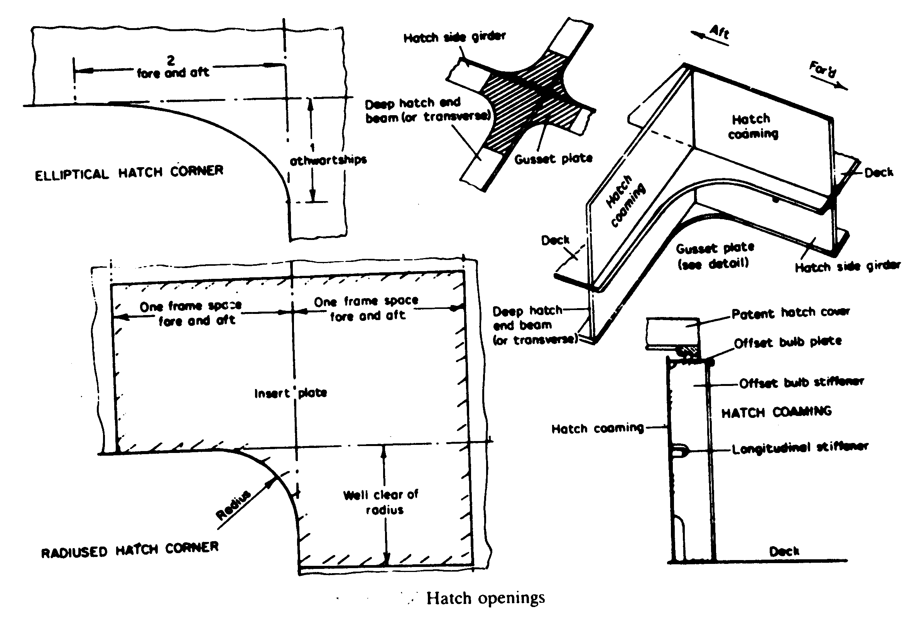

Hatch corners rounding off to maintain continuity of strength

Hatch corners rounding off to maintain continuity of strength

Countering Stresses due to Discontinuity

Pounding
Torsion

---The End of Chapter---

