Fillet Welds
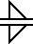
The fillet weld (pronounced "FILL-it," not "fil-LAY") is used to make lap joints, corner joints, and T joints. As its symbol suggests, the fillet weld is roughly triangular in cross-section, although its shape is not always a right triangle or an isosceles triangle. Weld metal is deposited in a corner formed by the fit-up of the two members and penetrates and fuses with the base metal to form the joint. (Note: for the sake of graphical clarity, the drawings below do not show the penetration of the weld metal. Recognize, however, that the degree of penetration is important in determining the quality of the weld.)
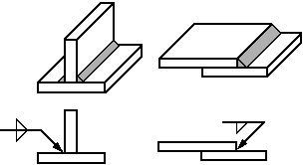
The perpendicular leg of the triangle is always drawn on the left side of the symbol, regardless of the orientation of the weld itself. The leg size is written to the left of the weld symbol. If the two legs of the weld are to be the same size, only one dimension is given; if the weld is to have unequal legs (much less common than the equal-legged weld), both dimensions are given and there is an indication on the drawing as to which leg is longer.
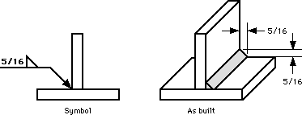
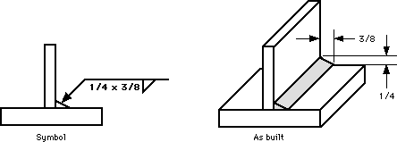
The length of the weld is given to the right of the symbol.
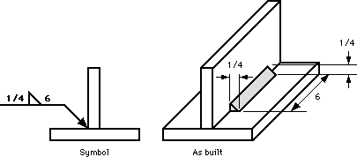
If no length is given, then the weld is to be placed between specified dimension lines (if given) or between those points where an abrupt change in the weld direction would occur (like at the end of the plates in the example above).
For intermittent welds, the length of each portion of the weld and the spacing of the welds are separated by a dash (length first, spacing second) and placed to the right of the fillet weld symbol.
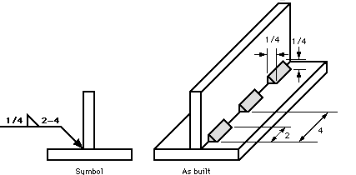
Notice that the spacing, or pitch, is not the clear space between the welds, but the center-to-center (or end-to-end) distance.

