TOPIC: DECK CONSTRUCTION

Learning Objectives :
At the end of the lesson the student should be able to do the following:

11. Understand the construction of the strength deck.

11.1 With the aid of a sketch, explain the reasons for the variation of the thickness of the strength deck.
11.2 Briefly explain the purpose of a deck expansion plan.

11.3 With the aid of a sketch, explain the construction of the deck in way of a hatchway with respect to stresses.

DECK
A deck is generally a horizontal plated structure supported by transverse or longitudinal beams (depending on the framing system adopted), deck girders, webs, bulkheads and ship sides.

Its function is dependent on the location. There are many different types of decks such as weather deck, tween deck, strength deck, platform deck, enclosed deck, accommodation deck, etc.

Weather deck
The weather deck is the deck of the vessel exposed to the weather. It is normally the highest deck, which is exposed to the weather. On a single deck vessel with a forecastle and poop, the main deck, the forecastle deck and poop deck are the weather decks. Weather deck protects the space below the weather and all the openings are normally watertight.

It is also normal to find a camber incorporated on the weather deck to provide for better drainage of water collected on the weather deck.

Tween deck
In dry cargo ships there may be more than one deck in the cargo holds. These decks are known as tween decks. The purpose of tween decks are to allow for better storage of general cargoes (or refrigerated cargo in a refrigerated ship) and to prevent the cargoes at the bottom from being crushed.

Strength deck
A strength deck is a deck, which is included in the longitudinal strength calculation. Hence for a dry cargo ship with many tween decks, and if these decks are included in the longitudinal strength calculation, then they are also called the strength decks.

Platform deck
Platform decks are decks not included in the longitudinal strength calculations. These decks are normally very short and are found in the engine rooms for housing auxiliary engines, pumps, compressors, boilers etc. Sometimes platform decks are also found in dry cargo holds.

Perforated deck
Perforated deck (or perforated flat) is a deck found in liquid tanks such as the deep tank, the aft peak and the fore peak tanks. The deck has holes cut over the entire surface so that liquid can flow through the deck. The size of each hole is about the size of the manhole.

Accommodation deck
Accommodation decks are decks located in the accommodation deck house or aft accommodation area (superstructure) of the ship.

Deck openings are found in both dry cargo spaces and liquid cargo holds. A deck opening or a hatch opening in a dry cargo hold is for the purpose of loading and discharging the cargo. These hatches are made as large as possible to facilitate the loading and discharging operation. In way of the hatch corners thicker insert plates are normally fitted to reduce stress and prevent cracks from developing.

The strengthening of the hatch opening is provided by a combination of longitudinal members (e.g. hatch side girder under deck and hatch coaming above deck) and transverse members (e.g. hatch end beams under: deck and hatch end coaming above deck). The hatch corners are rounded elliptically to reduce stress concentrations.

The height of the hatch coaming is specified by statutory requirements and to be at least 600mm when located at position 1 (normally the main weather deck and the forecastle deck) and at least 450mm when located at position 2 (normally the poop deck and the bridge deck level).

The hatch opening for a tanker is normally made big enough only for the purpose of man entry. The diameter of the hatch does not normally exceed 1000mm and the coaming height also complies with the statutory requirements for dry cargo ships.

Deck framings
Decks may be framed transversely or longitudinally but when the ship’s length exceed 120 m it is preferred that longitudinal framing should be adopted for the strength deck.

When the decks are longitudinally framed, the longitudinals are supported by deck transverses e.g. the hatch end beams.

Transversely framed decks are fitted with deck beams at every frame. Deck beams are supported by longitudinal girders e.g. the hatch side girder. Each beam is connected to the side frame by a "beam knee' and in the line of the hatches "half beams" are fitted with a suitable supporting connection at the hatch side girder.

In way of the fore and aft, hatch side girders are fitted to support the inboard ends of the half beams and transverses. At the ends of the hatches, heavy transverse beams are fitted and these may be connected at the intersection with the hatch side girder by horizontal gusset plates. As a girder the coaming must extend one frame space beyond the hatch opening above the deck, but where this is not possible it may extend two or more frame spaces beyond the hatch end beams below the deck.

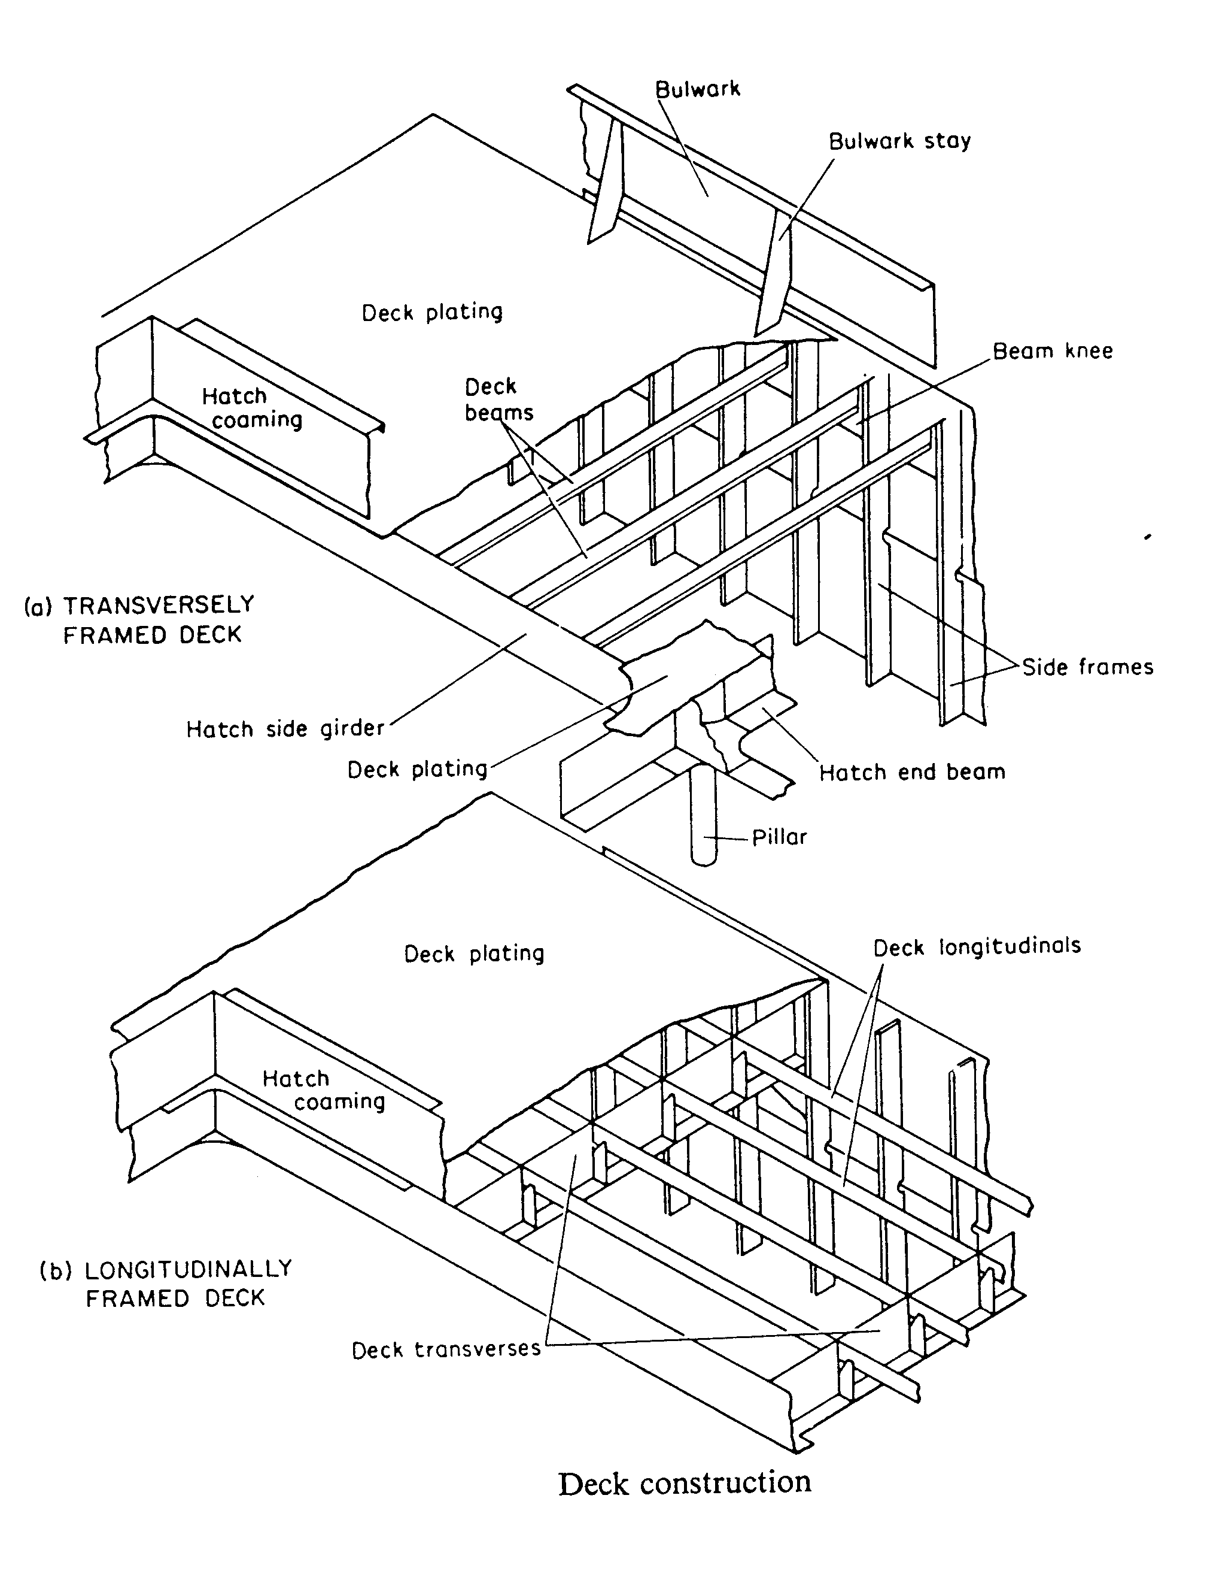

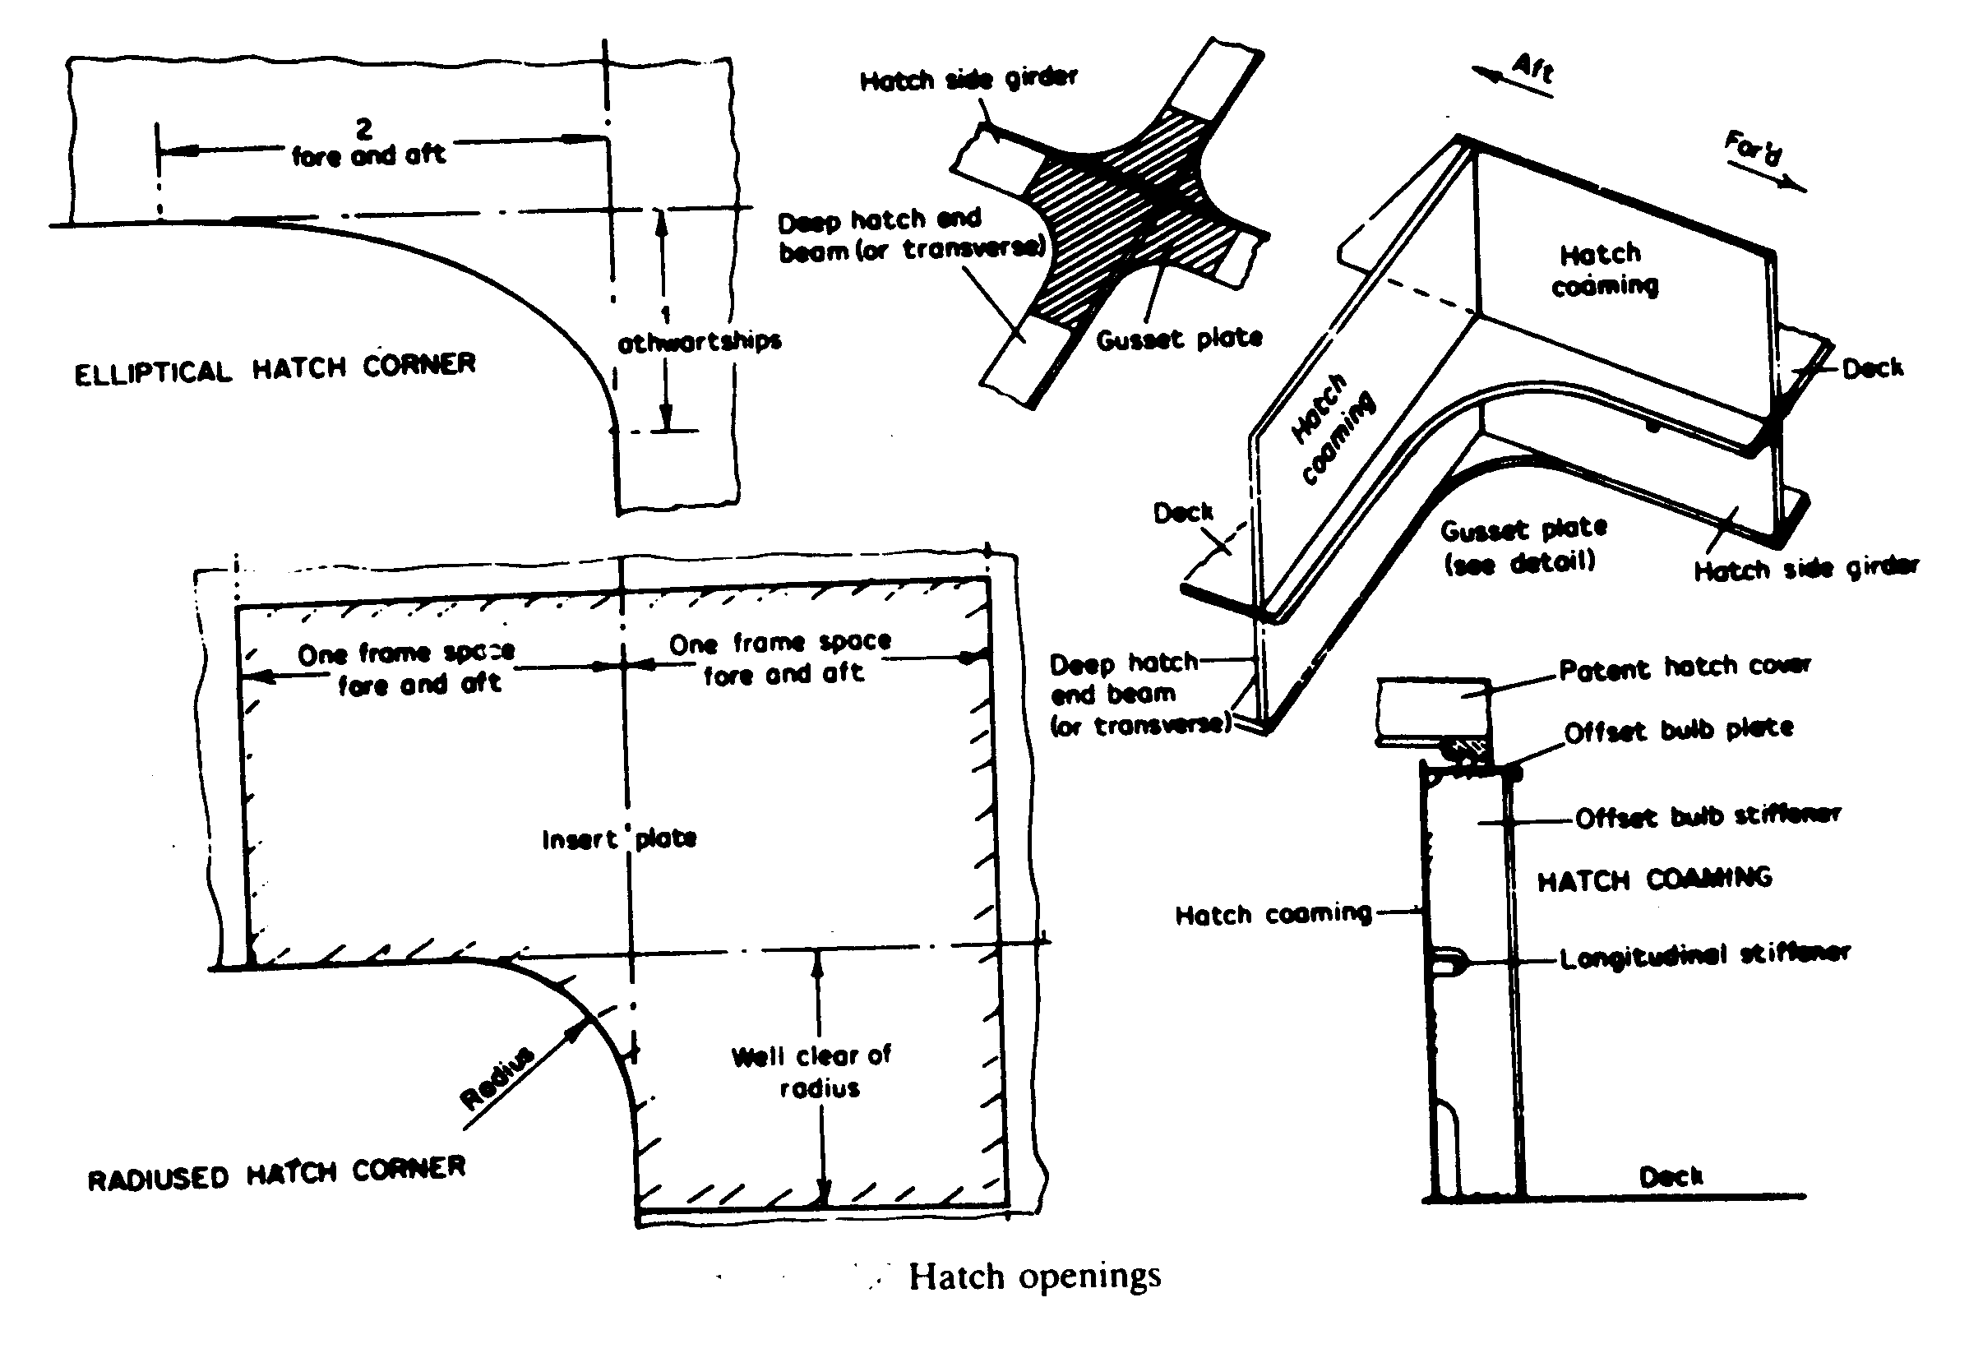

---The End of Chapter---

