TOPIC: HULL FRAMING SYSTEMS

Learning Objectives :

At the end of the lesson the student should be able to do the following:

7. Understand the use of the various principal hull framing systems.
7.1 Sketch the mid-ship hull section and label the essential structural members that make up the framing system of a ship with a
(a) transverse framing system
(b) longitudinal framing system, and
(c) combination framing system.

7.2 Compare the merits and the demerits of the transverse and longitudinal framing systems.

7.3 List the advantages of the combination framing system.
FRAMING

The shell (bottom and side) and deck plating of a ship has to be stiffened internally to prevent it from collapsing. The stiffening generally is provided by primary supporting and secondary supporting members.

Primary supporting members are the big members or metaphorically speaking the big bones such as web frames, girders, solid (i.e. plate) floors, etc.

Secondary supporting members are the small bones of the ship such as longitudinals hold frames, deck beams etc.

The word ‘scantlings’ denotes the cross-sectional dimensions of structural members, as distinct from their lengths. Thus an angle bar whose scantlings are 200 x 150 x 12.5 mm has one 200 mm leg and one 150 mm leg and is 12.5 mm thick, regardless of its length. Steel plate scantlings normally refer only to the plate thickness regardless of its length or width.

PRIMARY SUPPORTING MEMBERS
They consist of
- transverse rings and
- longitudinal girders.

Transverse rings
They are fitted along the length of the ship at intervals of about 3 to 4 meters apart, and can be divided into three parts:

- Bottom tranverse
- Web frame
- Deck transverse

Bottom transverse

The first part at the bottom is known as the bottom transverse and is represented by a solid floor in ships with double bottom construction. The height of the bottom transverse is similar to that of a centreline girder.

Web frame

The second part on the side is known as the web frame. The depth of the side web frame is about 0.125 times the vertical distance from the tank top to the deck above, e.g. if this vertical distance is 10 meters, the depth of the web will be 1250mm.

Web frames are fitted at about every five frame spaces.

Deck transverse
The third part on the deck is known as deck transverse. The depth of the deck transverse (deck web) varies dependent on the span between supporting girders or bulkheads, or between girder and side frame.

These three parts consist of a web and a face-plate (or a web) and a flange. Together, they form a stiff transverse ring, which supports the shell and deck plating as well as the other longitudinal members.

Longitudinal girders
They are fitted at the bottom, deck and on the ship-side. On the bottom and deck of a ship, centreline and side girders are fitted. On the shipside, horizontal girders known as side stringers (or stringers) are fitted. The number of side stringer depends on the depth of the ship.

SECONDARY SUPPORTING MEMBERS
They are much smaller in size as compared to the primary supporting members. Manufactured sections of bulb plates or unequal angles are normally used for those secondary supporting members. They are fitted usually at spacing of less 1000 mm apart.

There are three possible ways to fit the secondary supporting members:
- Transverse Framing System
- Longitudinal Framing System
- Combined or Mixed Framing System

Transverse Framing System
In the transverse framing system, the hold frames are fitted transversely. The bottom member is known as an open floor (for ships with double bottoms), the side member is known as the hold frame (or main frame) and the deck member is known as the deck beam. Longitudinal deck girders support the transverse deck beams.

Longitudinal strength in a transversely framed ship is provided by:
- the center girder, the shell plating and inner bottom plating,
- by the deck plating outboard of hatch and machinery casing openings, and
- by a number of large, widely spaced longitudinal members e.g. longitudinal deck girders.

Longitudinal Framing System
In this system, all the secondary supporting members are fitted the longitudinal direction and are known as longitudinals (bottom longitudinals, side longitudinals, and deck longitudinals respectively). The system consists of many small, closely spaced longitudinals supporting the plating directly and being supported in turn by a few large, widely spaced longitudinals.

This is the main system used for larger tankers where longitudinal strength is a major consideration, and adoption of any other system will result in unacceptably large hull weight. Longitudinal stiffeners spaced about 600 to 900 mm apart give direct support to the plating of the deck, sides, bottom, and bulkheads. They also contribute to the longitudinal strength of the ship, making the longitudinal framing system more structurally efficient than the transverse system.

The bottom longitudinal on centerline, or center girder, is extra large and heavy, principally to carry the loads imposed by keel-blocks during dry-docking. Very deep, heavy transverse structures called transverse webs or web frames are constructed at intervals of about 3 to 5 meters to provide transverse strength and to support the longitudinals. These heavy transverse webs consist of deck, side, and bottom transverses plus a vertical web on each longitudinal bulkhead. The side transverse and vertical web on the bulkhead are usually tied together with one to three horizontal struts or cross ties,

Where a ship's length exceeds 120m it is considered desirable to adopt longitudinal framing. Tankers greater than about 200m in length must be framed longitudinally.

Two Systems Compared

Although the transversely framed ships were structurally sound and satisfactory in service, the fact that most of their stiffeners contributed nothing to the ship's resistance to longitudinal bending. The transverse framing system was not optimal from the standpoint of structural efficiency, that is, of achieving the required strength for the least weight. The longitudinal system, in which most of the plating stiffeners are disposed in the fore and aft direction, has superior structural efficiency.

Many longitudinal stiffeners serve dual purposes: they support the shell plating against local loading caused by water pressure and cargo loads (just as transverse frames in the transverse system do), and at the same time they contribute to the ship's resistance to longitudinal bending (which transverse frames do not). Therefore, a longitudinally framed ship has superior longitudinal strength to a transversely framed ship of equal size and structural weight.

Advantages of the longitudinal framing system:
Longitudinally stiffened plating is more resistant to buckling (especially prevalent in a ship's upper deck) between longitudinal stiffeners, when the deck or bottom is subjected to compressive stresses as it bends in a seaway than it would be if stiffened transversely.

Longitudinal stiffeners supporting side shell and bulkhead plating are subjected to variable pressures from the sea or from liquid cargo. The hydrostatic pressure on each successive longitudinal and its associated plating increases with its depth below the waterline or below the surface of the liquid in the tank. Each longitudinal can be sized to withstand the maximum pressure associated with its depth in the ship, thus achieving an efficient use of the structural material. This "graduated size" configuration cannot be done effectively with transverse frames, which as a result are overly heavy at their upper ends.

Disadvantages of the longitudinal framing system:
The intrusion of deep webs into prime cargo spaces for ships carrying packaged cargo is an disadvantage. Another difficulty arises in the structural arrangements near the ends of the ship. The spacing of the longitudinals around the girth of the ship can be maintained constant so long as the girth does not change.

As the hull narrows toward bow and stem, however, the girth necessarily reduces and the longitudinals become closer together. Difficulties in construction arise when they converge so closely that some longitudinals have to be eliminated. For this reason, transverse framing is usually resorted to at the bow and stem of longitudinally framed ships.

Combined or Mixed Framing System
In this system, a combination of both transverse and longitudinal framing is adopted in the same cross section of the ship. Longitudinal framing is used in the bottom and decks, where the advantages of extra longitudinal strength and resistance to compressive plate buckling are most needed, and transverse framing is used in the sides, precluding the need for deep webs that might inhibit efficient cargo stowage.

The transverse framing members are the deep, widely spaced transverses that support the longitudinals in the decks and bottom. More closely spaced, smaller transverse side frames support the side shell plating between the deep transverses.

Combination systems are employed in many types of ships, including general dry cargo ships, containerships and RO/RO ships.
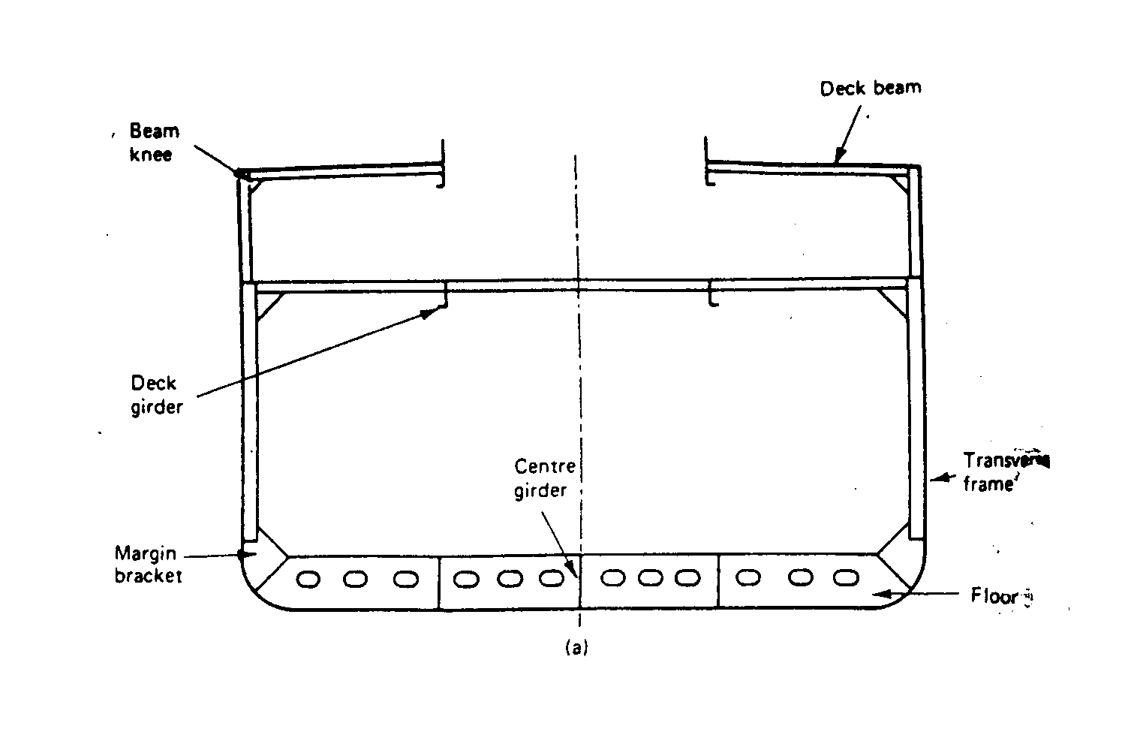
(a) Transverse Framing System

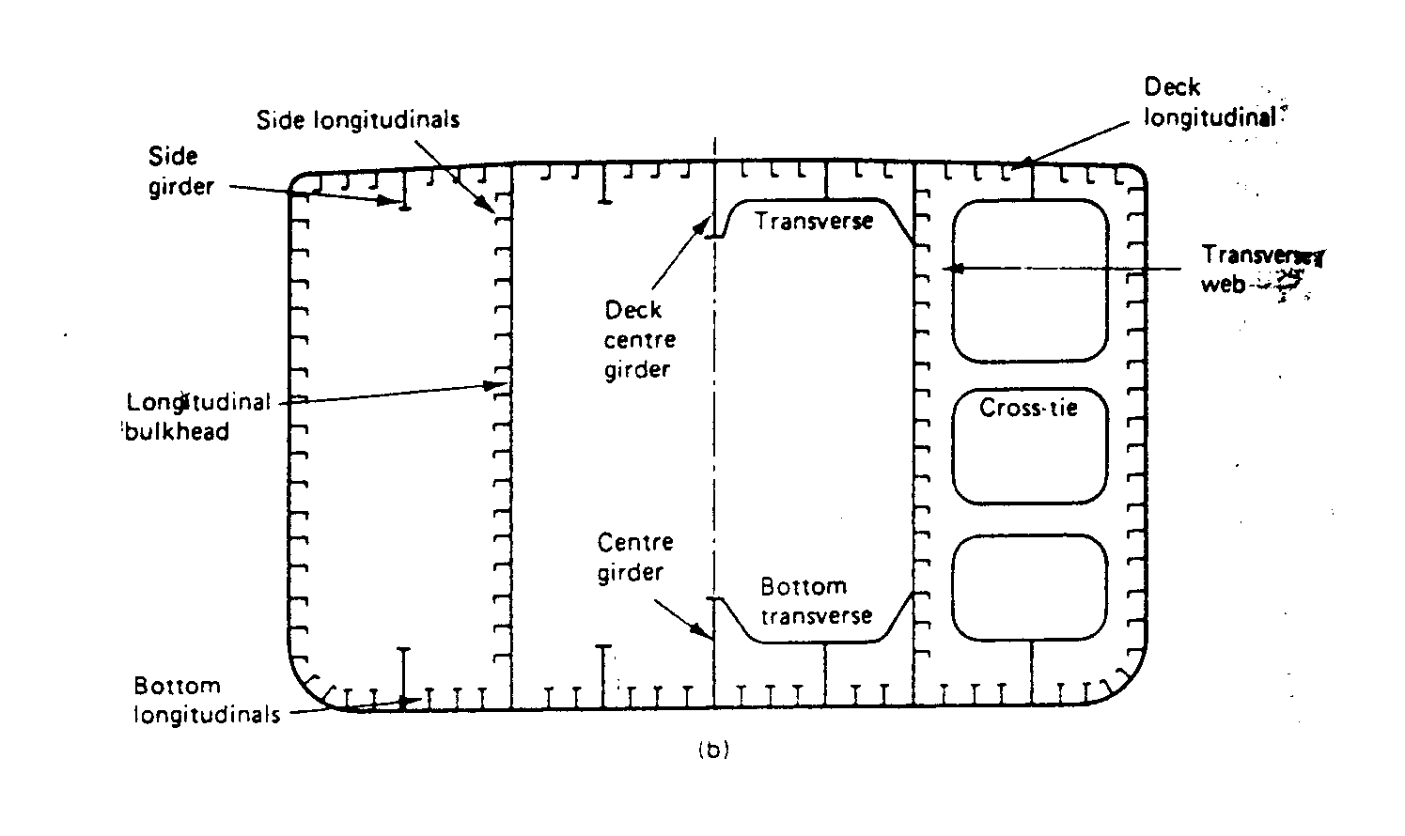
(b) Longitudinal Framing System

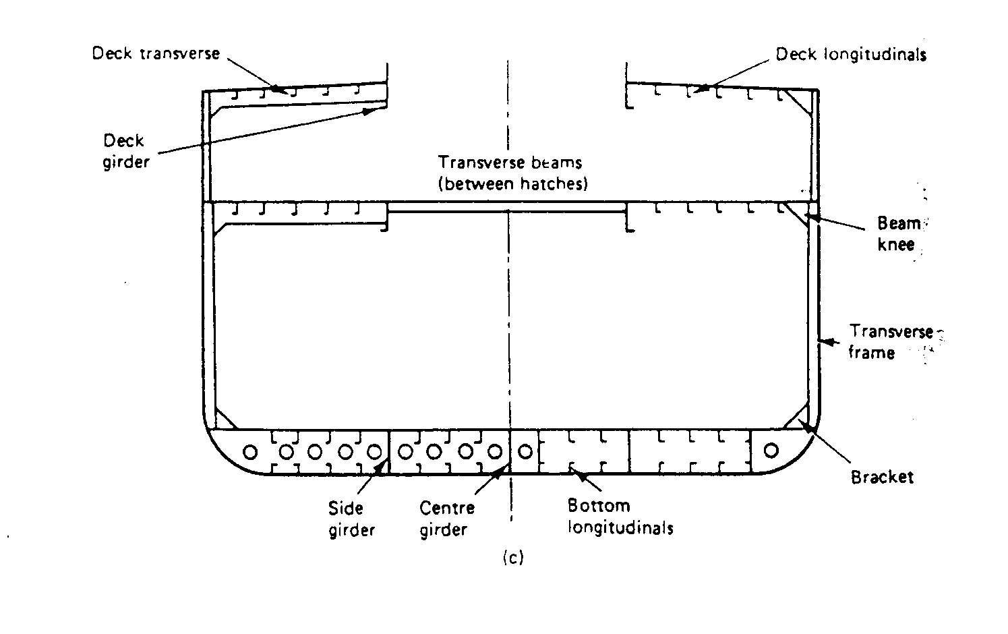
(c) Combined or Mixed Framing System

- Sloping Margin
- Flat Margin
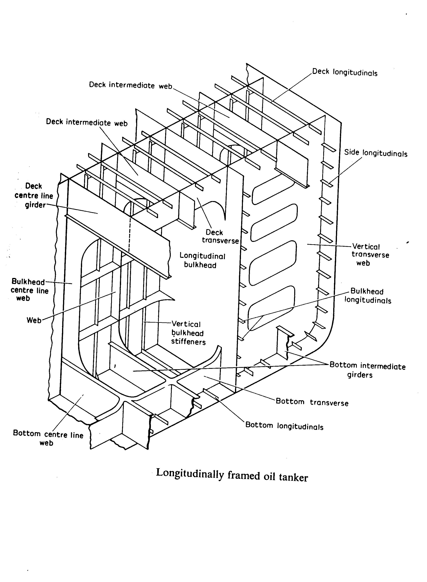
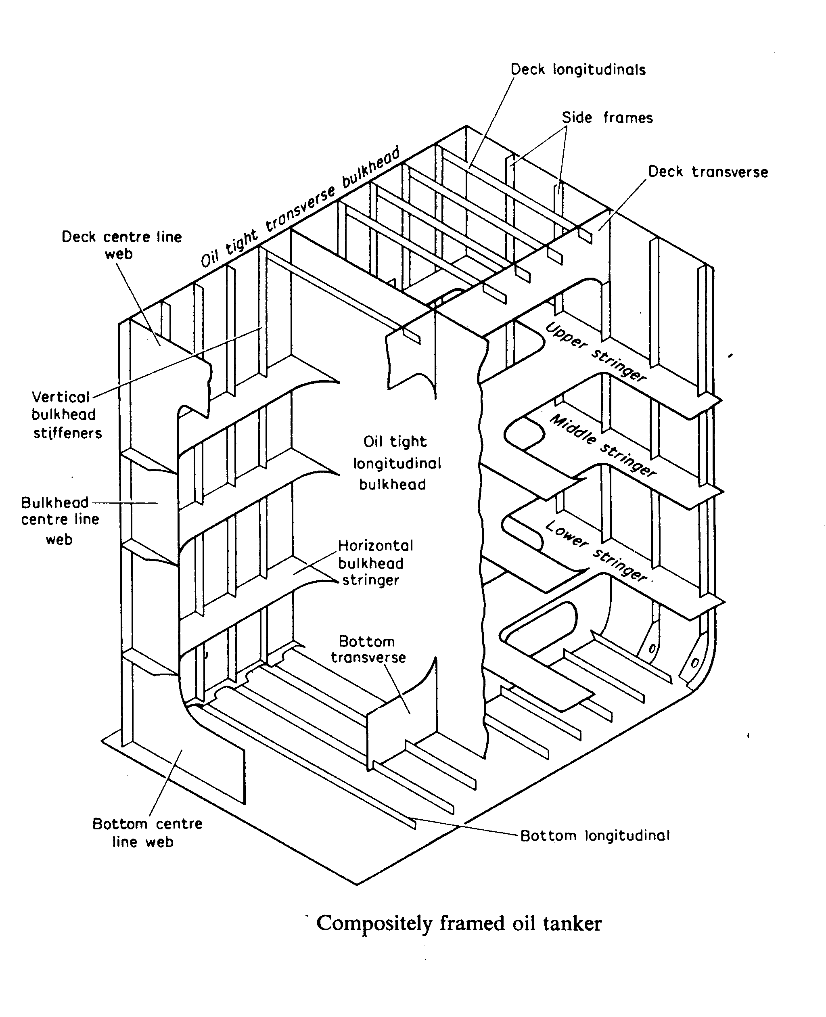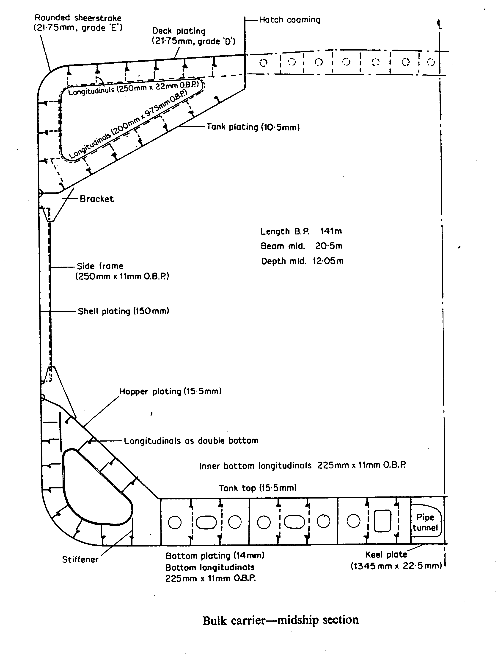

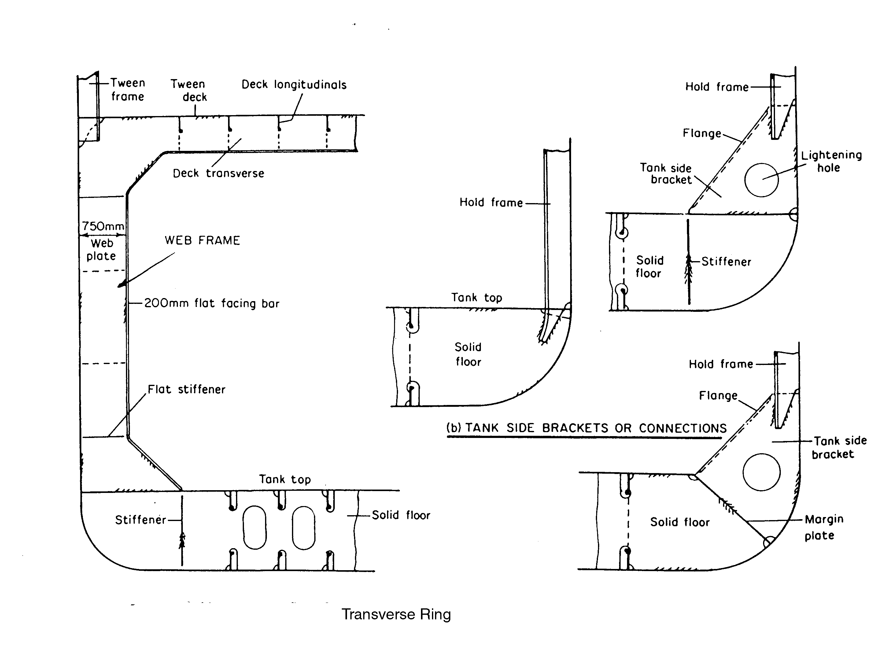
General Cargo Ship

Transverse Section through Typical Container Ship

Transverse Section through Very Large Crude Carrier

---The End of Chapter---

