TOPIC: BULKHEADS

Learning Objectives :

At the end of the lesson the student should be able to do the following:

12. Understand the functions and design of steel bulkheads.

12.1 Briefly explain the primary function and the secondary functions of
(a) transverse watertight bulkheads, and
(b) continuous longitudinal oil/watertight bulkheads.

12.2 For a watertight bulkhead that is hydrostatically loaded on one side with the water edge at its top edge, sketch
(a) load diagrams showing the vertical and the horizontal hydrostatic loads (at various heights)
(b) the vertical shear force curve, and
(c) bending moment curves at various heights.

12.3 Distinguish between vertical and horizontal framing of bulkheads with respect to function and ship type.

12.4 Sketch the side profile of and briefly describe the construction of a vertically framed bulkhead from the strength deck through two lower decks to the bottom structure showing the method of stiffening and the connection to the inner bottom structure and the hull.

12.5 List the advantages of using corrugated bulkhead construction.

12.6 Briefly describe how a watertight bulkhead is hose-tested.

Bulkheads
Bulkheads in ships are similar to internal walls dividing a building into separate rooms. Vertical partitions arranged either transversely or longitudinally in ships are known as transverse bulkheads and longitudinal bulkheads respectively-

Functions of bulkheads

1. Bulkheads divide the main hull into different compartments and in the event of a damage to the shell plating bulkheads limit the extend of flooding and hence of loss of buoyancy.

2. Bulkheads also prevent spread of fire from one compartment to another.

3. Transverse bulkhead prevents racking and torsional distortion on a ship.

4. Longitudinal bulkheads contribute to the longitudinal strength of the ship.

5. Bulkheads divide the main hull of a ship into different compartments such as the aft peak tank, engine room, cargo holds, deep tanks, cofferdam space, and the fore peak tank.

Bulkheads are either watertight or non-watertight although such terms as oil tight and gas tight bulkheads have been used.

Transverse watertight bulkheads divide the main hull into many different watertight compartments. Watertight bulkheads are attached to the shell, the deck, and the bottom or tank top by welding.

Non watertight bulkheads are any other types of bulkhead which are non water tight such as centreline wash bulkhead in the peak tanks, partial bulkheads in the accommodation spaces, stores and cargo holds.

The number of transverse bulkheads in a ship is dependent on the length of the ship. However all ships must have the following bulkheads-

- a collision or fore peak tank bulkhead

- an aft peak tank bulkhead

- a bulkhead at each end of the engine room

The number of transverse bulkheads in passenger ship is determined by flooding calculation. There are generally more transverse bulkheads fitted in passenger ships than in cargo ships due to the more stringent damage stability requirements.

The collision bulkhead is positioned such that it is not too forward to be damaged by collision. The distance of this bulkhead from the fore end of the waterline is stipulated by classification society to be 5 to 7.5% of the ship's length.

The aft peak (tank) bulkhead is intended to enclose the stern tubes in a watertight compartment preventing any emergency from leakage where the propeller shaft pierce the hull. It is located well aft so that the peak when flooded would not cause excessive trim by the stern.

Engine room bulkheads provide a self-contained compartment for engine room spaces preventing damage by flooding from an adjacent compartment/hold.

There are two types of bulkhead construction:

i) Plain bulkhead
ii) Corrugated bulkhead

Plain Bulkhead

- Plain bulkheads consist of plates stiffened by rolled sections such as bulb plates and angles spaced approximately 760mm apart.

- The thickness of the plates are generally thickest at the bottom because of the maximum hydrostatic pressure experienced there, and thinnest at the top and generally not less than 6.5 mm thick. The plates of the bulkhead are laid in a horizontal direction.

- Where the depth of the bulkhead is great, horizontal stringers or girders are fitted as well as vertical girders with face plate and tripping brackets.

Corrugated bulkheads

- A corrugated plate is stronger than a flat plate if subject to a bending moment or pillar load along the corrugations.

- Corrugations (or swedges) are formed on a corrugated bulkhead to eliminate the need to fit the vertical stiffener, as in those of the plain bulkhead.

- A corrugated plate is stronger than a flat plate without stiffening if subject to bending moment or a pillar load along the corrugations.

- The elimination of vertical stiffeners also results in saving in steel weight and cost of stiffeners.

- The angle of corrugation is normally about 45 degrees.

- The troughs are vertical on transverse bulkheads but must be horizontal on continuous longitudinal bulkheads, which form part of the longitudinal strength of the ship.

- Diaphragm plates or horizontal stringers are fitted on the bulkhead to keep the corrugation in place.

COFFERDAM

In cargo ships where various liquid cargoes are carried, cofferdams or simply void spaces between two bulkheads are fitted between tanks to arrest contamination of liquid of different density. Cofferdams are also fitted between tanks carrying fresh water and oil. Pump rooms and ballast tanks can be designed to take the place of a cofferdam. The spacing of adjourning bulkheads of a cofferdam can be 760 mm, a generally accepted space through which a person can pass through.

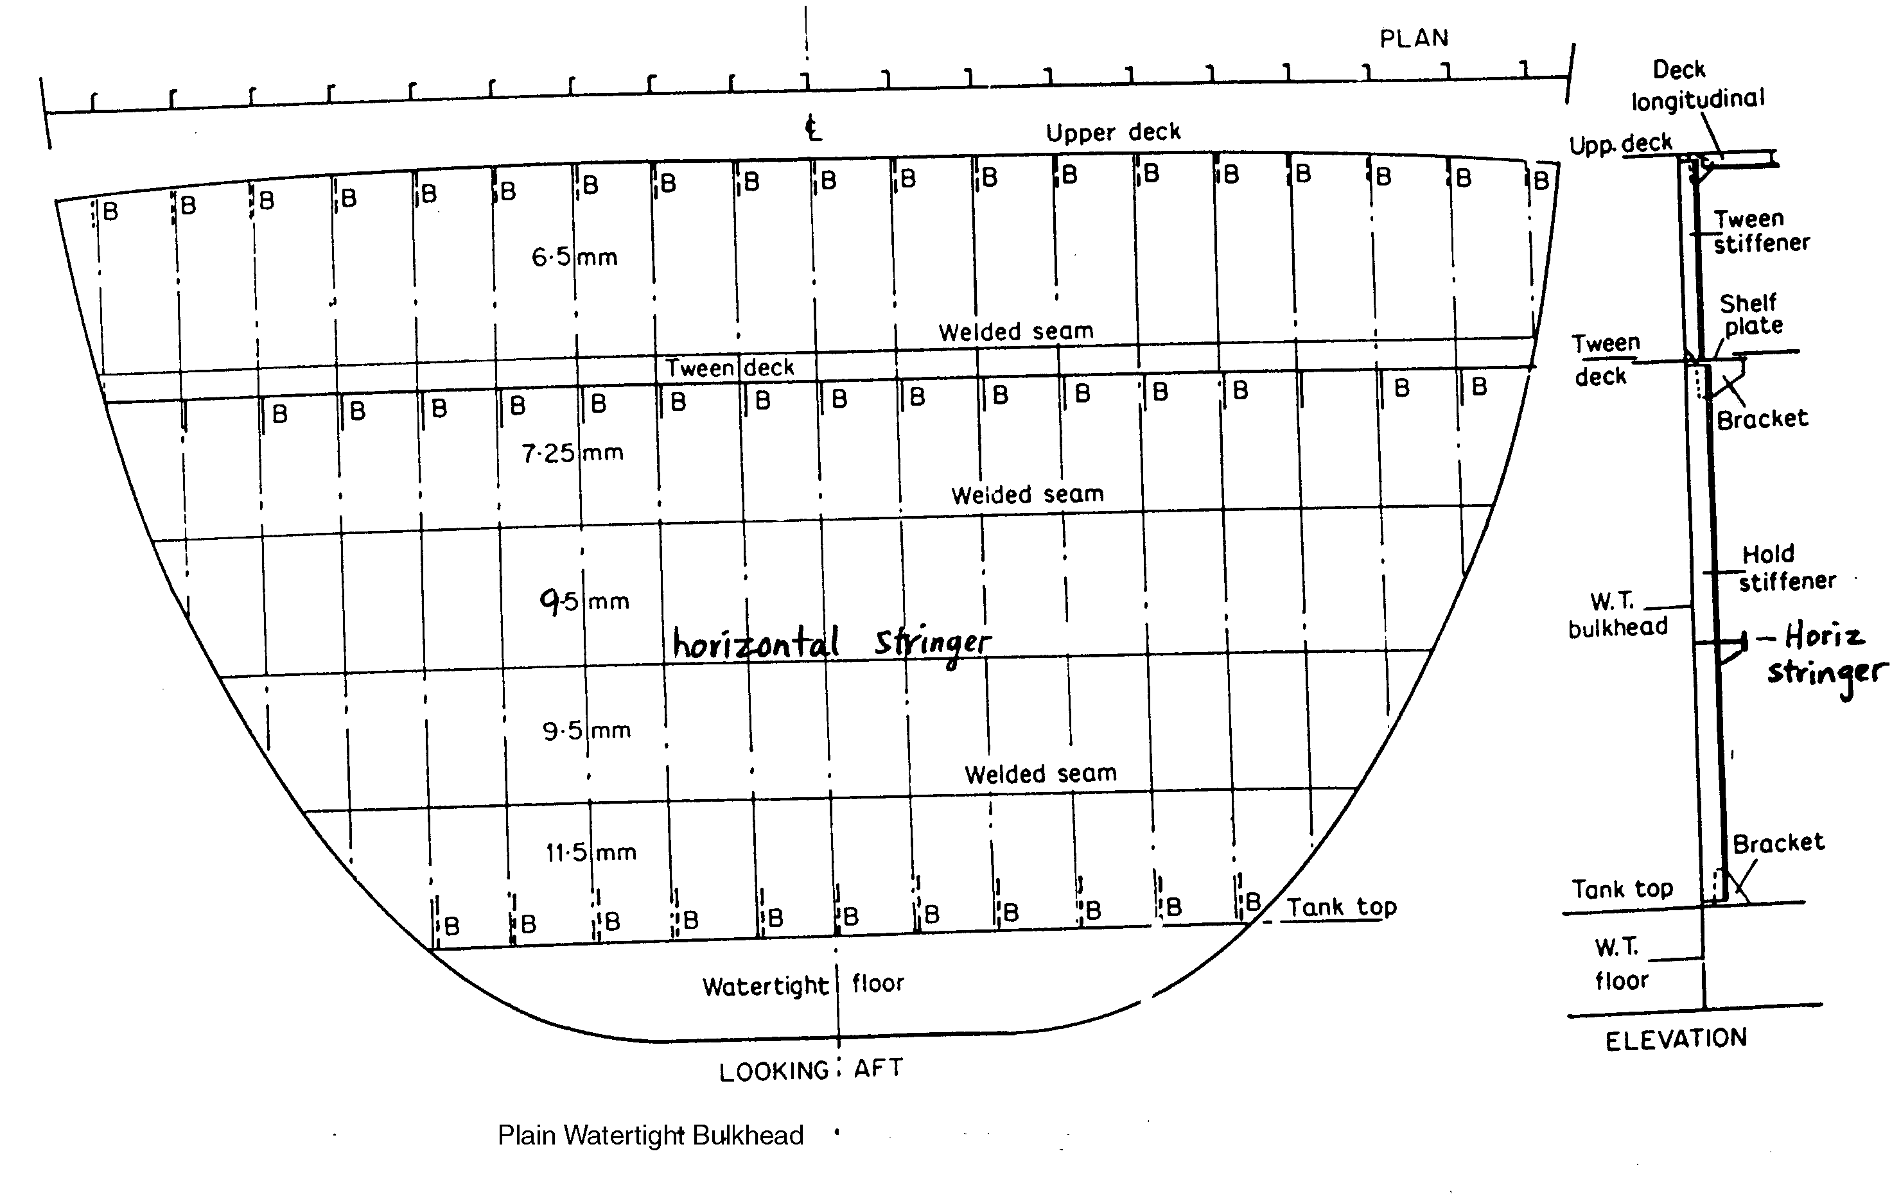

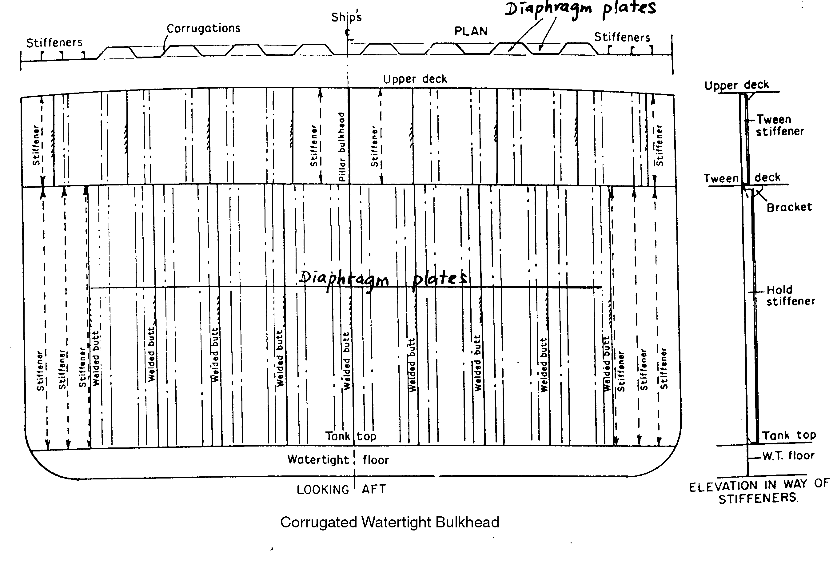

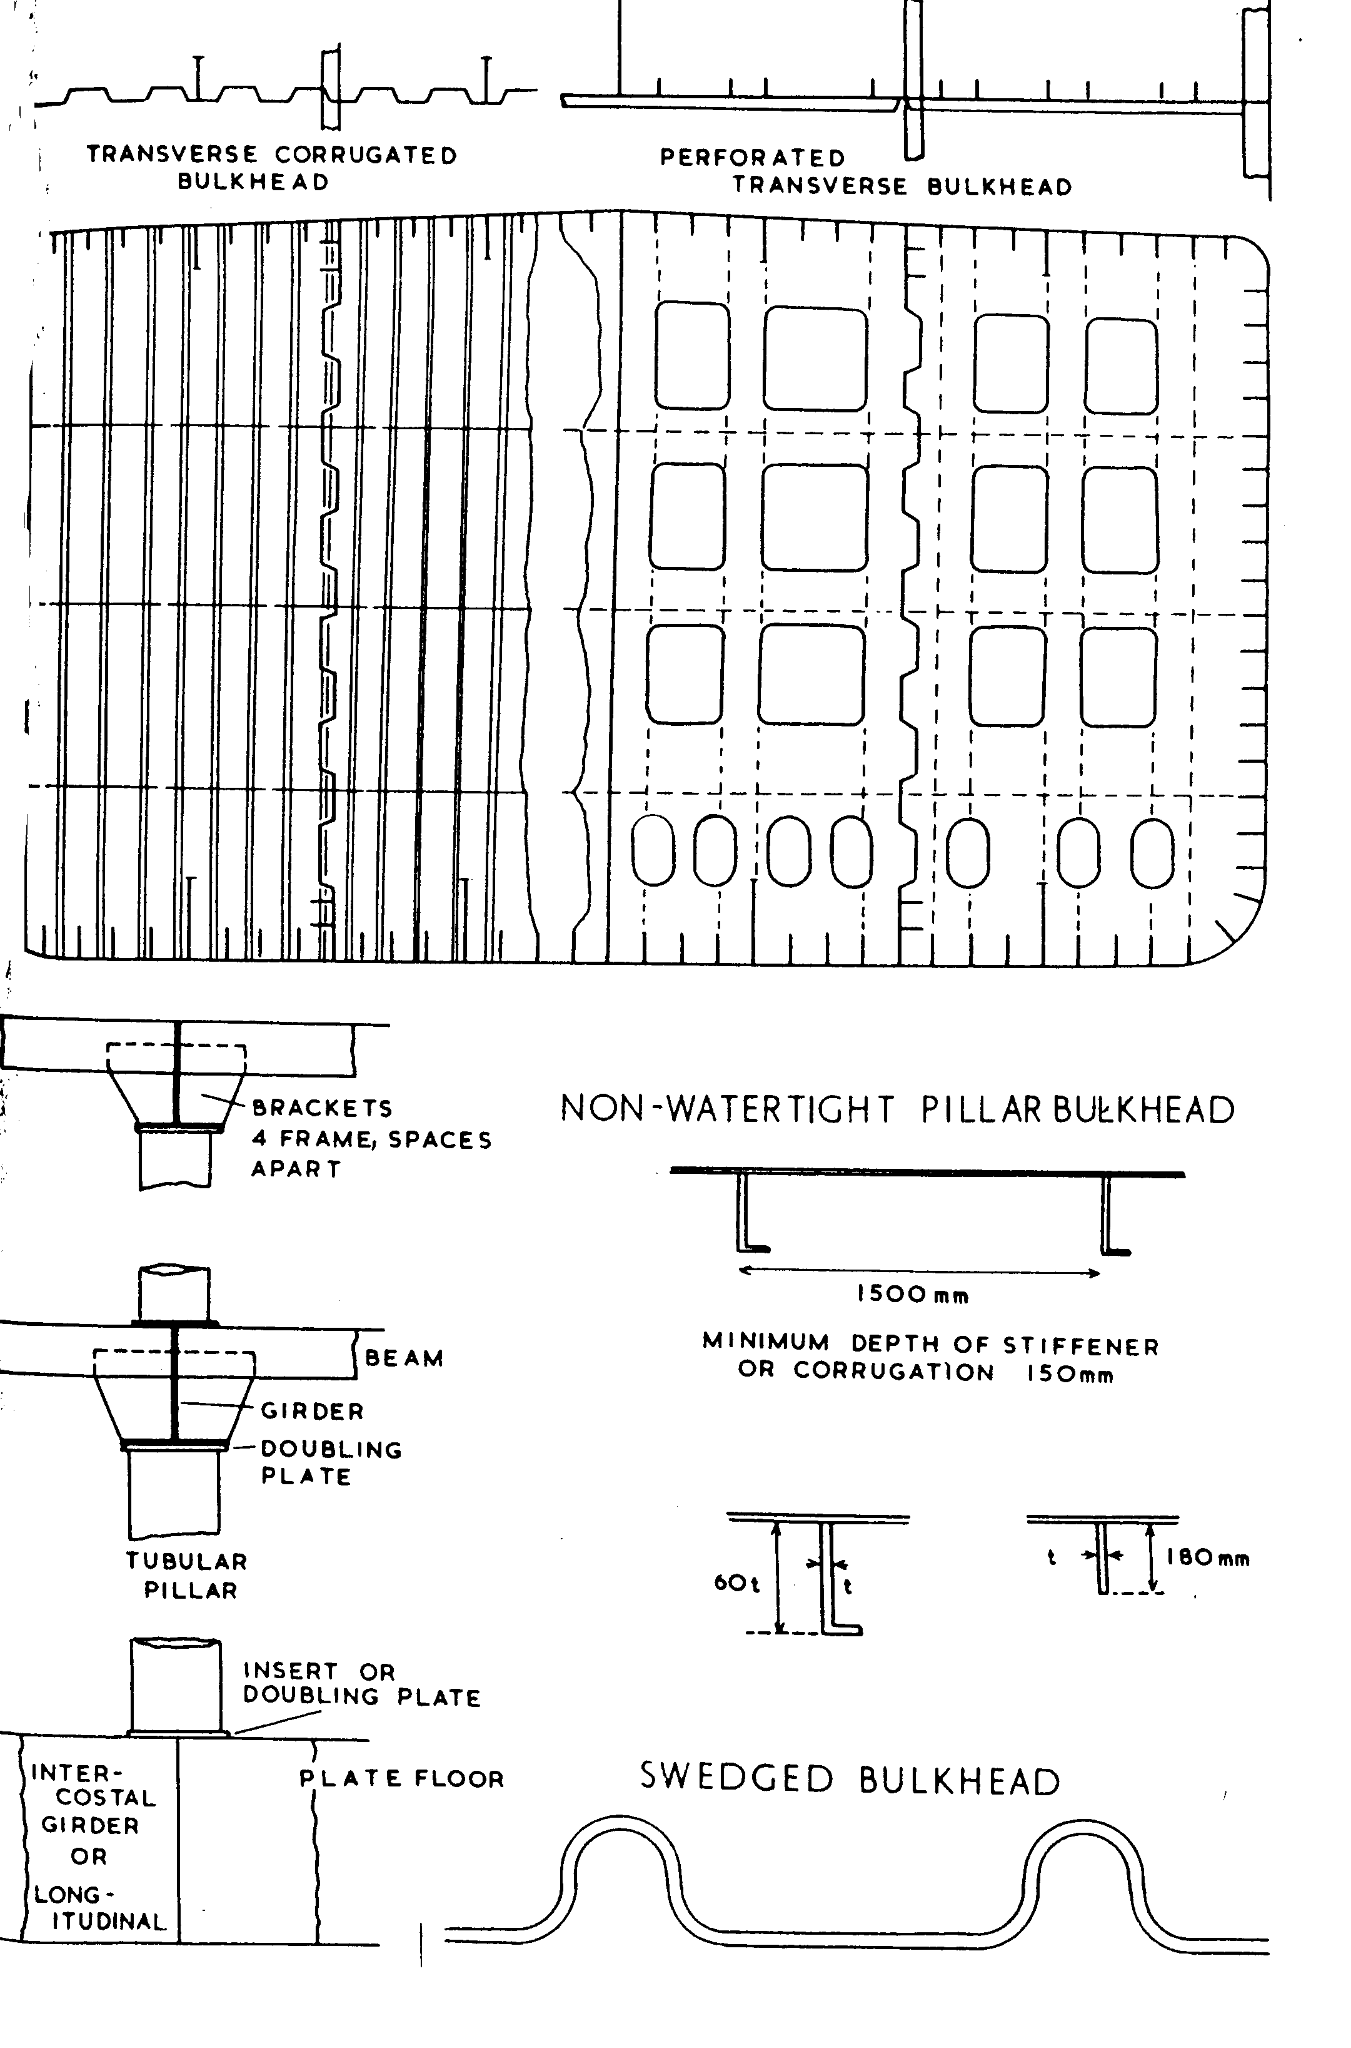

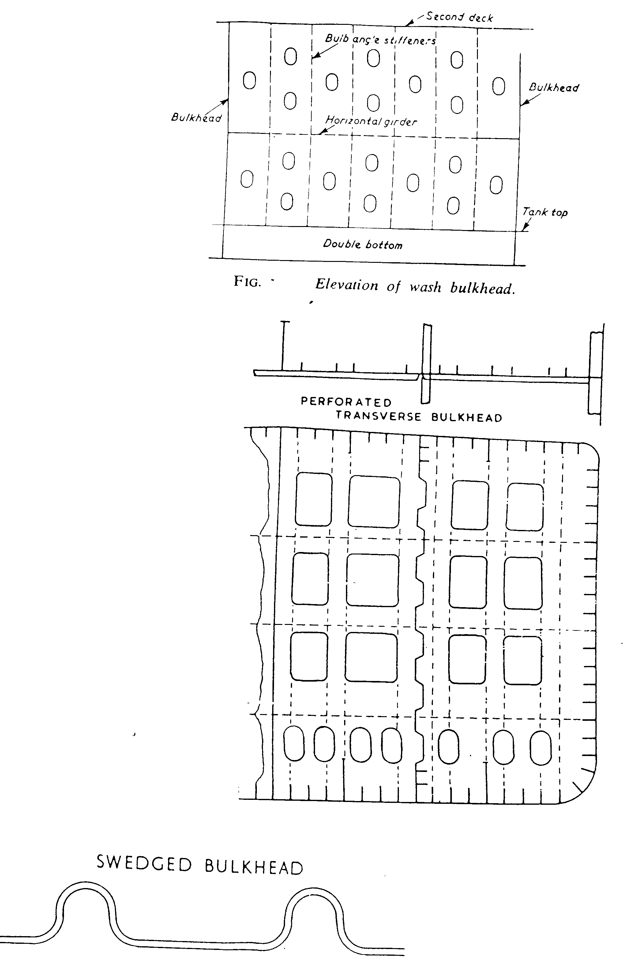

---The End of Chapter---

