TOPIC: FORE END ARRANGEMENT

Learning Objectives :

At the end of the lesson the student should be able to do the following:

8. Understand the design of the fore end structure with respect to local loads stresses, stability, safety and ship resistance.

8.1 With the aid of a simple sketch, explain how a ship is structurally strengthened to counter the effects of
(a) slamming, and
(b) panting.

8.2 Sketch and describe the fore-end construction suitable for a large ship.

8.3 Briefly describe the fore peak tank construction.

8.4 Briefly explain the function of the bow flare.

8.5 Briefly explain how the fitting of a forecastle is the best way to satisfy the minimum bow height requirement for most ships.

8.6 Briefly explain the purpose of the bulbous bow and state how it works.

Fore End Construction
This is normally the structure, which is the forward quarter (25 %) of the ship's length. This part of the ship is subjected to additional forces during slamming and pounding in heavy weather. For higher speed vessels such as container ships the forward hull below the waterline is subject to additional hydrodynamic forces.

The purpose of fitting a fore-castle superstructure at fore end is to protect foredeck fittings against green sea loads and minimize the impact of such loads on fore hatch covers. Minimum bow height and reserve buoyancy would require additional reserve buoyancy forward consistent with the provision of some sheer and/or a forecastle.

Shipbuilding rules require additional stiffening in the forward part of the ship in form of reduced frame spacing, fitting of panting beams, panting stringers etc in addition to the collision bulkhead, floors, frames, beams and other normal internal structures.

Fore Peak Tank
It is a watertight tank normally used for ballast purposes so that the ship can be provided with the proper trim especially on the ballast journey.

A watertight collision bulkhead is fitted in the fore peak tank so that in the event of a collision, damage to the cargo located aft of the collision bulkhead will be minimized.

The chain locker for storing the anchor chain is normally located inside the fore peak tank.

Fore Peak Tank Construction
The following structures are found in the fore peak tank:

- Stem plate or stem bar or a combination of both in the forward most structure, which forms the profile of the bow. The stem plate is normally made of steel plate and is stiffened by a centerline girder or stiffener. The stem runs from the highest point at the forecastle to the keel of the ship.

(2) Breast hooks are fitted at intervals to stiffen the stem plate and to connect the stem plate to the panting stringers or side stringers.

(3) Panting stringers or side stringers are fitted at regular intervals on the ship side to reduce panting, the inward and outward deformation of side plating (the "hungry horse” effect) caused by the changes in water pressure.

(4) Panting beams are normally spaced at every other frame space to absorb the transverse fluctuating forces induced during slamming and pounding of the ship. Channel bars are normally used as panting beams. Panting beams are also sometimes supported by pillars.

(5) Perforated bulkhead (also known as swash bulkhead or wash bulkhead) refers to the centreline bulkhead which is not watertight. Its main function is to reduce free surface effect or heeling moments of water in tanks, which are not fully filled.

(6) Perforated flat (also called perforated deck) is a horizontal deck which is non watertight. It acts as a kind of a full panting stringer to absorb the transverse forces. The deck is supported by panting beams and longitudinal girders like a usual deck. The perforations on the deck are to facilitate the flow of liquid in the fore peak tank and also for man entry.

(7) Solid floors are fitted at every frame spacing to reinforce the ship's bottom. A centreline girder is normally fitted to provide for rigidity of the structure with the transverse floors.

(8) Collision bulkhead is mandatory and to be fitted at aft of the fore peak tank at a distance of 5 to 7.5% length of the ship from forward perpendicular.

(9) Deckhead is the uppermost deck of the fore peak tank which is watertight. Entry to the fore peak tank is through man holes which are kept watertight by covers when ship is under way.

Bulbous Bow
If a sphere is immersed just below the surface, and pulled through the water, a wave is created just behind the sphere. The wave from the sphere interferes with the normal bow wave and results in a smaller bow wave. Thus the force required to produce the bow wave is reduced. However, the wetted surface area of the ship is increased, causing a slight increase in the frictional resistance. Fitting a bulbous bow reduces the wave making resistance, which forms a large proportion of the total resistance. A bulbous bow also increases the buoyancy forward and hence reduces the pitching of the ship to some small degree.

The construction of the bulbous bow consists of steel plates, internally supported by a center-line web and horizontal plates (about 1 m apart). Due to the reduced width at the waterline caused by the bulb, complete internal perforated flats are fitted. The outer bulb plating is thicker than the normal shell plating, partly because of high water pressures and partly due to the possible damage by anchors and cables.

Bow Flare
It is the 'fall out' of the bow plating, outward curvature of the plating as the deck is approached. It increases reserve buoyancy thus helping to prevent the bow from diving deeply into heavy seas. The shape tends to throw water aside and keep it off the deck if the ship should plunge deeply into a wave. It also increases the breadth of the forecastle and allows the anchor to drop clear of the shell plating.

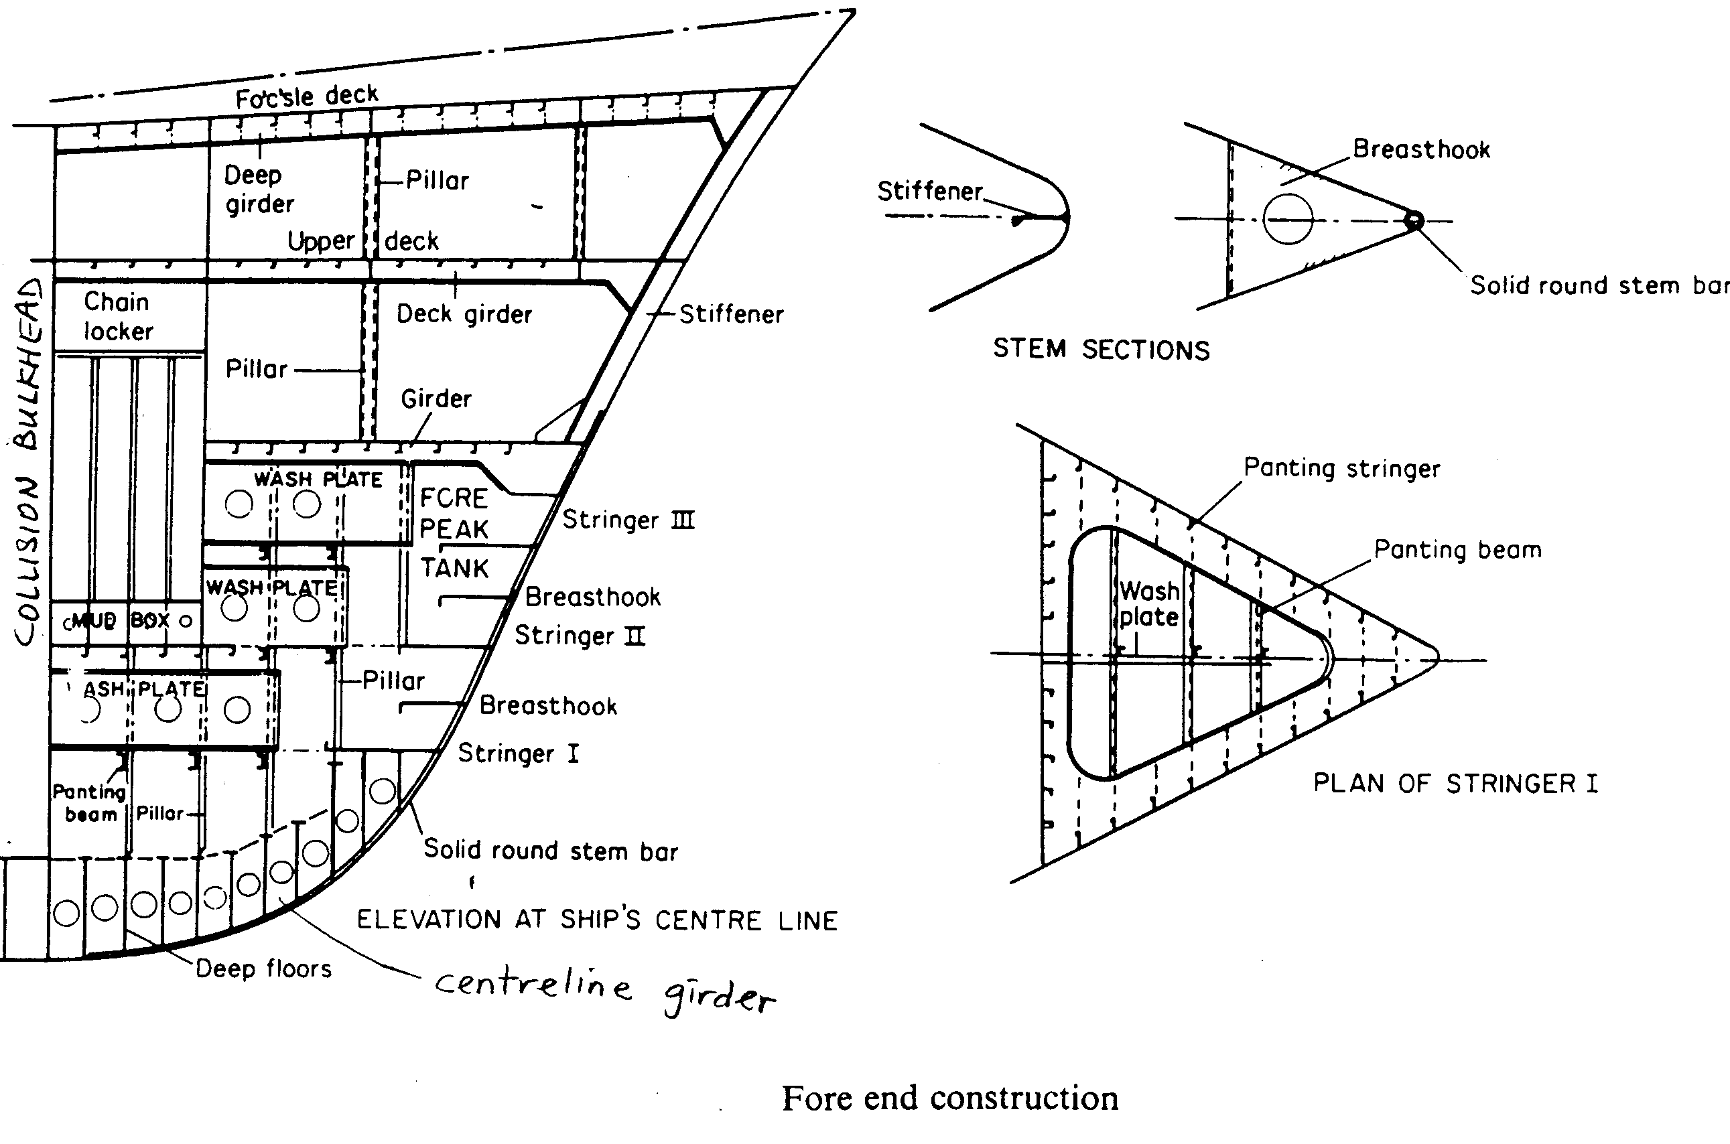

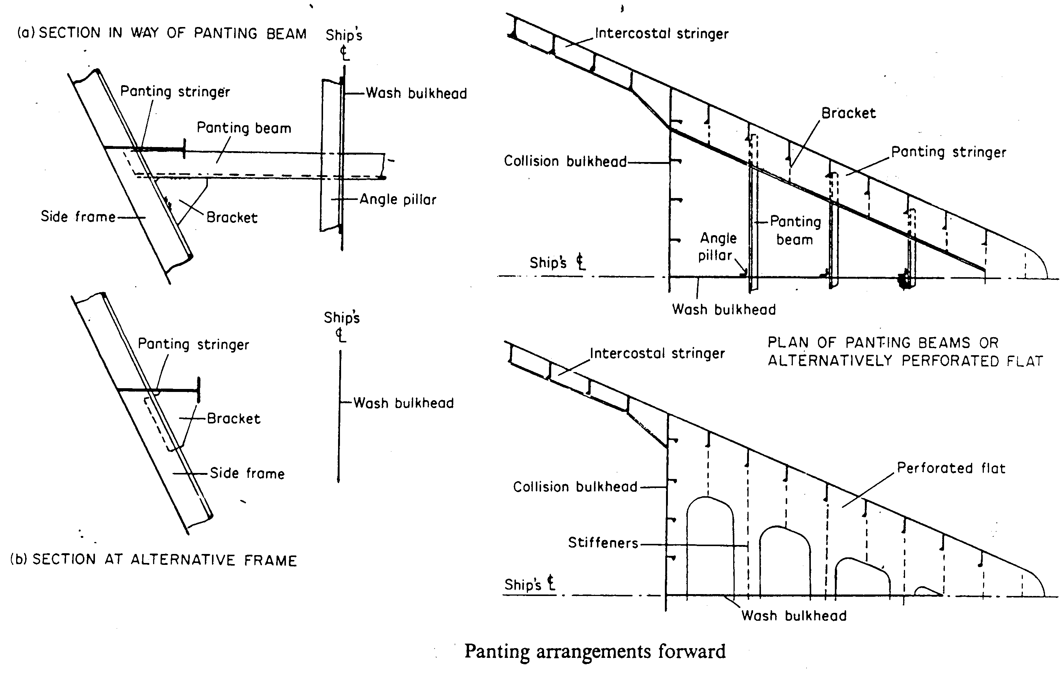

Fore End Structure
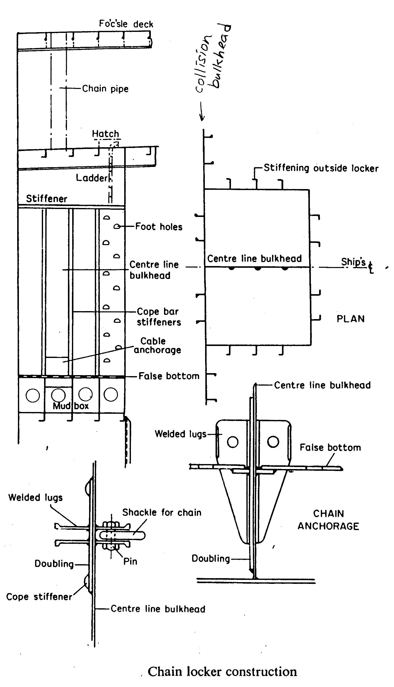

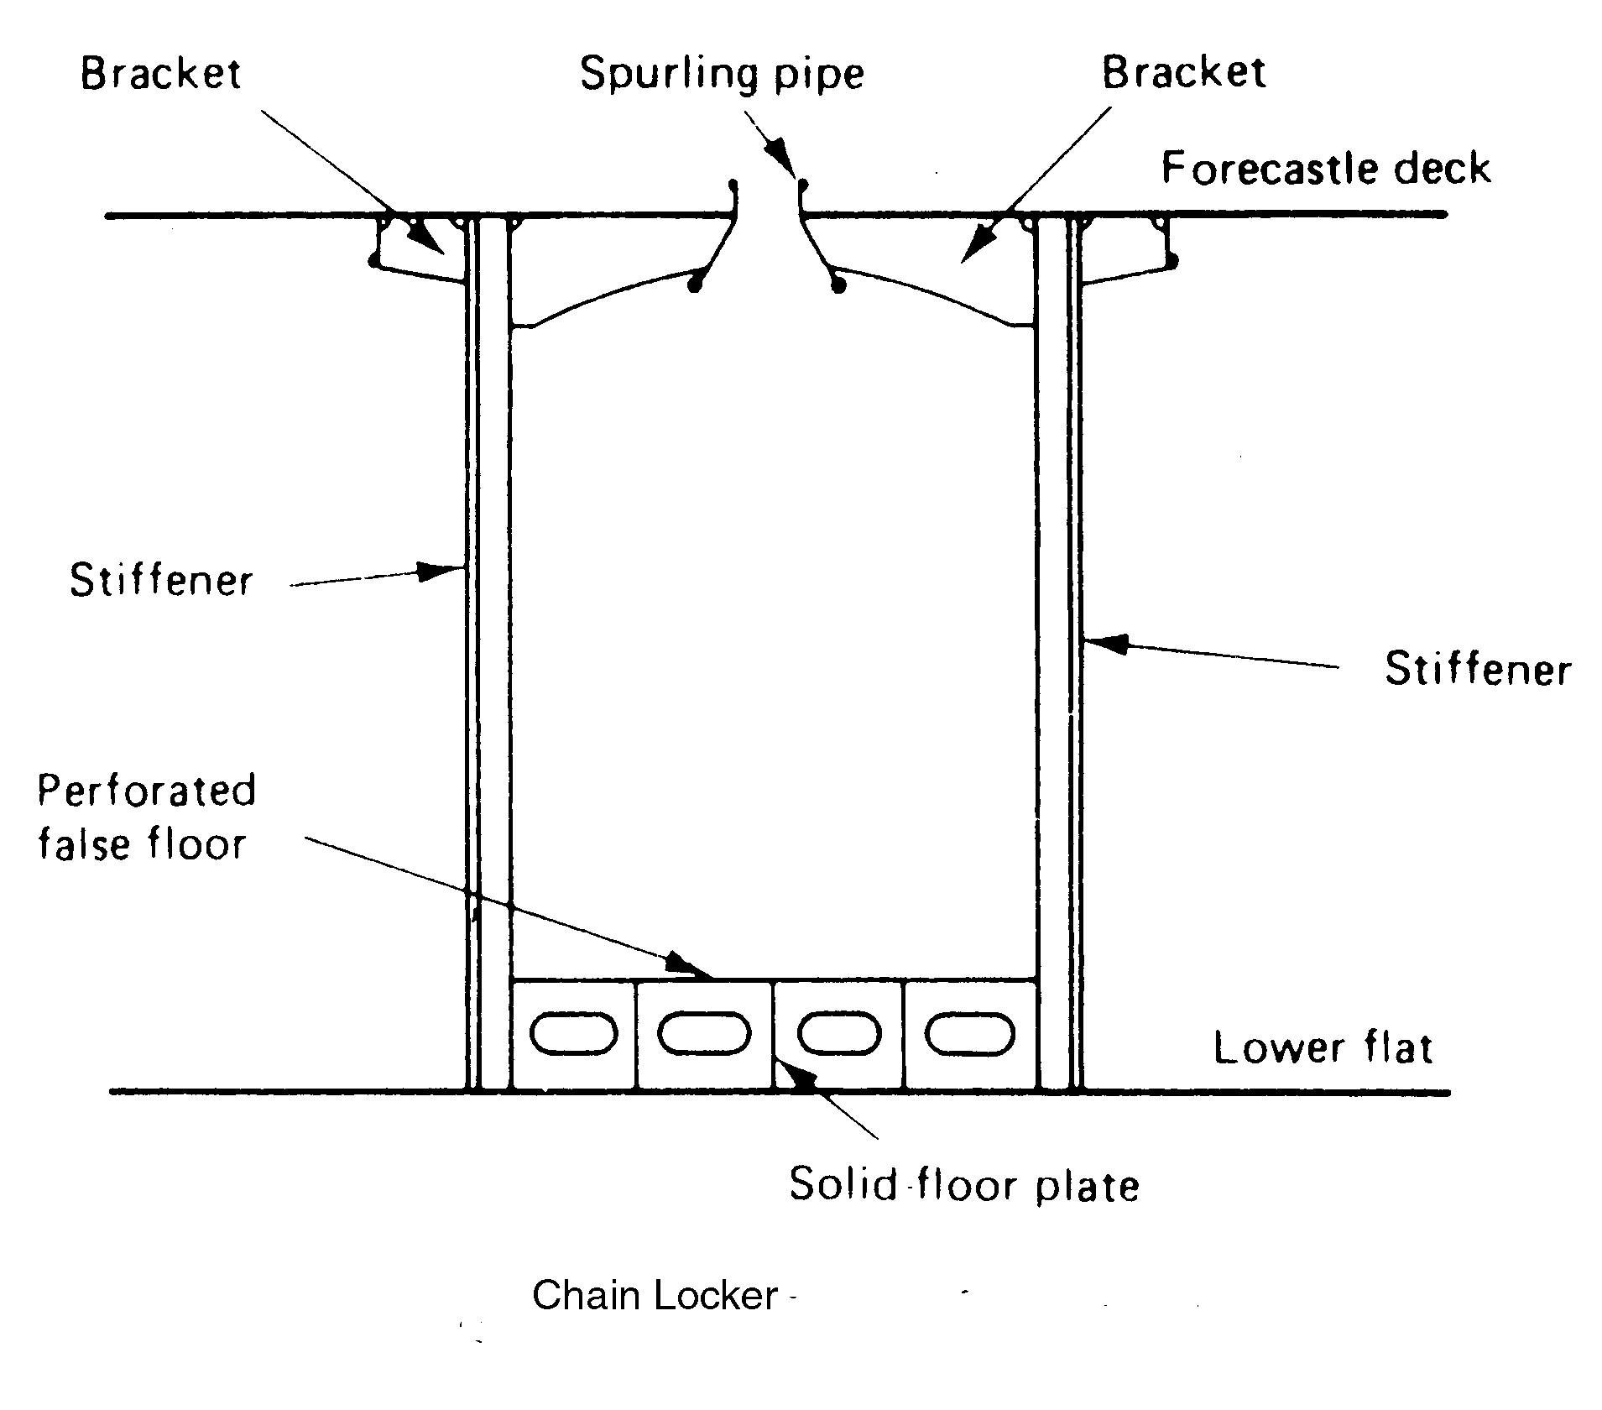
---The End of Chapter---

