TOPIC: SHELL CONSTRUCTION

Learning Objectives :

At the end of the lesson the student should be able to do the following:

10. Understand the stresses on shell-plating and its construction.

10.1 Briefly explain the functions of the shell plating.

10.2 With the aid of a sketch, explain the reasons for the variation of the thickness of the shell plating.

10.3 Briefly explain the purpose for having a shell expansion plan.

SHELL PLATING

The shell plating is the external skin of a ship. It consists of the bottom shell plating and the side shell plating.

The shell plating has the following functions:

a) It acts as a watertight skin.
b) It contributes significantly to the longitudinal strength of the ship to resist bending and shear stresses.

The bottom plating refers to the plating from the keel to the turn of bilge. The bottom plating to the turn of bilges have the greatest thickness because bending stresses is greatest as the plates are located furthest from the neutral axis of the ship.

Shell plating consists of strakes of plates arranged longitudinally.

A strake is a wide strip of longitudinal plating parallel to the keel plating (which itself is called the keel strake) of uniform thickness at the parallel middle body region but tapering towards the ends of the vessel. The strake may be made up of several plates welded together, the dimensions (i.e. length and breadth) of the plating dependent on the sizes of plates that can be obtained from the steel mills. The shell plating is made up of these strakes.

The strake of bottom plate next to the keel strake is known as the garboard strake.

The side shell plating refers to the vertical plating from the upper turn of bilge to the weather deck. The upper strake of the plating adjacent to the strength deck is known as the sheer strake. As the sheer strake is located at a great distance from the neutral axis it has a greater thickness than the other strakes of side shell plating.

The breadth (b) of the sheer strake as per classification society rules is given by:

b = 800 + 5L mm, maximum 1800 mm.

Since the sheer plate deck connection is located at the highly stressed region it is necessary to avoid welding attachments to the sheer strake or introduce cutouts, which would introduce stress raisers.

There are two different ways to connect the sheer strake to the strength deck plating adjacent to it (the deck plating there is known as the stringer plate).

(a) By fillet weld, with deck plate almost perpendicular or slightly inclined to the sheer strake.
(b) By butt weld, using a rounded sheer strake, with a minimum radius of bending of at least 15 times the sheer plate thickness.

The region where the sheer strake meets the deck plate is known as the gunwale.
The shell plating has to be stiffened by internal members to prevent it from being deformed. The longitudinal welding joints between strakes are known as seams and the transverse joints within the strakes are known as butts. The shell plate constitutes about 25% of the total hull weight.

The thickness of bottom shell plating depends mainly on the length, the depth, the draft and the frame spacing of the ship.

Classification society requires thickness calculation of bottom plates be based on lateral pressure and longitudinal buckling strength of plate. It is generally-uniform in thickness along 40% of its length forward and aft of midships and the thickness tapers towards the forward and aft ends of the ship except in way of the areas forward subjected to pounding and slamming where it could be thicker.

Heavy shell plating are fitted in way of attachments to stern frame for heel and boss plates and in way of spectacle bossing as these areas are subjected to heavy stresses. Heavy insert plates or doubler plates are fitted in way of the hawse pipes.

For large ships with high longitudinal bending moments it is economical, by minimizing of ship's hull weight and thereby maximizing the vessel’s cargo deadweight, to use higher tensile strength steel mainly on the bottoms, the sheer strakes and the strength deck as these are subjected to the maximum bending stresses.

Also found on the shell plates are many attachments such as the sea-chests, other discharge openings, bilge keels, skeg, echo sounder and other navigational equipments, etc.

Shell expansion and numbering of plates
A shell expansion drawing is made for every ship so that each individual strake of shell plating can be identified and its individual size and thickness immediately identified. It is constructed by girthing the body plan and expand it vertically in the profile view.

Starting from the Keel strake K, the next strake A is the Garboard strake, then B, C, D, etc outwards towards the turn of the bilge and upwards to the highest strake on the shipside. The numbering of each strake starts from aft increasing towards the forward end, e.g. : K-1, K-2, K-3, etc from the keel strake.

Since the midship section is the broadest and the fullest, its girth length is also the longest. The girth length tapers towards the end of the ship. As the individual strake of plate becomes narrower and narrower, two strakes may be combined into one to form a stealer plate.

The sheer strake is the first strake from the top of side shell.

An oxter plate is a plate having double curvature, immediately below the transom floor and running into the fore side of the stern post. This plate may often require shaping after furnace heating.

A coffin plate is the after plate of the keel which may dished to fit the stern frame section.

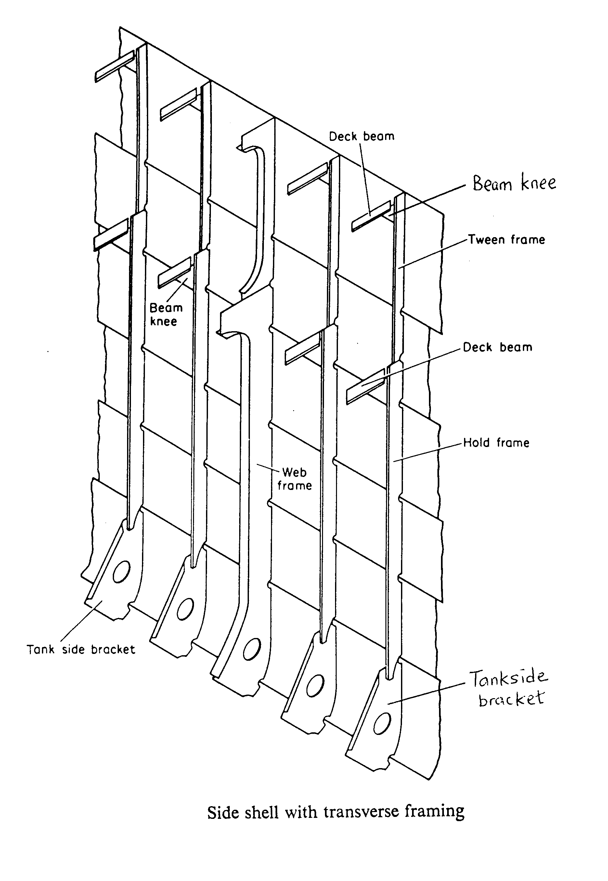

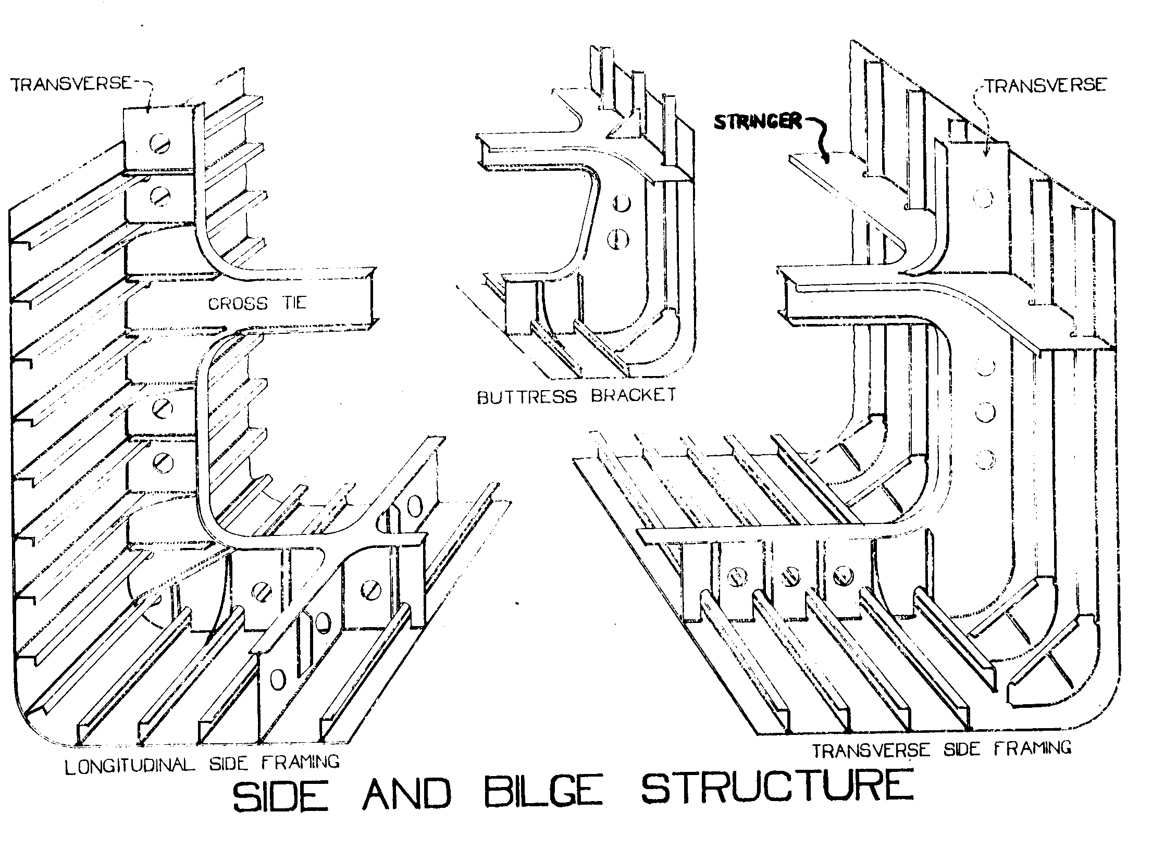

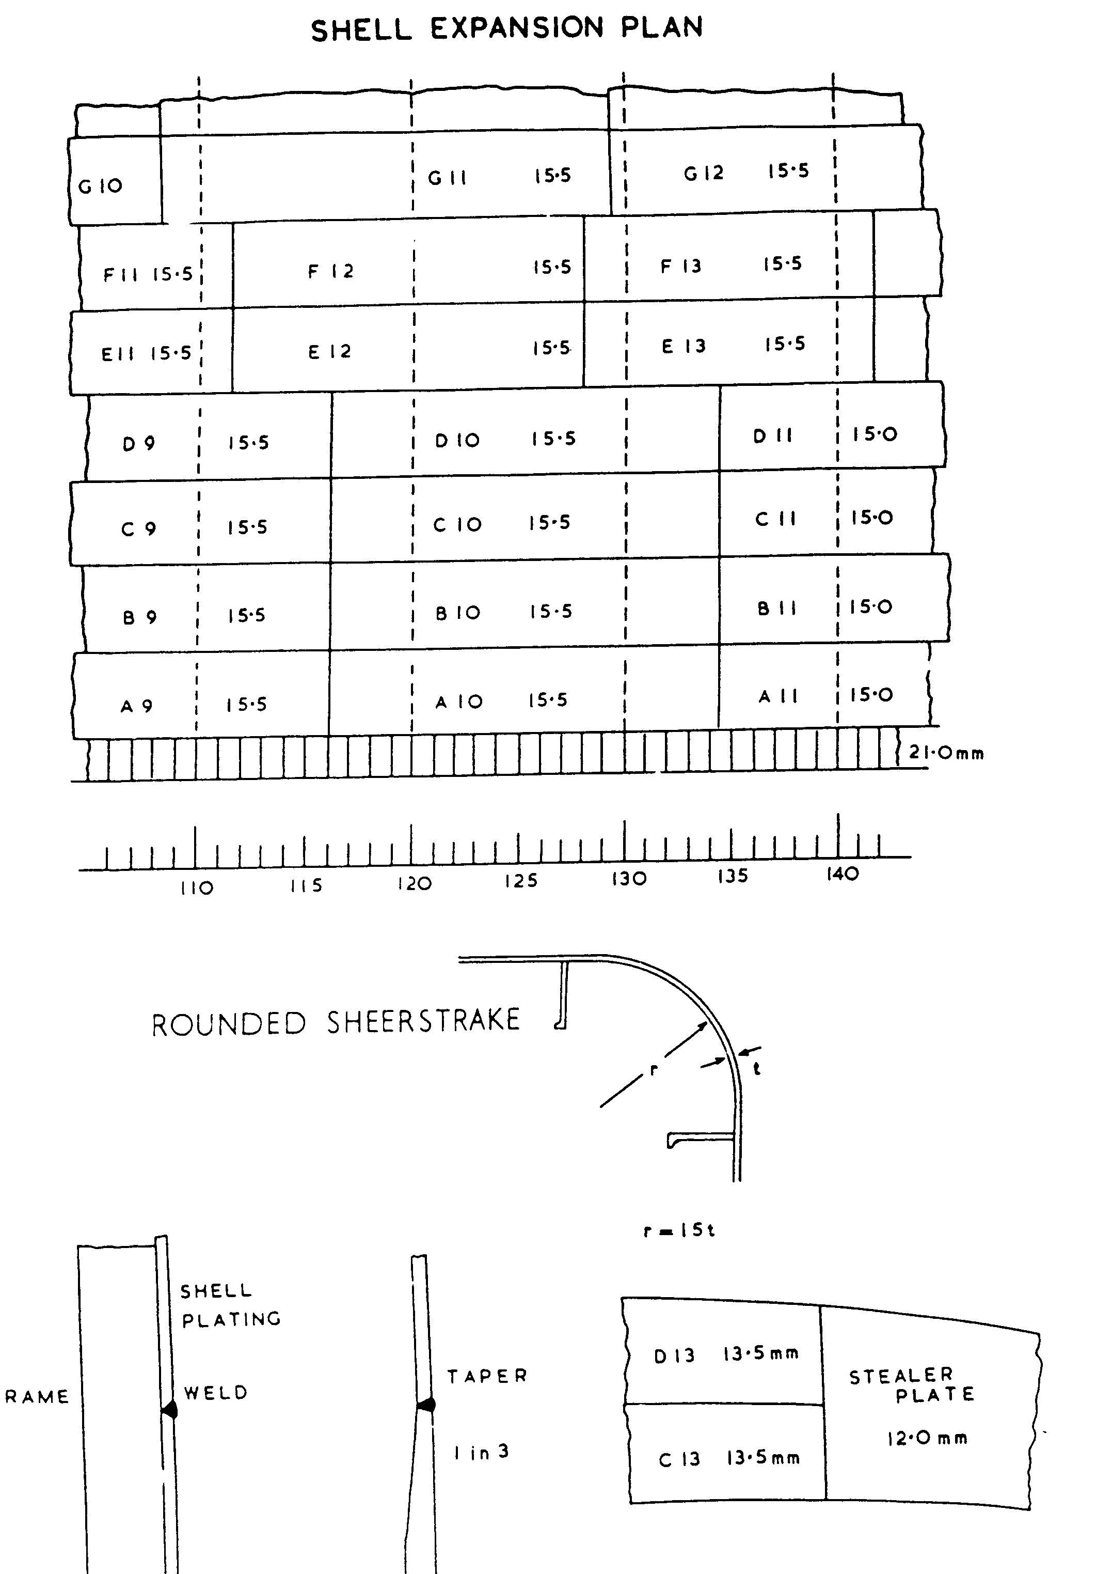

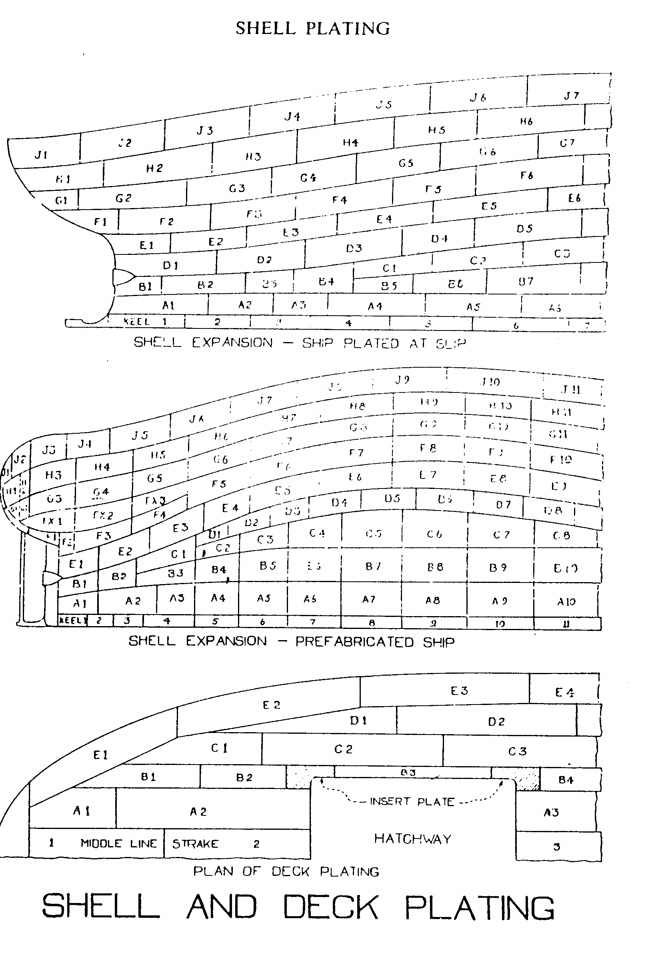

---The End of Chapter---

