TOPIC: PILLARS

Learning Objectives :

At the end of the lesson the student should be able to do the following:

13. Understand the functions and construction of pillars.

13.1 Sketch and describe the construction of a major pillar from a lower deck to the bottom plating through the inner bottom structure showing and labelling the end supports and connections for a pillar that is designed to bear
- compressive loads only, and
- both compressive and tensile loads

13.2 With the aid of sketches, briefly explain how a pillar could be subjected to tensile loads.

.

Introduction

Pillars are vertical structures fitted on board ships very similar to pillars of ordinary buildings on land. Most pillars are subject to compression. However some pillars on board ships are subjected to tension as well.

Functions

The primary function of pillars is to carry the load of the decks, weights upon the decks and weights in machinery spaces vertically down to the ship’s bottom structure where these loads are supported by the upward buoyant forces.

Another function of the pillar is to tie the structure in a vertical direction.

Hold pillars are usually large in section and few in number to reduce the interference with cargo hold stowage to a minimum. Pillars are provided to reduce the need to fit heavy webs to support the hatch girders or end beams. The use of pillars also enables a reduction in size of the hatch girders and beams, since their unsupported span is reduced. Fitting of pillars in way of the corners of a hatch of a cargo hold reduces the efficiency of loading and discharging dry cargo and most modern ships eliminate corner pillars by fitting deep cantilever frames.

Construction

Hold pillar sections are usually a hollow fabricated shape manufactured from steel plate. Typical sections are round, square and sometimes octagonal. Machinery space pillars are usually fabricated from sections, while smaller in dimensions than hold pillars, are greater in number.

When fitting pillars between a number of vertical decks they should be in line below one another to efficiently transfer the loads.

Pillars subject to compression require little or no bracketing to the surrounding structure.

In deep tanks the pillars are subjected to tension e.g. when the tanks are fully pressed up. Pillars subjected to tension are fitted with rider/insert plates and heavily bracketed at both top and bottom structural members (webs, girders, stiffeners).

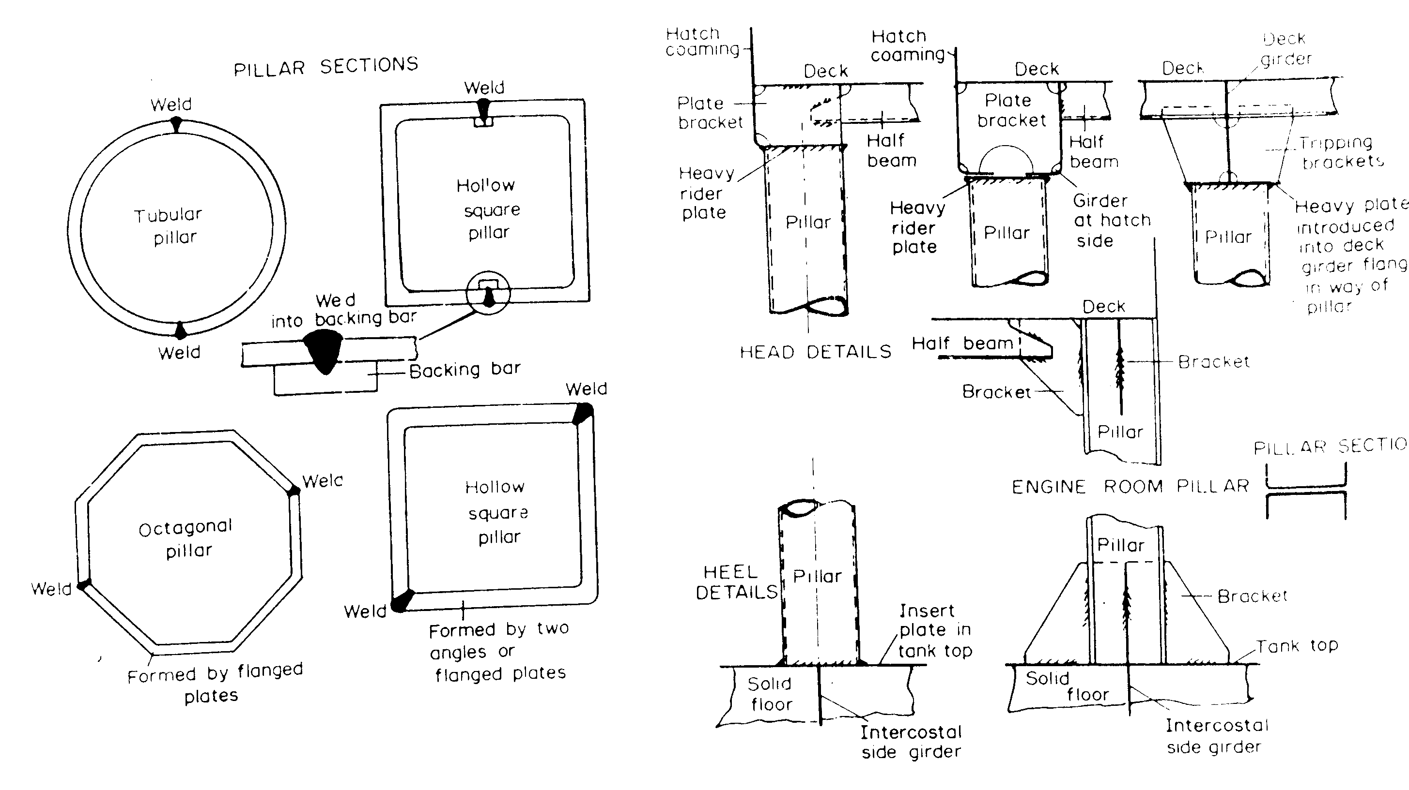

Hollow Pillars

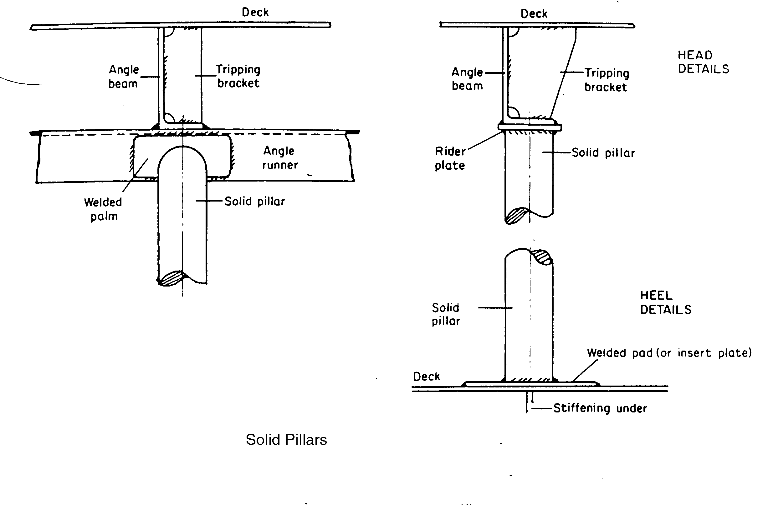

---The End of Chapter---

