TOPIC: KEEL CONSTRUCTION

Learning Objectives :

At the end of the lesson the student should be able to do the following:

14. Understand the functions and construction of the centre keel.

14.1 Briefly explain the primary function of the keel.

14.2 Briefly explain how maintenance or repair work is carried out on the keel when the ship is in dry-dock.

14.3 Sketch and describe
(a) a fabricated plate keel, and
(b) a duct keel..

Types of Keels

At the center-line of the bottom structure is located the keel, which is often said to form the backbone of the ship. This contributes substantially to the longitudinal strength and effectively distributes local loading caused when docking the ship.

There are three main types of keels:

- Flat plate keel,
- Bar keel, and
- Duct keel.

Flat Plate Keel

The commonest form of keel is that known as the flat plate keel, and this is fitted in the majority of ocean-going and other vessels.

Flat plate keel may be fitted on ships with either single or double bottom.

The plate keel is also the thickest bottom plate and it is thicker than the adjacent bottom shell plating (e.g. “A”- strake plating) by about 1.5 mm.

In the single bottom construction, the flat plate keel forms a strong “I” structure with a vertical plate along the centerline (also called the centre keelson) and a horizontal plate (also called the rider plate) above the vertical plate.

In the double bottom construction, the flat plate also forms a strong “I” structure, the vertical plate commonly called the centre girder, and the horizontal plate being part of the tank-top structure.

Bar Keel
First used when shipbuilding changed from wood to steel.
It is a form of keel, found on smaller vessels like trawlers, tugs and ferries. It

is usually constructed only on single bottom vessels supported by solid floors with or without the centre keelson.

The bar keel is made up of a flat bar or steel plate of depth and thickness built to classification rules requirements.

Bar keel did not provide sufficient strength for large vessel, as there was no direct connection between the keel and the floors. It has been replaced by the flat plate keel.

Flat Plate Keel
It is the commonest form of keel, and this is fitted in the majority of ocean-going and other vessels.

Duct Keels

Duct keels are provided in the double bottoms of some vessels. These run from the forward engine room bulkhead to the collision bulkhead and are utilized to carry the double bottom piping. The piping is then accessible when cargo is loaded, an entrance to the duct being provided at the forward end of the engine room. At the same time it is possible to carry oil and water pipes in the duct, preventing contamination, which could occur if the pipes passed through tanks. No duct is required aft of the engine room as the piping may be carried in the shaft tunnel. For safety reason, the access to the duct keel should be closed and watertight at all times unless in use.

The duct keel is formed by two longitudinal girders up to a width of about 2.0 m apart. This distance must not be exceeded as the girders must be supported by the keel blocks when docking. The structure on each side of the girders is the normal double bottom arrangement. The keel and tank top centre strake must be strengthened either by supporting members in the duct or by increasing the thickness of the plates considerably.

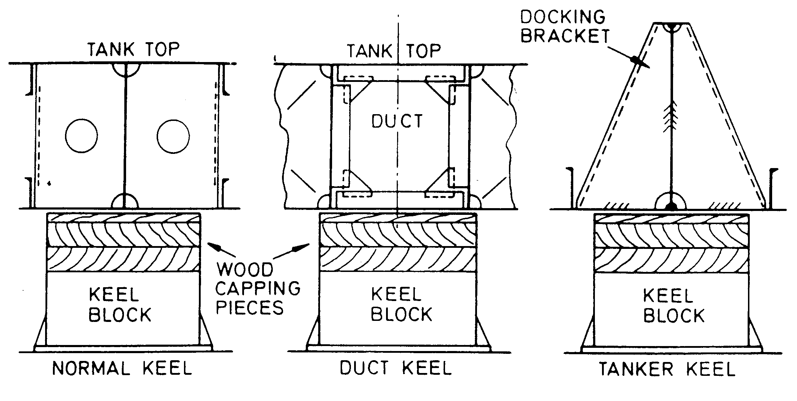

---The End of Chapter---

