The Environment as an Integrating Context (EIC) in Massachusetts

EIC is a model that has been developed in conjunction with the State Environmental Education Roundtable (SEER), and has been funded primarily through the Massachusetts Environmental Trust (MET), for several years. In 2005, there are at least four schools participating in the model.

The following grant report to MET is an example of how one school and one non-profit organization cooperated to gain funding and develop a successful EIC program.

Massachusetts Environmental Trust
Grant to the Nashua River Watershed Association for
“Using the Environment in an Integrating Context in Schools in the Nashua River Watershed:
Deepening the Roots”
Contact Award Period 7/1/2004 to 6/30/2006
FINAL REPORT : June 30, 2005

Summary: The NRWA has successfully fulfilled 100% of the scope of the services for this MET grant, has expended 100% of the funds, and is submitting this final report on the project.

1. Goals and Objectives: The goal of this project is to assist model schools in the Nashua River watershed to meet state learning standards through the Environment as Integrating Context approach. The objective is to support and strengthen the on-going relationship with J.R. Briggs Elementary School
1a. What were your major accomplishments?
- Planning meetings with NRWA and EIC teachers: in August 2004, the NRWA Environmental Education Director met with 9 EIC teachers from last year for a half day planning meeting. We began the meeting by reviewing Grace Leiberman’s site visit evaluation from spring 2004 and Polly Zajac’s Innovation Configuration reports about the J.R. Briggs EIC program and teachers. While reviewing evaluations, this was the perfect opportunity to re-address the EIC model. Teachers then developed unit plans and time lines (attached).
In January, the NRWA met with all 14 EIC teachers to once again review the EIC model and the Massachusetts State Frameworks to refine winter and spring units for all grades 1st to 5th. This was the first opportunity for the new EIC teachers to participate in planning. All of the meetings went well, with a short review of the EIC Model. We also revisited Grace Lieberman’s evaluation from last Spring. All planning meetings focused on planning EIC units for winter/spring 2005, with special attention to service learning, authentic assessment and constructivist learning.
In May, the NRWA and the EIC teachers had an all EIC community meeting after school to complete PDP requirements for EIC work, to plan end of year EIC parties for each grade, and set dates for summer meetings.
- In September 2004, 5 new teachers at J.R. Briggs asked if they could join the EIC team. The NRWA consulted Grace Leiberman and she agreed that the new teachers could learn about EIC during the school year. This gave J.R. Briggs a total of 14 active EIC classrooms. To our knowledge, this is the largest EIC program at any one school in the state of Massachusetts. All 14 teachers did actively participate in EIC all year and they plan on attending planning meetings summer 2005. This past spring, one new teacher joined EIC for a total of 15.
- Implementation of 96 EIC lessons with 625 students and 15 teachers. In September and October, J.R. Briggs and the NRWA began the fall session with a focus on the Project Approach within EIC. The 3-week units were designed to give students a chance to design service learning projects within their community that are directly aligned with the MA Frameworks. Using the constructivist approach component in the EIC model, students designed their own environmental projects. In the spring, service learning projects were continued with all grades.
- Coaches Meetings: In September, 2004 and February 2005, the NRWA hosted EIC coaches meetings. The coaches were able to discuss specific EIC activities and units and each school. This sharing of ideas is an important element of EIC innovation.
- The NRWA provided support for the EIC Content Institute in New Bedford in the summer of 2004. Two fifth grade teachers and one enrichment teacher from Berlin Memorial School attended the workshop. With assistance from the NRWA in 2003-04, the Berlin Memorial school has now become a very active EIC school.
1b. Steps or Actions used to meet goals
- In order to provide professional support and EIC facilitation at J.R. Briggs, teachers were able to participate in EIC planning meetings during school. Substitutes were paid for by the MET grant. Professional support was also provided during Grace Leiberman’s visit since we were able to hire a sub to fill in for teachers when they met with Grace. This year, since the NRWA is a PDP provider with the State of Massachusetts, teachers were able to receive 10 PDP’s for EIC model review sessions. Another form of professional support was from the teachers at Berlin Memorial School. Three teachers from Berlin visited the Briggs school on February 15th, 2005 and they spent time in each classroom observing EIC activities, talking with teachers during lunch breaks and sharing lesson ideas.
- With “Natural and Social Systems of Ashburnham” as the school EIC theme this year, the following EIC units are being implemented this year with Mary serving as an instructor with each teacher: 1st grade-Vernal Pool Studies, 2nd grade- Growing Things, 3rd grade-Water Resources (drinking water, reservoirs in Ashburnham), 4th grade- Geology, Erosion and the Effects of Development, and 5th grade- The Scientific Process.
- All of the 96 EIC lessons taught by the NRWA and the J.R. Briggs teachers are planned along with the Massachusetts State Frameworks for Science and Technology/Engineering, History, Math and the English Language (Massachusetts Environmental Education Plan goal number 2.0). Examples of such lessons are Wetland and Upland Soil for 5th grade, Rocks, Minerals and Stone Walls for the 4th grade, and Vernal Pool in the Fall (seasonal changes) for first grade (see attachments for all NRWA lessons).
- The NRWA hired Assistant EIC Coach Dana Brennan, naturalists Kat Dikau and George Moore to help with the implementation of EIC at Briggs.
1c. Measures used to determine progress
- The success and progress of the EIC program this year was noted by the 5 new teachers who agreed to take on EIC responsibilities in the fall of 2005. This demonstrates the fact that teachers are noticing the benefit of EIC in the Briggs school. This spring one more new teacher, Russ Foster (the fourth 5th grade teachers) asked to join the EIC team. This increases our constituents to over 600 children (see graph attached).
- The EIC units designed by teachers have been planned with authentic assessment elements and rubrics. The NRWA lessons include a task that must be completed such as collection of soil samples, measurement of rock wall dimensions or sketching of vernal pool inhabitants. Once these tasks are completed, students must complete data collection sheets (examples in attachments).
- In order to determine progress in the teachers support area, the NRWA met with each grade level separately during planning sessions. Each grade had a mixture of new and experienced EIC teachers, so planning included a review of the EIC model, discussion of lessons that were successful last year, and an inclusion of new ideas from EIC teachers who have joined the team. Teachers leave the planning session with an outline for their EIC units, which have been designed with the State frameworks and the EIC model.
- The EIC summer and spring planning meetings (all teachers together) provide EIC teachers a chance to develop curricula that is supported school-wide. We discuss what each grade level will focus on and make sure that replication is minimal. By following the Massachusetts State Frameworks and the EIC model, we can be assured units are designed well.
- Grace Leiberman did a site visit to observe EIC teachers, talk with students, and discuss success with school administrators. Her evaluation (attached) will be reviewed during the summer planning meeting.
- The coaches meetings are unique to the state of Massachusetts and provide both the teachers and the coaches with an opportunity to measure success, discuss problems and plan for the future. By observing EIC in other schools, we can learn about other EIC programs and reinforce our own ideas and thoughts.
1d. Unexpected results or key learnings
The most unexpected result from this year was the voluntary addition of 6 new EIC teachers. This allowed us to have all of the 3rd, 4th and 5th grades, and half the 2nd and 1st grade teachers, Students are beginning to know that EIC will be a part of each grade level. They are exposed to lessons about the vernal pool, dragonfly pond and the forest each year. This repetition hopefully will lead to an educated population of Ashburnham residents.
As was stated last year in our final report, the constructivist element of the EIC model continues to challenge teachers. However, this year, at the end of the year celebration, one of our teachers that struggled the most with child-centered learning, had her students write and read EIC poems to parents. Change can happen!

2. Describe any setbacks
Implementation of this grant was very successful. We did not have any setbacks, but we did have a few changes in our timetable. Due to the fact that we added five more teachers in the fall 2004, the NRWA implemented two to three collaborative lessons with each grade in order to introduce the new teachers to the EIC model in action. The NRWA chose to use the project approach where students are involved in community-based investigations. Since these units took a longer time to implement, the November planning session times were replaced by EIC activities in the classroom. In the winter and spring, the NRWA taught two to three collaborative lessons instead of one. We felt that in-the-field lessons were critical to support the new EIC teachers. Also due to the huge increase in number of teachers and classrooms, the two community meetings were replaced by small meetings where each teacher met with parent volunteers to discuss lessons in each classroom. The teachers felt that these meetings would work better and take less time. Parents were recruited at the beginning of the year with a “Dear Parents” letter about EIC. The planned school visits with the Orange schools were replaced by visits with the Berlin Memorial School. The teachers in Orange were too busy and the Berlin teachers were very interested in Briggs vernal pool units. The Briggs teachers did not have time to travel to another school and this line item was absorbed by increased teaching time by the NRWA. The March all school network meeting was replaced by the first EIC newsletter. Since we have added so many teachers to the team, finding a time when they can all meet is very difficult. The NRWA developed a newsletter and sent it to all teachers through the mail.
Another change in the timetable was the spring visit by Grace Leiberman (Grace did come in November 2004). Usually, Grace or Polly Zajac with the Schooner Ernestina comes to Briggs in the spring to complete Ms. Leiberman’s IC’s. Polly’s employment situation changed this year and so she did not make it to Briggs.

3. Who else funded this project?
Mary Gagnon and Kate Bennett received a grant to participate in a service learning workshop through Mass DOE. They received a stipend, course credit and some funds to implement the project which was a part of their EIC units. The Briggs PTO provided funds to pay for George Moore, maple sugaring expert. The Ashburnahm/Westminister School District paid for science supplies such as nets and soil augers. The Ashburnham Conservation Trust donated $1000 for Magiscopes. The bulbs that the 2nd grade planted in the fall were donated by a parent who owns a landscaping business.

4. Sustainability of the project beyond this grant period
J.R. Briggs teachers and administrators have been participating in EIC for four years now. The team of teachers has grown from 2 to 15. The former Vice Principal, Candace Wright, participated in the first EIC Content Institute in New Bedford in the summer of 2002. This year, Ms. Wright became Principal of J.R. Briggs. This gives the EIC team strong administrative support. Candy is supportive of all our activities. She understands that EIC supports both the Massachusetts Curriculum frameworks and the Ashburnham/Westminister School District requirements. She was proud to host the visit by the new EIC school, Berlin Memorial School, this spring. Ms. Wright also met with the AWRSD Superintendent, Grace Leiberman, Mary Gagnon and the NRWA last year, to explain EIC. The Superintendent is aware that we continue to grow EIC. With a strong commitment from teachers and the administration, we are building a framework that will allow the district to embrace EIC beyond this grant period.
Also, the teachers have been quite active in pursuing additional funding for projects within EIC. In addition to the grants mentioned in number #3 above, the teachers, the NRWA and Harvard Forest have submitted two proposals to provide science-based training to four teachers. The Harvard Long Term Environmental Research Program provides teachers an opportunity to do research with students that is supported by the scientist at Harvard Forest. We applied to the National Science Foundation and the Stoneyfield Foundation for this project..

5. Collaboration
Collaboration is the key to the J.R. Briggs/NRWA EIC program. The teachers at Briggs and the naturalists from the NRWA have developed strong relationships of trust and respect. The teachers have learned that their students will be safe and in control while in class and outside on the nature trail when the NRWA is helping to facilitate an EIC lesson. These relationships of trust are critical to foster change in a traditional school setting.
- NRWA, Briggs and SEER (State Environmental Education Roundtable): Grace Leiberman (SEER) is the national coordinator for EIC. We are in communication with Grace often and she visits the EIC schools for evaluation and consultation. Her professional comments help us to guide our EIC efforts
- NRWA, Briggs and the community of Ashburnham: this year we had many parent volunteers that came in to help with EIC lessons. We had a horticulturist donate gardening supplies and labor, a geologist provide a program about rock formation, the recycling coordinator for the Ashburnham transfer station came in to talk about recycling, the Ashburnham Historical Society presented artifacts and many parents helped to facilitate teacher lesson such as building stone walls and studying the vernal pool.
- NRWA, Hitchcock, Millers River, and Schooner Ernestina: In FY04-05, the NRWA hosted three coaches meetings to encourage discussion of EIC progress. These meetings were quite successful.
NRWA and Berlin Memorial: Berlin has become a sort of “sister” EIC program. They visited our school for a half day and we visited their end of year “Wicked Big Puddle Presentation”. Since the Hitchcock Center did not receive funding to do a summer EIC workshop, Berlin and Briggs are planning a training session.

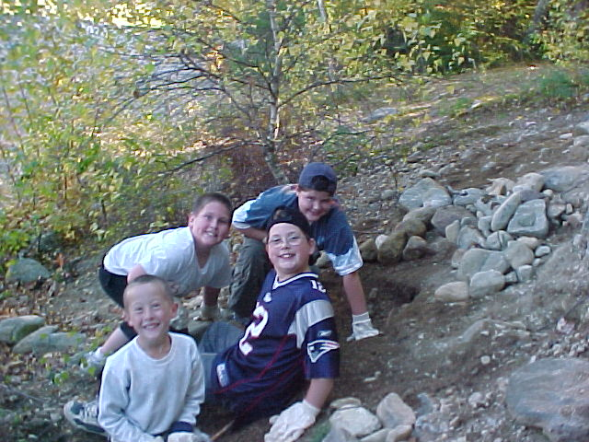

Building Erosion Prevention Walls with the 4th grade

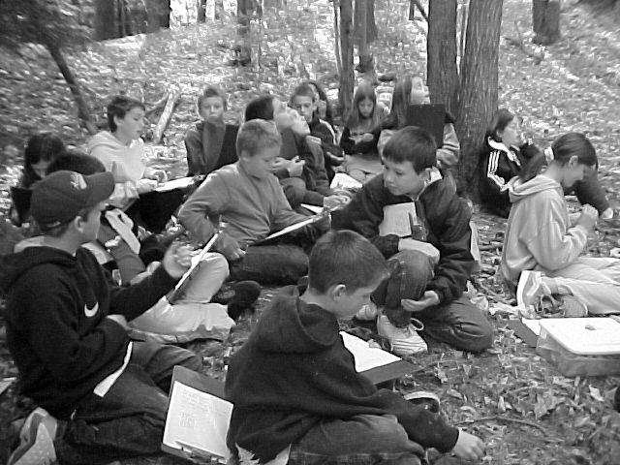

Summarizing Self-designed Mathematical Forest Investigations

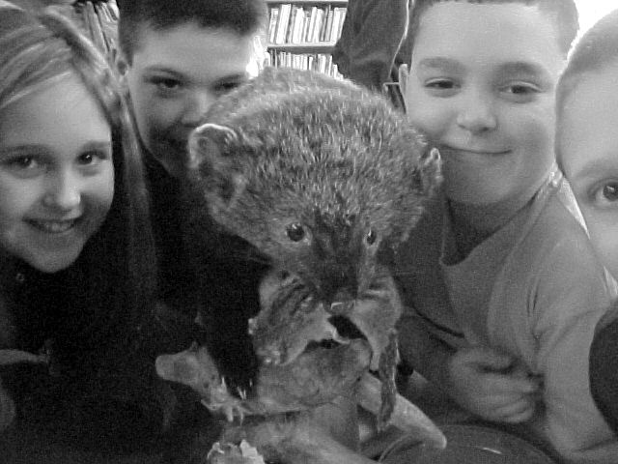

Learning about animal adaptations with Mr. Fisher

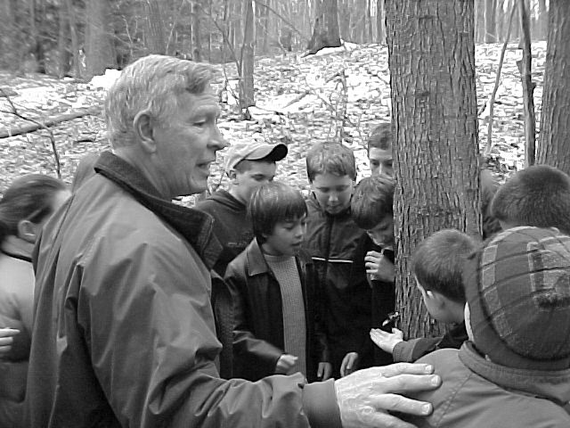Maple Sugaring with George Moore

Nashua River Watershed Association
EIC lessons taught by NRWA staff at J.R Briggs
Winter-spring 2004

Wildlife Stations: learning the characteristics of insects, birds, mammals and turtles
In the grade 1 Life Science frameworks, students are expected to group living things according to characteristics they share (e.g., insects, birds, mammals). Students visited five stations where they completed activities designed to teach students how animals are different. Each stations allowed for hands-on exploration.
January 20
Grade 1
Lynne and Linda’s classes

Wildlife and Trapping in the Colonial Days
Using real animals skins, naturalist George Moore taught students about local wildlife today and in colonial times. They specifically discussed the beaver and how colonists changed the environment to reduce wetland habitats
January 20
5th grade
Kate’s class

White Pines for the King
Students learn about how white pines were used for masts on the British ships in early colonial days. Classes go outside and look for white pines, measure the circumference and then mark the large, straight trees with the King’s red arrow.
January 21
3rd grade
Mary, Peg and Laurie’s classes

The Enviroscape Watershed model with a focus on erosion prevention
The 4th grade teachers are teaching erosion/weathering and the watershed model allows students to create solutions to erosion and other non-point source pollution.
January 22
4th grade
Wendy, Pat and Julie’s classes

Maple Sugaring
The 5th grade learned about maple sugaring in colonial days, learned how to tap a tree,
and tasted sap in the school yard.
March 12th

Bones Investigations
NRWA naturalists provided a hand-on bones investigations study that support the district frameworks. Students have an opportunity to measure, weigh, and fit together bones of local wildlife.
March 4
4th grade
Wendy, Pat and Julie’s classes

Enviroscape with a focus on changes in the land with colonialism
The hand-on demonstration reinforces history lessons about colonial times.
Discussions about how people and animals interacted and the effects on the economy and the land.
March 24
12:15 pm
5th grade
Kate’s class

Enviroscape with a focus on water cycle, watershed, ground water
The 3rd grade students used the Enviroscape to learn about local streams in the watershed and how local actions affect the lakes in Ashbunham.
March 16
3rd grade
10-11:00, 11:00-12:20, 1:15-2:15 pm
Mary, Peg and Laurie’s classes

Erosion Survey
The 4th grade students collected data on erosion at their study site.
The students are monitoring the man-made road that passes by Dragonfly Pond.
April 9th and 12th
Wendy, Julie and Pat’s classes

Vernal Pool
Students investigated the vernal pool as a water resources in Ashburnham. They collected aquatic insects, used a macroinvertebrate key and recorded names of insects found.
April 30th (3rd grade): 10-11:00, 11-12;00, 1:15-2:15
3rd grade
Mary, Peg and Laurie’s classes

Vernal Pool Sketching
First grade students are studying living things and changes with seasons (State frameworks). They collected living things and did beautiful drawing of the vernal pool and of creatures that live there.
April 30th 9:30-10:00, 12:15-12:45
1st grade
Lynne and Linda’s classes

Vernal Pool Life Identification and photography
For their service learning activity, the fifth grade decided to create a Vernal Pool
Guide for the young students at Briggs. We collected insects and photographed them.
May 12th: 9-11:00
Kate’s class

Dragonfly Pond Insect Monitoring
Since the 4th grade is studying the effects of road development on the pond, they collected aquatic life to see if there had been any changes since last fall.
May 17th : 8:45-9:45, 11;00-12:00, 1-2:00
Mary, Peg and Laurie’s classes

Dragonfly Pond: Effects of Development?
Students visited Dragonfly pond with an awareness of the fact that the land is owned by a developer who is planning to develop property up hill from the pond. We investigated the condition of the pond, including life living there, and discussed how development could impact the pond.
June 8th (5th grade) 10-11:30
Kate’s class

Dragonfly Pond Physical Survey
Teachers wanted to document the size and depth of the pond to determine if any changes
will occur with development above the pond. This was out first measurement date.
Students had to figure out how to measure the width, length and depth of the pond.
June 8th 8:45-9:45, 9:00-9:45, 1:15-2:00
4th grade
Wendy, Pat and Julie’s classes

Dragonfly Pond: Endangered Dragonfly?
Students investigated the pond in pursuit of a rare dragonfly that has been cited in Ashburnham. They collected, photographed and released dragonfly nymphs. The photos will be sent to the Field Biologist that identified the dragonfly.
June 18th
8:40-9:30, 9:30 -10:30, 10:30-11:30
3rd grade
Mary, Peg and Laurie’s classes

