Singapore Polytechnic



Singapore Maritime Academy
&
Maritime Institute Of William Barentsz

Bachelor Degree in Maritime Operations (BMO)
MA9022
Diesel Technology & Emissions
Assignment 3: Exhaust Emissions Reduction Technology

Team members: Jannell Toh
Pururav Nagaraj
Celeste Yeong
Date: 17 July 2006

This assignment is done in the fulfillment of bachelor degree in maritime operations for diesel technology and emission Unit 5.

- Briefly explain why large diesel engine produces more NOx and SOx than other pollutants.

(Ref: - Recent Development in Marine Engines Edited by Kee-Rong Wu and T.C. Yang)

Owing to the high efficiency of diesel engines, the emissions of carbon dioxide, carbon monoxide and hydrocarbons are low in their exhaust gases but high emissions of nitrogen oxides are also inherently characteristic of the diesel cycle. The same high combustion temperatures that give high thermal efficiency in the diesel engine are also the most conducive to NOx formation. By running on low-quality fuels with a low fuel consumption, large diesel engines offer enormous savings in fuel costs compared with those of alternative prime movers. Yet the heavy fuel oil leads to substantial emissions of oxides of sulfur and particulates. They are formed in the combustion process out of the sulfur, ash and asphaltenes that are always present in heavy fuel oil.

2. Briefly describe the research activities to reduce emissions of Sulzer diesel from 1992 to 1998. (Sulzer RTA Series, Emission Technology)

Research and development of low-emission technologies for Sulzer diesel engine intensified from the beginning of the 1980s. Tests were carried out on many of the actual low-speed two-stroke engines of that time starting with Sulzer RND and RNF engine series, going to the RLA and RLB, and later with the RTA engine series. There has also been a continual two-way interchange of test results and experience between Sulzer four-stroke and two-stroke engines. Naturally this course of R& D activities involved many steps. Some of the principal ones however, may be summarized as follows:

1982-1986
The efficiency of fuel/w diesel emulsions to reduce NOx emissions was investigated. This included test on eight-ten cylinder sulzer RNF90M engines and 4RLB76 engines. As fuel, marine diesel oil as well as heavy fuel oil was used.
During this period, tests were also made with other primary measure on various other Sulzer diesel engines.

1992-1995
On the Sulzer 6RTA38 research engine in Gravenchon, an extensive test programme was carried out jointly with Mobil Oil Corporation and Lloyd’s Register of Shipping to investigated new selective catalytic reduction (SCR) technologies and define the best operating conditions for SCR system.

1993
Fuel/water emulsion tests with marine diesel oil were carried on a 7RTA84T engine.

1993
An intensive research programme was carried out on the 4RTX54 research engine in Winterthur to analyze different primary measures.

1994
At the Federal Institute of Technology (ETH) in Zurich, Switzerland, a Sulzer 9S20 was installed with SCR system. A five-year research programme was initiated focusing on primary NOx reducing technologies including a new concept for exhaust gas recirculation, Miller supercharging and new fuel injection systems.

1994
A research programme was started to investigate possibilities for removing dust from exhaust gas by the injection of different types of liquids in the exhaust gas. A wet scrubber was installed after 4RTX54 research engine in Winterthur.

1995
A direct water injection system was installed on the 4RTX54 research engine and showed the high potential of this technology for the reduction of NOx emissions.

1995
The Diesel Technology Center was inaugurated. The 4RTA58T and 8ZA40S engines were installed for testing. Both engines are equipped with SCR units to meet the local emissions by means of primary measures covering the variation of all tuning parameters available on engines.

1996
Dedicated exhaust gas recirculation tests were carried out on the two-cylinder ZA40S high-pressure gas engine.

1996
The 6ZA50S four-stroke engine was installed in the Diesel Technology Center and adjusted for low emissions and compliance with IMO NOx regulation.

1998
A new type of cyclone for the reduction of particle in the exhaust gas was tested in the Diesel Technology Center with 4RTA58T engine running on heavy fuel oil.

3. Summarise and explain the IMO regulation on marine exhaust emission.
(http://www.imo.org/home.asp)

The protocol of 1997 (MARPOL Annx VI), Prevention of air pollution from ship, develop to set limits on sulphur oxide and nitrogen oxide emissions from ship exhausts and prohibits deliberate emissions of ozone depleting substances came into force in 19th May’2005.

Based on findings which started in mid 1980s on the emission of noxious gases from ship (SOx, Nox , CFC and Halon emmission) and its effects to the environment, the Annex was develop over six years.

MARPOL Annex VI:
  - Global cap of 4.5% m/m on the sulphur content of fuel oil and calls on IMO to monitor the worldwide average sulphur content of fuel.
  - Sets limits on emissions of nitrogen oxides (NOx) from diesel engines.
  - Contains provision for special SOx Emission Control Areas (SECAS) to be established with more stringent controls on sulphur emissions. In these areas, the sulphur content of fuel oil used onboard ships must not exceed 1.5% m/m.
  - Prohibits deliberate emissions of ozone depleting substances, which include halons and chlorofluorocarbons (CFCs).
  - Prohibits the incineration onboard ship of certain products, such as contaminated packaging materials and polychlorinated biphenyls (PCBs).

“(3) (a) Subject to the provision of regulation 3 of this Annex, the operation of each diesel engine to which this regulation applies is prohibited, except when the emission of nitrogen oxides (calculated as the total weighted emission of N0₂) from the engine is within the following limits:

(i) 17.0 g/kW h when n is less than 130 rpm

(ii) 45.0 x n^{(-0.2)} g/kW h when n is 130 or more but less than 2000 rpm

(iii) 9.8 g/kW h when n is 2000 rpm or more

where n = rated engine speed (crankshaft revolutions per minute).

A review of the Annex in July’2005 and to be carried out by 2007:
- Examine available and developing techniques for the reduction of emissions of air pollutants; review the relevant technologies and the potential for a reduction of NOx emissions and recommend future limits for NOx emissions
- Review technology and the need for a reduction of SOx emissions and justify and recommend future limits for SOx emissions
- Consider the need, justification and possibility of controlling volatile organic compounds emissions from cargoes
- With a view to controlling emissions of particulate matter (PM), study current emission levels of PM from marine engines, including their size distribution and quantity, and recommend actions to be taken for the reduction of PM from ships. Since reduction of NOx and SOx emission is expected to also reduce PM emission, estimate the level of PM emission reduction through this route
- Consider reducing NOx and PM emission limits for existing engines
- Consider whether Annex VI emission reductions or limitations should be extended to include diesel engines that use alternative fuels and engine systems/power plants other than diesel engines

4.Briefly state the three main sources of NO formation during the combustion process. (Recent Development in Marine Engines Edited by Kee-Rong Wu and T.C. Yang and http://en.wikipedia.org/wiki/Nitrogen_oxide)

The major source of NO_{x} production from nitrogen bearing fuels such as certain coals and oil, is the conversion of fuel bound nitrogen to NO_{x} during combustion. During combustion, the nitrogen bound in the fuel is released as a free radical and ultimately forms free N₂, or NO.

Thermal NOx
Thermal NO_{x} refers to NO_{x} formed through high temperature oxidation of the diatomic nitrogen found in combustion air. The formation rate is primarily a function of temperature and the residence time of nitrogen at that temperature. At high temperatures, usually above 2200° F, molecular nitrogen (N₂) and oxygen (O₂) in the combustion air disassociate into their atomic states and participate in a series of reactions.
The three principal reactions producing thermal NO_{x} are:

N₂ + O → NO + N
N+ O₂ → NO + O
N + OH → NO + H

Fuel NOx
Fuel NO_{x} can contribute as much as 50% of total emissions when combusting oil and as much as 80% when combusting coal.
Although the complete mechanism is not fully understood, there are two primary paths of formation. The first involves the oxidation of volatile nitrogen species during the initial stages of combustion. During the release and prior to the oxidation of the volatiles, nitrogen reacts to form several intermediaries which are then oxidized into NO. The second path involves the release of nitrogen radicals during the combustion of the char portion of the fuels. This reaction occurs much more slowly than the volatile phase.

Prompt NO_{x}
This third source is attributed to the reaction of atmospheric nitrogen, N₂, with radicals such as C, CH, and CH₂ fragments derived from fuel, where this cannot be explained by either the aforementioned thermal or fuel processes. Occurring in the earliest stage of combusion, this results in the formation of fixed species of nitrogen such as NH (nitrogen monohydride), HCN (hydrogen cyanide), H₂CN (dihydrogen cyanide) and CN (chloracetophenone or CN gas) which can oxidize to NO. In fuels that contain nitrogen, the incidence of prompt NO_{x} is especially minimal and it is generally only of interest for the most exacting emission targets.

In low- and medium-speed diesel engines, by far the most important part of NOx is generated in the thermal NO process. However, fuel-derived NO becomes important when using heavy fuel oil because such fuels contain more organic nitrogen than marine diesel oil and other distillate fuels. Heavy fuel oil typically contains about 0.3% nitrogen, but can contain up to 0.5% nitrogen. Marine diesel oil typically contains 0.1% nitrogen. Most of the nitrogen in the fuel is oxidized to NO in the combustion region. Typically, some mono oxides (3-10 % of the total NO) form from oxidation of the nitrogen in the fuel. In addition, a small amount of the nitrogen in air is converted to NO, called prompt NO, in the combustion region owing to some fast reactions.

Air contains 76.7% nitrogen (N₂) and 23.3% oxygen (O₂) by mass. Combustion of hydrocarbon fuels requires a minimum of about 20 kg of air for every kg of fuel burnt. In diesel engines, air is usually supplied 2 or 3 times in excess of the minimum requirement. Nitrogen is normally an inert gas. At the temperatures in the burning fuel spray, nitrogen is no longer inactive and some will combine with oxygen to form oxides of nitrogen. Initially mostly nitric oxide (NO) is formed. Later, during the expansion process and in the exhaust, some of this NO will convert to nitrogen dioxide (NO₂) and nitrous oxide (N₂O), typically 5% and 1%, respectively, of the original NO. The mix of oxides of nitrogen is called NOx.

A basic requirement for the calculation of NOx is knowledge about the main reactions involved. It was Zeldovich who first described with sufficient accuracy the chemical reactions leading to thermal nitric oxide:

$$\begin{aligned}N_{2}+O↔\text{NO}+N \\ N+O_{2}↔\text{NO}+O \\ N+\text{OH}↔\text{NO}+H\end{aligned}$$

5. Explain the major difference in Primary and Secondary measures in exhaust emissions control.
(Ref Exhaust emissions reduction technology for sulzer marine diesel engines: General aspects by Rudolph Holtbecker)

Primary Measures (combustion control techniques) –

- Primary measures focus on decreasing the production of emission components during combustion.

- All primary measures which aim to reduce NO_{x} production, focus on lowering the concentrations of Oxygen and Nitrogen and peak temperatures.

- Some primary methods deal with the optimum mixing of fuel and air in the combustion chamber to achieve even more complete combustion of the injected fuel. This reduces the production of particulates and exhaust gas components, such as hydrocarbons or carbon monoxide.

- These measures are the first choice when it comes to reducing the formation of pollutants on board ships.

Secondary Measures (exhaust gas aftertreatment) –

- Secondary measures focus on the abatement of the emissions in the exhaust gas.

- This type of measures is a second choice when it comes to reduce the formation of pollutants on board ships.

- The drawbacks in this measure is mainly the necessity of a reducing agent together with the additional space required for the catalytic reactor, make them barely acceptable to marine diesel engine users.

6. Briefly describe the following methods in NO_{x} emissions control.

(Ref: - 1. research.nkmu.edu.tw/teachdata/07-new_me.doc
2. Exhaust emissions reduction technology for sulzer marine diesel engines: General aspects by Rudolph Holtbecker. )

- Scavenging air cooling and Miller supercharging- Both scavenge air cooling and miller supercharging aim to reduce the maximum temperatures in the cylinder by lowering the temperature before compression. The straightforward method is the reduction of scavenge air temperature by improving the air cooler efficiency. Tests showed that for every 3˚C reduction there may be emitted around one percent less NO_{x.} But the physical limit is given by the water temperature entering the air cooler, which may be as high as 32˚C in the tropics, so that further cooling below the standard values becomes impossible.

Energy is required for further cooling. One solution is the turbo-cooling concept with an extra turbocharger after the main cooler. The principal idea is to compress, cool down and re-expand the air in the extra turbocharger to obtain lower air temperatures.

Reduced charge air temperature results in lower overall temperatures and less heat losses, resulting in improved thermal efficiency. Standard air cooling techniques can only achieve scavenge air temperatures of about 50˚C, so the potential for this measure is limited. However, on 4-stroke engines, the Miller supercharging concept can be applied to achieve lower scavenge air temperature. Using a higher than normal pressure turbocharger, the inlet valve is closed before the piston reaches bottom dead center on the intake stroke. The charge air then expands inside the engine cylinder as the piston moves towards bottom dead center resulting in a reduced temperature. Even though the pressure supplied by the turbocharger is higher than normal, the mass of charge and thus excess air ratio is similar to normal because the inlet valve closes earlier. In fact, the same charge air mass can be achieved with a lower charge air pressure at the start of compression, because of the increased density. This allows more fuel to be burnt without increasing peak cylinder pressure.

Miller supercharging can reduce NOx by 20% without increasing fuel consumption. Wärtsilä NSD reports the implementation of early inlet valve closing on Sulzer ZA40S medium speed engine. Caterpillar introduced the Miller supercharging concept by earlier closing of inlet valves and slightly increased charge pressure. However, excessive cooling of the inlet air can lead to increased smoke due to poor oxidation of soot formed during combustion. Caterpillar found that increased smoke at low load limited the applicability of Miller supercharging.

- Turbocharging and Valve timing- Tests have been performed on diesel engines and prototypes and showed that by decreasing excess air ratio NO_{x} emissions can be reduced. The excess air ratio in the combustion chamber may be varied by changing the scavenge pressure or valve timing. In two-stroke engines the reduction of the excess air ratio from 2.2 to 1.9 was achieved by retarding the exhaust valve closing and increasing the compression ratio to keep the firing ratio constant. Reductions of NOx emissions of about 15 percent and a decrease in fuel consumption by about 2 g/kWh have been measured. Combining higher excess air ratios by increasing the scavenge air pressure together with retarded fuel injection may increase or decrease NO_{x} emissions, depending on engine design.

Retardation of fuel injection- Nitrogen oxide formation depends on temperature as well as residence time. An important factor in NOx production during combustion is the after compression of burnt gases. When fuel and air have burned, high peak temperatures are achieved. If these burnt gases are further compressed, even higher temperatures and pressures will be reached leading to increased NOx emissions. The problem may be overcome by later injection of the fuel. This method may be the best known way to reduce the NOx emissions.

Basically the delayed injection leads to lower peak pressures and therefore to less compression after combustion. Delayed injection leads to lower pressure and temperature throughout most of the combustion. Retarding injection timing also decreases the amount of fuel burnt before peak pressure, thus reducing the residence time and degree of after-compression of the first burnt gas. Peak pressure occurs when the rate of pressure fall due to the piston motion outstrips the rate of pressure rise due to combustion. Delayed injection increases fuel consumption due to later burning, as less of the combustion energy release is subject to the full expansion process and gas temperatures remain high later into the expansion stroke resulting in more heat losses to the walls. Smoke also increases due to reduced temperatures in the later part of the combustion process and thus less oxidation of the soot produced earlier in the combustion. An example of the effect of delayed injection on emissions and fuel consumption is illustrated in Fig. 2.28 [2.18]. Injection timing retard of 7 degrees reduced NOx by about 30% and increased BSFC by about 7% from MAN B&W 4T50MX research engine.
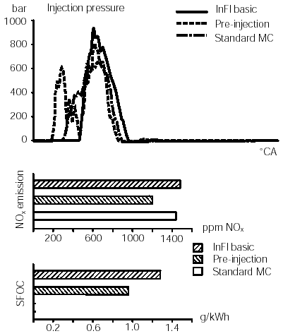
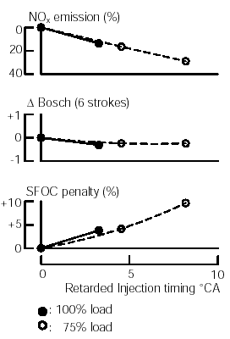

Fig. 2.28 Effect of injection timing on SFOC, Bosch Smoke Number and NOx [2.18]

Fig.2.29 Fuel injection patterns,including
pre-injection and the effects on SFOC and NOx emissions [2.18]

It has been found that changing injection characteristics of the fuel injection, a NOx reduction of about 20% is possible at a fuel penalty of 3.5%, as indicated in Fig. 2.4.9 [2.23]. Obviously, further development work has improved the fuel consumption. Pre-injection can be used to shorten the delay period in medium speed engines and thus decrease temperature and pressure during the early stages of combustion, resulting in reduced NOx [2.12]. Pre-injection can reduce particulates that are increased by other NOx control measures, thus allowing greater flexibility in NOx control.
With pre-injection, a small part of the fuel charge is injected before the main charge in Sulzer RT-Flex common rail engine [2.19]. With triple injection, the fuel charge is injected in separate, short sprays in succession. With sequential injection, each of the three nozzles in a cylinder is actuated with different timing. The results are shown in Fig. 2.30. For HFO, pulsed injection gave about 20% NOx reduction with about 7% increase in fuel consumption. Sequential and pre injection gave less NOx reduction and less fuel consumption increase. Thus, the NOx/fuel consumption trade-off is still a problem. However, the ability to maintain high injection pressure in combination with early exhaust valve closing at low loads with the common rail engine results in low smoke at low loads without having to compromise NOx at other loads.

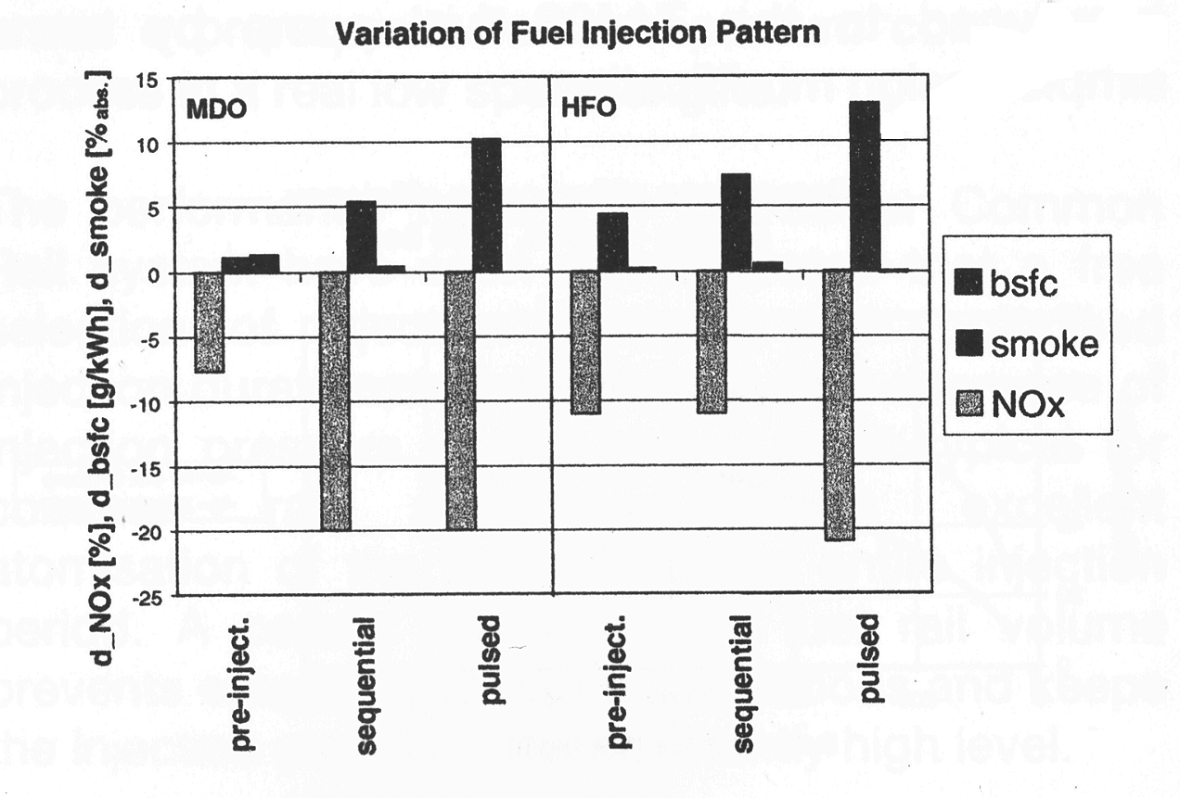

Fig. 2.30: Effects of different injection patterns on Sulzer RT-flex engine [2.19]

Fig. 2.31a: Effects of combined measures applied to RTA engines [2.22]

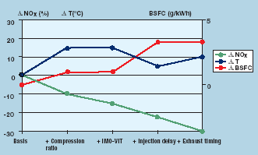

- Increasing compression ratio- The decrease of efficiency by delayed fuel injection can be countered by increasing the compression ratio. This can be accomplished by either increasing the geometric compression ratio or adjusting the valve timing. As valve timing would also increase the excess air ratio, changing the geometric compression ratio is preferred. The maximum NOx reduction that can theoretically be achieved by this measure is approximately 25 percent with an increase in fuel consumption of about 1%.

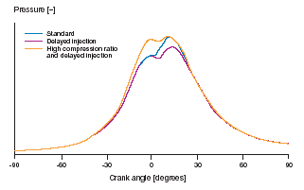

- Changing fuel injection nozzle- The design of nozzles strongly influences the combustion process itself. Orientation and size of the nozzle holes define the depth of penetration and location of the fuel spray, and as a consequence the evaporation process, turbulence, mixing and combustion. Looking at the different geometries of two and four-stroke engines, it becomes evident that the freedom in defining the parameters of the nozzle is greater for two stroke engines.



In four-stroke engines, the central injection together with the flat combustion chamber given by the relatively low stroke-to-bore ratio demands an equal distribution of the holes. With the side injection used in two-stroke engines, the interference of the sprays coming from the two or three nozzles in the combustion chamber can be used to influence the combustion process.

- Changing injection pressure and duration- By changing the diameter of the fuel pump plunger or total fuel nozzle flow area, the maximum injection pressure and duration of injection can be modified. Both parameters influence the penetration of the spray, the break up process of the liquid core exiting the fuel nozzle and the turbulence induced in the combustion chamber. Research shows that injection pressure alone has only a marginal influence on the NO_{x} emissions. A positive effect could be detected by a longer injection period on the engine. Starting from the standard configuration, in the best case up to five percent reduction in NOx could be achieved with every ten percent prolongation of injection, which can be explained by a weaker combustion at the beginning.

- Water addition- Introduces a supply of water into the diesel engine’s fuel delivery mist. This water injection decreases the combustion temperatures and thus reduces NOx emissions to the atmosphere. However, successful field testing has been limited to only one engine type, Wartsila. This technology also requires increased onboard storage space and the associated weight increases necessary for water storage. End users in the marine environment are critically sensitive to decreased storage space and increased weight burden requirements.

- Emulsion- Fuel/Water emulsion is a well known technique for reducing NOx emissions. Running an engine on fuel/water emulsion makes it theoretically possible to reduce NOx emissions by up to 50% with the required water quantity being about one percent for each percentage point reduction in NOx. The limiting factor for fuel/water emulsion is the maximum delivery capacity of the fuel injection pumps so that, in practice, the engine has either to be derated or the maximum achievable reduction of NOx limited to about 10 or 20 per cent. To obtain the maximum NOx reduction also at full load, it may be necessary to redesign not only the injection system but also the camshaft with all the consequences in the camshaft drive, etc. another aspect of fuel/water emulsion is that the injection nozzle design (hole diameter, etc) has to be adapted to the increased quantity of liquid injected. With this modified nozzle design, both fuel consumption and component temperatures may be penalised when the engine is running without water. Additionally, it has to be considered that whereas heavy fuel oil and water can easily be emulsified owing to the small difference in densities, emulsifying gas oil is only possible with the use of an emulsifying agent, entailing additional costs.

The test results of a MAN B&W 6L48/60 engine in February 2000: a NOx cycle value of 7.7 g/kWh and a fuel consumption rate still within tolerance (5%) was measured as shown in Fig. 2.31b. This is 40% below the NOx limit set by the IMO. This result was achieved with only 15% water in the water-fuel emulsion and a slightly retarded injection below 80% engine.
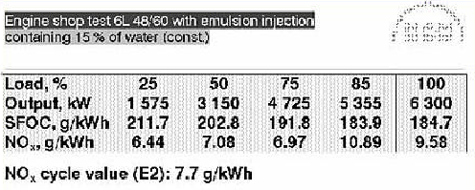
Fig. 2.31b: The test results of a MAN B&W 6L48/60 engine [2.7]

- Direct injection- In this system, the water is handled by a second, fully independent injection system, preferably under electronic control. This offers the possibilities firstly of injecting very large amounts of water without the requirement to derate the engine and secondly to inject the water and fuel injection with different timing. The water can be injected in parallel with the fuel and/or during the compression stroke, so that optimizing injection timing, with respect to fuel and water consumptions, NOx emissions and other emissions, such as hydrocarbons and carbon monoxide, is possible without influencing engine reliability. Independent injection systems also allow water injection to be switched on and off without influencing the fuel injection.

- Exhaust Gas Recirculation (EGR)- Recirculating part of the exhaust gas is an efficient method for reducing NOx emissions. The tendency of exhaust gas recirculation to reduce the formation of NOx is based on three factors:
  - The reduced oxygen concentration obtained by EGR in the combustion air increases the quantity of gas that has to be heated for combustion of the fuel. The resulting lower adiabatic flame temperature reduces the rate of NOx formation. As the average temperature is not influenced when applying cooled EGR, the efficiency of the engine does not deteriorate when the negative effects of the lower oxygen concentration on the combustion process are disregarded.
  - The reduced oxygen concentration also diminishes the reaction between nitrogen and oxygen to form NO, therefore reducing NOx emissions.
  - The inert compounds (such as H₂O and CO₂) recirculated to the engine cylinder have to be heated up during the combustion. At elevated temperatures, the recirculated three-atomic compounds H₂O and CO₂ have an approximately 25% greater heat capacity than air which comprises two-atomic elements, mainly oxygen and nitrogen. This leads to an increase of the overall heat capacity of one to two percent and therefore to a further reduction in local peak temperatures and thus NOx emissions.

