ABB turbochargers - boosting engine power and efficiency
Esko Laustela
Ever since the world’s first heavy-duty exhaust gas turbocharger left the Baden works of the then Brown Boveri in 1924, ABB turbochargers have been helping to raise the bar for engine output and efficiency. New-generation TPS and TPL turbochargers, launched on the market in the late 1990s, not only uphold this tradition but also introduce new technologies that allow future improvements in engine performance as well as compliance with stricter emissions legislation.
Turbocharged diesel engines are a key factor in the world economy. As prime movers or auxiliary engines on ships as diverse as supertankers and fast ferries, they drive trade between nations and contribute to the movement of people. But it is not only the marine sector that relies on these highly efficient machines: generating plants, locomotives and large off-highway vehicles around the world are powered by turbocharged diesel or gas engines.
Engine output is boosted fourfold
In 2004, worldwide demand for new turbocharged diesel engines rated above 500 kW was around 50 gigawatts. More than half of this engine power was for marine vessels, one quarter for stationary power plants, and the rest for traction and other applications. The popularity of the diesel engine in each of these sectors is strongly linked
to the turbocharger, as turbocharging increases engine output by up to four times. Thus, 75 percent of the engine’s power depends on reliable and efficient operation of the turbocharger see textbox 1.

Textbox 1 - How turbocharging works
The output of an internal combustion engine is determined by the amount of air and fuel that can be pressed into its cylinders (1) and by the engine’s speed. Turbochargers supply air to the engine at a high pressure, so more air is forced into the cylinders and is available for combustion.

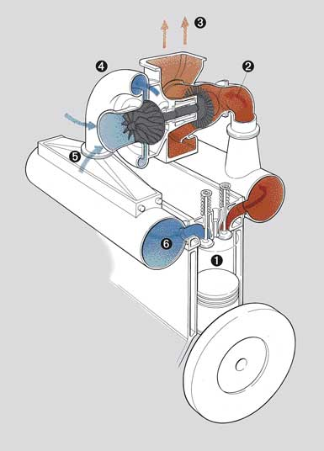

An exhaust gas turbocharger is driven, as its name implies, by the engine’s exhaust gas (2). This gas, at
a temperature approaching 600°C, is directed at high velocity onto the blades of a turbine (3), which drives a compressor wheel (4) mounted on the same shaft. As it rotates, the wheel (or “impeller”), sucks in ambient air through a filter-silencer, compresses it and feeds it via an after-cooler (5) to the engine’s air receiver (6), from where it passes to the cylinders.
Turbocharging increases engine output by up to four times. Thus, 75 percent of the engine’s power is dependent upon the turbocharger functioning efficiently.

Turbocharging not only raises the already high efficiency of diesel and gas engines to an even higher level, but also has important environmental benefits. By reducing fuel consumption, it lowers exhaust-gas emissions and supports end-users in their efforts to meet the stricter regulations that are on the way. Nevertheless, it is the increase in engine power output that is the most striking advantage of turbocharging. The power increase factor corresponds approximately to the pressure ratio of the turbocharger compressor operated at full engine load. 1 shows the statistical mean value of the compressor pressure ratio of ABB turbochargers over the last 45 years.
1 Statistical mean compressor pressure ratio of ABB turbochargers delivered for two- and four-stroke engines over the last 45 years.

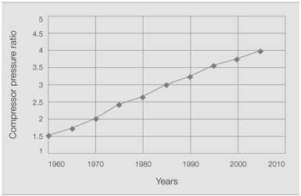

The TPS/TPL generation leap
Extensive market studies in the mid-1980s showed that new, benchmark turbochargers would be needed to meet the changing needs of the engine-building industry. Development of the highly successful VTR, VTC and RR series, of which more than 150,000 units are currently in operation, was reaching its limits. Advanced engines were being developed that required more sophisticated turbochargers. For the new engines, higher pressure ratios and flow rates as well as increased efficiency were required. At the same time, end-users were raising their expectations of high reliability, and calling for longer times between overhauls, easier maintenance and longer lifetime.
ABB therefore began in the early 1990s to develop a new generation of more compact, lighter high-performance turbochargers. Two new families, the TPS for engine ratings from 500 to 3,000 kW, and the TPL for engine applications with outputs from 2,500 kW up to the highest in the business, were designed from the ground up.
TPS turbochargers
The TPS is an entirely new generation of small, heavy-duty turbochargers catering to the foreseeable needs of future high-speed and small, medium-speed diesel and gas engine applications. The performance of these new turbochargers is considerably better than that of machines of comparable size and weight from the RR series, while they also achieve much higher efficiencies than the VTC and small VTR units.
Two different compressors were developed, the D-version for pressure ratios up to 4.2 at maximum continuous rating, and the E-version for pressure ratios up to 4.5. High airflow rates are ensured by a splitter bladed impeller with backswept blades at the exit 2 that also guarantee a wide compressor map. Peak efficiencies of more than 84 percent can be achieved.
2 TPS..-E compressor and turbine.

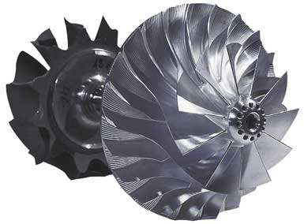

For the TPS range, ABB developed a brand-new mixed flow turbine that can be used for constant pressure as well as pulse turbocharging. The nozzle ring can be supplied with a special coating to allow applications in which low-quality fuel is used. A new oil-cooled bearing casing allows the TPS to be used for applications with turbine inlet temperatures of up to 680°C at constant load.
ABB has delivered more than 12,000 TPS turbochargers since their introduction to the market in the late 1990s.
TPS..-F
The continuing trend in engine development towards higher specific power goes hand in hand with an urgent need to reduce emissions, and this has led to most modern engines having some version of the so-called Miller cycle incorporated in it (see textbox 2). For these and future advanced engines, ABB has developed three new series. The first, denoted TPS..-F33 3 was introduced to the market in 2000/2001, being followed two years later by the TPS..-F32, and in 2004 by the TPS..-F31. Based on the TPS..-D/E platform, they achieve full-load pressure ratios of up to 4.75, 5.0 and 5.2, respectively, with an aluminium compressor wheel. Four frame sizes cover the engine power range of 500 to 3,300 kW.

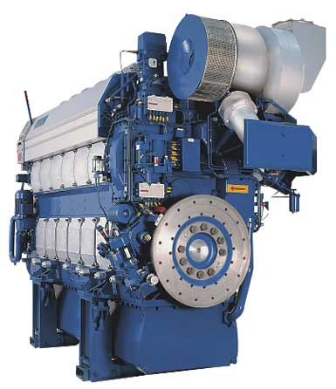

Textbox 2 - Engine emissions and Miller timing
The first years of the new millennium have seen an unbroken trend in diesel engine development towards higher brake mean effective pressures and lower fuel consumption. However, this trend has been accompanied by closer scrutiny of the environmental impact of marine traffic, and especially of diesel engine emissions. With tougher legislation definitely now on the way, turbochargers offering even higher compressor pressure ratios are going to be needed for compliance.
An issue that is inseparable from the industry’s efforts to reduce engine emissions is “Miller timing”, ie. early or late closing of the inlet valve. Providing the engine output and boost pressure are constant, the cylinder filling is then reduced and the pressure and temperature in the cylinders remain lower throughout the process. Miller timing is one of the few measures that can be applied in an internal combustion engine to simultaneously reduce NOx emissions and fuel consumption. A considerably higher boost pressure is, however, needed to reduce the temperature in the engine’s cylinders during the Miller process.
The new compressor stages developed for the TPS..-F allowed a 15 percent increase in the flow rates that can be covered by a given impeller size. This was achieved by adopting the same approach to the compressor design as for the TPL. Instead of conventional “trimming”, whereby the blade size is adjusted to obtain the required flow rates, the volume flow area for each turbocharger was divided into three so-called design areas. Different, individual performance targets were formulated for these areas to ensure an optimal compressor design within the physical limits of each one.
The TPS..-F was also the first ABB turbocharger to feature recirculation technology – a bleed slot around the compressor wheel which, by improving the flow field, increases the surge margin. The effect of this slot is to enlarge the map width without compromising the compressor’s high efficiency.
TPS with variable turbine geometry
Special requirements in the diesel and gas engine markets also led in the mid-1990s to a version of the TPS with variable turbine geometry (VTG).
One reason was the increasing popularity of single-pipe exhaust systems for diesel engines. Using conventional turbochargers with these systems tends to make part-load operation difficult and results in poor load response and high particle and smoke emissions.
Gas engine performance had also progressed impressively due to increased efficiency and bmep, high altitude capability and controlled air-to-fuel ratios. However, it was not possible to simply use conventional turbochargers with these gas engines, either. Solutions ranged from installing a waste gate or throttle mechanism to special matching of the turbocharger, but each of these had its drawbacks. Demand for a turbocharger that would solve the problem was especially strong in the 1,000 kW to 3,000 kW market segment.
ABB turbochargers are in use on all the world’s seas. They operate in the Australian outback, in the Antarctic, below the waves in submarines and at altitudes of 4,000 meters above sea level.

Variable turbine geometry 4 was seen to be the ideal solution for both types of engine. Apart from eliminating the losses occurring with a waste gate, a turbocharger with VTG is more flexible in applications with varying operating or ambient conditions. Precise control of the air-to-fuel ratio, so-called “lambda regulation”, is achieved with an innovative nozzle ring that enables the effective turbine area to be varied without any significant drop in turbine efficiency. The clearances for the movable nozzle blades are reduced almost to zero by springs that push the blades against the opposing casing wall.

4 Variable nozzle ring of a TPS57 VTG turbocharger.

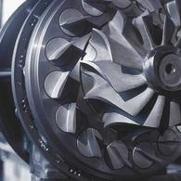
TPL turbochargers
The TPL concept was developed as a platform for large modern diesel and gas engines with outputs from 2,500 kW upwards. For this family, ABB developed a new axial turbine family with the blade lengths and stagger angles needed to cover the entire volume flow range. A unique feature of the TPL is the new bearing assembly with free-floating thrust disk. Two new, different centrifugal compressor stages were also developed to ensure the full range of pressure ratios required by modern turbocharged engines. The optimized aerodynamic design of the TPL compressor, like that of the TPS compressor, features a splitter bladed impeller for high airflow rates as well as backswept blades at the impeller exit for a wide compressor map. A large range of turbine inlet casings, including optional waste gate connections, was also developed to enable the TPL to be used with all turbocharging systems currently in use 5.

5 TPL80 turbocharger.
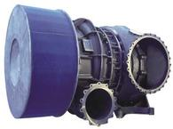
The price of oil is defining trends in diesel engine development toward higher boost pressures and higher efficiencies.
Development goals for the future
The continual improvements in turbocharger and engine efficiency have always relied on close cooperation and the exchange of information between ABB and the leading engine-builders. It is this cooperation which defines the development goals and which will, in all probability, become closer as the demands made on the “turbocharging system”, and not just the turbocharger as a component, increase. Adjustable turbocharger components or multi-stage turbocharging are two of the possibilities here. As in the past, ABB will make the results of sophisticated simulations available to customers wherever this promises to take turbocharger development forward and bring benefit to both.
That there is a need for further development goes without saying. End-users will demand reductions in diesel engine emissions as international regulations tighten. And with fuel prices unlikely to move much from their present high level, it will be up to the engine-builders, and with them the turbocharger manufacturer, to ensure highest efficiency for these “prime’movers” of the world economy.
Esko Laustela
ABB Turbo Systems Ltd.
Baden, Switzerland
esko.laustela@ch.abb.com

Reference:

http://www.abb.se/global/gad/gad02077.nsf/lupLongContent/EDDB5B1DFCC390BCC125706900437CBE

