Bachelor Degree in Maritime Operations (BMO)

DIESEL TECHNOLOGY & EMISSIONS

MA 9022

Unit 3: Marine Diesel Fuel

Done By:

- Jannell Toh
- Pururav Nagaraj
- Celeste Yeong

Date:
11 July 2006

This assignment is done in the filfument of Bachelor Degree in Maritime Operations for Diesel Technology and Emission Unit 3…

- Briefly describe characteristics of marine diesel fuels. (http://www.caltex.com.my/products/fuels_marine.htm#marine)

Diesel fuels, for use in low and medium speed diesel engines in stationary and marine services. They have satisfactory cetane index, flow characteristics, and sulphur content for these engines and provide good economy in use. They may also be used as a burner fuel in commercial and industrial installations.

- State and explain ideal properties and characteristics of marine diesel fuel.
(http://www.me.iastate.edu/biodiesel/Pages/biodiesel15.html)

Ideal diesel fuel should ensure:

Ease of start-up
Low wear (lubricity)
Sufficient power
Low temperature operability
Low noise
Long filter life (stability)
Good fuel economy
Low emissions

Lower sulphur levels often results in lighter and thinner diesel fuels
Improved lubricity can reduce the rate of deterioration of injection spray holes.
New injectors will stay much longer if fed with higher lubricitity clean diesel, Improves viscosity and lubicity.
Reductions in diesel viscosity and lubricity can reduce the film thickness to a point where metal to metal contact occurs
Process is accelerated with thinner fuels of lower viscosity.
Wear in the sliding area, between Plunger and the Barrel, will result in a reduction in the injection pressure through the spray holes, and poorer atomization. Squirting and dribbling are believed to be the cause of the very premature failures, associated with liner glazing and excessive carbon build up around the rings. Worn material cannot be replaced but increased lubricity and viscosity , between the Barrel and the Plunger, can elliminate slow response and stiction

Diesel fuel is characterized in the United States by the ASTM standard D 975 which five grades of diesel fuel.
Grade No. 1-D and Low Sulfur 1-D:
A light distillate fuel for applications requiring a higher volatility fuel for rapidly fluctuating loads and speeds as in light trucks and buses. The specification for this grade of diesel fuel overlaps with kerosene and jet fuel and all three are commonly produced from the same base stock. One major use for No. 1-D diesel fuel is to blend with No. 2-D during winter to provide improved cold flow properties. Low sulfur fuel is required for on-highway use with sulfur level < 0.05%.
Grade No. 2-D and Low Sulfur 2-D:
A middle distillate fuel for applications that do not require a high volatility fuel. Typical applications
are high-speed engines that operate for sustained periods at high load. Low sulfur fuel is required for on-highway use with sulfur level < 0.05%.
Grade No. 4-D:
A heavy distillate fuel that is viscous and may require fuel heating for proper atomization of the fuel. It is used primarily in low and medium speed engines.
ASTM D975 specifies the property values shown in Table 1 for these grades of diesel fuel. The surprising aspect about ASTM D 975 is how few requirements are actually included. The standard says nothing about the composition of the fuel or its source. It only defines some of the property values needed to provide acceptable engine operation and safe storage and transportation.

Table 1. Requirements for Diesel Fuel Oils (ASTM D 975-97)
 | Grade | Grade | Grade | Grade | Grade
Property | LS #1 | LS #2 | No. 1-D | No. 2-D | No. 4-D
Flash point °C, min | 38 | 52 | 38 | 52 | 55
Water and sediment, % vol, max.
Water and sediment, % vol, max. | 0.05 | 0.05 | 0.05 | 0.05 | 0.50
Distillation temp., °C, 90%
Min. | -- | 282 | -- | 282 | --
Max. | 288 | 338 | 288 | 338 | --
Kinematic Viscosity,
Mm²/s at 40°C
Min. | 1.3 | 1.9 | 1.3 | 1.9 | 5.5
Max. | 2.4 | 4.1 | 2.4 | 4.1 | 24.0
Ramsbottom carbon residue,
on 10%, %mass, max. | 0.15 | 0.35 | 0.15 | 0.35 | --
Ash, % mass, max. | 0.01 | 0.01 | 0.01 | 0.01 0.10
Sulfur, % mass, max | 0.05 | 0.05 | 0.50 | 0.50 2.00
Copper strip corrosion,
Max 3 hours at 50°C | No. 3 | No. 3 | No. 3 | No. 3 | --
Cetane Number, min. | 40 | 40 | 40 | 40 | 30
One of the following
Properties must be met:
(1) cetane index | 40 | 40 | -- | -- | --
(2) Aromaticity,
% vol, max | 35 | 35 | -- | -- | --

The cloud point, (°C, max.) is also included in ASTM D975, however, the actual values are determined by the local climate. Should be 6ºC higher than the tenth percentile minimum ambient temperature for the region. For Iowa the values for each month are:
Month 10th % minimum temp
Oct -2º
Nov -13
Dec -23
Jan -26
Feb -22
Mar -16

- Briefly explain the formation of the following air pollutant and their effects to the environment.
(http://www.chevron.com/products/prodserv/fuels/bulletin/diesel/L2_3_4_fs.htm)
(http://en.wikipedia.org/wiki/)

- Volatile organic compound
Volatile organic compound are organic chemical compounds that have high enough vapour pressures under normal conditions to significantly vaporize and enter the atmosphere. (The term VOC is also occasionally used as an abbreviation, especially in biological contexts, for "volatile organic carbon".) A wide range of carbon-based molecules, such as aldehydes, ketones, and hydrocarbons are VOC's
Common artificial sources of VOCs include paint thinners, dry cleaning solvents, and some constituents of petroleum fuels (eg. gasoline and natural gas). Trees are also an important biological source of VOC. It is also known that trees emit large amounts of VOCs especially isoprene and terpenes. Significant biological sources of methane are termites, cows (ruminants) and cultivation (estimated emissions 15, 75 and 100 million tons per year respectively).

VOCs are an important outdoor air pollutant. In this field they are often divided up into the separate categories of methane (CH₄) and non-methane (NMVOCs). Methane is an extremely efficient greenhouse gas which contributes to enhanced global warming. Other hydrocarbon VOCs are also significant greenhouse gases via their role in creating ozone and in prolonging the life of methane in the atmosphere, although the effect varies depending on local air quality. Within the NMVOCs, the aromatic compounds benzene, toluene and xylene are suspected carcinogens and may lead to leukaemia through prolonged exposure. 1,3-butadiene is another dangerous compound which is often associated with industrial uses.
Some VOCs also react with nitrogen oxides in the air in the presence of sunlight to form ozone. Although ozone is beneficial in the upper atmosphere because it absorbs UV thus protecting humans, plants, and animals from exposure to dangerous solar radiation, it poses a health threat in the lower atmosphere by causing respiratory problems. In addition high concentrations of low level ozone can damage crops and buildings.
The EPA estimates that, nationwide, about equal quantities of VOC emissions come from manmade and natural sources. Diesel engines accounted for only about 5% of the manmade VOC emissions in 1996 (see Figure 3-3).
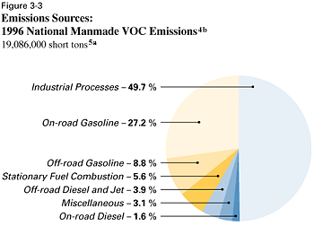
- CO

Carbon monoxide, chemical formula CO, is a colorless, odorless, tasteless, and highly toxic gas. It is a major product of the incomplete combustion of carbon and carbon-containing compounds.

Carbon monoxide is formed by combustion of carbon in oxygen at high temperatures when there is an excess of carbon. It is also formed with a byproduct oxygen by decomposition of carbon dioxide at very high temperatures (above 2,000 °C), as it is more stable oxide than CO₂ in high temperatures. It is present in the exhaust of internal-combustion engines, such as those found in automobiles; and is generated in coal stoves, furnaces, and gas appliances functioning in low-oxygen environments (often due to insufficient ventilation.)

Carbon monoxide from automobile and industrial emissions is a dangerous pollutant that may contribute to the greenhouse effect and global warming. In urban areas carbon monoxide, along with aldehydes, reacts photochemically to produce peroxy radicals. Peroxy radicals react with nitrogen oxide to increase the ratio of NO₂ to NO, which reduces the quantity of NO that is available to react with ozone. Carbon monoxide is also a constituent of tobacco smoke

Carbon monoxide is dangerous and life-threatening to humans and other forms of air-breathing life, as inhaling even relatively small amounts of it can lead to hypoxic injury, neurological damage, and possibly death.

Early symptoms of carbon monoxide poisoning include drowsiness and headache, followed by unconsciousness, respiratory failure, and death.

The EPA estimates that diesel engines were responsible for about 5% of the manmade CO emissions in 1996 (see Figure 3-4). CO's toxicity stems from its ability to reduce the oxygen carrying capacity of blood by preferentially bonding to hemoglobin.

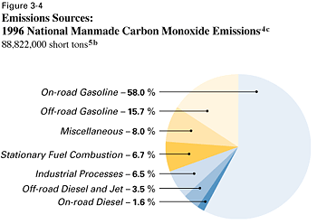

- NO2

NO_{x} is a generic term for the various nitrogen oxides produced during combustion. They are believed to aggravate asthmatic conditions, react with the oxygen in the air to produce ozone, which is also an irritant and eventually form nitric acid when dissolved in water. When dissolved in atmospheric moisture the result can be acid rain which can damage both trees and entire forest ecosystems.

Diesel engines mainly produce NOx by "burning" a small amount of the nitrogen in the air drawn into the cylinder. At the high temperatures encountered in a diesel combustion chamber, the nitrogen combines with oxygen to form NOx. The formation of NOx becomes significant at about 2900°F (1600°C) and increases rapidly as the temperature rises above this threshold.
Any organic nitrogen in the fuel also contributes to NOx emissions, but this source is miniscule compared to nitrogen in the air. Combustion chamber deposits increase NOx emissions slightly. The deposits are believed to raise the combustion temperature because they act as thermal insulators, reducing heat loss to the combustion chamber walls.
The air quality standard applies only to NO2, but where emissions are concerned, NO and NO2 are usually analyzed simultaneously and expressed as NOx. Most (94%) of the NOx emissions are manmade. The EPA estimates that diesel engines generated about 27% of the manmade NOx emissions in 1996 (see Figure 3-5).

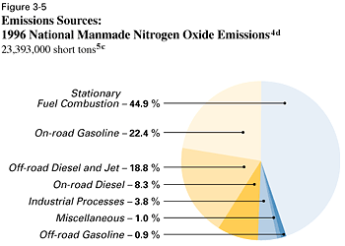

- SO2

SO2 is produced primarily by the combustion of fuels containing sulfur. Facilities (stationary sources) that burn fuel oil and coal are the major source. On-road and off-road engine fuels are estimated to be the source of less than 3% of the total SO2 emissions.
SO2 is a moderate lung irritant. Along with NOx, it is a major precursor to acidic deposition (acid rain).
- Particulate Matter (PM10 and PM2.5)

PM emissions are mainly the result of the heterogeneous nature of diesel combustion. When fuel is injected into hot compressed air in the cylinder, regions develop that are fuel-rich and oxygen deficient. Because of the high temperature and pressure in the cylinder, the fuel may start to break down before it has a chance to mix with air and burn normally. These high temperature cracking reactions (pyrolysis) lead to the formation of carbonaceous soot particles. Unburned or partially burned fuel can condense on these particles, increasing their size and mass. Finally, these particles can stick together (agglomerate) to create visible smoke.

PM10 is particulate matter with a particle size less than or equal to 10 microns (0.0004 inch) and PM2.5 has a particle size less than or equal to 2.5 microns (0.0001 inch). The EPA estimates that fugitive dust from roads accounts for about two-thirds of the total PM10 nationwide. Less than 2% of PM10 is attributed to on-road and off-road engines, but the percentage is higher in urban areas where there is less dust and more combustion sources. Particulates from diesel engines include primary carbon particles and secondary sulfate and nitrate aerosols formed from SO2 and NOx.
After a review of scientific evidence of the health effects of particulate matter, the EPA recently established a new standard for PM2.5. The EPA found that while both coarse and fine particles can increase respiratory symptoms and impair breathing, fine particles are more likely to contribute to serious health effects. Most of the particulate emissions from diesel engines are smaller than 2.5 microns.
- Ozone

Ozone (O₃) is a triatomic molecule consisting of three oxygen atoms. It is an allotrope of oxygen (O₂), a much more stable diatomic molecule. Ozone is a pale blue gas at standard temperature and pressure, and one of the most toxic inorganic compounds known to science. It forms a dark blue liquid below −112 °C and a dark blue solid below −193 °C. Ozone is a powerful oxidizing agent. It is also unstable, decaying to ordinary oxygen through the reaction: 2 O₃ → 3 O₂. This reaction proceeds more rapidly with increasing temperature and decreasing pressure.

Ozone is not directly emitted by car engines or by industrial operations themselves. These sources emit hydrocarbons and nitrogen oxides that react with sunlight to form ozone directly at the source of the pollution being emitted and in the atmosphere's boundary layer (1 to 3 km altitude). The mix of hydrocarbons, nitrogen oxides, and ozone are the major components of smog that frequently occurs in urban and suburban areas.

There is a great deal of evidence to show that ozone at the earth's surface can harm lung function and irritate the respiratory system. Ozone has been found to convert cholesterol in the blood stream to plaque (which causes hardening and narrowing of arteries). This cholesterol product has also been implicated in Alzheimer's disease, suggesting a link between the inflammatory response associated with head injury and Alzheimer's.

There is also evidence of significant reduction in agricultural yields due to increased ground-level ozone which interferes with photosynthesis and stunts overall growth of some plant species.

Ozone reacts directly with some hydrocarbons such as aldehydes and thus begins their removal from the air, but the products of ozonolysis are themselves key components of smog. Ozone photolysis by UV light leads to production of the hydroxyl radical and this plays a part in the removal of hydrocarbons from the air, but is again a step in the creation of components of smog such as peroxyacyl nitrates which are powerful eye irritants. Ultimately, ozone is one component of smog which is harmful in itself and contributes both to the production and ultimate removal of other air pollutants.

Ground-level ozone is formed by the interaction of volatile organic compounds (VOC), oxides of nitrogen (NOx), and sunlight The role of sunlight explains why the highest concentrations of ozone in the atmosphere occur in the summer months and why there is a diurnal pattern to the concentrations, with the highest concentrations occurring in the afternoon and lower concentrations at night.

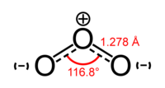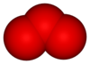
- Briefly state the high value products of an crude oil refining process.
(http://science.howstuffworks.com/oil-refining4.htm)
(http://en.wikipedia.org/wiki/Image:Crude_Oil_Distillation.png)
(http://en.wikipedia.org/wiki/Oil_refinery#Products_of_oil_refinery)
(http://www.chevron.com/products/prodserv/fuels/bulletin/diesel/L2_4_2_fs.htm)

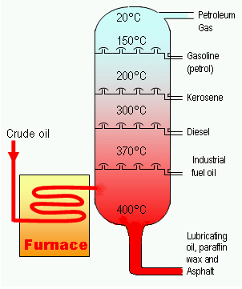

The high value products of a crude oil refining process are as follows:-

- Asphalt is a sticky, black and highly viscous liquid or semi-solid that is present in most crude petroleum’s and in some natural deposits. Asphalt is composed almost entirely of bitumen. There is some disagreement amongst chemists regarding the structure of asphalt, however it is most commonly modeled as a colloid, with asphaltenes as the dispersed phase and maltenes as the continuous phase.

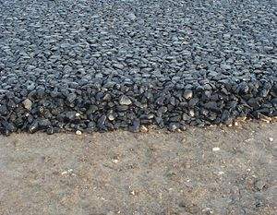
Base layer of asphalt in a road under construction.

- Diesel or Diesel fuel is a specific fractional distillate of fuel oil (mostly petroleum) that is used as fuel in a diesel engine invented by German engineer Rudolf Diesel. The term typically refers to fuel that has been processed from petroleum, but increasingly, alternatives such as biodiesel or biomass to liquid (BTL) or gas to liquid (GTL) diesel that are not derived from petroleum are being developed and adopted.

- Fuel oil is a fraction obtained from petroleum distillation, either as a distillate or a residue. Broadly speaking, fuel oil is any liquid petroleum product that is burned in a furnace for the generation of heat or used in an engine for the generation of power, except oils having a flash point of approximately 40 °C (about 100 °F) and oils burned in cotton or wool-wick burners. In this sense, diesel is a type of fuel oil. Fuel oil is made of long hydrocarbon chains, particularly alkanes, cycloalkanes and aromatics. Factually and in a stricter sense, the term fuel oil is used to indicate the heaviest commercial fuel that can be obtained from crude oil, heavier than gasoline and naphtha.

- Gasoline (or petrol) is a petroleum-derived liquid mixture consisting primarily of hydrocarbons, used as fuel in internal combustion engines.

Many Commonwealth countries use the term petrol (abbreviated from petroleum spirit). The term gasoline is commonly used in North America. The word is commonly shortened in colloquial usage to "gas" (see other meanings). The term mogas, short for motor gasoline, for use in cars is used to distinguish it from avgas, aviation gasoline used in light aircraft. This should be distinguished in usage from genuinely gaseous fuels used in internal combustion engines such as hydrogen. Contrary to common belief, it is not the liquid that is flammable, but the fumes which it gives off.

- Kerosene or paraffin oil is a colorless flammable hydrocarbon liquid. Kerosene is obtained from the fractional distillation of petroleum at 150°C and 275°C (carbon chains from the C12 to C15 range).

- Liquified petroleum gas (also called liquefied petroleum gas, liquid petroleum gas, LPG, LP Gas, or autogas) is a mixture of hydrocarbon gases used as a fuel in heating appliances and vehicles, and increasingly replacing chlorofluorocarbons as an aerosol propellant and a refrigerant to reduce damage to the ozone layer. Varieties of LPG bought and sold include mixes that are primarily propane, mixes that are primarily butane, and mixes including both propane and butane, depending on the season—in winter more propane, in summer more butane. Propylene and butylenes are usually also present in small concentration. A powerful odorant, ethanethiol, is added so that leaks can be detected easily. LPG is manufactured during the refining of crude oil, or extracted from oil or gas streams as they emerge from the ground.

- Lubricating oils are an essential part of modern machinery. Everything from computer hard disk drives to the Airbus A380 requires lubrication of its moving parts.

A lubricant (colloquially, lube, although this may also refer to personal lubricants) is a substance (usually a liquid) introduced between two moving surfaces to reduce the friction and wear between them. A lubricant provides a protective film which allows for two touching surfaces to be separated, thus lessening the friction between them.

Typically lubricants contain 90% base oil (most often petroleum fractions, called mineral oils) and less than 10% additives. Vegetable oils or synthetic liquids such as hydrogenated polyolefins, esters, silicone, fluorocarbons and many others are sometimes used as base oils. Additives deliver reduced friction and wear, increased viscosity, resistance to corrosion and oxidation, aging or contamination, etc.

- Paraffin Wax is a common name for a group of high molecular weight alkane hydrocarbons with the general formula C_{n}H_{2n+2}, where n is greater than about 20, discovered by Carl Reichenbach. In the UK, as well as in most Commonwealth countries, the fuel known in the U.S. as kerosene is called paraffin oil (or just paraffin), and the solid forms of paraffin are called paraffin wax.

Paraffin is also a technical name for an alkane in general, but in most cases it refers specifically to a linear, or normal alkane, while branched, or isoalkane are also called isoparaffins. The name is derived from the Latin parum (= barely) + affinis with the meaning here of "lacking affinity", or "lacking reactivity").

- Tar is a viscous black liquid derived from the destructive distillation of organic matter. Most tar is produced from coal as a byproduct of coke production, but it can also be produced from petroleum, peat or wood. The use of the word "tar" is frequently a misnomer. Naturally occurring "tar pits" (e.g. the La Brea Tar Pits in Los Angeles) actually contain asphalt, not tar, and are more accurately known as asphalt pits. Tar sand deposits contain bitumen rather than tar, as does the Tar Tunnel in Shropshire. "Rangoon tar", also known as "Burmese Oil" or "Burmese Naphtha", is actually petroleum. In English and French, "tar" means primarily the coal derivative, but in northern Europe, it refers primarily to the wood distillate, which is used in the flavoring of candy (among other things).

THE MODERN REFINERY

A schematic layout of a modern, fully integrated refinery is shown in Figure 4-1 (the diesel fuel related streams are highlighted). Crude oil is fed to the distillation column where straight-run naphtha,
kerosene, and diesel are separated at atmospheric pressure.

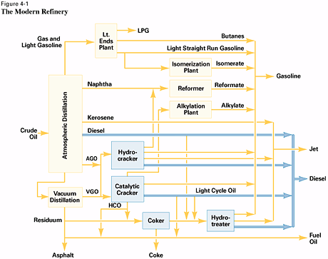

The bottoms from the atmospheric column are vacuum distilled to obtain VGO for FCC or hydrocracker feed. The VGO may be hydrotreated to reduce sulfur and nitrogen to levels that will improve the performance of the FCC process.
Previously, the vacuum resid might have been used as a low value, high sulfur fuel oil for onshore power generation or marine fuel. But to remain competitive, refiners must wring as much high value product as possible from every barrel of crude. As a result, the vacuum resid may be sent to a resid conversion unit, such as a resid cracker, solvent extraction unit, or coker. These units produce additional transportation fuel or gas oil, leaving an irreducible minimum of resid or coke
Refining Flow Diagram
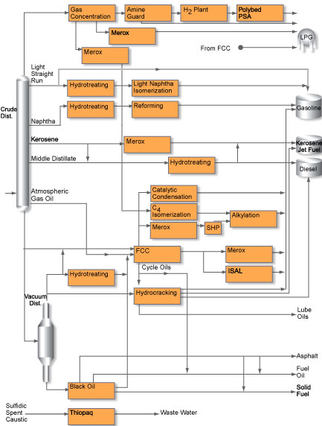

(http://www.uop.com/refining/1010.html)

REFINING
(http://www.dit.ie/DIT/science/chemistry/rsccomp/competition02/entry1/oil.html)

Crude oil is rarely used in its raw form but must instead be processed into its various products. Aside from contaminant minerals such as sulfur and small amounts of trace metals--which are removed during refining--petroleum is composed of hydrocarbons, essentially varying combinations of carbon and hydrogen atoms; any hydrocarbon can be converted into any other given the appropriate application of energy, chemistry, and technology. The smaller the molecule and the lower the ratio of carbon to hydrogen, the lighter the hydrocarbon, the lower the evaporation temperature, and, usually, the more valuable the product.

Every crude oil contains a mix of these different hydrocarbons, and the two tasks of a refinery are to separate them out into usable products and to convert the less desirable hydrocarbons into more valuable ones.

The tall metal towers that characterize petroleum refineries are distillation, or fractionating, towers. Distillation is the primary method used to refine petroleum. When the heated crude oil is fed into the lower part of a tower, the lighter oil portions, or fractions, vaporize. Losing temperature as they rise, they condense into liquids, which flow downward into the higher temperatures and are revaporized. This process continues until the various fractions have achieved the appropriate degrees of purity. The lighter fractions, like butane, gasoline, and kerosene, are tapped off from the top; heavier fractions, like fuel and diesel oils, are taken from below.

At more complex refineries the less valuable products of distillation are refined once again through various conversion processes, broadly referred to as "cracking." Through the application of vacuum, heat, and catalysts, larger, heavier molecules are broken down into lighter ones. Thermal cracking, for instance, uses heat and pressure, while catalytic cracking employs a finely powdered catalyst, and hydrocracking involves the addition of hydrogen to produce compounds with lower carbon to hydrogen ratios, such as gasoline. Other processes produce high-octane products for blending with fuels, remove undesirable constituents, or make special petroleum compounds, including lubricants.
Petroleum products are usually distributed from the refinery in the form in which they are to be used. Depending on the geographical location, customer demand, and seasonal needs, refiners can substantially alter their production. In winter, for example, less gasoline and more heating oil is produced.

The chief refinery products are liquefied petroleum gas (LPG); gasoline and jet fuel; petroleum solvents; kerosene; the so-called middle distillates, including heating oil and diesel fuel (known as gasoil outside the United States); residual fuel oil; and asphalts (bitumens), the heaviest fractions. In the United States, with its high demand for gasoline, refineries typically upgrade their products much more than in other areas of the world, where the heavy end products, like residual fuel oil, are used in industry and power generation.

Petroleum products are used to produce petrochemicals, which are the costliest of all petroleum derivatives. In petrochemical production, oil distillation products are broken down by cracking them into light, unsaturated gases, which are then recombined to yield intermediate products, such as ethanol, styrene, ethyl chloride, butadiene, and methanol. These intermediates are used for the manufacture of plastics, synthetic rubbers, synthetic fibers, and other products. There are many advantages to making the first conversion in a refinery, and the oil industry has undertaken chemical manufacture on a large scale .
The refinery industry originally was concentrated in or near the oil fields, in part because natural gas, which could not then be economically transported long distances, was available to fuel the highly energy-intensive refining process. The combination of cheap oil, larger crude tankers, and concern about refinery security--particularly after the 1951 nationalization in Iran shut down the world's largest refinery at Abadan--led to the shifting of the refining industry to the major consuming nations. After the oil price shocks of the 1970s relatively cheaper natural gas and the exporting nations' desire to export the highest value-added product possible have meant a new movement of the refining industry back to the oil-producing areas.

- Briefly explain the differences of the following four classes of hydrocarbons. Give an example of each.
(http://www.chevron.com/products/prodserv/fuels/bulletin/diesel/L2_4_4_rf.htm)
Hydrocarbons are organic compounds composed entirely of carbon and hydrogen atoms. There are four major classes of hydrocarbons: paraffins, naphthenes, olefins, and aromatics. Each class is a family of individual hydrocarbon molecules that share a common structural feature, but differ in size (number of carbon atoms) or geometry. The classes also differ in the ratio of hydrogen to carbon atoms and in the way the carbon atoms are bonded to each other.

- Paraffins
Paraffins have the general formula CnH2n+2, where "n" is the number of carbon atoms (carbon number) in the molecule. There are two subclasses of paraffins: normal paraffins and isoparaffins.
Normal paraffins have carbon atoms linked to form chain-like molecules, with each carbon – except those at the ends – bonded to two others, one on either side. Isoparaffins have a similar carbon backbone, but they also have one or more carbons branching off from the backbone. Normal decane and 2,4-dimethyloctane have the same chemical formula, C10H22, but different chemical and physical properties. Compounds like this, with the same chemical formula but a different arrangement of atoms, are called structural isomers
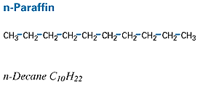

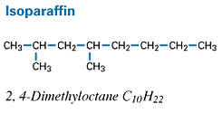

- Naphthenes

Naphthenes have some of their carbon atoms arranged in a ring. The naphthenes in diesel fuel have rings of five or six carbons. Sometimes two or more rings are fused together, with some carbons shared by adjacent rings. Naphthenes with one ring have the general formula CnH2n.

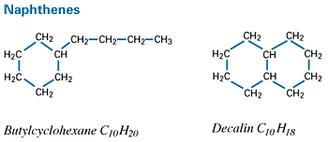

- Olefins

Olefins are similar to paraffins but have fewer hydrogens and contain at least one double bond between a pair of carbon atoms. Olefins rarely occur in crude oil; they are formed by certain refinery processes. Like paraffins, olefins with four or more carbons can exist as structural isomers. Olefins with one double bond have the general formula CnH2n, the same as naphthenes.

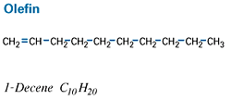

- Aromatics

As with naphthenes, some of the carbon atoms in aromatics are arranged in a ring, but they are joined by aromatic bonds, not the single bonds found in naphthenes. Aromatic hydrocarbon rings contain six carbon atoms. Benzene is the simplest aromatic compound. The benzene structure was originally conceptualized as two equivalent structures with alternating single and double bonds. Each structure continually transformed itself into the other as the double bonds flipped back and forth between different pairs of carbon atoms. Now, we know that all the carbon to carbon bonds in benzene are equivalent. The shorthand representation of benzene is a hexagon with a circle inside representing the aromatic bonds. One-ring aromatics have the general formula CnH2n-6. Polycyclic aromatics are compounds with two or more aromatic rings. These rings are often fused together, with some carbons being shared by adjacent rings.

Can cause lung cancer - caringenognic
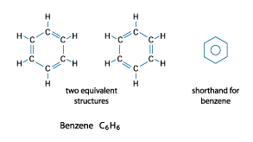
- State the major difference of saturated and unsaturated hydrocarbons.
(http://www.ilpi.com/msds/ref/hydrocarbon.html)
(http://genchem.rutgers.edu/org.html)
(http://chemed.chem.purdue.edu/genchem/topicreview/bp/1organic/organic.html#unsaturated)
(http://mchi.mcallenisd.org/www/mchi/site/hosting/ipc/ipc/ipcch21htm/ipcch21sec1.htm)
(http://www.tef.marmara.edu.tr/makine/gurcan/enerji/industry/dictu.htm)

Main difference between saturated and unsaturated hydrocarbons:
- Bonding - Saturated molecules contains only sing-boned carbons atoms while unsaturated molecules contains contains C=C double bonds and/or CðC triple
- Susceptible to oxidation - Unsaturated molecules are more susceptible to oxidation than saturated molecules.
- Reactivity - Unsaturated molecules are more reactive than saturated molecules.
- Stability – Saturated molecules are more chemically stable than unsaturated molecules.

Hydrocarbons:
An hydrocarbon is an organic chemical compound that is comprised only of carbon (C) and hydrogen (H) atoms. Many oils, fats, waxes, solvent and paraffin are either hydrocarbons or contain large hydrocarbon sub-units.

It can be classified as:
Saturated (unreactive) – hydrocarbons containing only sing-bonded carbons atoms. It is saturated with respect to hydrogen and cannot combine with the atoms of other elements without giving up hydrogen. The saturated hydrocarbons are also known as alkanes with the basic formula CnH2n+2. The more carbon atoms in a chain the higher the boiling point.

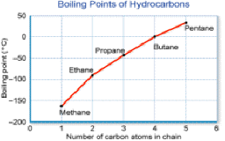
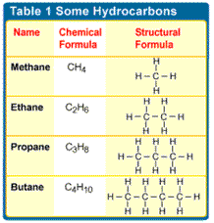

The simplest alkane is methane: CH₄. The Lewis structure of methane can be generated by combining the four electrons in the valence shell of a neutral carbon atom with four hydrogen atoms to form a compound in which the carbon atom shares a total of eight valence electrons with the four hydrogen atoms.
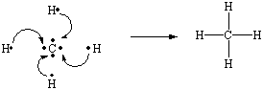

Unsaturated (reactive) - hydrocarbons that contains C=C double bonds and/or CðC triple bonds, and therefore contains less hydrogen than a saturated hydrocarbon. These bonds may be broken and new atoms attached without disrupting the existing skeleton of the hydrocarbon.. Unsaturated hydrocarbons readily attract additional hydrogen, oxygen, or other atoms, and are therefore highly reactive. Compounds that contain C=C double bonds were once known as olefins (literally, "to make an oil") because they were hard to crystallize. (They tend to remain oily liquids when cooled.) These compounds are now called alkenes. The simplest alkene has the formula C₂H₄ and the following Lewis structure.
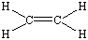

Saturated and Unsaturated Hydrocarbons
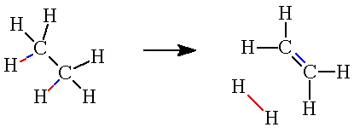

- Briefly describe the following diesel fuel properties to engine performance.
(http://tdiclub.com/articles/Diesel_Fuel_Guidlines/)
(http://www.syntroleum.com/tech_specifications.aspx)
(http://www.tef.marmara.edu.tr/makine/gurcan/enerji/industry/dicts.htm)
(http://www.me.iastate.edu/biodiesel/Pages/biodiesel19.html)
(http://www.enginerx.com/glossary.htm)

- Water and sediments

Diesel fuel should be clear in appearance and free of water and sediment. The presence of these materials generally indicates poor fuel handling practices. Water and sediment can and will cause shortened filter life or plugged fuel filters which can in turn lead to fuel starvation in the engine. In addition, water can have negative impact on fuel corrosion and on microbial growth.

- Volatility

The volatility characteristics of diesel fuel are expressed in terms of the temperature at which successive portions of the fuel are distilled from a sample of the fuel under controlled heating in a standardized apparatus. One of the most widely used methods is the American Society for Testing and Materials D-86.
The distillation or boiling range of fuel depends on the fuel’s chemical composition and, therefore, influences other properties such as viscosity, flash point, auto ignition temperature, cetane number and density.
The boiling range influences parameters that are important for the operating behavior of the diesel fuel. Changing the boiling range usually affects more than one fuel property. For example, extension of the boiling range towards lower temperatures leads to a fuel that has better low temperature properties such as pour and cloud point, but the cetane number is reduced. When the boiling range is moved toward higher temperatures, refiners can include heavy compounds in their final diesel blend, thereby increasing their yield of diesel fuel. However, the heavier compounds in this fuel could produce increased soot and cause injection nozzle choking.
The back-end volatility of diesel fuel, expressed as the 90-percent or 95-percent distillation recovery temperature (T90/T95), has some effect on emissions. When the volatility is reduced, a slight increase in HC an CO emissions and a small decrease in the NO2 emission is observed. Reducing the volatility does not have an effect on PM emissions. Given the small nature of these effects, diesel fuel volatility is a minor factor in determining emission performance.
- Copper strip corrosion

The tendency of a petroleum product to corrode cuprous metals, as determined by test method ASTM D 130; the corrosion stains in a test copper strip are matched against standardized corroded strips.

The copper strip corrosion test indicates potential compatibility problems with fuel system components made of copper, brass or bronze. The limit requires that the fuel not darken these parts under the test conditions

- Heating value

The heating value or heat of combustion of diesel fuel is the measured amount of available energy content from a known quantity of fuel. The heating value is directly proportional to the fuel density. Diesel fuels with higher values result in higher power and increased fuel economy.
Two factors can be altered to change the heating value of a fuel. These factors include (1) increasing the aromatics content and (2) changing the distillation profile by raising the initial boiling point and/or the end point. However, these factors are limited by other fuel properties. Changing the aromatic content is restricted by the minimum cetane-number requirement, and adjustments to the distillation profile are limited by the 90-percent distillation maximum-temperature requirement

- Stability

A fuel is considered unstable when it undergoes chemical changes that produce undesirable consequences such as deposits, acidity, or a bad smell. There are three different types of stability commonly described in the technical literature: thermal stability, oxidative stability, and storage stability.
Thermal stability addresses fuel changes that occur due to elevated temperature. These changes may occur at conditions commonly found in diesel fuel injection systems (60 - 100 degrees C) and particularly at conditions found at the fuel injector tip (300 degrees C).
Oxidative stability refers to the tendency of fuels to react with oxygen at temperatures near ambient. These reactions are much slower than those that would occur at combustion temperatures, and they produce varnish deposits and sediments.
Storage stability is also a frequently used term and refers to the stability of the fuel while it is in long-term storage. These terms are not necessarily exclusive terms. For example, oxidative attack is probably one of the primary concerns of storage stability but storage stability might also involve issues of water contamination and microbial growth. For this reason, we won't focus on the use of these terms but will describe the actual processes that cause the chemical changes in the fuel.
Vegetable oils are generally more susceptible to oxidative attack because they are less saturated, that is, they contain more carbon-carbon double bonds. When unsaturated oils, and the biodiesel made from them, are exposed to oxygen, the oxygen attaches to a carbon that is immediately adjacent to those involved in the double bond (a beta carbon). This forms a hydroperoxide molecule. The presence of these compounds is measured with the Peroxide Value, which is an indicator of early steps in the oxidation process.
Depending on the physical conditions for the oil, the hydroperoxides can either break apart to form short chain aldehydes and acids or they can attach together to form dimers and polymers. The short chain acids can be volatile and cause a foul smell, and a lowering of the flashpoint. Polymerization can cause an increase in viscosity and the formation of insoluble sediments and varnish deposits.

- Lubricity

Lubricity describes the ability of a fluid to minimize friction between, and damage to, surfaces in relative motion under loaded conditions. Diesel fuel injection equipment relies somewhat on the lubricating properties of the fuel. Shortened life of engine components such as fuel injection pumps and unit injectors usually can be ascribed to a lack of fuel lubricity and hence is a concern to engine manufacturers. This property is not addressed adequately by ASTM D 975.

ASTM has issued two tests to measure lubricity: the High Frequency Reciprocating Rig (HFRR) and the Scuffing Load Wear (SBOCLE) test. Current acceptability guidelines for both tests are provided in our chart. Aftermarket additives for improving diesel fuel lubricity should not be necessary and are not covered by this recommended guideline since they may react chemically with other additives causing them to lose their effectiveness, drop out of solution or even plug filters.

- Water separability

Water separability is the test time required for a specified oil-water emulsion to break, using ASTM D1401 test method. Highly refined straight mineral oils have inherently good demulsibility. Even after violently shaking an oil/water mixture, the oil separates and rises rapidly to the top of the water. This is true also of other oils formulated for good demulsibility. It is a desirable characteristic of oils such as circulating oils that must separate from water readily. Demulsibility is thus a measure of a lubricating oil's ability to separate from water, an important consideration in the maintenance of many circulating oil systems. It is an important characteristic in most turbine, compressor, pump, and blower applications for water to come out of suspension and fall to the bottom of the reservoir or sump where it can be drained, and not carried with the lubricant to the bearings where it will cause corrosion and other problems
Reference:

- http://www.caltex.com.my/products/fuels_marine.htm#marine
- http://www.me.iastate.edu/biodiesel/Pages/biodiesel15.html
- http://www.chevron.com/products/prodserv/fuels/bulletin/diesel/L2_3_4_fs.htm
- http://science.howstuffworks.com/oil-refining4.htm
- http://en.wikipedia.org/wiki/Image:Crude_Oil_Distillation.png
- http://en.wikipedia.org/wiki/Oil_refinery#Products_of_oil_refinery
- http://www.chevron.com/products/prodserv/fuels/bulletin/diesel/L2_4_2_fs.htm
- http://www.chevron.com/products/prodserv/fuels/bulletin/diesel/L2_4_4_rf.htm
- http://www.ilpi.com/msds/ref/hydrocarbon.html
- http://genchem.rutgers.edu/org.html
- http://chemed.chem.purdue.edu/genchem/topicreview/bp/1organic/organic.html#unsaturated
- http://mchi.mcallenisd.org/www/mchi/site/hosting/ipc/ipc/ipcch21htm/ipcch21sec1.htm
- http://www.tef.marmara.edu.tr/makine/gurcan/enerji/industry/dictu.htm
- http://tdiclub.com/articles/Diesel_Fuel_Guidlines/
- http://www.syntroleum.com/tech_specifications.aspx
- http://www.tef.marmara.edu.tr/makine/gurcan/enerji/industry/dicts.htm
- http://www.me.iastate.edu/biodiesel/Pages/biodiesel19.html
- http://www.enginerx.com/glossary.htm
- http://www.dit.ie/DIT/science/chemistry/rsccomp/competition02/entry1/oil.html

