Direct Water Injection

Another technique for introducing water into the combustion process for lowering NOX emissions is to inject the water directly into the combustion chamber separately from the fuel. Under development for Sulzer low-speed engines at Wärtsilä since 1993, this direct water injection (DWI) technique directly reduces cycle temperatures and thus NOX formation. Unlike other techniques for introducing water into the combustion process, direct injection enables the water to be injected at the right time and place to obtain the greatest reduction in NOX emissions.

For DWI, the water is handled by a fully independent, second common-rail injection system under electronic control (Figure ). It offers the possibilities firstly of injecting very large amounts of water without compromising the engine performance and secondly to inject the water and fuel injection with different timings.

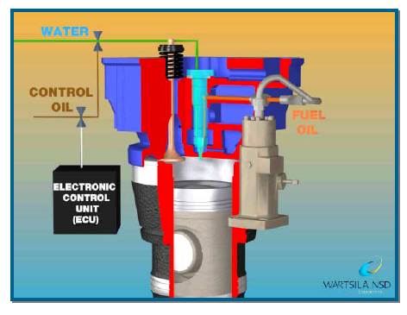
Figure 1: DWI units for pressurizing water

The water can be injected in parallel with the fuel and/or during the compression stroke, so that optimizing injection timing, with respect to fuel and water consumptions, NOX emissions and other emissions, such as hydrocarbons and carbon monoxide, is possible without affecting engine reliability (Figure 2)

Direct water injection does not impose any restriction on the quantity of water injected. It could even be more than 100 per cent, which is a 1:1 ratio of water: fuel. With about 70 per cent water/fuel ratio, DWI has been shown to be capable of reducing NOX emissions down to around 8 g/kWh, or to some 50 per cent below the IMO limit.

Figure 2

