Singapore Polytechnic



Singapore Maritime Academy
&
Maritime Institute Of William Barentsz

Bachelor Degree in Maritime Operations (BMO)

Diesel Technology & EmissionsAssignment

WASTE HEAT RECOVERY

Lecturer: MR. KALYAN CHATTERJEA
Assignment done by: Tam Kong Whee

Date: 4th September 2006

CONTENTS

1. INTRODUCTION AND OVERVIEW---------------------------------------------PAGE 3

2. THE TECHNOLOGY AND ITS WORKING PRINCIPLE-------------------PAGE 4

3. EMISSION CONTROL---------------------------------------------------------------PAGE 7

4. CONCLUSIONS------------------------------------------------------------------------PAGE 8

5. REFERENCES--------------------------------------------------------------------------PAGE 9

1) INTRODUCTION AND OVERVIEW

In the recent days, there has been much emphasis on the emission reduction technology through various innovations. Technology such as direct water injection, Selective Catalytic Reduction (SCR), fuel / water emulsion and injection timing advancement focus more on NOx emission reduction whereas low sulphur fuel is used to reduced SOx emission.

Through such technology, there is always a trade-off between the fuel consumption and the emission reduction. Costly installation and expensive maintenance are also important factors when deciding the type of technology to be used. Currently, most attentions were on NOx and SOx emission reduction with less focus on CO₂ emissions. It has also to be recognized that there is very little margin left in the large marine diesel engine for reducing CO₂ emission through improving engine thermal efficiency.

In order to achieve both reduction in emission & fuel consumption, the engine maker managed to identify an avenue that is able to address both issues with not only consistency to the engine performance and fuel consumption, but also at the same time provide surplus energy to generate power supply for ship-board services and additional output power for the propeller shaft. This technology is simply known as “Waste Heat Recovery”. With today’s modern low-speed engines having an efficiency of up to 50%, there is still 50% of the fuel input energy to be put to productive use.

The implementation of the waste heat recovery system will not only contribute to emission reduction. In term of commercial aspect, the operation of the vessel will be more economical due to less fuel consumption and surplus electronic power for ship-board services, generated by the waste heat. In the case of a Sulzer 12 RTA6C engine developing a maximum constant output of 68,640 kW, this means that an equivalent quantity of energy is being wasted; this is also equivalent to a consumption of 300 tonnes of HFO. Consider the same amount of fuel that you are able to put to productive use, it not only achieve performance benefit but also economic benefit at the same time.

To get a better overview of the heat distribution in the marine diesel 2-stroke engine, we’ll illustrate using the heat distribution diagram as shown below.
Fig. 1: Heat balance of a Sulzer 12RTA96C engine shows the potential for waste heat recovery with current large, low-speed marine engines.

As shown in figure 1, it is apparent that only 49.3% of total power output is generated as shaft power with the majority of other power been distributed through exhaust gas (25.4%), scavenge air cooling (14.1%), jacket water (6.3%), lubricating oil (4.9%) and radiation (0.6%).

From all these heat losses, exhaust gas contribute to the largest portion and this is where we’re going to apply the waste heat recovery system to recover as much heat energy from the exhaust can convert it into other productive output. With that in mind, let’s look at how the implementation of this technology and to what extent it is able to recover the amount of heat loss.

2) THE TECHNOLOGY AND ITS WORKING PRINCIPLE

As discuss previously, the waste heat recovery system utilized heat energy from the exhaust to generate surplus power output for various purposes. In order to do that, firstly it is important to study the 2-stroke engine cycle and how is it possible to improve the intake efficiency in order to increase the exhaust temperature to achieve higher power output.

Exhaust gas temperature can be increased by adapting the engine for ambient suction air intake. Usually marine engines are designed for intake temperatures of up to 45°C for tropical conditions with turbochargers drawing intake air from the engine room. If instead the intake air is drawn from outside the engine room through an air intake duct, the maximum intake temperature can be assumed to be no more than 35°C. See Figure 2.

Fig. 2
Far left: Engine room air suction.
Left: Ambient air suction.

The reason for drawing air from at a lower temperature is simply to increase the density, and subsequently the mass of air required for combustion. This increase in air density, when react with fuel in the combustion chamber, will ignite and produce high exhaust temperature required for the waste recovery system.

As we know, the turbo-charger plays an important part in such operation. To be able to achieve air intake from the atmosphere, in such a case, the turbochargers can be rematched to return the thermal load of the engine back down to what prevails for the intake temperature at 45°C. When considering such a tuning to reach an increased exhaust gas temperature, it is important that the thermal load of the adapted engine is no greater than that of the usual engine so as not to jeopardize engine reliability.

Fig. 3:
Schematic of the Waste Heat
Recovery Plant.

In Figure 3, it briefly illustrates the layout of waste heat recovery plant and the components involved in the cycle.

As shown in the diagrams, the exhaust gas from the main engine will be diverted to the power turbine and the exhaust gas economizer. The power turbine uses a part of the exhaust gas stream {about 10%) from the diesel engine to generate shaft power which can be added to the steam turbine driving the generator.

The turbine is a derivative of a well-proven model of turbocharger turbine with minor adaptations for use as a power turbine. A special matching of the power turbine is necessary for the application in a waste heat recovery system because the turbine operates on a constant-speed operating profile as it is coupled to the generator unlike in a turbocharger with a free-running rotor. The torque of the power turbine is fed to the steam turbine rotor through a reduction gear and an overrunning clutch. The overrunning clutch is needed to protect the power turbine from over speeding in case the generator trips.

With the supplementary shaft power generated by the power turbine, it can allowed a vessel with 3 eight-cylinder Wartsila 32 generating sets with a combined electrical output of some 11 MWe to reduce the installation of one or two fewer auxiliary generating sets than would normally required, taking into account the ship’s capacity for reefer container.

Apart from the power turbine, on the economizer side, the exhaust serves to generate superheated steam and saturated steam for the turbo-generator and shipboard services respectively. In tandem with the heat recovered form this process, it uses 6 MWe Brotherhood turbo-generator set which incorporates a multi-stage dual-pressure turbine and an exhaust gas turbine.

Considering the multi-stage dual-pressure design of the turbo-generator, it is important to generate steam of different pressure and feed them into the different stages of the turbo-generator to allow maximum expansion efficiency. With that in mind, the exhaust gas economizer is segregated into a low-pressure side and a high pressure. A feed water pump will circulate feed water through different stages of heating in the economizer and eventually produced high-pressure and low-pressure superheated steam required for the multi-stage dual pressure turbo-generator and high pressure saturated steam for other ship-board services.

On the propeller shaft, a shaft/alternator of the low speed type is mounted to either supply additional shaft output power or act as an alternator when additional power is required on board. It can be divided into 3 modes:

A. Motor mode
The heat recovery system generates more electrical power than is needed for shipboard service. The surplus electric power is applied in a motor/alternator adding power to the propeller shaft.

B. Alternator mode
The heat recovery system generates less electrical power than is needed for shipboard service. The missing electrical power is generated by the motor/alternator system.

C. Booster mode
More propulsion power is needed than what is available from the main engine. The motor/alternator system acts as motor with the required electrical power being generated by the heat recovery system and the auxiliary engines.

Figure 4 – A typical waste heat recovery system incorporating a shaft generator/motor with energy management system to regulate the different modes.

3) EMISSION CONTROL

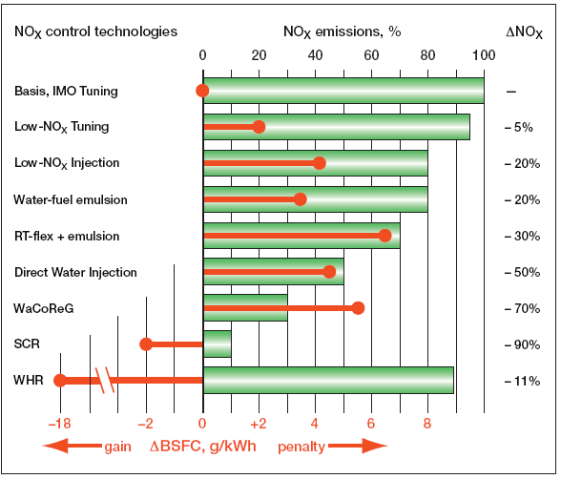
Fig. 5:

Summary of the changes in
NOX emissions and specific
fuel consumption (BSFC)
for various emissions control
technologies.

As mentioned earlier, although it is said that WHR system greatly reduces the amount of
CO₂ emission, when it comes to reduction in NOx emission, it is one of the most effective method among all the other control measures. Marpol Annex VI stipulated the engine requirement and compliance with a “Technical File” approved by the ship’s flag state’s Administration.

“Technical File” or TF for short is an approved document that specifies the actual engine’s performance data, the engine Group (a number of engines defined by the engine with the highest NOx emission – the Parent engine), the emission characteristics of the Group, and how to survey the engine on board for NOx compliance.

The environmental effects of NOx are diverse. Nitrogen oxide is of particular concern because of its detrimental effects on respiration and plant life, as well as its significant contribution to acid rain. In addition, NOx, together with volatile organic compound, is also involved in a series of photo-chemical reactions that lead to an increase in troposphere ozone which, in turn, adversely affects human health, crop yields and natural vegetation.

During the heat recovery process, waste heat from the exhaust is used for other applications instead of releasing into the atmosphere. In addition to that, less fuel are required to be burnt due to the surplus electric power being generated by the heat recovery plant to boost the shaft output power and also to provide ship board power to other services. All this will eventually lead to a reduction in NOx emission without taking any toll on the engine performance and the fuel consumption (Figure 4).

CONCLUSIONS

With the growing interest in reducing emissions and reducing engine operating cost, the waste heat recovery technique is thus a practical path forward. It addresses issues related to emission control without compromising the engine efficiency and fuel consumption. No expensive installation work is involved and cost of maintenance is comparably lower than some other methods.

By adapting the running of the Sulzer low-speed two-stroke marine engines to increase exhaust gas energy and employing both steam and exhaust gas turbines in a waste heat recovery plant, an electrical output of about 11% of engine power is possible. Such savings can make a major contribution to improving both plant efficiency and engine emissions.

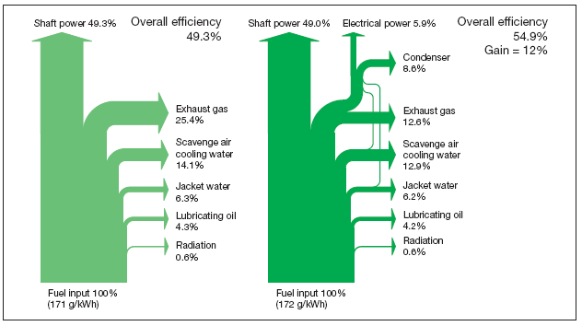

Fig. 6: Comparison of heat balances for Sulzer 12RT-fl ex96C engines without heat recovery (left) and with the Total Heat Recovery Plant (right) showing the 12% gain in overall efficiency for the Total Heat Recovery Plant.

REFERENCES

- Wartsila, Switzerland, April 2004, Less Emission Through Waste Heat Recovery, Available from: http://www.wartsila.com/Wartsila/docs/en/ship_power/media_publications/technical_papers/sulzer/waste_heat_recovery.pdf#search=%22waste%20heat%20recovery%20for%20marine%20engine%22. [Accessed on the 2nd of September]

