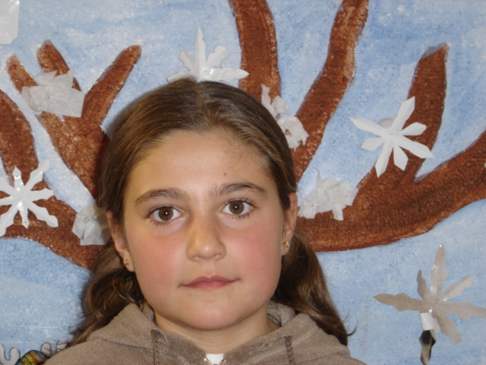
Hello! My name is Patricia .
I´m ten years old.
I´m from Spain .
I live in Grisuela Del Paramo .
I can play football and computer games .
I like pizza and eggs .
My favourite colour is blue and red .
I like animals , especially monkeys.
I´ve got brown eyes.

