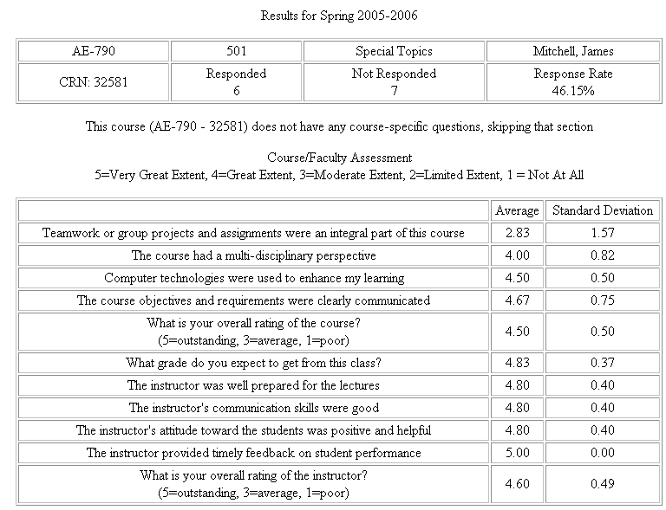

------------------------------------------------------------
COURSE COMMENTS
------------------------------------------------------------

--
sometimes went slowly

--
Strengths
_ Challenged our thought processes _ such as a grad course should do.
_ Was not too technical since the definition of the topic, intelligent buildings, has not been universally decided.
_ Used various methods to convey one thing _ database, concept maps, logs, and papers.
_ Always looking in the future. Preparing us to face upcoming challenges.

Weaknesses
_ None

--
Very interesting topics, open format allowed for free exchange of ideas... Cmap is an excellent tool to expose to students. Log is a great idea.

Raised many interesting questions but few answers _ got a little frustrating. At times class discussion topics could become repetitive. It seemed that too much time was spent on Access _ it_s a great tool and should be mandatory for students to know and understand, but it felt like it took a bit of time away from other topics that could have been explored.

--
It was good intergrating a lot of issues and components of buildings. It used CMap, which was very interesting and forced students to break down differnt issues in buildings_building systems and see how they overlap and influence each other. It also used Access, which can be a helpful tool in the future with databases. This course focused on technology and its integration into buildings which was very interesting and useful since technology is continuing to have a larger influence in buildings.

------------------------------------------------------------
INSTRUCTOR COMMENTS
------------------------------------------------------------

--
Very well organized and prepared for the lecture each week

--
- Well prepared.
- Timely feedback.
- Challenged us to think beyond the here and now.
- Friendly.
- Knowledgable.

--
Excellent communicator, presents expectations clearly, welcomes class discussion, and very good at directing/leading questions to get discussions to certain area.

--
He is very prepared and organized for class, which allows him to be an efficient teacher. He challenges his students and forces them to look at differnt issues/perspectives than they are normally asked. This forces us to ask questions and start to understand what we are learning in his class and how it relates to other classes and aspects of Architectural Engineering.

------------------------------------------------------------
GENERAL COMMENTS AND SUGGESTIONS
------------------------------------------------------------

--
_ Make sure advertisement in the course is clear; some students came in expecting one thing and received another, which wasn_t always a bad thing either.

--
Probably impossible, but make laptops mandatory requirement of the course.

Set up a voluntary _field trip_ to the nearest Intelligent Building_Smart Home or one that is marketed as such.

Perhaps offer some insight into how other countries have advanced_succeeded with research, funding, development, marketing, etc. _ or perhaps that_s another course entirely.

--
I thought it was good.

