Scale Formation

When a bubble of steam forms on a metal surface, there will be local concentration of solids in the evaporating water and a ring of crystals will be deposited around the perimeter of the bubble.

If the salt crystals are highly soluble in water, they will quickly go back into solution as the water closes over the metal after the steam bubbles move away. If, however, they are relatively insoluble the crystals will adhere to the heated surface and start to build up a hard scale.

The calcium and magnesium salts are divided into two groups:

Temporary Hardness

The bicarbonates of calcium and magnesium, which are easily decomposed by heat, cause alkaline hardness or also known as temporary hardness.

The decomposition of these bicarbonates by heat may be represented by the following equations:

Calcium bicarbonate precipitated carbon water
calcium carbonate dioxide
Ca(HCO₃)₂ CaCO₃ + CO₂ + H₂O

Magnesium bicarbonate precipitated carbon water
magnesium carbonate dioxide
Mg(HCO₃)₂ MgCO₃ + CO₂ + H₂O

The CO₂ is released in the boiler and will produce an acid steam condensate. Trace quantities of magnesium and calcium bicarbonate may be present in evaporated sea water and will decompose in the boiler to produce insoluble carbonate which, if not removed by boiler blowdown, will form a deposit on the boiler tubes.

Permanent Hardness

The chlorides, sulphates, nitrates and silicates, CaCl_{2,} MgCl_{2,} CaSO_{4,} Ca(NO₃)₂ and Mg(NO₃)₂) are not decomposed by boiling. They cause non-alkaline hardness or permanent hardness.

The effect of adherent scales and deposits is to form a thermal insulator on the heating surfaces leading to a rise in the temperature of the metal causing softening or rupture of the metal surfaces. Excessive scale can lead to blockage of tubes in water tube boilers, resulting in water starvation.

The effect of scale on the strength of the steel tubes

To exist in the heat of the furnace, the steel boiler tubes are kept sufficiently cool by the boiler water and steam circulating within them, which transfer the heat to the boiler drum and remove it from the system as steam. Anything which interferes with the transfer of heat through the tube wall causes overheating and rupture of the tube.

Steel is quite a good conductor of heat and clean tubes quickly transfer heat from the furnace to the water. If a hardness scale, or a build-up of loose scale, forms on the inside surface, the heat transfer will be slower and the tube will eventually overheat. As the local temperature of the tube increases more, solids are deposited and the situation gets worse. The outside of the tube becomes considerably hotter, the mill scale (concrete form) forms which later breaks away. Successive losses of metal eventually thin the tube wall and add to the weakening of the tube caused by the high temperature. Ultimately, the tube ruptures.

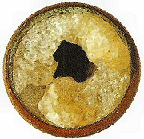

Figure 1 Example of scale formation

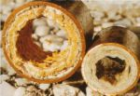

Figure 2 Example of scale formation
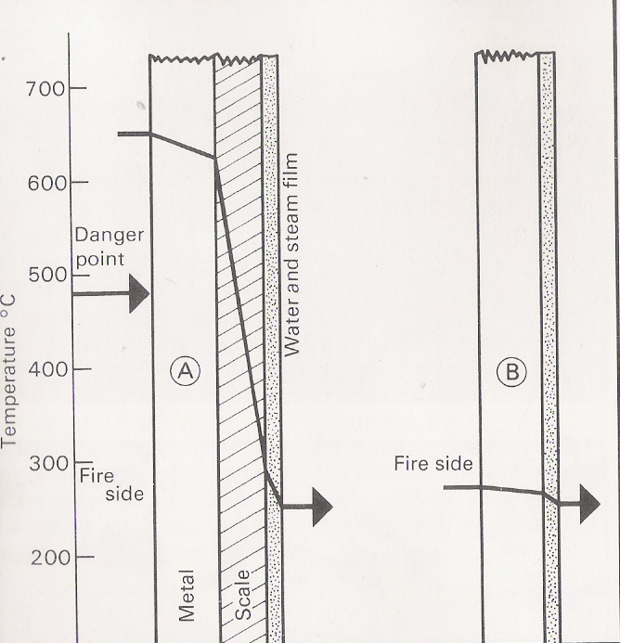

Figure 3 Heat transfer

Scale on the inside of a water tube delays the transfer of heat from the fire and severe scale (example A) will cause the metal temperature to rise above the danger point at which the mechanical properties of the steel start to deteriorate. The temperature of a clean tube (example B) remains safely below the danger point.

