THE DESERTIFICATION

Gonzalo Gimeno, Mario Gonzalez and Luis Carlos Beristaín 3ºC

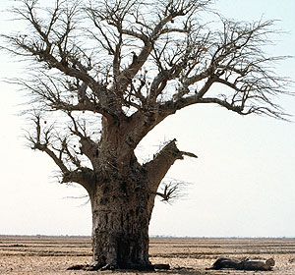

Desertification

Is called a desertification to the transformation of lands used for cultures or pastures in desert or almost desert lands, with a decrease of the productivity of 10 % or more. The desertification is moderated when the loss of productivity is between10 % and 25 %. It is severe if the loss is between 25 % and 50 % and very severe if it is major.

The process of desertification is observed in many places of the world and is a serious threat for the environment and for the agricultural yield in some zones. When it is provoked by the human activity there is in the habit of being calling he a desertification.

Natural desertification
Most of the desertification is natural in the zones that tack to the deserts. In epochs of drought these places are dehydrated, lose vegetation and good part of his soil is dragged by the wind and other agents erosivos. Nevertheless, this natural phenomenon meets aggravated by human activities that debilitate the soil and make it more inclined to the erosion

Human activities that accelerate the desertification
Between the human actions that debilitate the soil and accelerate the desertification are:
· Sobrepastoreo. - Is the attempt of supporting excessive heads of cattle in a territory, with the result of which the vegetation is started and trodden by the herbivores and it is not possible to re-put. The nake soil is great easier eroded. It is the principal human reason of desertification in the world.

· Badly I use of the soil and of the water. - The irrigation with water with you go out in dry and hot places it finishes salinizando the soil and this prevents the growth of the vegetation. Some technologies of culture likewise facilitate the erosion of the soil.
· Felling of trees and mining industry to sky open. - When one takes the vegetablecover and does not re-put on the loss of soil is much easier.
· The compact of the floor. - The use of heavy machinery or the action of the water in soils undressed of vegetation produce a hard and compact soil that impedes the growth of the plants and favors the desertification.

Extension of the desertification in the world

Is not easy to determine what surfaces are submitted to desertification provoked by the man. In many cases it is a natural process that follows the climatic oscillations; in a few epochs the deserts grow and in others they move back, depending on the evolution of the climate.
According to some estimations of the Program of the United Nations for the Environment an extension similar to that of the whole America they are in risk of desertification.

Erosion of the soil in Spain

Let's come back to the conference of Nairobi. Already in this moment there is discovered that it is a complex problem with multiple factors to bearing in mind. This fact leads them, already in the year 1977, to defining the desertification as " the process of ecological degradation for which the productive land loses part or all his potential of production, which leads to the appearance of the desert conditions ".

In this definition we can see as the authors they refer to the ecological conditions of a territory, complex reality and multifactorial, in that there affect all the elements that form an ecosystem. Besides one does not circumscribe only to zones close to the deserts, but it is a more wide problem.

The successive investigations led to the formulation of multiple definitions, according to the factor that his different authors wanted to highlight. We think that the concept coined in the conference on Development and Environment of Rio of Janeiro (1992), accepted later by the international agreement of struggle against the desertification, is very appropriate: " processes that produce the soil degradation in the specific context of climatic arid, semiarid and subhumid dry conditions, as result of climatic variations and human performances not tending to the support of the system ".

Therefore, we can see that not only it is a problem that is restricted to the climatic conditions, but the man across his socioeconomic system alters the conditions of productivity of the natural resources, in this case since we will see later, of the soil. This phenomenon affects at present 20 % of the emerged lands, approximately 30 millions of Km2 in arid and semiarid zones of the planet, and in major or minor degree to other zones, since we can observe in the map of risk of desertification.

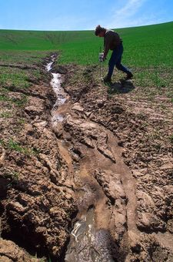

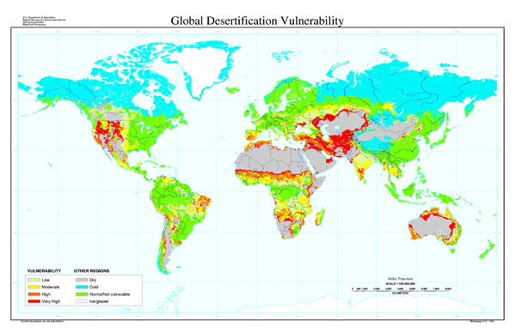

Map of the Department of Agriculture of The United States. The colors red and orange indicate major risk of desertification.
These phenomena demonstrate with the appearance of bad grasses that they fix worse the soil, which they are more coarse and less desired for the cattle, decrease of the dampness, salinización and loss of the soil. We can say, in conclusion, that the term desertification alludes to the progressive degradation of the ecosystems owed to natural processes, and / or to human slightly respectful performances that we can identify for an endemic and progressive aridity that makes difficult the vegetable and animallife, impeding the exploitation of both resources on the part of the man.

For example, when the lands of culture or of pastures have transformed and degraded, with a loss of productivity of between 10 % and 25 %, one speaks about moderate desertification; it is severe if the loss is between 25 % and 50 %, and very severe if it is major.

