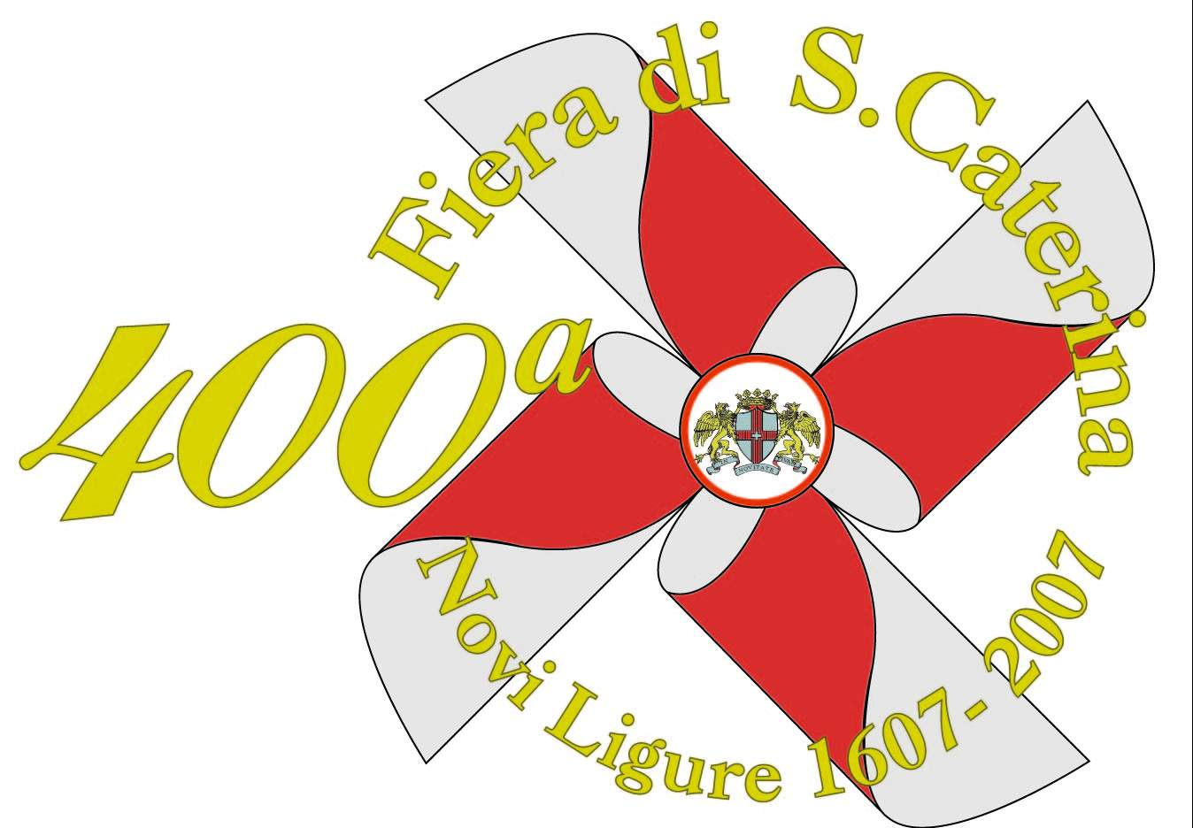 ST. CATHERINE FAIR
St. Catherine’s fair takes place on the 25th November and it is one of the oldest in Italy. The origin of this festivity dates back to the XII and XVI century, but its official celebration started in 1607.
This year it celebrates its 400th birthday . On this occasion there will be special events during the month of November. In particular there will be a Cattle fair and a show devoted to the history of Funfair.
