ThE ChOcOlAtE
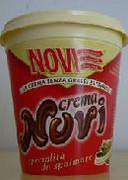
Chocolate
Novi Ligure and the surrounding area maintain a deeply rooted tradition of confectionery and chocolate arts. The head offices of another prestigious brand name are also located here.
Pernigotti, along with numerous other smaller firms that “export” sweetness to other areas of Italy and the world
Novi, Elah and Dufour are the most famous names, specialized in nougat, chocolate and candies production.

