Benjamin Zisman AE 790
April 24, 2008 Assignment 2

In 2008, there are many problems with buildings that have been constructed as far back as the 1900s. The causes of these problems include, but are not limited to, water penetration in the roofs and walls, poor sound absorption against outside noise, as well as the large environmental impact buildings have on the surrounding area. There are, of course, many other problems that exist in today’s buildings, but these three problems will be the main focus.
Water penetration in buildings has many terrible results, not only on the structural integrity of the framework, but also for the people who occupy the residential or office space. For wooden structures, the addition of mold to the building envelope can deteriorate the wood causing a structural failure. In large office buildings or residential buildings, structural integrity is not necessarily the case, but there are still mold and fungi issues, which greatly effects indoor air quality which, in turn, can affect people’s health. Exposure to fungi can produce three reactions from people. They can be allergic reactions, infections, and toxic responses. A possible solution to water penetration, one that an intelligent building could have, would be moisture detection equipment. By installing moisture meters, buildings can monitor proper moisture levels of building components prior to their installation. These components would be gypsum board, plaster, concrete, brick, roofing, and insulation.
Poor sound absorption in buildings has many negative effects on the building occupants such as hearing loss, stress, sleep disturbance, interrupted thought, as well as decreased productivity. There are, however, methods to reducing the noise that penetrates buildings. By lining plywood in buildings with fiber glass, the noise level is able to be reduced, as seen in the table below.

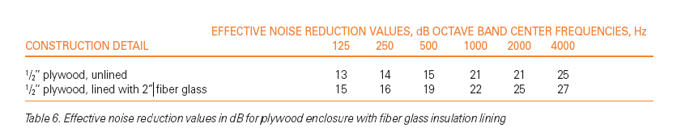
http://www.certainteed.com/NR/rdonlyres/EEC471FE-1427-4A52-9946-4A17EF3BAA12/0/3025047.pdf

For windows, using double pane windows and/or storm windows reduce sound transmission. These solutions might be considered characteristics of a smart building. A definite way to find large sound problem areas is to use a decibel measuring device and use the knowledge gained to diagnose the problem.
Although water penetration and noise pollution are important, perhaps the biggest problem with buildings today is the environmental impact that they have. Older buildings produce heat islands, they reduce rain water runoff, and produce large amounts of waste. Heat islands, which are formed by light being absorbed into the roofs and ground levels of buildings, cause temperatures in cities to be 2 to 10 degrees Fahrenheit higher than that of rural areas. Elevated temperatures can impact communities by increasing peak energy demand, air conditioning costs, air pollution levels, and heat-related illness and mortality. Reduced rainwater runoff can produce flooding in cities as well as degrading soil and plant life. Finally, all of the waste that is produced by these large buildings contributes greatly to global warming and the destruction of the natural habitats close to the polluting region. One way to combat these issues is to demand more green space around buildings to absorb rainwater runoff, change the materials used on roofs and walls to either reflect light or absorb it for energy alternatives, and use more recyclable or sustainable materials to reduce waste produced.

