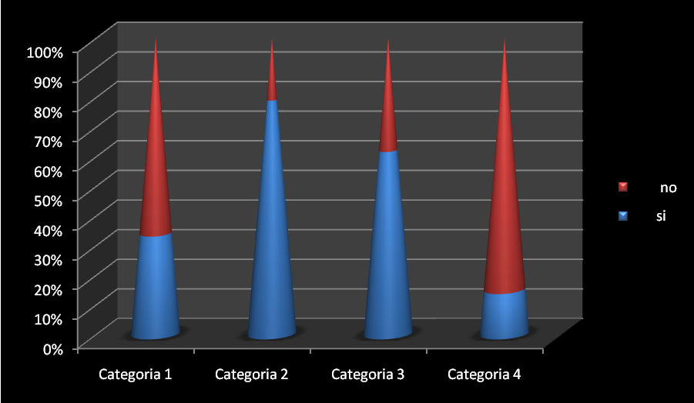
Si | No
34% | 66%
79% | 21%
62% | 38%
15% | 85%

