Hard Times (1854)
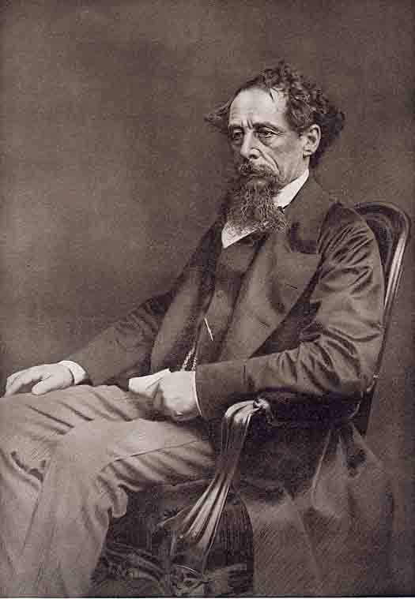
"Coketown"
COKETOWN, to which Messrs. Bounderby and Gradgrind now walked, was a triumph of fact; it had no greater taint of fancy in it than Mrs. Gradgrind herself. Let us strike the key-note, Coketown, before pursuing our tune.
It was a town of red brick, or of brick that would have been red if the smoke and ashes had allowed it; but as matters stood, it was a town of unnatural red and black like the painted face of a savage. It was a town of machinery and tall chimneys, out of which interminable serpents of smoke trailed themselves for ever and ever, and never got uncoiled. It had a black canal in it, and a river that ran purple with ill-smelling dye, and vast piles of building full of windows where there was a rattling and a trembling all day long, and where the piston of the steam-engine worked monotonously up and down, like the head of an elephant in a state of melancholy madness. It contained several large streets all very like one another, and many small streets still more like one another, inhabited by people equally like one another, who all went in and out at the same hours, with the same sound upon the same pavements, to do the same work, and to whom every day was the same as yesterday and to-morrow, and every year the counterpart of the last and the next.[...]
You saw nothing in Coketown but what was severely workful. If the members of a religious persuasion built a chapel there - as the members of eighteen religious persuasions had done - they made it a pious warehouse of red brick, with sometimes (but this is only in highly ornamental examples) a bell in a birdcage on the top of it. The solitary exception was the New Church; a stuccoed edifice with a square steeple over the door, terminating in four short pinnacles like florid wooden legs. All the public inscriptions in the town were painted alike, in severe characters of black and white. The jail might have been the infirmary, the infirmary might have been the jail, the town-hall might have been either, or both, or anything else, for anything that appeared to the contrary in the graces of their construction.
Fact, fact, fact, everywhere in the material aspect of the town; fact, fact, fact, everywhere in the immaterial. The M'Choakumchild school was all fact, and the school of design was all fact, and the relations between master and man were all fact, and everything was fact between the lying-in hospital and the cemetery, and what you couldn't state in figures, or show to be purchaseable in the cheapest market and saleable in the dearest, was not, and never should be, world without end, Amen.
A town so sacred to fact, and so triumphant in its assertion, of course got on well? Why no, not quite well. No? Dear me!

