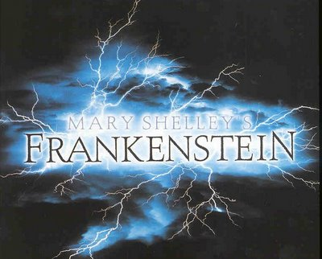
One day, at the age of 13, Victor Frankenstein, whose family has meanwhile settled down in Geneva, when forced by a storm to remain inside, discovers the works of some scientists from an earlier age. That is the discovery that will change his life forever. Thus he conceives a passion to know the physical secrets of the world. His pleasure and curiosity for learning from books, his strong willing to improve his mind eventually lead him to study science and unveil the secrets of nature. At the age of 15, Victor witnesses a summer thunderstorm with lightning which arouses his interest in electricity and possible applications for its use. Victor sees how the lightning has the power of destruction when a tree near their home is destroyed from a lightning strike. This accident gives Victor the chance to learn more about technology and science, especially referred to electricity and galvanism, which for him are now worthy subjects for further study especially after a visitor in the Frankenstein home explains the electrical phenomena to the young boy. This indirectly causes a change in his scientific interests and thinking. Actually Victor decides to abandon his earlier study of alchemy and to study mathematics and pure science. Yet his life as a scientist is doomed.
[One day, at the age of 13, Victor Frankenstein, whose family has meanwhile settled down in Geneva, when forced by a storm to remain inside, discovers the works of some scientists from an earlier age. That is the discovery that will change his life forever. Thus he conceives a passion to know the physical secrets of the world. His pleasure and curiosity for learning from books, his strong willing to improve his mind eventually lead him to study science and unveil the secrets of nature. At the age of 15, Victor witnesses a summer thunderstorm with lightning which arouses his interest in electricity and possible applications for its use. Victor sees how the lightning has the power of destruction when a tree near their home is destroyed from a lightning strike. This accident gives Victor the chance to learn more about technology and science, especially referred to electricity and galvanism, which for him are now worthy subjects for further study especially after a visitor in the Frankenstein home explains the electrical phenomena to the young boy. This indirectly causes a change in his scientific interests and thinking. Actually Victor decides to abandon his earlier study of alchemy and to study mathematics and pure science. Yet his life as a scientist is doomed.]

This extract echoes some experiments that in late 18th century had demonstrated the power of electric current to cause spasms in dead tissue, according to some pseudo-scientific notions such as “Galvanism” and “Galvan-tropism”.

Galvanism is the use of galvanic current, i.e., a steady direct current, for medical or biological purposes; Galvan-tropism is the response of an organism to electrical stimulation.

