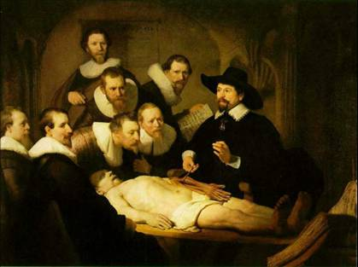

Rembrandt: Anatomy Lesson of Dr. Nicolaes Tulp

